**Assignment -2 :**

**C-programming**

#include <stdio.h>

#define int long long int

double power(int x, int y);

double fact(int x);

int main()

{

    printf("Enter the value of n and x\n");

    int n;

    float x;

    scanf("%d%f", &n, &x);

    double a = 1;

    for(int i = 1; i <= n; i++)

    {

        a += ((double)power(x, i)/fact(i));

    }

    double b = 1;

    for(int i = 1; i <= n; i++)

    {

        b += ((double)power(x, i) * fact(n)/fact(n - i)/fact(i));

    }

printf("The value of e^x is %f\n", a);

    printf("The value of (1 + x)^n is %f\n", b);

}

double power(int x, int y)

{

    double res = 1;

    for(int i = 0; i < y; i++)

    {

        res *= x;

    }

    return res;

}

double fact(int x)

{

    double res = 1;

    for(int i = x; i >= 1; i--)

    {

        res *= i;

    }

    return res;

}

**Output:**

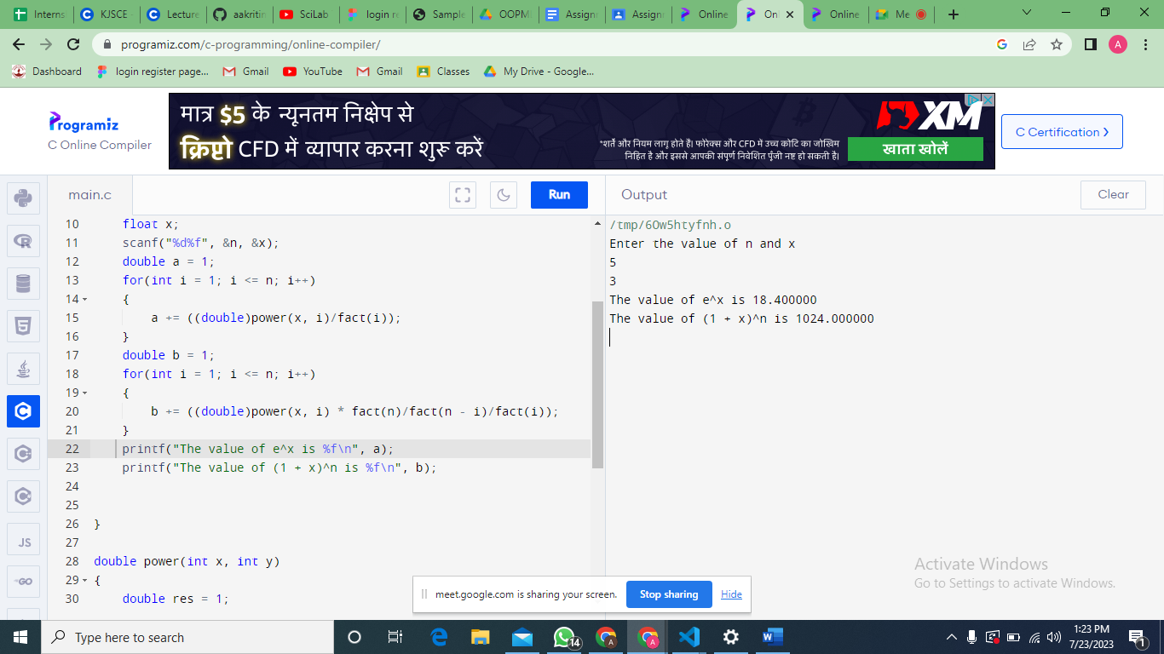

**Python:**

class myMath:

class myMath:

    def power(x, y):

        return x ** y

    def fact(x):

        if x == 0:

            return 1

        else:

            return x * myMath.fact(x - 1)

class SeriesExpansions:

    def e_x(x, n):

        result = 1

        for i in range(1,n+1):

            result += myMath.power(x, i) / myMath.fact(i)

        return result

    def e_n(x, n):

        result = 1

        for i in range(1,n+1):

            result += myMath.power(x, i) * myMath.fact(n)/myMath.fact(n-i) / myMath.fact(i)

        return result

if __name__ == "__main__":

    x = float(input("Enter the value of x for e^x and (1+x)^n: : "))

    n = int(input("Enter the number of terms for the series expansion: "))

    e_x_result = SeriesExpansions.e_x(x, n)

    print("The value of e^x using series expansion: ", e_x_result)

    one_n_result = SeriesExpansions.e_n(x, n)

    print("The value of (1+x)^n using series expansion: ",one_n_result )

**Output:**

