

| **TITLE:**  Menu driven program. |
| --- |

**AIM:** Write a menu driven program for following option

a.To find whether a number is palindrome or not. (e.g. 1221 is palindrome) using while loop

b. To calculate the sum of the Fibonacci series up to ‘n’ terms(use do-while loop only)

c. To find the numbers and sum of all integer between 100 and 200 which are divisible by both 3 & 5(use for loop only)

______**________________________________________________________________**

**Expected OUTCOME of Experiment:**

**_____________________________________________________________________**

**Books/ Journals/ Websites referred:**

1. Programming in C, second edition, Pradeep Dey and Manas Ghosh, Oxford University Press.
2. Programming in ANSI C, fifth edition, E Balagurusamy, Tata McGraw Hill.
3. Introduction to programming and problem solving , G. Michael Schneider ,Wiley India edition.
4. [**http://cse.iitkgp.ac.in/~rkumar/pds-vlab/**](http://cse.iitkgp.ac.in/~rkumar/pds-vlab/)

**_____________________________________________________________________**

**Problem Definition:**

The program accepts a choice from the user using a switch case statement and generates output accordingly.

**Choice a**: The program checks whether a given numbered by user is palindrome or not.If a number remains same, even if we reverse its digits then the number is known as palindrome number. For example, 12321 is a palindrome number because it remains same if we reverse its digits.

**Choice b:** Sum of Fibonacci series up to n terms will be generated. Fibonacci series is a series in which each number is the sum of the last two preceding numbers. The first two terms of a Fibonacci series are 0 and 1.(use while loop only)

**Example:**

Input: n = 5

Output: 7

Explanation: 0 + 1 + 1 + 2 + 3 = 7

**Choice c:** To find the numbers and sum of all integer between 100 and 200 which are divisible by both 3 & 5.(use for loop only)

**Algorithm:**

1 : START

2 : DECLARE & INITIALIZE VARIABLES choice, sum=0, temp, num, a=0, b=1, c, r

3 : PRINT "1. Palindrome"

4 : PRINT "2. Fibonacci”

5 : PRINT "3. 100 - 200 divisible by 3 & 5”

6 : PRINT "Enter a choice : "

7 : INPUT choice

8 : IF choice = 1 THEN GOTO 11

9 : IF choice = 2 THEN GOTO 19

10 : IF choice = 3 THEN GOTO 30

11 : PRINT "Enter a number : "

12 : INPUT num

13 : temp = num

14 : sum = (sum*10) + (num%10)

15 : num=num/10

16 : IF num> 0 THEN GOTO 13

17 : IF temp = sum THEN PRINT "Palindrome"

ELSE PRINT “Not Palindrome"

18 : END

19 : PRINT "Enter terms of fibonacci series : "

20 : INPUT num

21 : sum = sum + a

22 : PRINT “a, ”

23 : c=a+b

24 : a=b

25 : b=c

26 : num--

27 : IF num>0 THEN GOTO 21

28 : PRINT “Sum is sum”

29 : END

30 : i=100

31 : IF i%3=0 & i%5=0 THEN

sum=sum+i

PRINT “i, ”

32 : PRINT “Sum is sum”

33 : i++

34 : IF i<=200 THEN GOTO 30

35 : END

36 : PRINT “Invalid Choice”

37 : STOP

**Implementation details:**

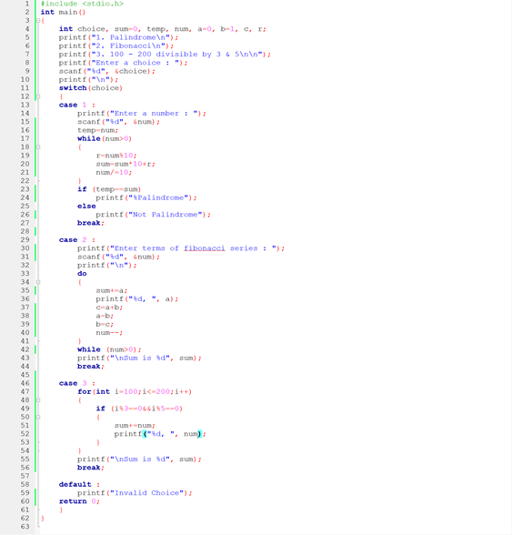

**Output(s):**

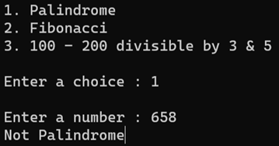

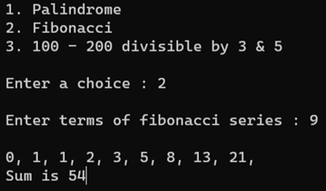

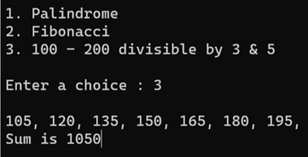

**Conclusion:**

Thus, we learnt how to make use of choice statement – **switch case**, control statements – **for, do while, while loop**.

**Post Lab Descriptive Questions**

**Write menu driven code for the following:**

The program allows a user to enter five numbers and then asks the user to select a choice from a menu. The menu should offer the following options –

1. Display the smallest number entered

2. Display the largest number entered

3. Display the sum of the five numbers entered

4. Display the average of the five numbers entered.

5. Exit

#include <stdio.h>

void main()

{

int ch, arr[5], r = 0, i, s = sizeof(arr)/sizeof(arr[0]);

printf("Enter 5 numbers : \n");

for(int i=0;i<s;i++)

scanf("%d", &arr[i]);

printf("\n\n1. Display the smallest number entered\n");

printf("2. Display the largest number entered\n");

printf("3. Display the sum of the five numbers entered\n");

printf("4. Display the average of the five numbers entered\n");

printf("5. Exit\n\n");

printf("Enter choice : ");

scanf("%d", &ch);

printf("\n");

switch(ch)

{

case 1 :

for (i=0;i<s-1;i++)

{

if(arr[i]>=arr[i+1])

r = arr[i];

}

printf("Smallest number entered is %d", r);

break;

case 2 :

for (i=0;i<s-1;i++)

{

if(arr[i]>=arr[i+1])

r = arr[i];

}

printf("Largest number entered is %d", r);

break;

case 3 :

for (i=0;i<s;i++)

r+=arr[i];

printf("Sum of 5 numbers entered is %d", r);

break;

case 4 :

for (i=0;i<s;i++)

r+=arr[i];

printf("Sum of 5 numbers entered is %d", (int)(r/s));

break;

case 5 :

exit(0);

default :

printf("Invalid Choice");

}

}

**Date: _____________ Signature of faculty in-charge**