

| **TITLE:**  Program to print patterns |
| --- |

**AIM:** Program to print patterns for ‘n’ rows using nested loop **______________________________________________________________________**

**Expected OUTCOME of Experiment:**

**_____________________________________________________________________**

**Books/ Journals/ Websites referred:**

1. Programming in C, second edition, Pradeep Dey and Manas Ghosh, Oxford University Press.
2. Programming in ANSI C, fifth edition, E Balagurusamy, Tata McGraw Hill.
3. Introduction to programming and problem solving , G. Michael Schneider ,Wiley India edition.
4. [**http://cse.iitkgp.ac.in/~rkumar/pds-vlab/**](http://cse.iitkgp.ac.in/~rkumar/pds-vlab/)

**_____________________________________________________________________**

**Problem Definition:**

The program is to print a pattern as given by the user. The program makes use of a nested loop to print a pattern of characters, numbers or alphabets.

**Example:**

Input: number of rows = 5, number of columns = 5

Output:

5

             4    5

         3   4   5

    2   3   4   5

1  2   3   4   5

**Algorithm:**

1. Start
2. Declare variable a for the loops (i,j,k) and for the number of rows. [ k is the space loop]
3. Input the number of rows.
4. Write the for loop of i,j and k to make the given pattern.
5. Print the following pattern using i and j for loops .
6. Stop

**Implementation details:**

#include<stdio.h>

void main()

{

int n;

printf("Enter the number of rows you want ");

scanf("%d",&n);

int t=n+1;

for(int i=1;i<=n;i++)

{

for(int j=1;j<=(n-i);j++)

{

printf(" ");

}

for(int k=1,m=t-i;k<=i;k++,m++)

printf("%d ",m);

printf("\n");

}

}

**Output(s):**

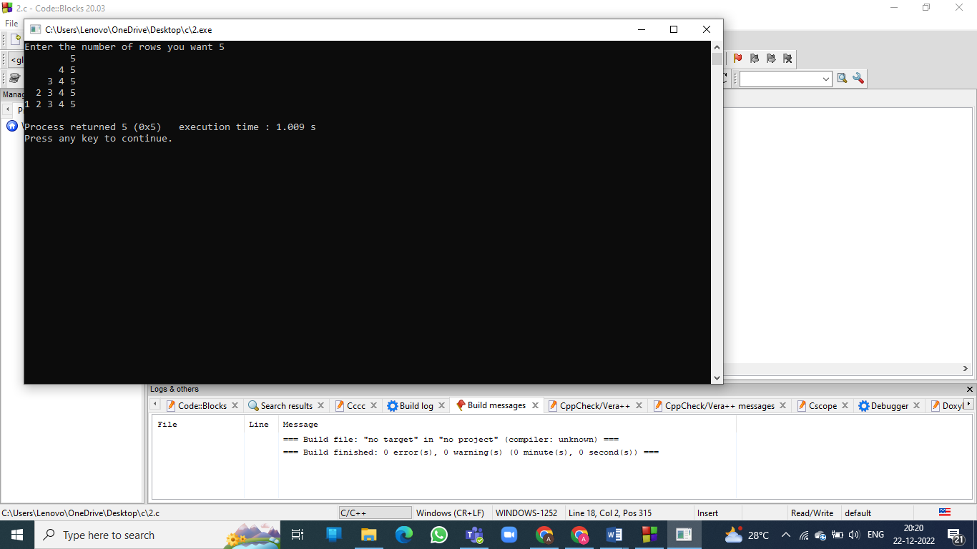

**Conclusion:**

Thus, we learnt to make pattern using c programming language.

**Post Lab Descriptive Questions**

1. Write a program to print the following:

1

2 4

3 6 9

4 8 12 16

5 10 15 20 25

6 12 18 24 30 36

7 14 21 28 35 42 49

8 16 24 32 40 48 56 64

9 18 27 36 45 54 63 72 81

10 20 30 40 50 60 70 80 90 100

CODE:

#include<stdio.h>

void main()

{

int m;

for(int i=1;i<11;i++)

{

for(int j=1;j<=i;j++)

{

m=i*j;

printf("%d ",m);

}

printf("\n");

}

}

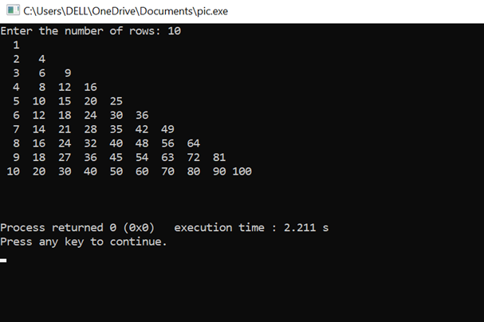

b) Write a program to print the following pattern:

A

ABA

ABCBA

ABCDCBA

CODE:

#include<stdio.h>

int main()

{

int i,j,k,n,sp;

printf("Enter no. of rows:");

scanf("%d",&n);

sp=n-1;

for(i=1;i<=n;i++)

{

for(k=1;k<=sp;k++)

{

printf(" ");

}

sp--;

for(j=1;j<=i;j++)

{

printf("%c",(char)(j+64));

}

for(j=i-1;j>=1;j--)

{

printf("%c",(char)(j+64));

}

printf("\n");

}

}

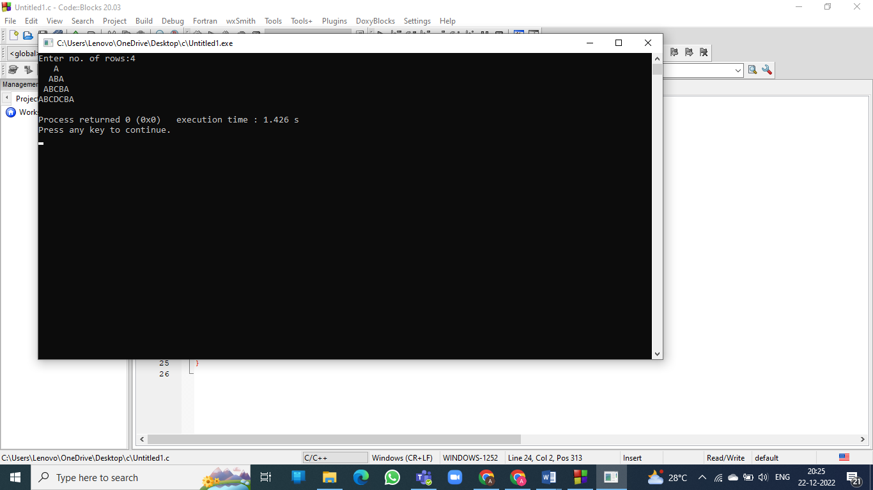

**Date: _____________ Signature of faculty in-charge**