### 

| **TITLE:**  Program to sort array |
| --- |

**AIM:** Program to sort the 1D array in the ascending or descending order and then accept the element from user and insert in the same array at its correct place by keeping array sorted **______________________________________________________________________**

**Expected OUTCOME of Experiment:**

**_____________________________________________________________________**

**Books/ Journals/ Websites referred:**

1. Programming in C, second edition, Pradeep Dey and Manas Ghosh, Oxford University Press.
2. Programming in ANSI C, fifth edition, E Balagurusamy, Tata McGraw Hill.
3. Introduction to programming and problem solving, G. Michael Schneider ,Wiley India edition.
4. [**http://cse.iitkgp.ac.in/~rkumar/pds-vlab/**](http://cse.iitkgp.ac.in/~rkumar/pds-vlab/)

**_____________________________________________________________________**

**Problem Definition:**

The program takes a 1D array and sorts it in the specified manner. The user enters an element and the same has to be inserted at the correct place in the sorted array.

**Flowchart:**

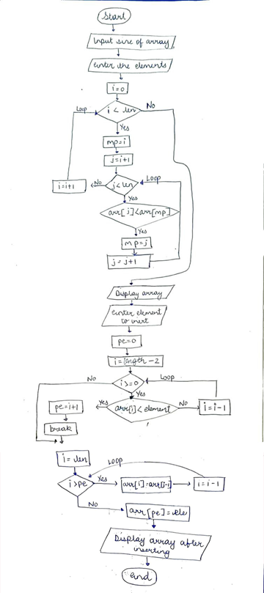

**Implementation details:**

#include<stdio.h>

intmain()

{

printf("Enter the number of elements:\n");

intlen;

scanf("%d",&len);

intarr[++len];

printf("Enter the list:\n");

for(inti=0;i<len-1;i++)

scanf("%d",&arr[i]);

arr[len-1]=100000;

// sorting elements

for(inti=0;i<len;i++)

{

intmp=i;

for(intj=i+1;j<len;j++)

{

if(arr[j]<arr[mp])

mp=j;

}

inttemp=arr[i];

arr[i]=arr[mp];

arr[mp]=temp;

}

printf("\nData After sorting: \n");

for(inti=0;i<len-1;i++)

printf("%d ",arr[i]);

printf("\n");

intele;

printf("Enter the element you want to insert:\n");

scanf("%d",&ele);

//finding where to insert

intpe=0;

for(inti=len-2;i>=0;i--)

{

if(arr[i]<ele){

pe=i+1;

break;}

}

//inserting here

for(inti=len;i>pe;i--)

arr[i]=arr[i-1];

arr[pe]=ele;

//completed inserting

printf("List after inserting and sorting:\n");

for(inti=0;i<len;i++)

printf("%d ",arr[i]);

return0;

}

**Output(s):**

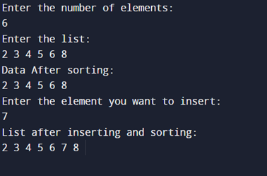

**Conclusion:**

Thus, we learnt sorting and inserting in array.

**Post Lab Descriptive Questions**

Write a program to enter n numbers, store them in an array and rearrange the array in the reverse order.

#include<stdio.h>

intmain() {

intn;

printf("Enter the number of Elements: ");

scanf("%d",&n);

printf("Enter the elements\n");

intarr[n];

for(inti=0;i<n;i++)

scanf("%d",&arr[i]);

for(inti=0;i<n/2;i++)

{

inttemp=arr[i];

arr[i]=arr[n-1-i];

arr[n-1-i]=temp;

}

printf("In Reverse order: \n");

for(inti=0;i<n;i++)

printf("%d ",arr[i]);

return0;

}

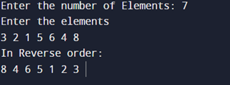

**Date: _____________ Signature of faculty in-charge**