Batch: C2-2 Roll No.: 16010122109

Experiment / assignment / tutorial No. 6

Grade: AA / AB / BB / BC / CC / CD /DD

Signature of the Staff In-charge with date

TITLE: Array of Structures.

______________________________________________________________________
AIM: Program to declare an array of structure `players` having data members (name, total matches played, best bowling figure). Program should do the following operations using functions.
- Insert Minimum 5 player data in array of structure
- Sort and display this data in descending order of their best bowling figure (if wickets are same then consider less run conceded as priority) and in proper tabular form
- Delete the data for any one player.
- Search for a particular player using its name.

Expected OUTCOME of Experiment:

_____________________________________________________________________
Books/ Journals/ Websites referred:

- Programming in C, second edition, Pradeep Dey and Manas Ghosh, Oxford University Press.
- Programming in ANSI C, fifth edition, E Balagurusamy, Tata McGraw Hill.
- Introduction to programming and problem solving , G. Michael Schneider ,Wiley India edition.
- http://cse.iitkgp.ac.in/~rkumar/pds-vlab/

_____________________________________________________________________

Problem Definition:

Create an array of structure ‘players’ which store information about multiple players having different data members such as name, total matches played, best bowling figure.
Program should read choice from the user and perform following function:

Choice 1: Insert data in array of structure.
Choice 2: Sort and Display
Choice 3: Delete a player
Choice 4: Traverse and search a player with given name.

Algorithm:
- Start
- Input the data(name , matches played,bestbowling figure) to create an array .
- Store the data.
- Sort and display the data of players in descending order of their best bowling figures.
- Input the players name to be deleted in the array.
- Then delete the data for a player with the given name from the array of players.
- Input the players name to be found in the array.
- Then search for a player with the given name in the array of players.
- Stop

Implementation details:

1 ] #include <string.h>
#include <stdio.h>
#include <stdlib.h>
typedef struct player{
char name[50];
int matches;
int best_wickets;
int best_runs;
} player;
void AddPlayer(int pos, player* arr);
void SortAndDisplay(player * arr, int n);
int Search(player* arr, int n);
void Delete(player *arr, int n);
int main() {
int n;
printf("Enter the number of players(Minimum 5)\n");
scanf("%d", &n);
player *arr = malloc(sizeof(player) * n);
for (int i = 0; i < n; i++)
{
AddPlayer(i, arr);
}

int choice;

while(1){
printf ("1. Add a new player\n2. Sort and display\n3.Delete a player\n4. Search for a player\n5. Exit\n");

scanf("%d", &choice);

switch(choice)
{

case 1:
arr = (player *)realloc(arr, (n + 1)*sizeof(player));
AddPlayer(n, arr);
n++;
break;
case 2:
SortAndDisplay(arr, n);
break;
case 3:
Delete(arr, n);
n--;
break;
case 4:
Search(arr, n);
break;
case 5:
return 1;

}
}
}

void AddPlayer(int pos, player* arr)
{
char name[50];
printf("Enter the name of the player\n");
scanf("%s", name);
int matches, wickets, runs;
printf ("Enter the number of matches played by the player\n");
scanf("%d", &matches);
printf ("Enter the best bowling figure in the format wickets then runs \n");
scanf("%d %d", &wickets, &runs);
strcpy(arr[pos].name, name);
arr[pos].matches = matches;
arr[pos].best_wickets = wickets;
arr[pos].best_runs = runs;
}

void SortAndDisplay(player * arr, int n)
{
for (int i = n - 2; i >= 0; i--)
{
for (int j = 0; j <= i; j++)
{
if (arr[j].best_wickets < arr[j + 1].best_wickets)
{
player temp = arr[j];
arr[j] = arr[j + 1];
arr[j + 1] = temp;

}
else if (arr[j].best_wickets == arr[j + 1].best_wickets){
if (arr[j].best_runs > arr[j + 1].best_runs)
{
player temp = arr[j];
arr[j] = arr[j + 1];
arr[j + 1] = temp;

}}
}

}
printf ("Name\tMatches\tBest figures\n");
for (int i = 0; i < n; i++)
{
printf("%s\t", arr[i].name);
printf("%d\t", arr[i].matches);
printf("%d/%d \t", arr[i].best_wickets, arr[i].best_runs);
printf("\n");
}

}

int Search(player* arr, int n)
{
char name[50];
printf("Enter the name of the player\n");
scanf("%s", name);
for (int i = 0; i < n; i++)
{
if (strcmp(name, arr[i].name) == 0)
{
printf("%s\t", arr[i].name);
printf("%d\t", arr[i].matches);
printf("%d/%d \t", arr[i].best_wickets, arr[i].best_runs);
printf("\n");
return i;
}
}
printf("No Player found\n");
return -1;
}

void Delete(player *arr, int n)
{
char name[50];

int pos = Search(arr, n);
for (int i = pos; i < n - 1; i++)
{
arr[i] = arr[i + 1];
}
}

2 ] #include<stdio.h>
struct cricketer
{
int runs,wickets;
char name[25];
}player[100],t;

void main()
{
int i,j,n;
printf("Enter the no of cricket players\n");
scanf("%d",&n);
printf("Enter player info as name , wickets taken , runs scored\n");
for(i=0;i<n;i++)
{
scanf("%s %d %d",player[i].name,&player[i].wickets,&player[i].runs);
}

for(i=0;i<n;i++)
{
for(j=0;j<n-1;j++)
{
if(player[j].runs>player[j+1].runs)
{
t=player[j];
player[j]=player[j+1];
player[j+1]=t;
}
}
}

printf("\nCricketer info in terms of runs scored from lowest to highest\n");
printf("\nNAME\t\tWICKETS\t\t\tRUNS_SCORED\n");
printf("-------------------------------------------------------------------------------\n");

for(i=0;i<n;i++)
{
printf("%s\t\t\t%d\t\t\t%d\n",player[i].name,player[i].wickets,player[i].runs);
}
}

Output(s):
1]
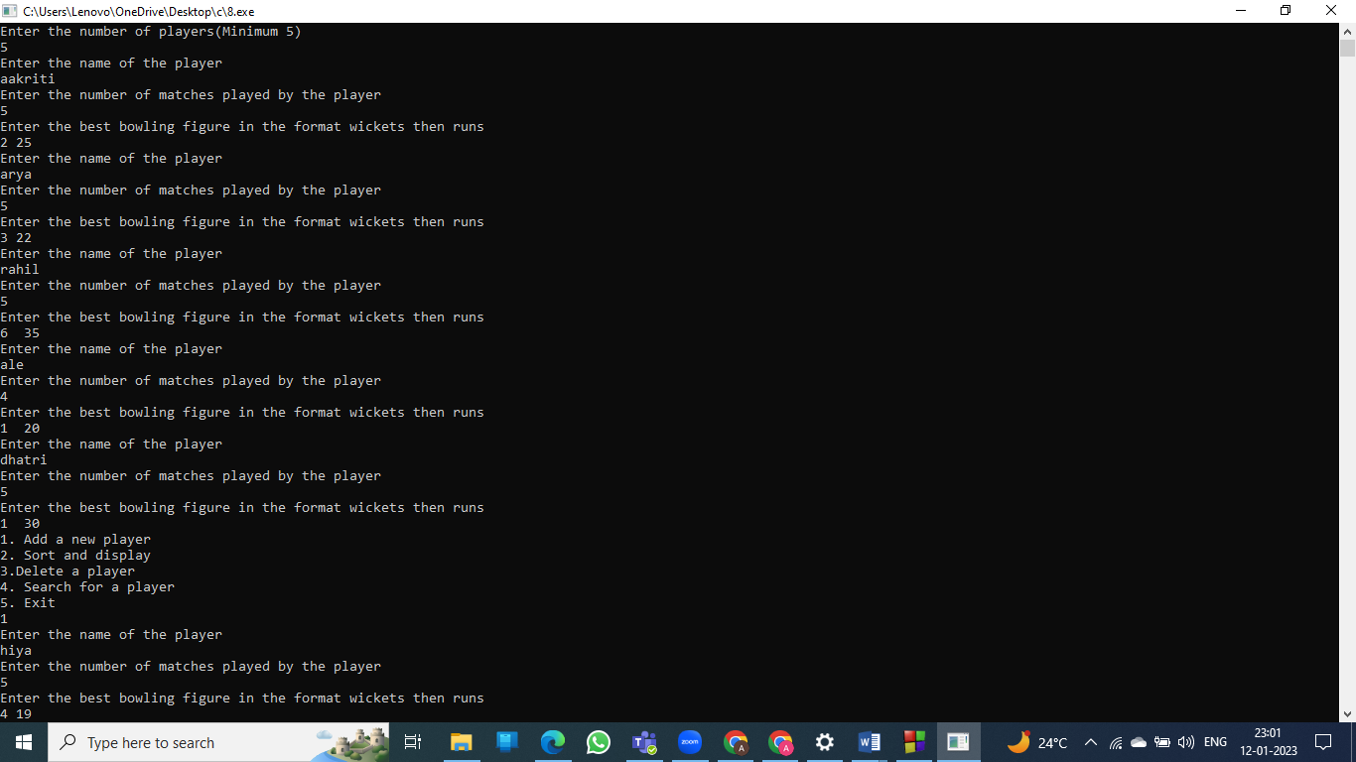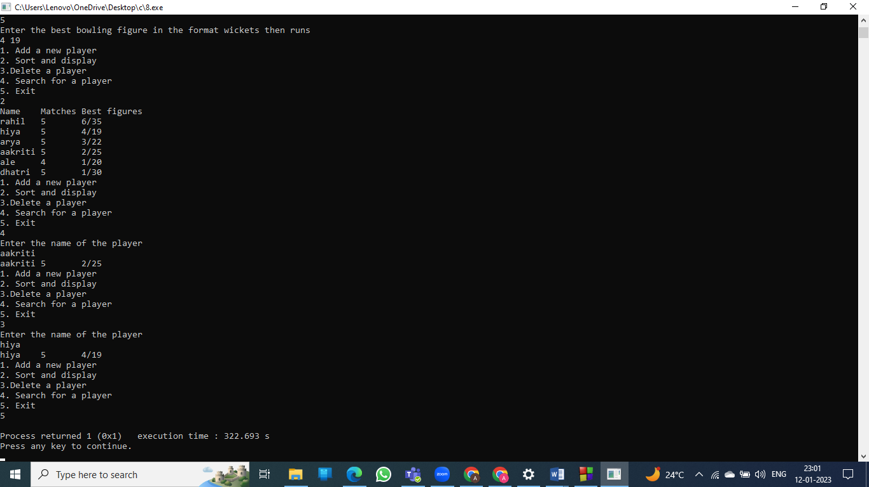

2]

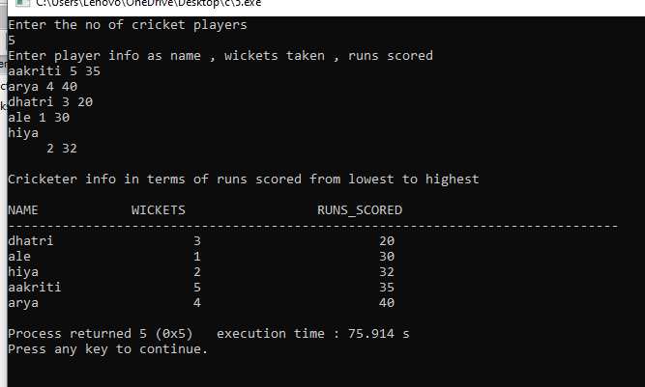

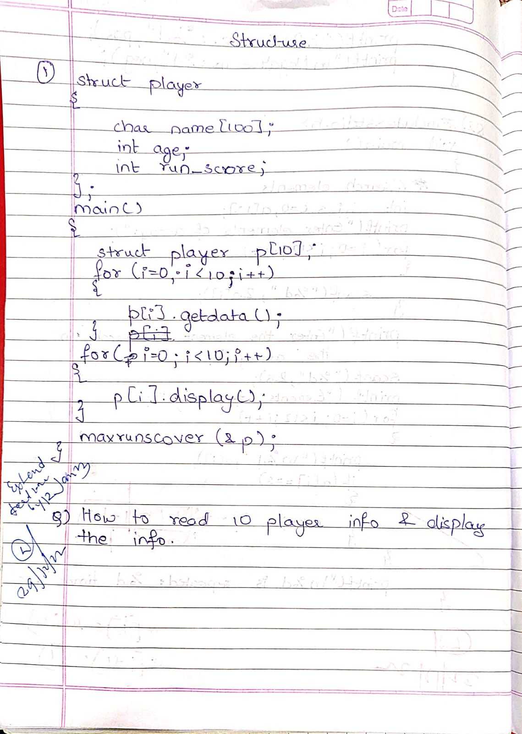
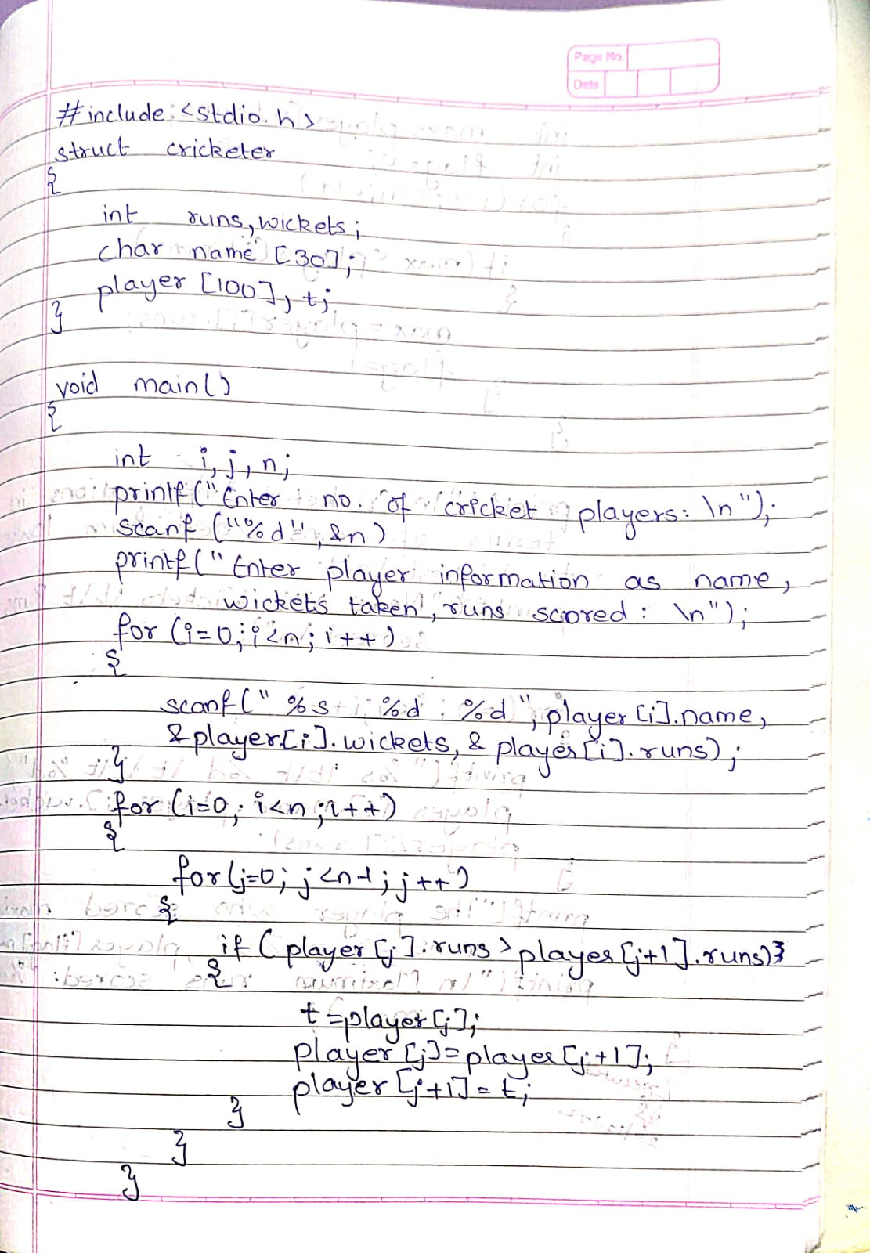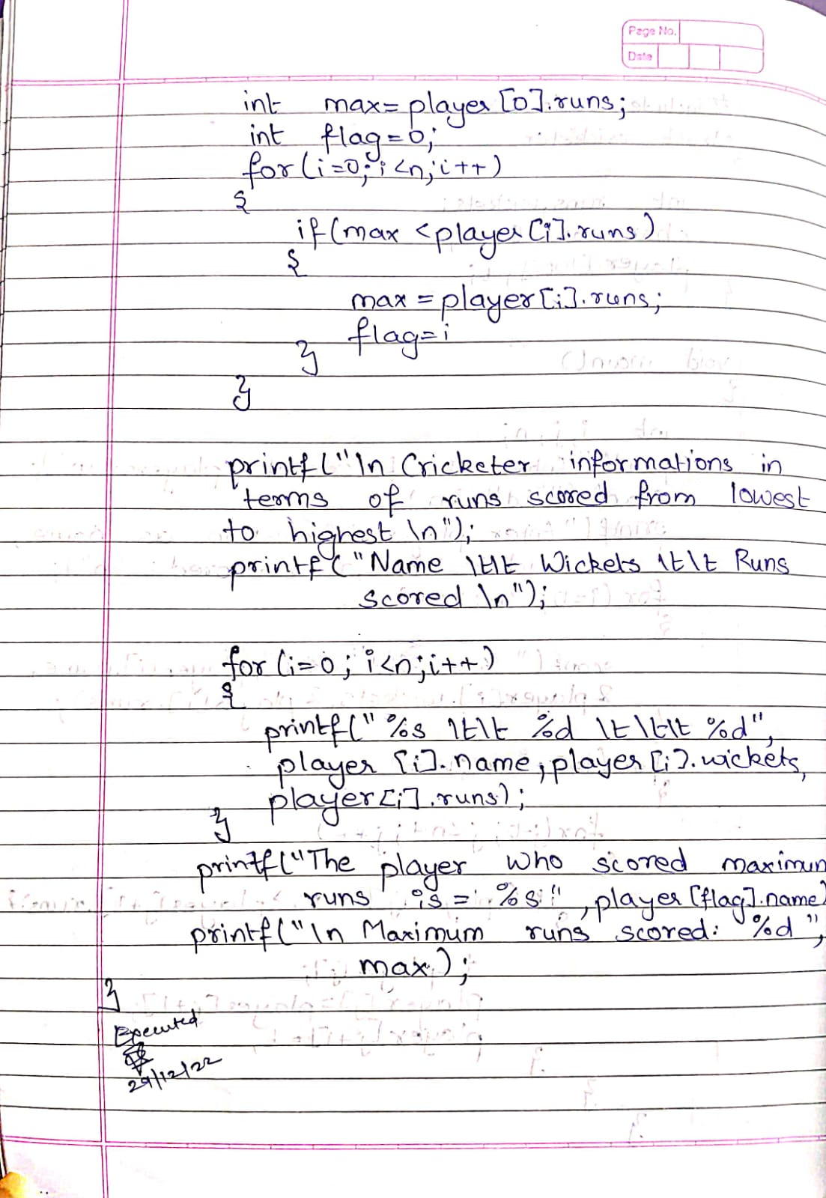

Conclusion:

Thus, we learnt how to use array of structure.

Post Lab Descriptive Questions

- Comment on the output of the following C code.

#include <stdio.h>
struct temp
{
int a;
int b;
int c;
};
main()
{
struct temp p[] = {{1, 2, 3}, {4, 5, 6}, {7, 8, 9}};
}

ANS: The C code does not produce any output. It does not display or print any data on the screen.

- Consider the following C code. What will be the output?

#include<stdio.h>
struct st
{
int x;
struct st next;
};

int main()
{
struct st temp;
temp.x = 10;
temp.next = temp;
printf("%d", temp.next.x);
return 0;
}

(A) Compiler Error
(B) 10
(C) Runtime Error
(D) Garbage Value

ANS: (A) COMPILER ERROR

- Difference between Structure and Union.

 | STRUCTURE | UNION
KEYWORD | The keyword struct is used to define a structure | The keyword union is used to define a union
SIZE | When a variable is associated with a structure the complier allocates the memory for each member. The size of structure is greater than or equal to the sum of sizes of its members. | When a variable is associated with a union the compiler allocates the memory by considering the size of the largest memory. So size of union is equal to the size of largest member.
MEMORY | Each member within a structure is assigned unique storage area of location. | Memory allocated is shared by individual members of union.
VALUE ALTERING | Altering the value of a member will not affect other members of the structure. | Altering the value of any of the member will alter other member values.
ACCESSING MEMBERS | Individual member can be accessed at a time. | Only one member can be accessed at a time.
INITIALIZATION OF MEMBERS | Several members of a structure can initialize at once. | Only the first member of a union can be initialized.

Date: _____________ Signature of faculty in-charge

