Used Fiddler to send Request and check received response.

I Used BadRequest status code 400 for invalid request. In the spec it was written to show 403 for Bad request which actually is for Forbidden.

Request : expiration date is past date

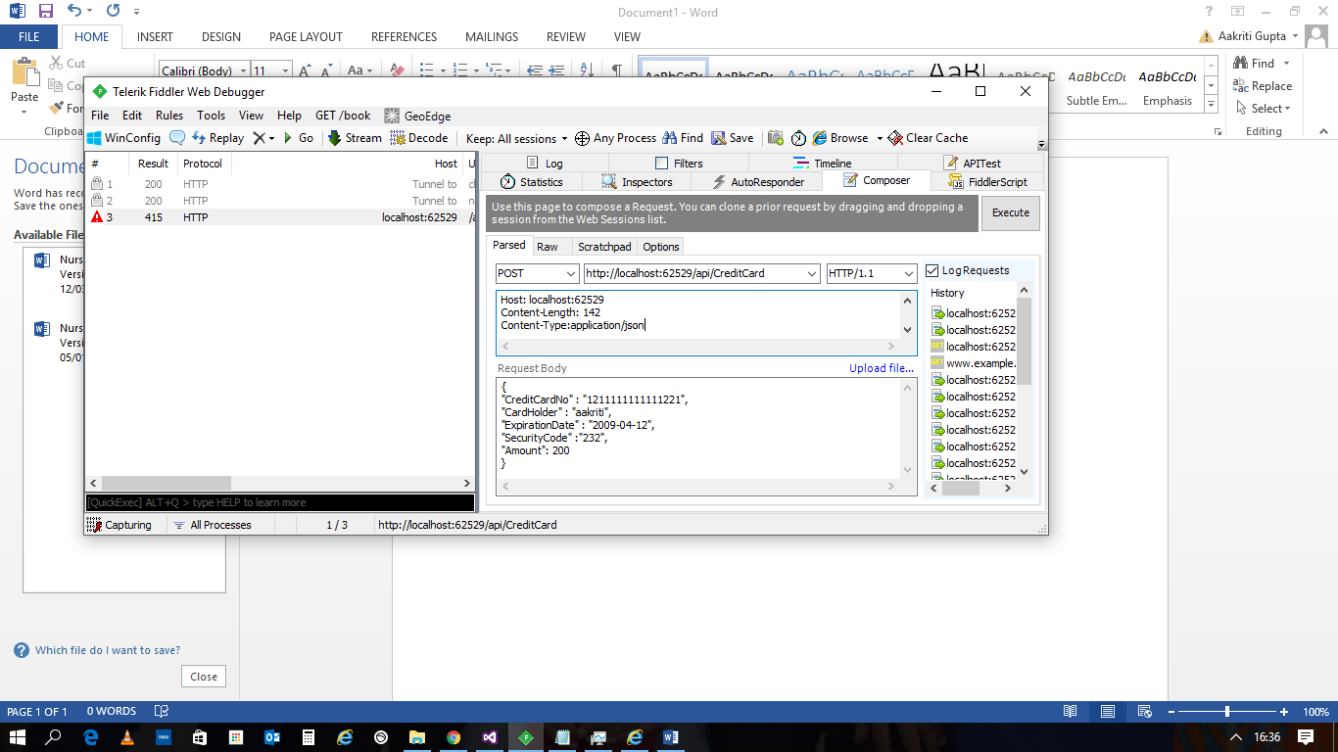

Response : Bad Request

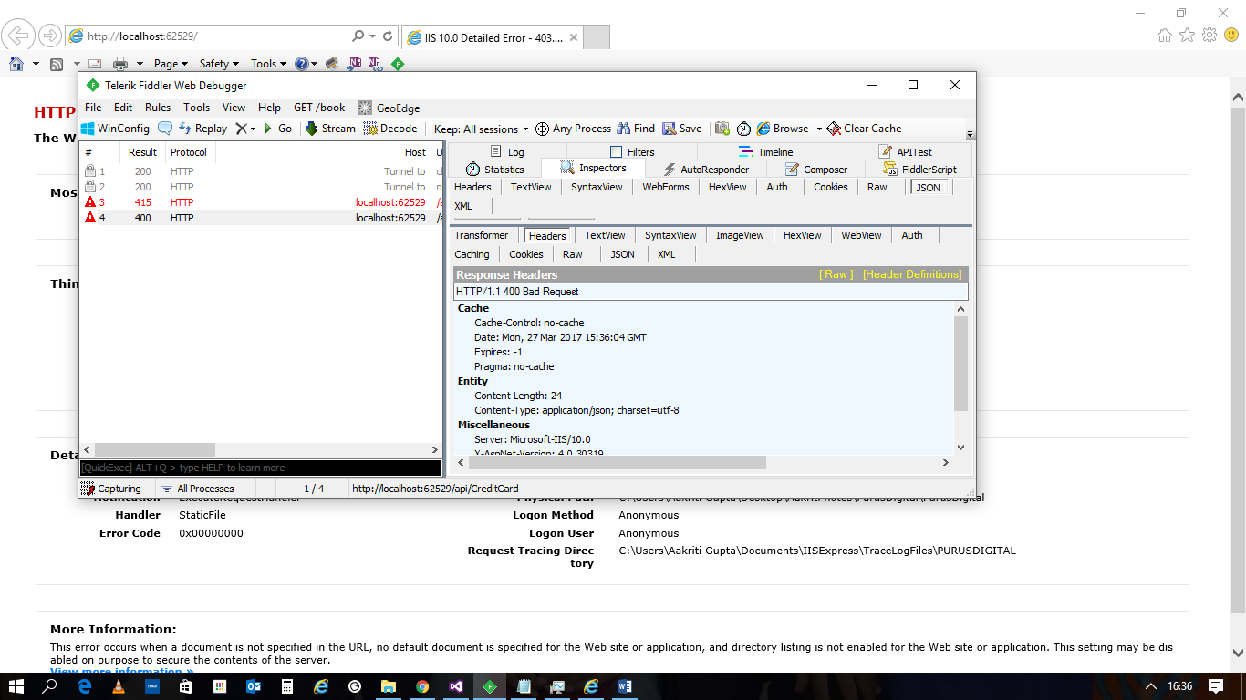

Request : amount £700, will try PremiumPaymentGateway

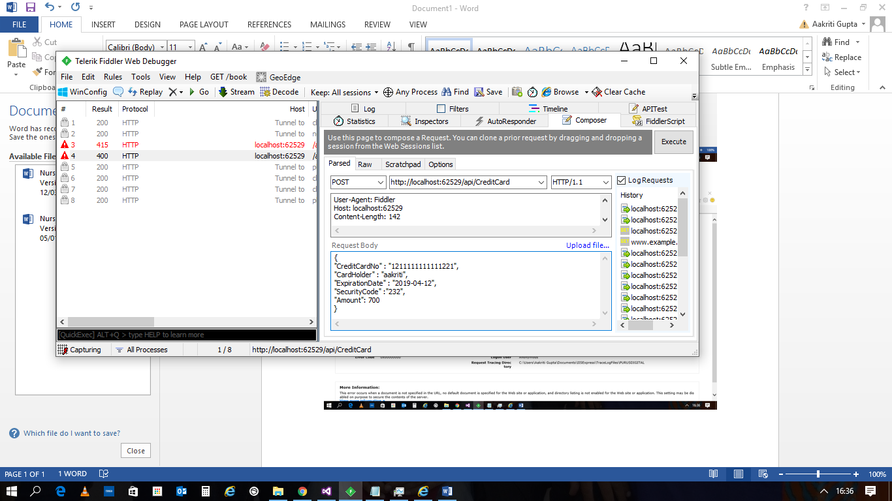

Response : 1st time, it was not successful 3 time so returned 500 error

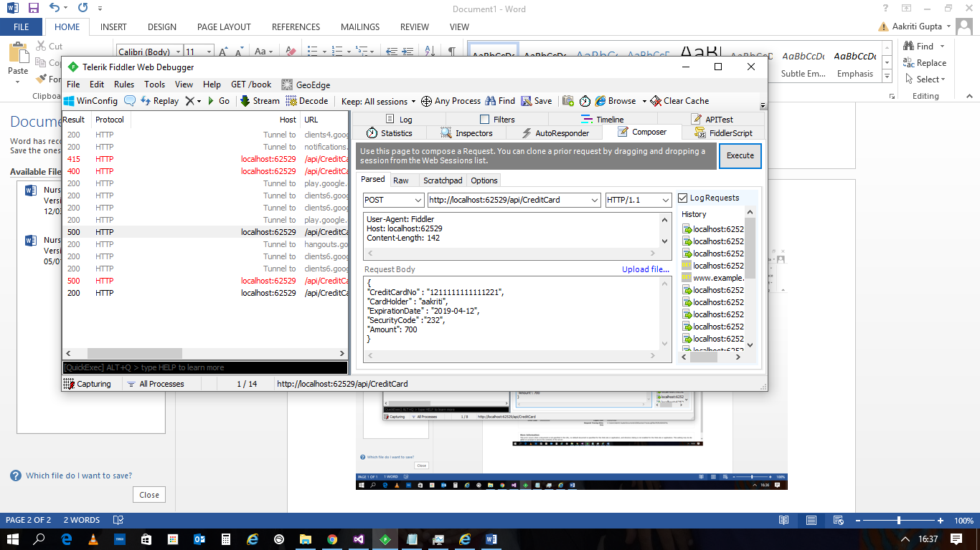

2nd time, on executing again it was successful, so returned 200.

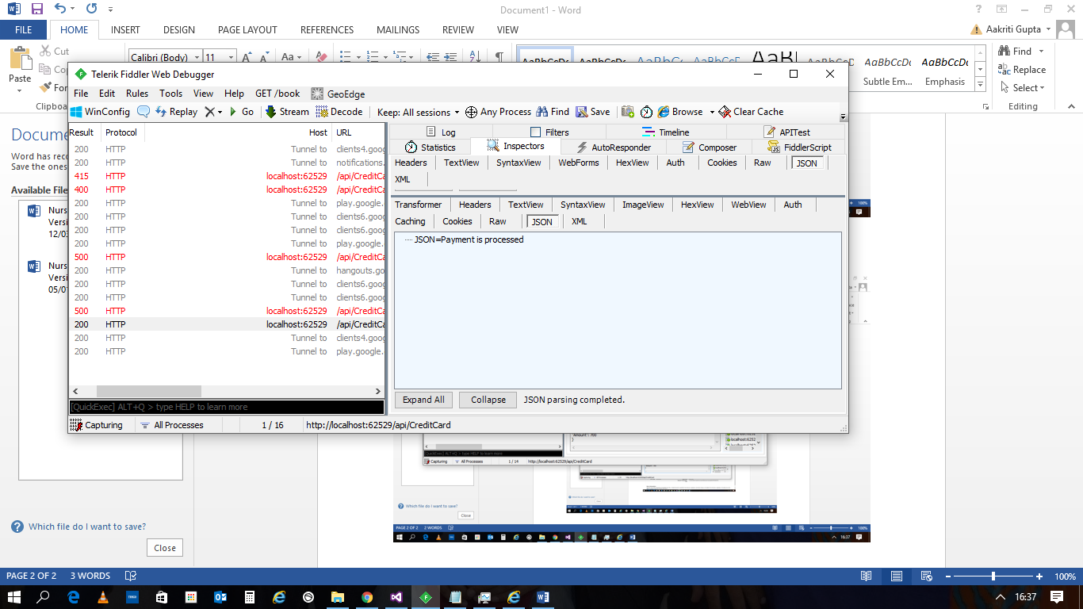

Request : amount 10, will go for CheapPaymentGateway

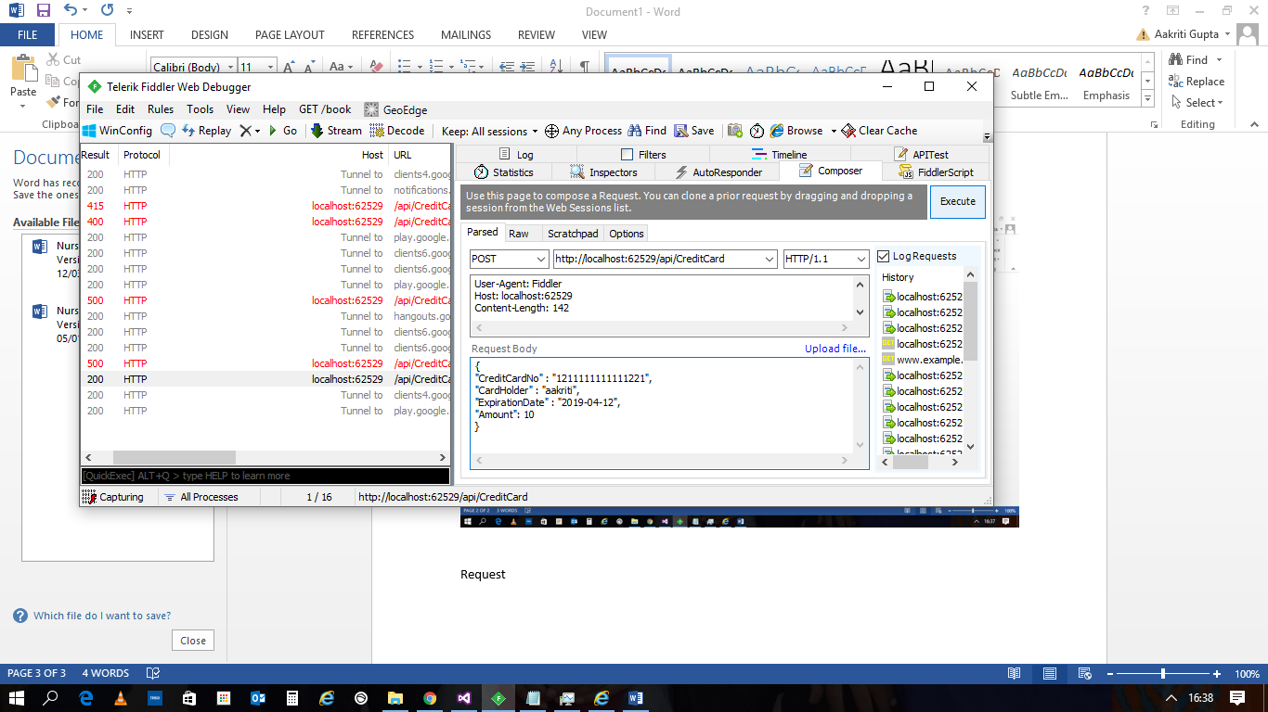

Response : Payment processed

