ReVive
Explainable Financial Anomaly Detection using a Corrupt-and-Repair Denoising Network
Software Engineering (5th Semester) Project Documentation — First Evaluation

1. Introduction
Financial fraud and market anomalies cause significant losses every year, and manual monitoring of transaction streams cannot scale to modern transaction volumes. This project builds an automated anomaly detection system for financial time series data, capable of flagging suspicious transactions and explaining why each one was flagged, so a human reviewer can act on it quickly and with confidence.
The system is built around ReVive, an independent reimplementation of a corrupt-and-repair denoising network described in a recent research paper (see Section 2). Unlike the original paper, which evaluates only general-purpose sensor and industrial benchmarks, this project applies the method to financial transaction data and adds an explainability layer that attributes each flagged anomaly to specific contributing features and time windows — a capability absent from the original work.

2. Literature Review

2.1 Reconstruction and Forecasting-Based Approaches
Early neural approaches to time series anomaly detection largely relied on predicting or reconstructing normal behavior, treating large prediction or reconstruction errors as evidence of anomalies. LSTM-based forecasting models learn to predict the next value(s) in a sequence and flag anomalies when actual values deviate sharply from predictions [1]. Donut applies a variational autoencoder (VAE) to model seasonal patterns in web application key performance indicators (KPIs) [2]. OmniAnomaly combines stochastic recurrent neural networks with normalizing flows for multivariate data [3]. SISVAE introduces a smoothness-inducing constraint into sequential VAE-based detection [4]. USAD combines autoencoding with an adversarial training scheme [5]. STREAM-VAE separates slow drift from fast dynamics through dual-path routing, applied to vehicle telemetry [6].

2.2 Corrupted-to-Clean (Denoising) Training
A distinct lineage of work trains models to reconstruct clean data from deliberately corrupted input. Denoising autoencoders were introduced as a representation-learning technique [7], [8]. Theoretical work connected this denoising objective to score matching, showing that a network trained to undo Gaussian corruption implicitly learns the gradient of the log-density of the smoothed data distribution [9]. Score-based generative models make this connection explicit [10]. CSDI applies a related iterative denoising principle to time-series imputation [11]. Recent work has further shown that predicting clean, low-dimensional targets can allow far smaller architectures to remain competitive [12]. This is the specific lineage our base method builds upon.

2.3 Complex, Structure-Aware Detectors
A parallel body of research has pursued increasingly complex architectures. Anomaly Transformer introduces attention-based association discrepancy [13]. GDN constructs a learned graph of inter-sensor dependencies [14]. TranAD combines transformer self-conditioning with adversarial training [15]. More recent work scores mismatches between predicted and target attention query dynamics [16]. These methods generally achieve strong benchmark performance at substantially higher computational cost.

2.4 Classical (Non-Neural) Detectors
Classical statistical and distance-based methods remain important baselines. Local Outlier Factor (LOF) measures local density deviation [17]. Isolation Forest isolates anomalies through random recursive partitioning [18]. COPOD estimates multivariate tail probabilities using empirical copulas [19]. MatrixProfile performs efficient all-pairs subsequence similarity search [20]. This project uses Isolation Forest and LOF as baselines for its state-of-the-art comparison (Section 5).

2.5 Positioning Our Work
The base method our project builds upon (Ozer, Ebeling, Enzweiler, 2026 [21]) falls within the corrupted-to-clean denoising lineage, but stays deliberately minimal: a single small convolutional residual block paired with a fixed, non-learned structural scoring function. No official source code was available at the time of writing (the authors' repository contained only a README pending paper acceptance), so this project's implementation, named ReVive, was written independently from the paper's architectural description and equations. Our project extends this method in two directions not explored in the original work: application to financial transaction data (Section 4), and an added explainability layer that attributes each anomaly to contributing features and time windows (Section 6).

3. Requirements

3.1 Functional Requirements
- The system shall accept transaction/time-series data via file upload.
- The system shall preprocess and window incoming data for model input.
- The system shall run the trained ReVive model to compute an anomaly/discrepancy score per window.
- The system shall generate a per-feature, per-timestep explanation for each flagged anomaly.
- The system shall classify each flagged point into a triage category (Normal / Review Needed / High Risk).
- The system shall log every flagged anomaly, its score, explanation, and timestamp to a database.
- The system shall display a dashboard showing the time series with anomalies highlighted.
- The system shall allow drill-down into any flagged anomaly to view its explanation.
- The system shall expose model inference via a REST API endpoint.

3.2 Non-Functional Requirements
- Performance: Anomaly scoring should complete within a short, defined latency to support near-real-time monitoring.
- Accuracy: Detection performance is benchmarked against classical baselines (Section 5) on the same dataset.
- Usability: Dashboard should be interpretable by a non-technical reviewer, not just the developer.
- Reliability: System should handle missing or malformed data without crashing.
- Scalability: Ingestion and storage should handle growth in data volume without redesign.
- Maintainability: Modular pipeline (ingestion, detection, explainability, storage, UI as separate components).
- Security/Privacy: Financial data should be access-controlled.
- Portability: Dashboard accessible via standard browser without special installation.

4. System Architecture
The system is organized into six stages: data ingestion, preprocessing, anomaly detection (ReVive), explainability, triage classification, and storage/dashboard display. The diagrams below document the system from five complementary perspectives.

4.1 Use Case Diagram
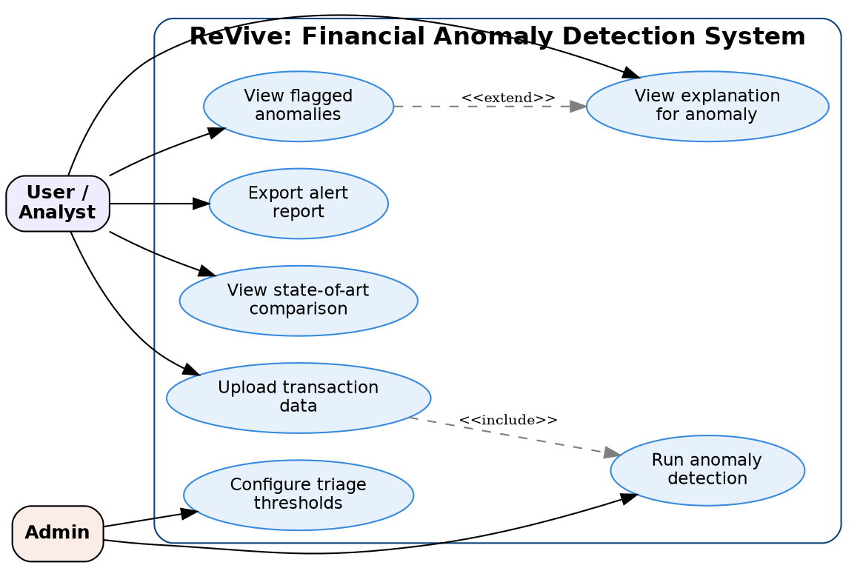
Figure 1: Use case diagram showing User/Analyst and Admin actors interacting with the system's core use cases.

4.2 Activity Diagram
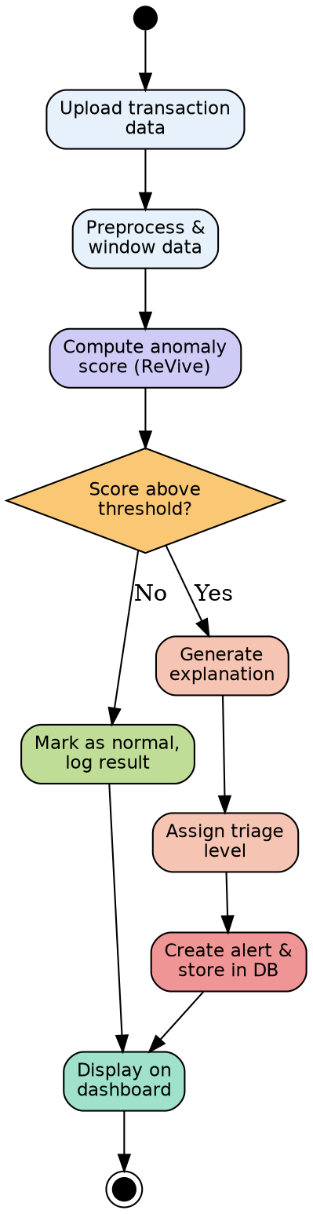
Figure 2: Activity diagram showing the anomaly detection workflow.

4.3 Class Diagram
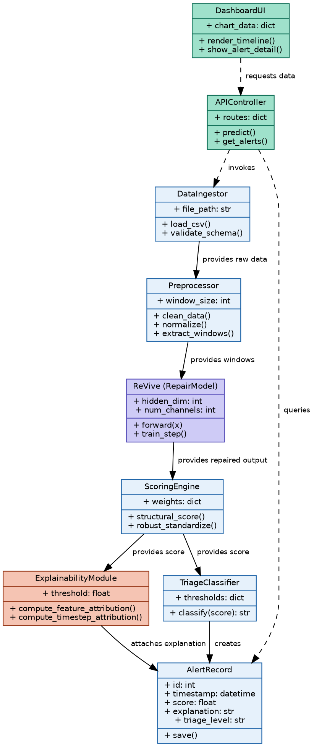
Figure 3: Class diagram showing core system components and their relationships.

4.4 Data Flow Diagram (DFD)
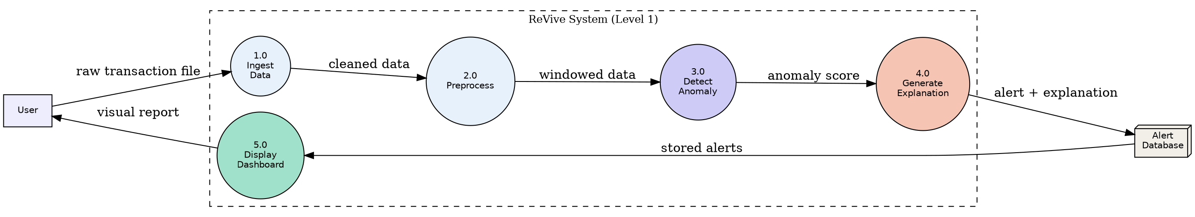
Figure 4: Level 1 DFD showing data flow through the system.

4.5 Sequence Diagram
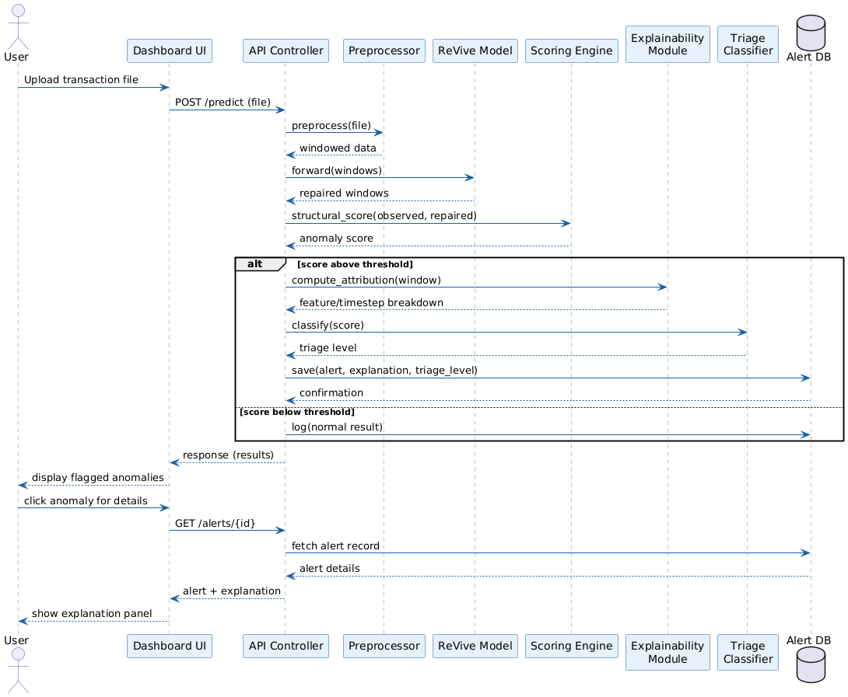
Figure 5: Sequence diagram for uploading data and viewing a flagged anomaly's explanation.

5. State of the Art / Evaluation
A fair state-of-the-art comparison for this project must evaluate all methods on the same dataset. The original paper's reported benchmark numbers were measured on general-purpose sensor and industrial datasets (TSB-AD, UCR) and are not directly comparable to results on financial data. We therefore benchmark our ReVive implementation against two classical baselines commonly used in the anomaly detection literature — Isolation Forest and Local Outlier Factor (LOF) — all evaluated on the same held-out test split of the Kaggle Credit Card Fraud dataset.
Method | AUC-PR | AUC-ROC
ReVive (ours) | 0.3639 | 0.8083
Isolation Forest | 0.1227 | 0.5651
LOF | 0.1337 | 0.6332

On this dataset, ReVive achieves roughly 3x higher AUC-PR than either classical baseline, and higher AUC-ROC. Given fraud accounts for approximately 0.17% of transactions in this dataset, AUC-PR is the more informative metric under this class imbalance. This result is consistent with the original paper's finding that the repair-based scoring approach is competitive with, and here outperforms, classical baselines — though measured on an entirely different dataset than the original benchmarks.

6. Novel Contribution
- New domain: Application to financial transaction anomaly detection, a domain not evaluated in the original paper (which uses only general-purpose sensor/industrial benchmarks).
- Explainability layer: The original method outputs only a single discrepancy score. We add a per-feature, per-timestep breakdown of reconstruction error, so each flagged anomaly is accompanied by an explanation of which features and time window contributed most.
- Working deployed system: The original paper is a research method with no released implementation or interface. We built a full pipeline — ingestion, detection engine, explainability module, triage logic, alert storage, and dashboard — around an independently reimplemented core.
- Independent reimplementation: No official code was available at the time of writing. The model architecture, training loop, and scoring function were reimplemented from the paper's mathematical specification and independently verified to match the paper's reported parameter count (17,665 parameters at single-channel configuration).

7. Limitations and Future Work
This section documents known limitations of the current approach, identified through team discussion, so they are stated explicitly rather than discovered later.
- Feature blind spots: The model can only flag deviations in the features it is given. Fraud that stays within normal-looking ranges on every available feature (e.g., low-and-slow fraud deliberately kept under known thresholds) cannot be detected by this or any anomaly-scoring method alone. This is a limitation of the available feature set, not of the detection method itself, and is typically mitigated in practice by combining anomaly scores with rule-based checks as a second layer.
- False positives are expected, not a failure: Legitimate but unusual behaviour (e.g., a first-time large purchase) can receive an elevated score. This is why the system uses a triage layer (Normal / Review Needed / High Risk) with human review, rather than automated blocking, and why the explainability layer is included — so a reviewer can quickly assess whether a flagged case is genuinely suspicious.
- Training data contamination: The model assumes historical training data is predominantly normal. If undetected fraud exists within the training set, the model may partially learn it as normal behaviour. At typical fraud prevalence (approximately 0.17% in this dataset), this effect is diluted since the model learns the dominant pattern, and all transactions with known fraud labels are explicitly excluded from training. This does not fully eliminate the risk for genuinely undetected historical fraud.
- Limited interpretability of anonymized features: The dataset's 28 principal features (V1-V28) are PCA-transformed by the dataset provider for privacy reasons, prior to this project's involvement. While this means dimensionality is already well-managed (29 total input features is a standard, manageable size), it also means the explainability layer's feature attributions (e.g., "feature V14 contributed most") do not correspond to human-interpretable concepts such as location or merchant type. This limits the practical usefulness of the explanation on this specific dataset, even though the underlying attribution mechanism is technically correct. On a dataset with named, human-readable features, this same explainability layer would produce directly actionable explanations.
- Proposed extension — self-cleaning / iterative retraining (not yet implemented): To further reduce the impact of training data contamination, a self-cleaning retraining procedure is proposed as future work: train the model once, run it on its own training data, remove the highest-scoring (most anomalous) points, and retrain on the cleaned remainder. This would progressively filter likely-undetected fraud out of what is assumed to be normal data. This has not been implemented in the current prototype and is documented here as a planned extension.
- Proposed extension — production feedback loop (not yet implemented): In a deployed setting, every alert's eventual human decision (confirmed fraud or false alarm) would be logged and used for periodic retraining, allowing the model to adapt to new fraud patterns and correct earlier misjudgements over time. This is documented as future work beyond the current course prototype scope.

8. Project Timeline
- Week 1-2: Literature review, architecture reimplementation and verification, dataset preparation, baseline implementation.
- Week 3: Diagram design, initial training and evaluation, explainability module development.
- Week 4: Backend API and database integration.
- Week 5: Dashboard development.
- Week 6-7: Testing, documentation, and first evaluation (current milestone — mid-semester submission).

9. Planned Changes and Updates for End-Semester Submission
This documentation reflects the state of the project at the mid-semester (first evaluation) milestone. The items below are explicitly identified as pending work, to be completed or refined before the end-semester submission.
- Corrected ensemble baseline: Add a properly normalized Isolation Forest + COPOD (and, pending evaluation, LOF) ensemble as an additional row in the state-of-the-art comparison table, using score standardization and PyOD's purpose-built combination methods (average, maximization, AOM/MOA) rather than naive unnormalized averaging. Results will be reported with and without LOF, since its standalone performance has been weaker than the other baselines in testing so far.
- Explainability module: Full implementation and evaluation of the per-feature, per-timestep attribution layer on flagged anomalies (currently designed but not yet fully evaluated end-to-end).
- Backend and dashboard integration: Complete the REST API and reviewer-facing dashboard, connecting the detection engine, explainability output, and alert storage into a single deployable system.
- Self-cleaning retraining (stretch goal): Implement and evaluate the proposed iterative retraining procedure (Section 7) that filters likely-undetected fraud from the training set before retraining, if time permits.
- Broader evaluation: Extend evaluation beyond the current single train/test split — e.g., cross-validation or multiple random splits — to report more robust performance estimates and confidence intervals rather than single-run numbers.
- Feature interpretability: Investigate whether a dataset with human-readable (non-anonymized) features can be used alongside or instead of the current PCA-transformed dataset, to produce more directly actionable explanations (see Section 7's discussion of this limitation).
The core detection engine (ReVive) and its current benchmark results against Isolation Forest and LOF are considered stable for this milestone; changes above are additive and evaluative, not architectural revisions to the core model.

References
[1] P. Malhotra, L. Vig, G. Shroff, and P. Agarwal, "Long short term memory networks for anomaly detection in time series," 2015.
[2] H. Xu et al., "Unsupervised Anomaly Detection via Variational Auto-Encoder for Seasonal KPIs in Web Applications," arXiv:1802.03903, 2018.
[3] Y. Su, Y. Zhao, C. Niu, R. Liu, W. Sun, and D. Pei, "Robust Anomaly Detection for Multivariate Time Series through Stochastic Recurrent Neural Network," in Proc. 25th ACM SIGKDD, 2019, pp. 2828-2837.
[4] L. Li, J. Yan, H. Wang, and Y. Jin, "Anomaly Detection of Time Series With Smoothness-Inducing Sequential Variational Auto-Encoder," IEEE Trans. Neural Netw. Learn. Syst., vol. 32, no. 3, pp. 1177-1191, 2021.
[5] J. Audibert, P. Michiardi, F. Guyard, S. Marti, and M. A. Zuluaga, "USAD: UnSupervised Anomaly Detection on Multivariate Time Series," in Proc. 26th ACM SIGKDD, 2020, pp. 3395-3404.
[6] K.-K. Özer, R. Ebeling, and M. Enzweiler, "STREAM-VAE: Dual-path routing for slow and fast dynamics in vehicle telemetry anomaly detection," in 2026 IEEE Intelligent Vehicles Symposium (IV), 2026, pp. 444-451.
[7] P. Vincent, H. Larochelle, Y. Bengio, and P.-A. Manzagol, "Extracting and composing robust features with denoising autoencoders," in Proc. 25th ICML, 2008, pp. 1096-1103.
[8] P. Vincent, H. Larochelle, I. Lajoie, Y. Bengio, and P.-A. Manzagol, "Stacked denoising autoencoders," J. Mach. Learn. Res., vol. 11, pp. 3371-3408, 2010.
[9] P. Vincent, "A connection between score matching and denoising autoencoders," Neural Comput., vol. 23, no. 7, pp. 1661-1674, 2011.
[10] Y. Song and S. Ermon, "Generative modeling by estimating gradients of the data distribution," arXiv:1907.05600, 2020.
[11] Y. Tashiro, J. Song, Y. Song, and S. Ermon, "CSDI: Conditional score-based diffusion models for probabilistic time series imputation," arXiv:2107.03502, 2021.
[12] T. Li and K. He, "Back to basics: Let denoising generative models denoise," arXiv:2511.13720, 2026.
[13] J. Xu, H. Wu, J. Wang, and M. Long, "Anomaly Transformer," arXiv:2110.02642, 2022.
[14] A. Deng and B. Hooi, "Graph Neural Network-Based Anomaly Detection in Multivariate Time Series," arXiv:2106.06947, 2021.
[15] S. Tuli, G. Casale, and N. R. Jennings, "TranAD," arXiv:2201.07284, 2022.
[16] K.-K. Özer, R. Ebeling, and M. Enzweiler, "Surprised by attention: Predictable query dynamics for time series anomaly detection," arXiv:2603.12916, 2026.
[17] M. M. Breunig, H.-P. Kriegel, R. T. Ng, and J. Sander, "LOF: identifying density-based local outliers," ACM SIGMOD Rec., vol. 29, no. 2, pp. 93-104, 2000.
[18] F. T. Liu, K. M. Ting, and Z.-H. Zhou, "Isolation Forest," in 2008 Eighth IEEE Int. Conf. Data Mining, 2008, pp. 413-422.
[19] Z. Li, Y. Zhao, N. Botta, C. Ionescu, and X. Hu, "COPOD," arXiv:2009.09463, 2020.
[20] C.-C. M. Yeh et al., "Matrix profile I," in 2016 IEEE 16th Int. Conf. Data Mining (ICDM), 2016, pp. 1317-1322.
[21] K.-K. Özer, R. Ebeling, and M. Enzweiler, "Just Repair: A Minimal Denoising Network for Time Series Anomaly Detection," arXiv:2604.17388, 2026.

