Design & Analysis of Algorithms

Monsoon Semester III 2020-21 Lab - 2

Date: **14 September 2020**

**Topic: Iterative Vs Recursion**

# AIM

To implement two sorting algorithm, quick sort and merge sort. The implementation to be carried out using iterative and recursive methods. Also compute the memory utilization for each program.

# EXPERIMENT

1. Merge sort and quick sort using iterative and recursive methods was implemented. The number of inputs elements has been passed from command line arguments. The elements has to been generated randomly within the code.

1. The performance of program by varying the number of elements was checked.
2. The time taken by each case (for particular number of inputs) was computed.
3. A graph with number of inputs to time taken in seconds was plotted.
4. The memory taken by recursive and iteration implementation of the two sorting algorithms was computed and compared.

# OBSERVATIONS

1.

2.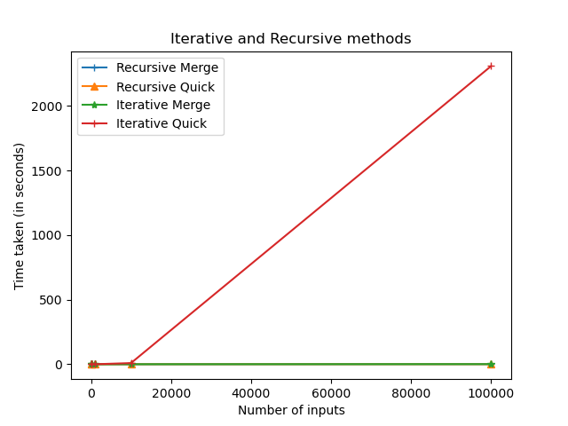

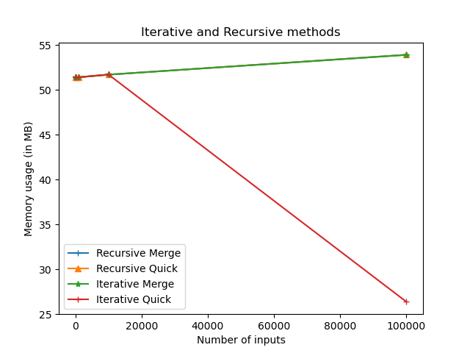

* The above graphs depicts the time and memory needed for an array size (n = 10, 100, 1000, 10000, 100000)
* We noted that, it is better to use Recursion in both the cases of sorting algorithms. There were few instances where iteration performed better than recursion in both memory and time and this was observed when the input of the array was small or if it was provided in the best case.

# CONCLUSION

Recursion algorithms seems to the fastest and highly efficient compared to Iterative algorithms, as it gives better memory and time scores.