

**LA GRANDEE INTERNATIONAL COLLEGE**

**Simalchaur, Pokhara Nepal**

A Project Proposal

On

**“Fund Fusion”**

(Charity and Donation Management System)

**Submitted to:**

Bachelor of Computer Application (BCA) Program

In partial fulfilment of the requirements for the degree of BCA under

Pokhara University

**Submitted by:**

|  |  |  |  |
| --- | --- | --- | --- |
| **Name:** | **Course** | **Semester** | **P.U. Registration Number** |
| Akriti Chapagain | BCA | 6th | 2019-01-53-0104 |
| Binaya Koirala | BCA | 6th | 2019-01-53-0111 |
| Laxman Parajuli | BCA | 6th | 2019-01-53-0119 |
| Ujjwal Adhikari | BCA | 6th | 2019-01-53-0138 |

**Date:07/05/2023**

**DECLARATION FOR**

**“Fund Fusion”**

# STUDENT’S DECLARATION

We hereby declare that we are the only authors of this work and that no sources other than the mentioned here have been used in this. We assure you that the work we present here is unique to ourselves and resemblances to another similar project are purely coincidental.

Akriti Chapagai (PU Exam Roll no): 2019-01-53-0104

Binaya Koirala (PU Exam Roll no): 2019-01-53-0111

Laxman Parajuli (PU Exam Roll no): 2019-01-53-0119

Ujjwal Adhikari (PU Exam Roll no): 2019-01-53-0138

Program: BCA, 6th Semester

Date: 07/05/2023

**TABLE OF CONTENTS**

1. INTRODUCTION 1

2. OBJECTIVES 2

3. LITERATURE REVIEW 3

4. PROBLEM STATEMENT 4

5. METHODOLOGY 5

6. DATA FLOW DIAGRAM 6

7. PROJECT GANTT CHART/ TIMELINE CHART 7

8. DELIVERABLES 8

9. CONCLUSION 9

10. REFRENCES: 10

**TABLE OF FIGURES**

Figure 1: Agile Model for Development of FundFusion 5

Figure 2: Data Flow Diagram of FundFusion 6

Figure 3: Ganntt Chart 7

# INTRODUCTION

FundFusion will be a powerful and innovative online platform that simplifies charity and donation management for charitable organizations. Our platform will offer a wide range of tools to manage donations, track donor information, and communicate with supporters. It will also provide additional services to help charities achieve their goals and create a positive impact in their communities. Our system will offer a secure and convenient way for donors to make online donations, ensuring their information is kept safe and confidential. FundFusion will also organize fundraising events and offer volunteering services to help charities plan and execute successful campaigns. Our team will work closely with charities to provide event planning, management, and marketing support. Additionally, we will provide a variety of volunteering opportunities, ranging from one-time events to ongoing initiatives.

At FundFusion, we believe in the power of technology to make a difference in the world. Our platform will be user-friendly and intuitive, allowing charities to manage their donation programs with ease. We will constantly update our system with new features and services to meet the evolving needs of the charity sector. FundFusion will be the perfect replacement for traditional paper-based donation systems and provide a much-needed digital solution to streamline donation and fundraising efforts for charities of all sizes. We are confident that FundFusion will be a game-changer in the charity sector, enabling charities to focus on their mission of helping others. With our platform, we hope to make a positive impact in the lives of those in need and help charitable organizations achieve their goals.

# OBJECTIVES

FundFusion is a platform that aims to address transparency concerns in the charity sector and make it easier for donors to contribute to charitable causes from around the world. However, to ensure that the platform is effective in achieving its goals, clear and specific objectives must be defined. The following objectives have been identified for FundFusion.

* To simplify the donation procedure for donors all around the world and make donation feasible for local donors by adding the local payment gateways.
* To provide event wise donation report which will indeed help in making best possible plan in accordance with the donations.
* To prioritize security and protect users' financial information.

# LITERATURE REVIEW

The success of a charity website depends on various factors that influence visitor behavior and their likelihood of making a donation. Previous research has identified two main variables that impact website success: information quality and system quality (Cyr et al., 2004).

Information quality refers to the perception of visitors regarding the completeness, accuracy, timeliness, and relevance of the information provided on the website. It includes details about the charity's performance, donation assistance, and financial transparency. Studies have shown that information quality plays a significant role in building trust, loyalty, and satisfaction among donors (Cyr, 2004; McInnis et al., 2012; Saaksjarvi & Lassila, 2011; Nicolaou & McKnight, 2001; Song & Zahedi, 2003). One crucial aspect of information quality is the mission statement of the charity. It allows donors to understand the organization's purpose and credibility. The mission statement, along with summaries of projects, vision, goals, objectives, and values, can create a positive attitude in visitors towards the charity's website. Research suggests that mission statements and project summaries are vital for establishing credibility and transparency in fundraising efforts (Waters, 2003; Frink et al., 2005; Saaksjarvi & Lassila, 2011).

In summary, providing high-quality information and clearly communicating the mission and projects of the charity on its website are crucial for building trust, credibility, and positive donor attitudes.

# PROBLEM STATEMENT

The charity sector faces ongoing transparency concerns and difficulties in donating to various ongoing serious matters worldwide. Donors are increasingly looking for assurance that their contributions are being used effectively and efficiently, but charities often lack transparency in their financial reporting or may be unclear about how donated funds are being used. In addition, it has become urgent need for online donation platforms and virtual fundraising events, as traditional in-person events have become difficult or impossible to organize. To address these challenges, FundFusion aims to provide a comprehensive platform that enables charities to manage their donation programs and fundraising efforts with ease. Our system offers real-time tracking and reporting on fundraising efforts, providing donors with clear and detailed information about how their contributions are being used. By providing a transparent platform, FundFusion aims to build trust between donors and charitable organizations.

Furthermore, FundFusion's online donation platform and event management services help to remove barriers to giving and encourage more people to support charitable causes. Our platform simplifies processes such as managing donor information and planning successful fundraising events, while also offering marketing and communication support. With FundFusion's help, charities can increase their visibility, engage with supporters more effectively, and organize successful fundraising events that generate meaningful contributions. Overall, FundFusion's goal is to make it easier for charities to achieve their goals and make a positive impact in the world. Our platform is designed to address ongoing transparency concerns, streamline donation management and fundraising efforts, and provide comprehensive support to charities of all sizes.

# METHODOLOGY

The Agile methodology will be used to develop the FundFusion. Agile is a flexible and iterative approach that allows for rapid development and testing. The Agile methodology is well-suited to projects with evolving requirements, such as FundFusion, where there may be changes in the features and functionalities that the platform requires. The Agile methodology will be implemented using the Scrum framework, which is a popular Agile methodology that involves working in small, cross-functional teams. The team will consist of four members who will each work on a specific part of the FundFusion platform. The team will meet regularly to discuss progress, plan for the next iteration, and address any issues that arise.

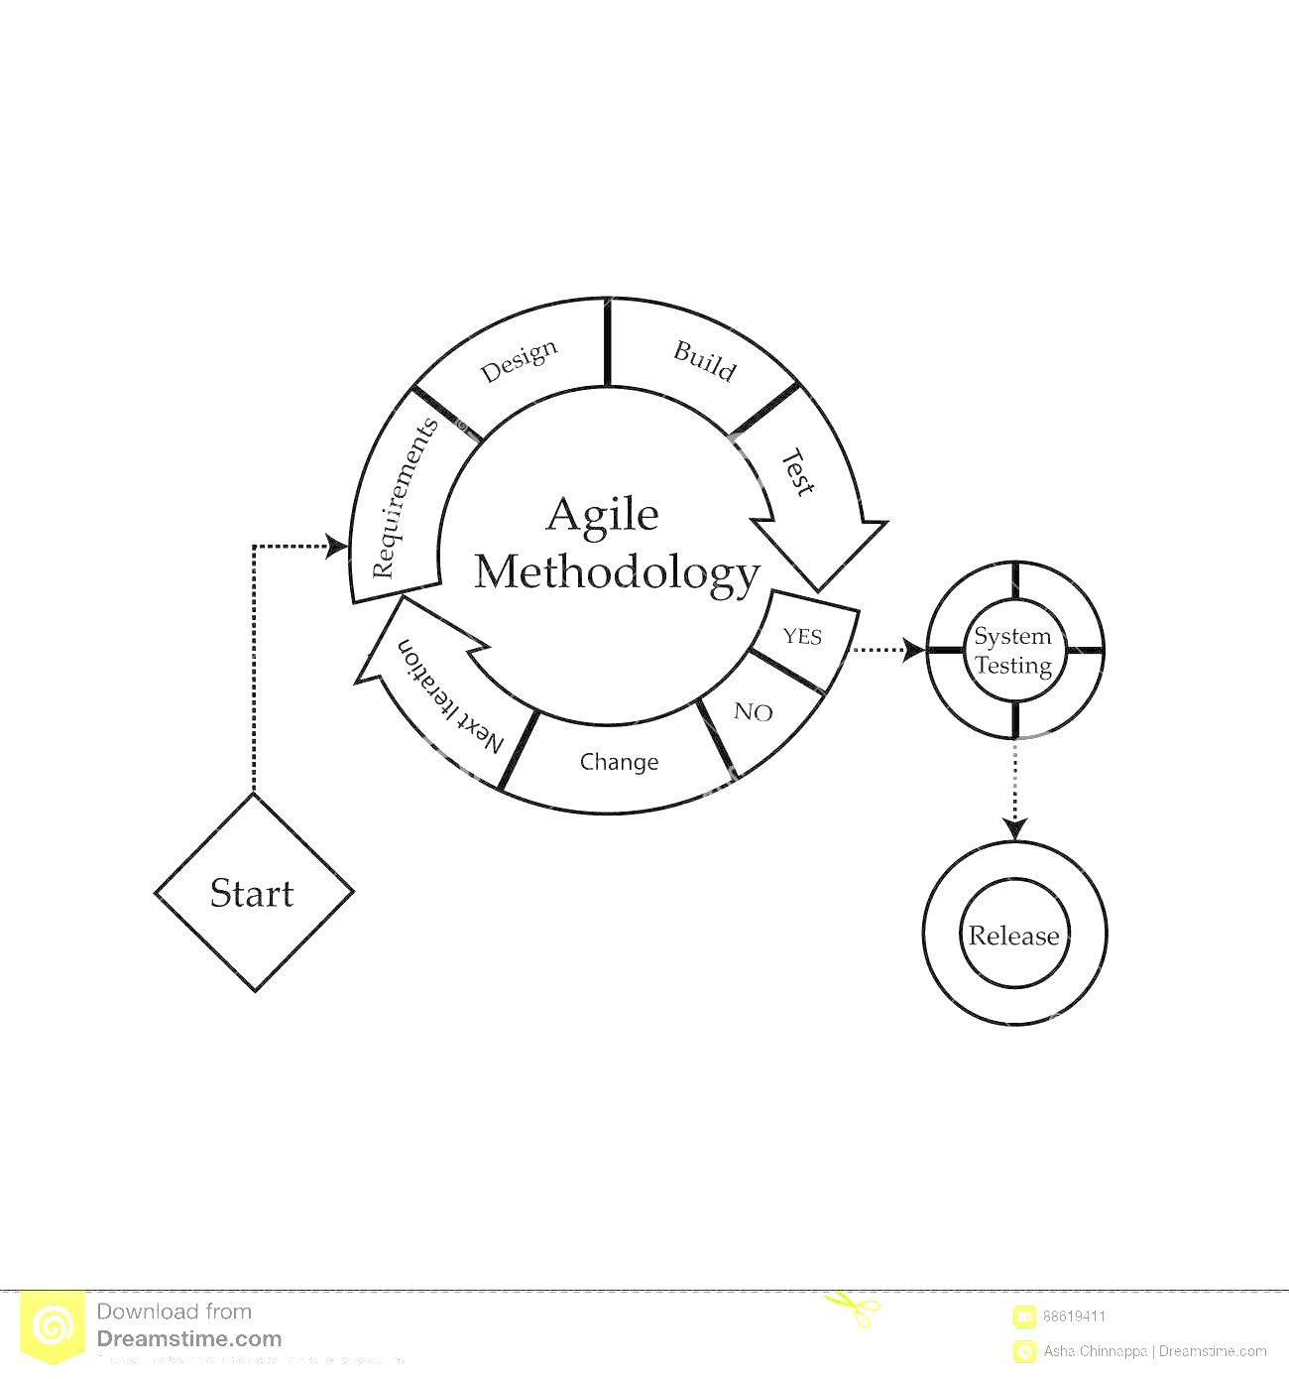

Figure 1: Agile Model for Development of FundFusion

# DATA FLOW DIAGRAM

DFD stands for Data Flow Diagram, which is a graphical representation of a system or process that shows the flow of data between different components of the system. It is a useful tool for analysing and designing complex systems, and it can help to identify potential problems and inefficiencies in a system.

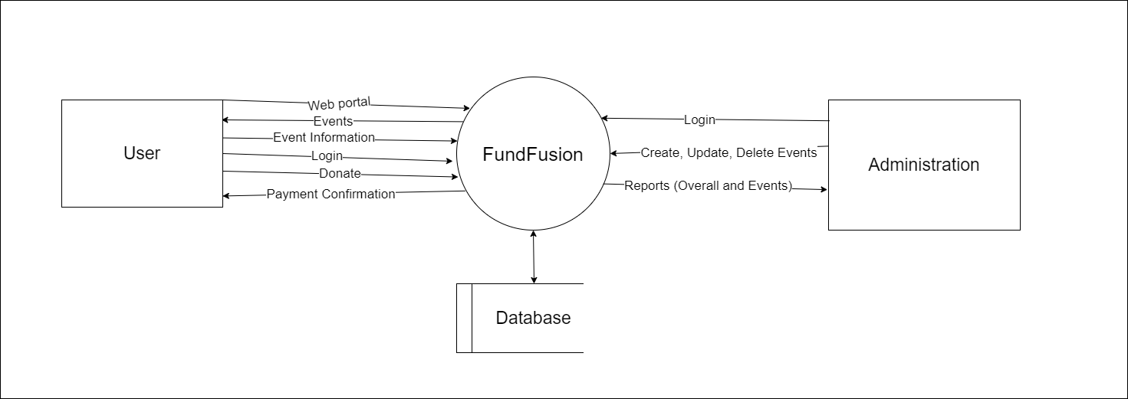

Figure 2: Data Flow Diagram of FundFusion

# PROJECT GANTT CHART/ TIMELINE CHART

A Gantt chart is a chart in which series of horizontal lines shows the amount of work completed in certain period of times in relation to the amount planned for those projects.

Gantt chart helps to keep track of the work progress. It helps to make better communication of the project plan with the team members. Gantt charts make the timeline visual, it’s easy to see where you can batch similar tasks together to save time and find the quickest path to finish.

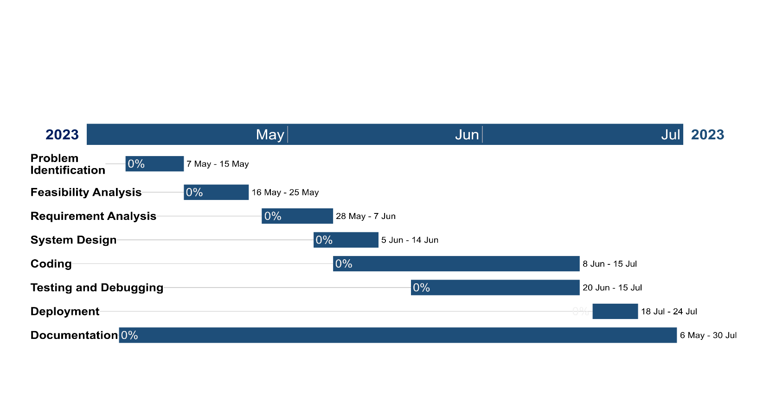

Figure 3: Ganntt Chart

# DELIVERABLES

* The app will be integrated with a payment gateway to enable users to donate easily and securely using their preferred payment method
* User authentication and authorization functionality will also be implemented, allowing users to create accounts, log in securely
* Social media integration: The app will be integrated with social media platforms to enable users to share donation and fundraising campaigns with their networks.

# CONCLUSION

To conclude, Our project entitle “FundFusion” application which will be creating using PHP and MySql as a database will be a powerful tool that will make a real difference in people’s lives. It will provide a simple and convenient way for users to donate to charities, and will help organizations streamline their fundraising efforts. By leveraging the power of technology, we will create a more effective and efficient way to support those in need. With the potential to reach millions of people, this app will have the power to make a significant impact in the world. We are confident that our proposal will be met with enthusiasm, and we look forward to creating a meaningful and impactful platform for charity donations.

# REFRENCES

* Saaksjarvi, M. C., & Lassila, S. (2011). Exploring antecedents and consequences of consumer trust in e-commerce: Evidence from Finland. European Business Review, 23(6), 612-627.
* Nicolaou, A. I., & McKnight, D. H. (2001). Perceived information quality in data exchanges: Effects on risk, trust, and intention to use. Information Systems Research, 12(3), 201-223.
* Song, I. Y., & Zahedi, F. M. (2003). Internet privacy concerns: An integrative model of privacy protection behavior. Journal of Association for Information Systems, 4(5), 296-336.
* Waters, R. D. (2003). Mission statements: A rhetorical analysis of organizational and corporate identity messages. Journal of Business Communication, 40(3), 269-296.