

**LA GRANDEE INTERNATIONAL COLLEGE**

**Simalchaur, Pokhara Nepal**

A Project Proposal

On

**“Fund Fusion”**

**Submitted to:**

Bachelor of Computer Application (BCA) Program

In partial fulfilment of the requirements for the degree of BCA under

Pokhara University

**Submitted by:**

|  |  |  |  |
| --- | --- | --- | --- |
| **Name:** | **Course** | **Semester** | **P.U. Registration Number** |
| Akriti Chapagain | BCA | 6th | 2019-01-53-0104 |
| Binaya Koirala | BCA | 6th | 2019-01-53-0111 |
| Laxman Parajuli | BCA | 6th | 2019-01-53-0119 |
| Ujjwal Adhikari | BCA | 6th | 2019-01-53-0138 |

**Date:01/05/2023**

# ACKNOWLEDGEMENT

The satisfaction that accompanies after the successful completion of any task will be incomplete without mentioning the people whose ceaseless and relentless cooperation, constant guidance and encouragement made this project proposal report possible.

We are grateful to our project supervisor and faculty teacher **Mr Sunil Pandey**, and **BCA** coordinator **Mr Ramesh Chalise,** for the guidance, inspiration and constructive suggestions that helped us in the preparation of this project.

We are also appreciative among each other and have understood that teamwork, the designation of the task per the skillset one portrays, constant synchronisation and monitoring of progress and instilling new knowledge and skill is imperative for the success of any given work.

Sincerely,

Akriti Chapagain

Binaya Koirala

Laxman Parajuli

Ujjwal Adhikari

**DECLARATION FOR**

**“Fund Fusion”**

# STUDENT’S DECLARATION

We hereby declare that we are the only authors of this work and that no sources other than the mentioned here have been used in this. We assure you that the work we present here is unique to ourselves and resemblances to another similar project are purely coincidental.

Akriti Chapagai (PU Exam Roll no): 2019-01-53-0104

Binaya Koirala (PU Exam Roll no): 2019-01-53-0111

Laxman Parajuli (PU Exam Roll no): 2019-01-53-0119

Ujjwal Adhikari (PU Exam Roll no): 2019-01-53-0138

Program: BCA, 6th Semester

Date: 01/05/2023

# SUPERVISOR’S DECLARATION

I hereby declare that the project entitled **“Fund Fusion”** has been carried out under my direct supervision by Akriti Chapagai (2019-01-53-0104), Binaya Koirala (2019-01-53-0111), Laxman Parajuli (2019-01-53-0119), and Ujjwal Adhikari (2019-01-53-0138) during their sixth semester for the partial fulfilment of the requirements for the degree of **BCA(Bachelors of Computer Application)** program under **Pokhara University**

**_______________**

**Mr Sunil Pandey**

(Project Supervisor)

Date: 01 May 2023

**TABLE OF CONTENTS**

ACKNOWLEDGEMENT i

STUDENT’S DECLARATION iii

SUPERVISOR’S DECLARATION iv

1. INTRODUCTION 1

2. PROBLEM STATEMENT 2

3. OBJECTIVES 3

4. METHODOLOGY 4

5. DATA FLOW DIAGRAM 5

6. PROJECT GANTT CHART/ TIMELINE CHART 6

7. DELIVERABLES 7

8. CONCLUSION 8

**TABLE OF FIGURES**

Figure 1:Prototype Model 4

Figure 2:Data Flow Diagram 5

Figure 3:Ganntt Chart 6

# INTRODUCTION

FundFusion will be a powerful and innovative online platform that simplifies charity and donation management for charitable organizations. Our platform will offer a wide range of tools to manage donations, track donor information, and communicate with supporters. It will also provide additional services to help charities achieve their goals and create a positive impact in their communities. Our system will offer a secure and convenient way for donors to make online donations, ensuring their information is kept safe and confidential. FundFusion will also organize fundraising events and offer volunteering services to help charities plan and execute successful campaigns. Our team will work closely with charities to provide event planning, management, and marketing support. Additionally, we will provide a variety of volunteering opportunities, ranging from one-time events to ongoing initiatives.

At FundFusion, we believe in the power of technology to make a difference in the world. Our platform will be user-friendly and intuitive, allowing charities to manage their donation programs with ease. We will constantly update our system with new features and services to meet the evolving needs of the charity sector. FundFusion will be the perfect replacement for traditional paper-based donation systems and provide a much-needed digital solution to streamline donation and fundraising efforts for charities of all sizes. We are confident that FundFusion will be a game-changer in the charity sector, enabling charities to focus on their mission of helping others. With our platform, we hope to make a positive impact in the lives of those in need and help charitable organizations achieve their goals.

# PROBLEM STATEMENT

The charity sector faces ongoing transparency concerns and difficulties in donating to various ongoing serious matters worldwide. Donors are increasingly looking for assurance that their contributions are being used effectively and efficiently, but charities often lack transparency in their financial reporting or may be unclear about how donated funds are being used. In addition, it has become urgent need for online donation platforms and virtual fundraising events, as traditional in-person events have become difficult or impossible to organize. To address these challenges, FundFusion aims to provide a comprehensive platform that enables charities to manage their donation programs and fundraising efforts with ease. Our system offers real-time tracking and reporting on fundraising efforts, providing donors with clear and detailed information about how their contributions are being used. By providing a transparent platform, FundFusion aims to build trust between donors and charitable organizations.

Furthermore, FundFusion's online donation platform and event management services help to remove barriers to giving and encourage more people to support charitable causes. Our platform simplifies processes such as managing donor information and planning successful fundraising events, while also offering marketing and communication support. With FundFusion's help, charities can increase their visibility, engage with supporters more effectively, and organize successful fundraising events that generate meaningful contributions. Overall, FundFusion's goal is to make it easier for charities to achieve their goals and make a positive impact in the world. Our platform is designed to address ongoing transparency concerns, streamline donation management and fundraising efforts, and provide comprehensive support to charities of all sizes.

# OBJECTIVES

FundFusion is a platform that aims to address transparency concerns in the charity sector and make it easier for donors to contribute to charitable causes from around the world. However, to ensure that the platform is effective in achieving its goals, clear and specific objectives must be defined. The following objectives have been identified for FundFusio.

1. To increase transparency in the charity sector by providing charities with a platform that allows them to track and report on their fundraising efforts in real-time.
2. To simplify the donation process and make it more convenient for donors to contribute to charitable causes from around the world.
3. To provide comprehensive tools and services to charities to help them address a range of challenges, including event planning and management, marketing and communication support, and volunteering opportunities.
4. To increase donor trust in charitable organizations by providing a transparent platform that allows donors to easily track their contributions and see exactly where their money is going.
5. To provide a user-friendly and secure online donation platform that addresses the growing need for virtual fundraising events and makes it easier for donors to contribute to charitable causes from around the world.

# METHODOLOGY

For this project we opted to use prototype method. Prototype method provides better understanding of the system and this model is flexible in design. There is a scope of refinement in this approach which signify that the new requirements can be easily accommodated.

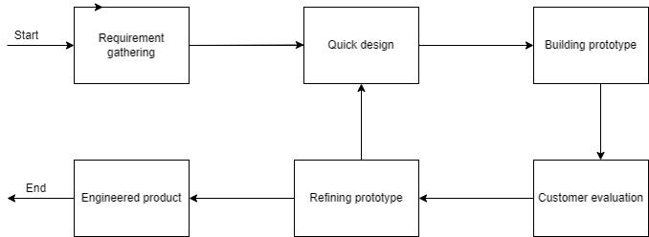

Figure 1:Prototype Model

In this system we are going to make different prototypes like:

* Home Page
* Donations
* Events
* Contributors
* About
* Contact
* User Account
* Dashboard

With the use of Prototype model, we can add other different prototypes as well since it can easily accommodate the use of frequent changes of the system requirements. Different prototypes are developed parallelly and once the prototype has become workable it is integrated with other prototypes and hence the fully working system is developed.

# DATA FLOW DIAGRAM

DFD stands for Data Flow Diagram, which is a graphical representation of a system or process that shows the flow of data between different components of the system. It is a useful tool for analysing and designing complex systems, and it can help to identify potential problems and inefficiencies in a system.

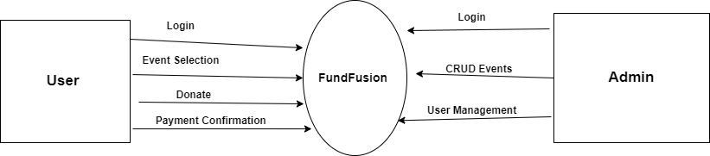

Figure 2:Data Flow Diagram

# PROJECT GANTT CHART/ TIMELINE CHART

A Gantt chart is a chart in which series of horizontal lines shows the amount of work completed in certain period of times in relation to the amount planned for those projects.

Gantt chart helps to keep track of the work progress. It helps to make better communication of the project plan with the team members. Gantt charts make the timeline visual, it’s easy to see where you can batch similar tasks together to save time and find the quickest path to finish.

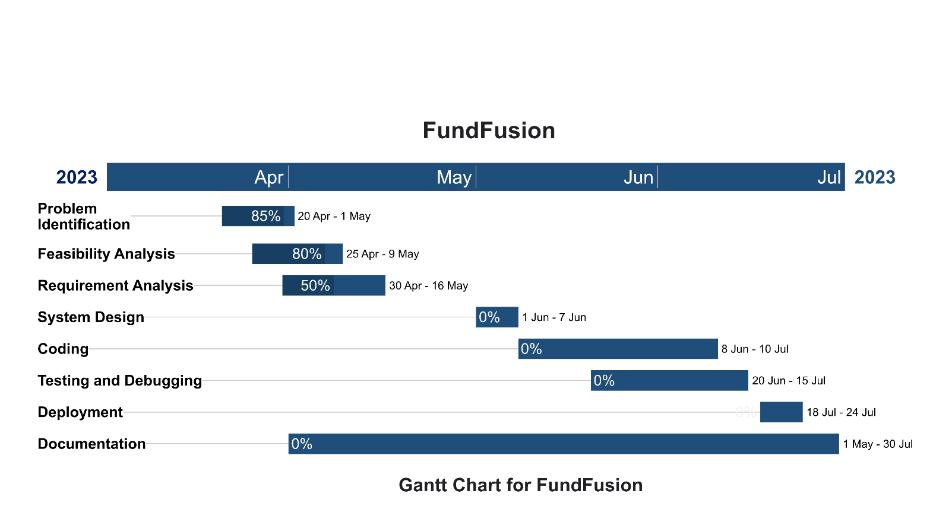

Figure 3:Ganntt Chart

# DELIVERABLES

* A fully functional charity donation app that will be built using PHP programming language and MySQL database
* An intuitive user interface that will allow users to make donations to their preferred charities with ease
* A secure and reliable payment gateway that will ensure the safety of donors financial information
* System Design ERD, DFD, FLOW CHART.
* A database system that will be designed to store donor information and track donations for future reporting and analysis
* User documentation and support materials that will be developed to help users understand how to use the app and troubleshoot any issues that may arise during its usage.

# CONCLUSION

To conclude, Our project entitle “FundFusion” application which will be creating using PHP and MySql as a database will be a powerful tool that will make a real difference in people’s lives. It will provide a simple and convenient way for users to donate to charities, and will help organizations streamline their fundraising efforts. By leveraging the power of technology, we will create a more effective and efficient way to support those in need. With the potential to reach millions of people, this app will have the power to make a significant impact in the world. We are confident that our proposal will be met with enthusiasm, and we look forward to creating a meaningful and impactful platform for charity donations.