Session : 1

Question : 1 Write a short paragraph in your own words defining what a 'program' is and give one real-life example from any app you use daily (like Instagram, Zomato, or Paytm).

Answer : A program is a set of instructions given to a computer to perform a specific task.
Example : In the Paytm app, when a user sends money to another person, a program processes the payment, verifies the details, and completes the transaction.

Question : 2 List three popular programming languages you have heard of, and for each, mention whether it is usually compiled, interpreted, or can be both.
Answer :
Programming Language | Type
Python | Interpreted
Java | Both (Compiled and Interpreted)
JavaScript | Interpreted

Question : 3 Draw a flowchart (on paper or using any online tool) for the process of booking a movie ticket on BookMyShow, starting from opening the app to receiving the booking confirmation.

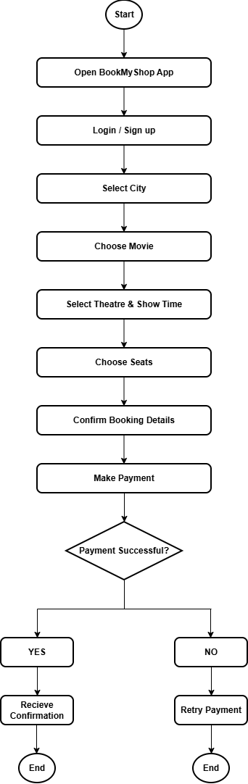
Question : 4 Write down the steps (as an algorithm, using simple numbered instructions) for ordering food on Swiggy — from opening the app to completing payment.

Answer :
- Start.
- Open the Swiggy app.
- Login to your account.
- Enter or confirm the delivery address.
- Search for a restaurant.
- Select the restaurant.
- Choose food items.
- Add items to the cart.
- Review the cart.
- Click on "Proceed to Checkout".
- Select a payment method.
- Make the payment.
- Receive order confirmation.
- Track the order status.
- Receive the food delivery.
- End.

