SESSION : 1

Question : 1 Install MySQL Workbench on your computer, connect to the local MySQL server, and take a screenshot of the default databases shown in the Schemas panel.
Answer :
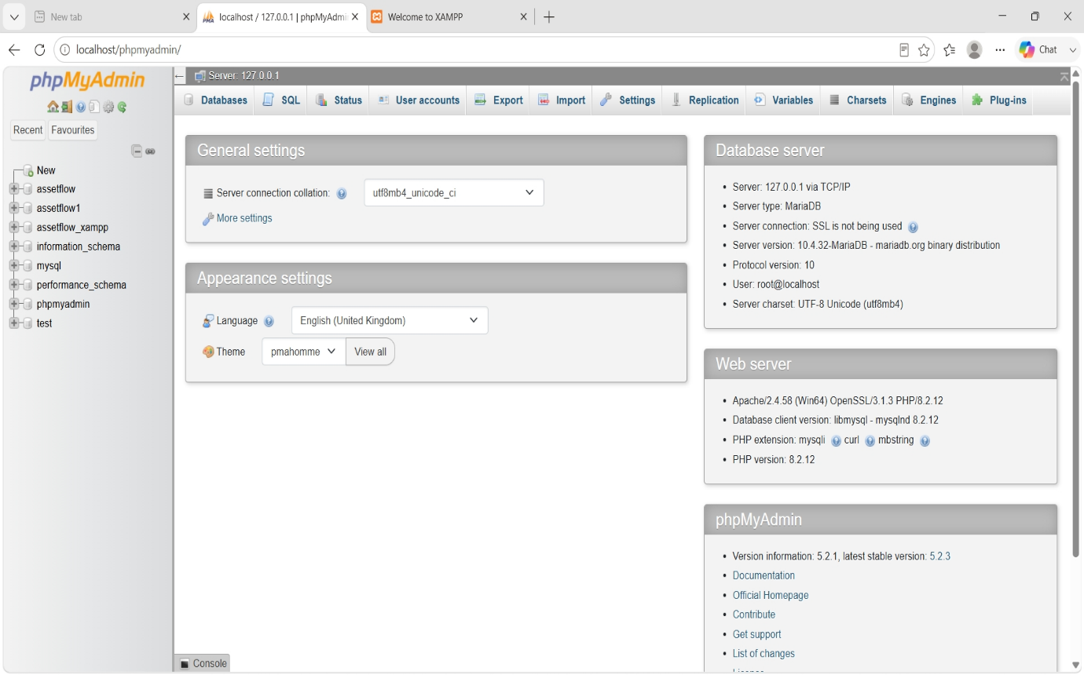

Question : 2 Create a new database called InstaClone in MySQL Workbench, then create a table named Users with columns: user_id (INT, primary key), username (VARCHAR), email (VARCHAR), and followers_count (INT).
Answer :

CREATE DATABASE InstaClone;

USE InstaClone;

CREATE TABLE Users (
user_id INT PRIMARY KEY,
username VARCHAR(50),
email VARCHAR(100),
followers_count INT
);

Question : 3 Insert 3 sample users into the Users table you created, using realistic Instagram-style usernames and follower counts.
Answer :

INSERT INTO Users (user_id, username, email, followers_count)
VALUES
(1, 'riya_shah', 'riya@gmail.com', 12500),
(2, 'rahul_patel', 'rahul@gmail.com', 8450),
(3, 'neha_sharama', 'neha@gmail.com', 19300);
SELECT * FROM Users;

user_id | username | email | followers_count
1 | riya_shah | riya@gmail.com | 12500
2 | rahul_patel | rahul@gmail.com | 8450
3 | neha_sharama | neha@gmail.com | 19300

Question : 4 Create another table in the InstaClone database called Posts with columns: post_id (INT, primary key), user_id (INT), caption (VARCHAR), and post_date (DATE). Add a foreign key from Posts.user_id to Users.user_id to establish a relationship.
Answer :

CREATE TABLE Posts (
post_id INT PRIMARY KEY,
user_id INT,
caption VARCHAR(255),
post_date DATE,
FOREIGN KEY (user_id) REFERENCES Users(user_id)
);

Question : 5 Write a short comparison (3-4 lines each) of MySQL, PostgreSQL, Oracle, and SQLite, focusing on where each one is commonly used (for example: web apps, mobile apps, enterprise systems, etc.).
Answer :

MySQL
- MySQL is an open-source relational database.
- It is commonly used for websites and web applications.
- Popular with PHP, Django, Laravel, and WordPress projects.
- It is easy to learn and provides good performance.
PostgreSQL
- PostgreSQL is an advanced open-source relational database.
- It is used in large web applications and data analytics.
- It supports complex queries and advanced features.
- It is popular in enterprise and GIS applications.
Oracle
- Oracle Database is a commercial database management system.
- It is mainly used by large enterprises, banks, and government organizations.
- It provides high security, reliability, and scalability.
- It is suitable for handling large amounts of business data.

SQLite
- SQLite is a lightweight, file-based database.
- It does not require a separate database server.
- It is commonly used in mobile apps, desktop software, and embedded systems.
- It is simple to use and ideal for small projects.

