Session : 8

Question : 1 Create a Flipkart-style product card in HTML and CSS, then use a meta viewport tag to ensure it scales correctly on mobile devices.
Answer :
<!DOCTYPE html>
<html lang="en">

<head>
<meta charset="UTF-8">

<!-- Makes the webpage scale correctly on mobile devices -->
<meta name="viewport" content="width=device-width, initial-scale=1.0">

<title>Flipkart Product Card</title>

<style>
body {
font-family: Arial, sans-serif;
background-color: #f1f3f6;
margin: 0;
padding: 30px;
}

.product-card {
width: 700px;
margin: auto;
padding: 20px;
background-color: white;
display: flex;
gap: 25px;
border-radius: 10px;
}

.product-card img {
width: 250px;
height: 250px;
object-fit: contain;
}

.product-details {
padding: 10px;
}

.product-details h2 {
color: #212121;
}

.price {
font-size: 22px;
font-weight: bold;
color: #388e3c;
}

.buy-btn {
background-color: #ff9f00;
color: white;
border: none;
padding: 12px 25px;
font-size: 16px;
cursor: pointer;
}
</style>
</head>

<body>

<div class="product-card">

<img src="/img/samsung.webp" alt="Smartphone">

<div class="product-details">
<h2>Samsung Galaxy S25</h2>

<p>High-performance smartphone with an advanced camera and powerful features.</p>

<p class="price">₹1,10,000</p>

<button class="buy-btn">Buy Now</button>
</div>

</div>

</body>

</html>

Question : 2 Add media queries to your product card so that when the screen width is 600px or less, the card layout switches from horizontal (image and details side by side) to vertical (image on top, details below).
Answer :
<!DOCTYPE html>
<html lang="en">

<head>
<meta charset="UTF-8">
<meta name="viewport" content="width=device-width, initial-scale=1.0">

<title>Responsive Flipkart Product Card</title>

<style>
body {
font-family: Arial, sans-serif;
background-color: #f1f3f6;
margin: 0;
padding: 30px;
}

/* Desktop Layout */
.product-card {
width: 700px;
margin: auto;
padding: 20px;
background-color: white;
display: flex;
gap: 25px;
border-radius: 10px;
}

.product-card img {
width: 250px;
height: 250px;
object-fit: contain;
}

.product-details {
padding: 10px;
}

.price {
font-size: 22px;
font-weight: bold;
color: #388e3c;
}

.buy-btn {
background-color: #ff9f00;
color: white;
border: none;
padding: 12px 25px;
font-size: 16px;
cursor: pointer;
}

/* Mobile Layout: 600px or less */
@media only screen and (max-width: 600px) {

.product-card {
width: 90%;
flex-direction: column;
text-align: center;
}

.product-card img {
width: 100%;
height: auto;
}
}
</style>
</head>

<body>

<div class="product-card">

<img src="/img/samsung.webp" alt="Smartphone">

<div class="product-details">
<h2>Samsung Galaxy S25</h2>

<p>
High-performance smartphone with an advanced camera
and powerful features.
</p>

<p class="price">₹1,10,000</p>

<button class="buy-btn">Buy Now</button>
</div>

</div>

</body>

</html>

Question : 3 Set up three breakpoints (600px, 900px, 1200px) for your product card and change the card's font size and padding at each breakpoint to improve readability on different devices.<br><br><em><strong>Hint:</strong> Use @media only screen and (max-width: ...) in your CSS for each breakpoint.</em>
Answer :
<!DOCTYPE html>
<html lang="en">

<head>
<meta charset="UTF-8">
<meta name="viewport" content="width=device-width, initial-scale=1.0">

<title>Responsive Product Card</title>

<style>
body {
font-family: Arial, sans-serif;
background-color: #f1f3f6;
margin: 0;
padding: 30px;
}

/* Default Desktop Style */
.product-card {
width: 700px;
margin: auto;
padding: 30px;
background-color: white;
display: flex;
gap: 25px;
border-radius: 10px;
font-size: 20px;
}

.product-card img {
width: 250px;
height: 250px;
object-fit: contain;
}

.product-details {
padding: 10px;
}

.price {
font-size: 24px;
font-weight: bold;
color: #388e3c;
}

.buy-btn {
background-color: #ff9f00;
color: white;
border: none;
padding: 12px 25px;
font-size: 16px;
cursor: pointer;
}

/* 1200px Breakpoint */
@media only screen and (max-width: 1200px) {
.product-card {
font-size: 18px;
padding: 25px;
}
}

/* 900px Breakpoint */
@media only screen and (max-width: 900px) {
.product-card {
font-size: 16px;
padding: 20px;
}
}

/* 600px Breakpoint */
@media only screen and (max-width: 600px) {
.product-card {
width: 90%;
font-size: 14px;
padding: 15px;
flex-direction: column;
text-align: center;
}

.product-card img {
width: 100%;
height: auto;
}
}
</style>
</head>

<body>

<div class="product-card">

<img src="/img/samsung.webp" alt="Smartphone">

<div class="product-details">
<h2>Samsung Galaxy S25</h2>

<p>
High-performance smartphone with an advanced camera
and powerful features.
</p>

<p class="price">₹75,000</p>

<button class="buy-btn">Buy Now</button>
</div>

</div>

</body>

</html>

Question : 4 Test your responsive product card by resizing your browser window and taking screenshots at mobile, tablet, and desktop widths; submit the screenshots along with a short note on what changes at each size.
Answer :
Phone
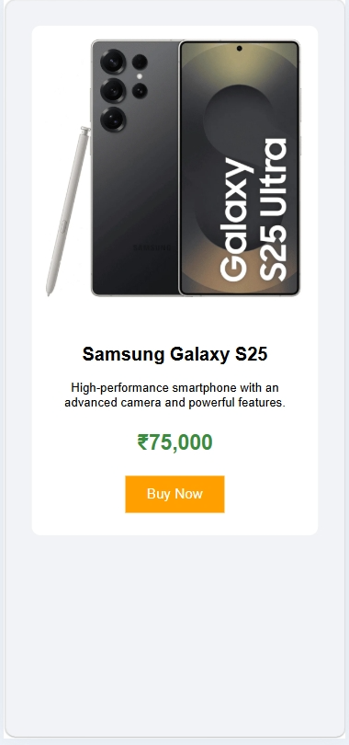

Tablet

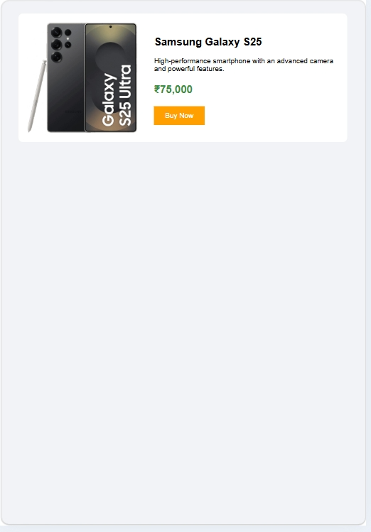

Desktop
