Session : 1 Theory Task

Question : 1 Install Python (latest version) and VS Code on your computer, then take a screenshot of both the Python installation confirmation and the VS Code welcome screen.
Answer :
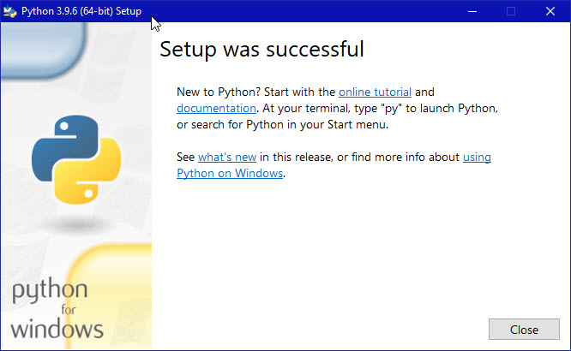

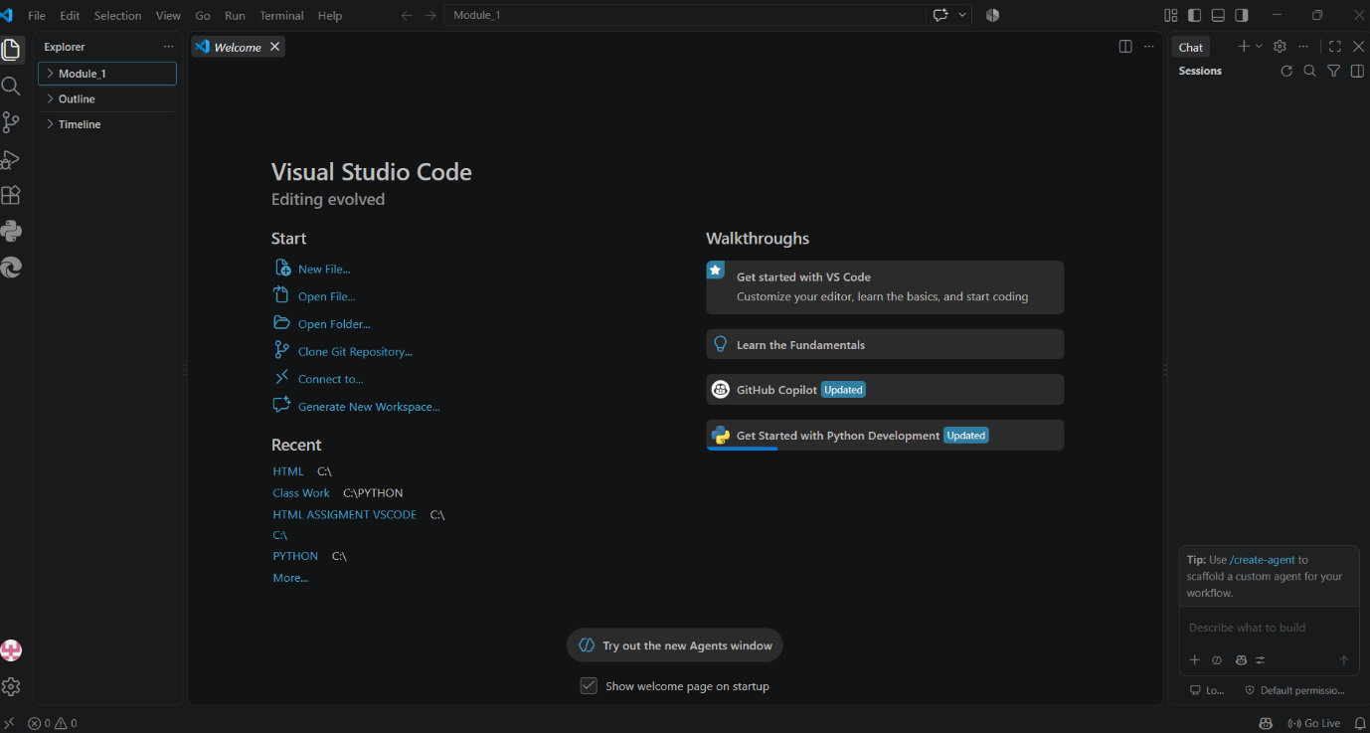
Question : 5 Explain the difference between how Python executes code versus how C or Java executes code, using your own words and a simple example for each. give me correct answer according to question and also give output
Answer :
C: Compile → Machine Code → Run
Example :
#include <stdio.h>
int main()
{
printf("Hello");
return 0;
}
Java: Compile → Bytecode → JVM → Run
Example :
Public class Main
{
public static void main(String[] args)
{
System.out.println("Hello from Java");
}
}
Python: Interpreter → Bytecode/PVM → Run
Example :
print(“Hello”)

