SCHOOL OF COMPUTER SCIENCE ENGINEERING AND INFORMATINO SYSTEMS
WINTER SEMERSTER 2025-26
FINAL ASSESSMEET TEST

April 15,2026

SET - 3

NAME : SABARISHWARAN J
REG_NO : 23MIS0100
COURSE : Agile Development process and Devops Lab
FACULTY : Dr. N . BALA GANESH

Online Ticket Canellation system
Problem Statement :
Ensure tickets are cancelled and refunded correctly

Project Structure:
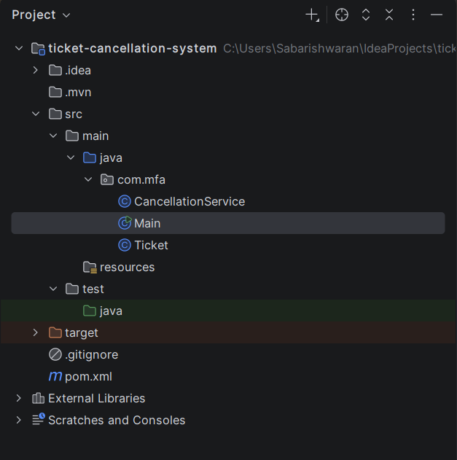
Ticket Class Implementation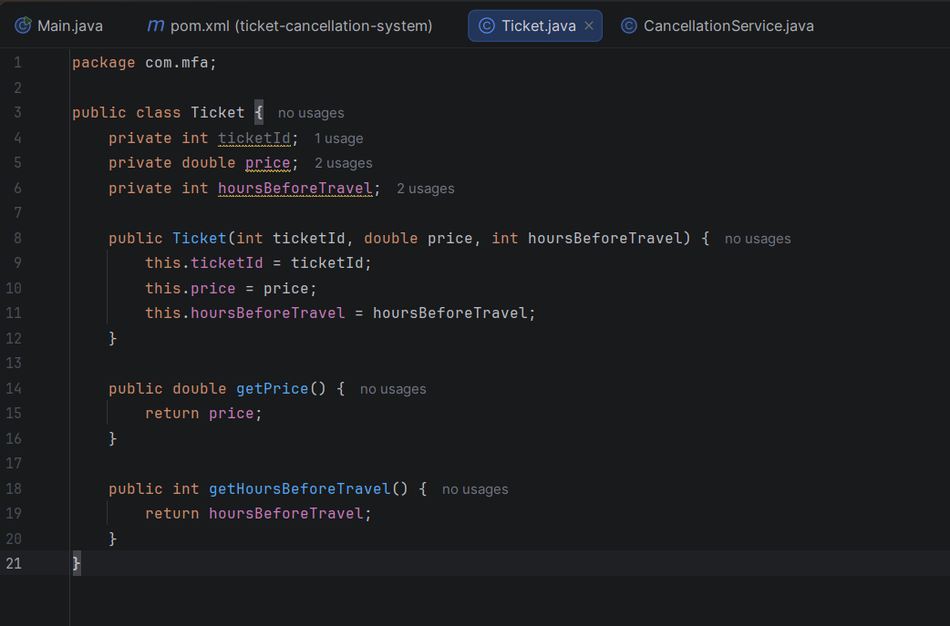
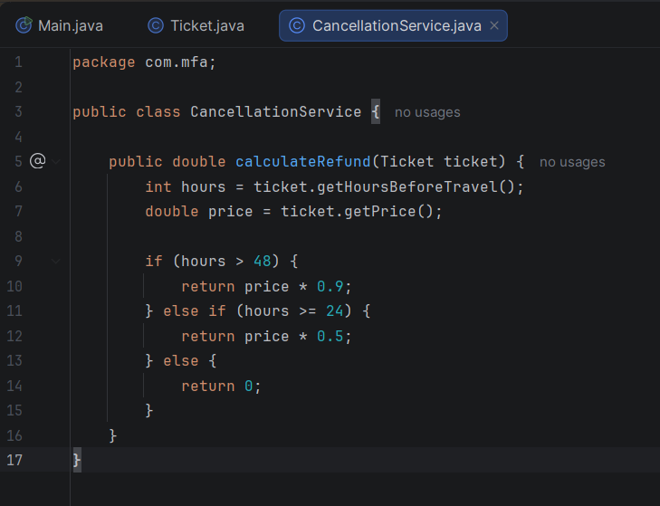
Refund Calculation Logic
Main Class for Execution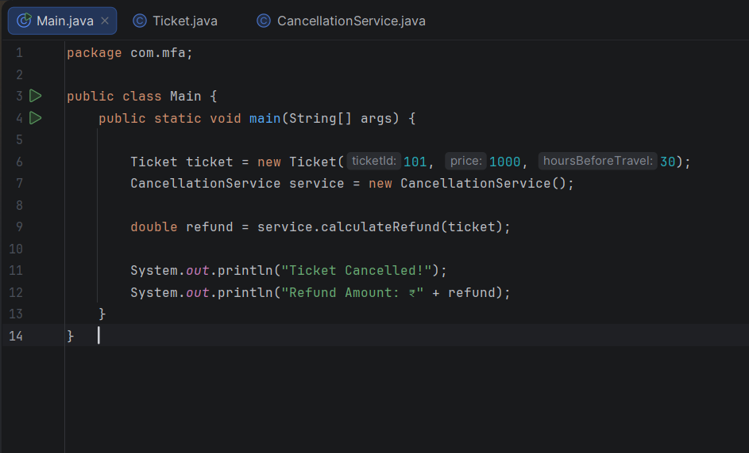
Execution Output Showing Refund Calculation
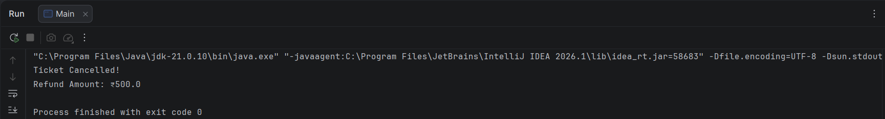
JUnit Test Cases for Refund Logic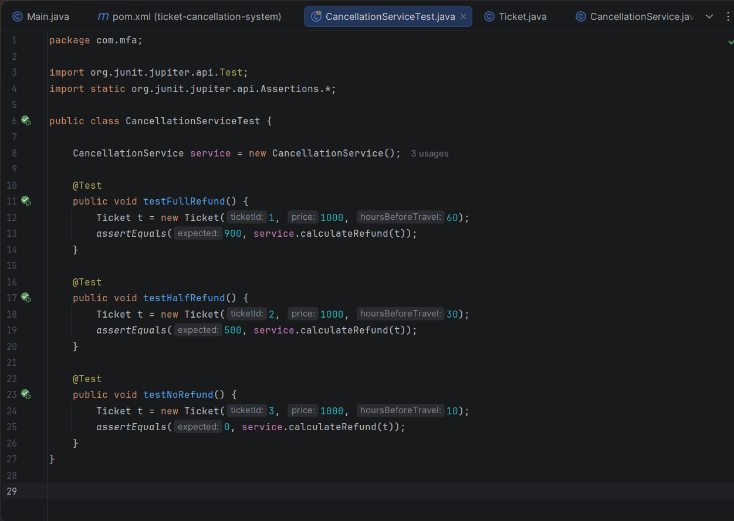

Successful Execution of JUnit Test Cases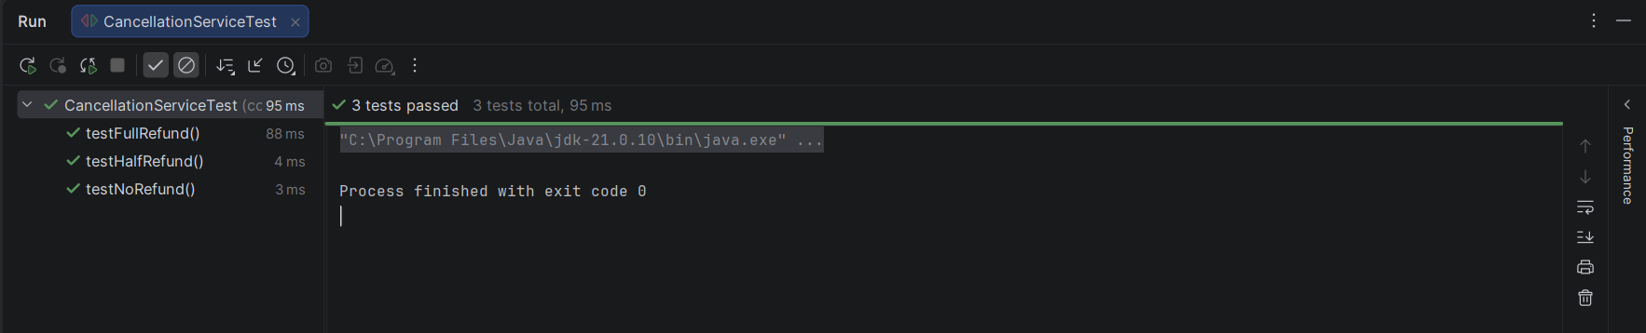

Maven Build Successful with Test Execution
mvn clean install
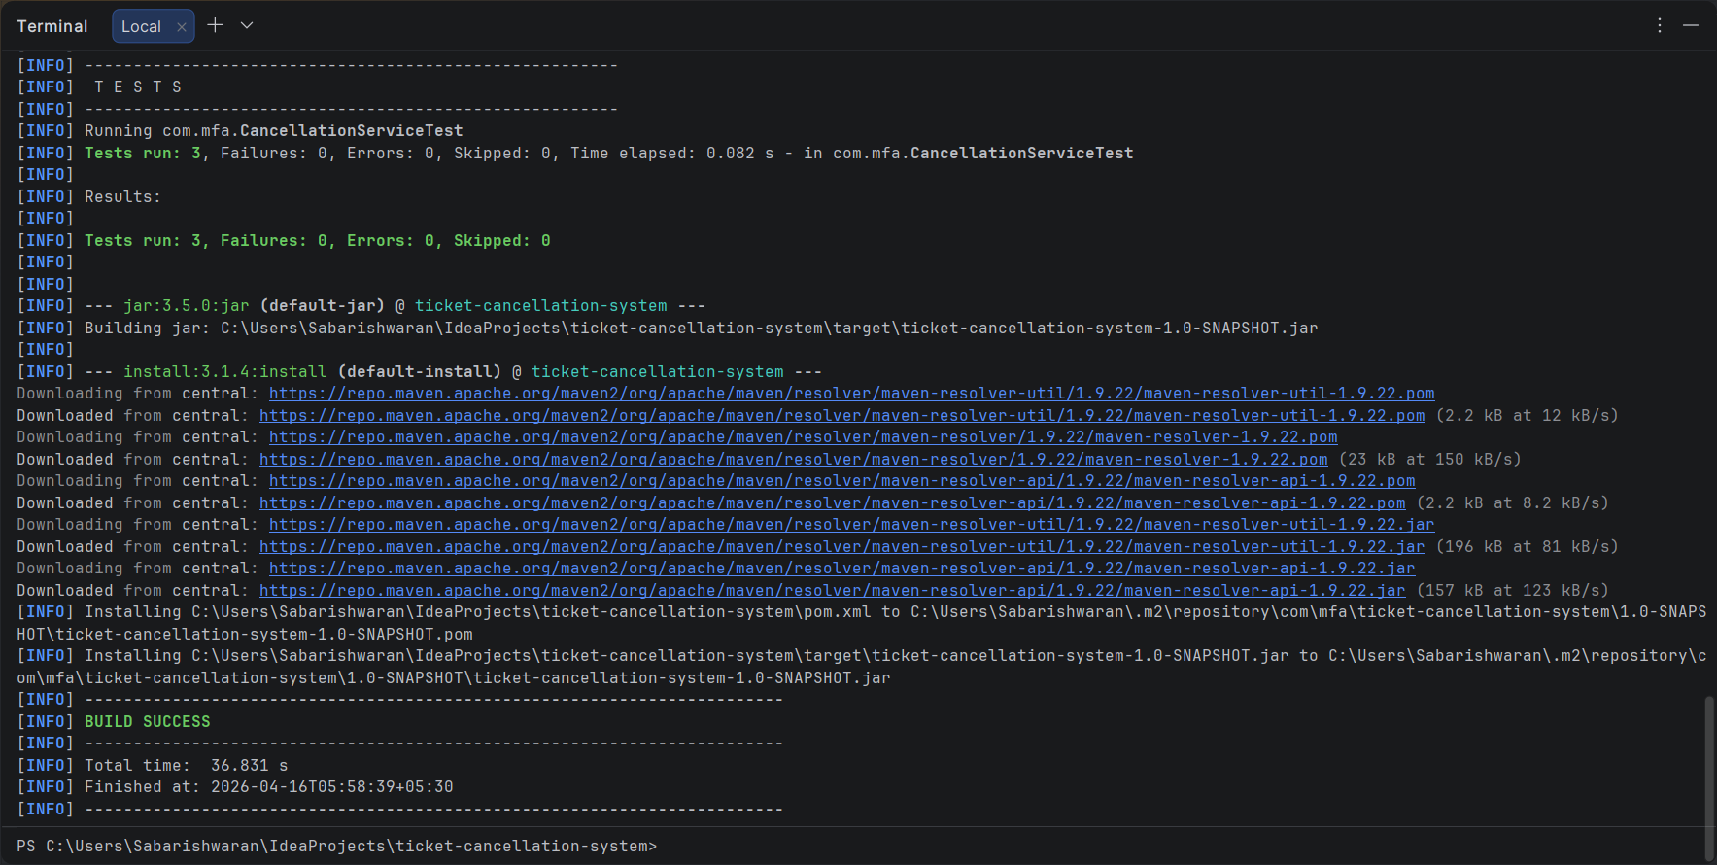Generated JAR File after Maven Build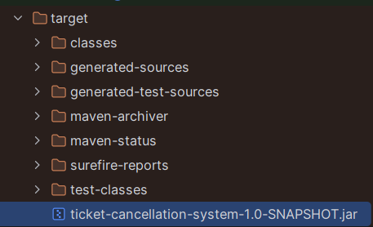

Connect IntelliJ Project to Git
git init
git add .
git commit -m "Initial commit - Ticket Cancellation System"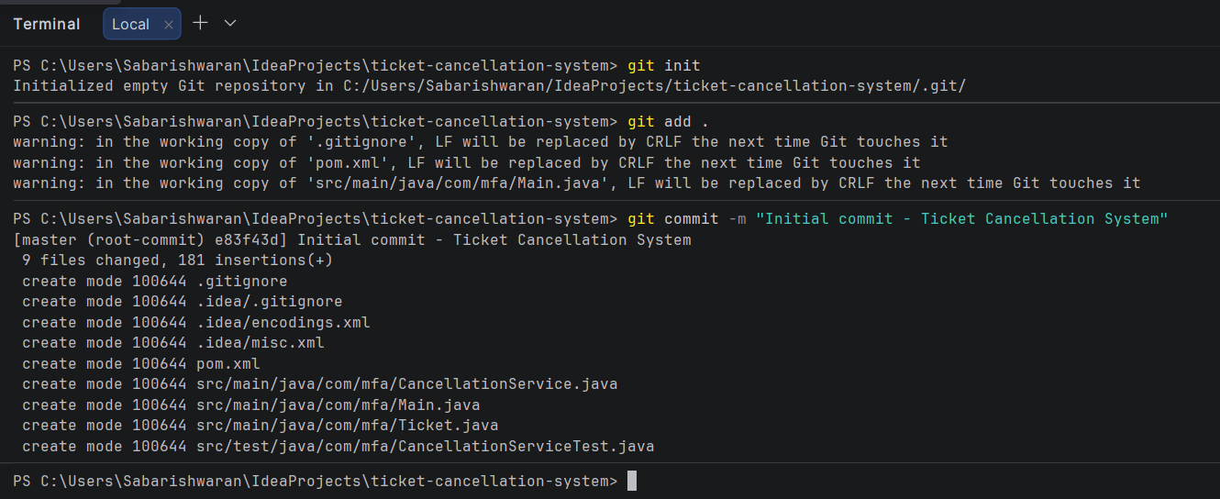

Link GitHub Repo
git remote add origin https://github.com/sabarishwaran2023-source/ticket-cancellation-system.git
git branch -M main
git push -u origin main
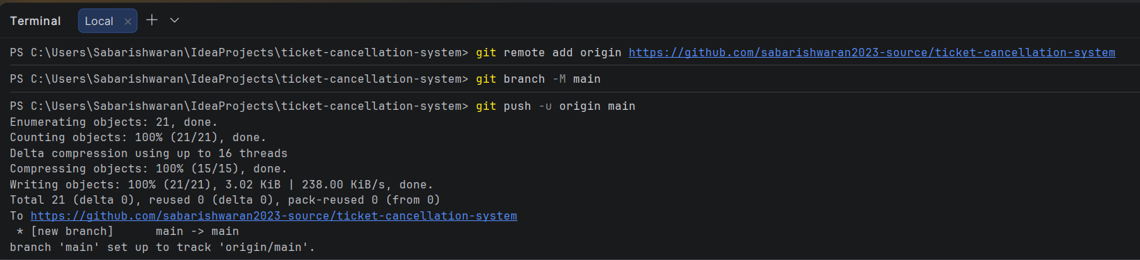
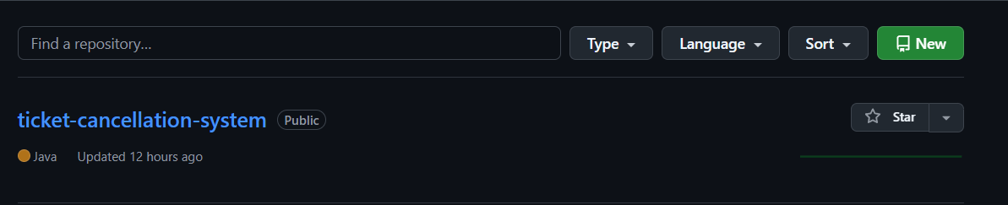

Successful Jenkins Build Execution
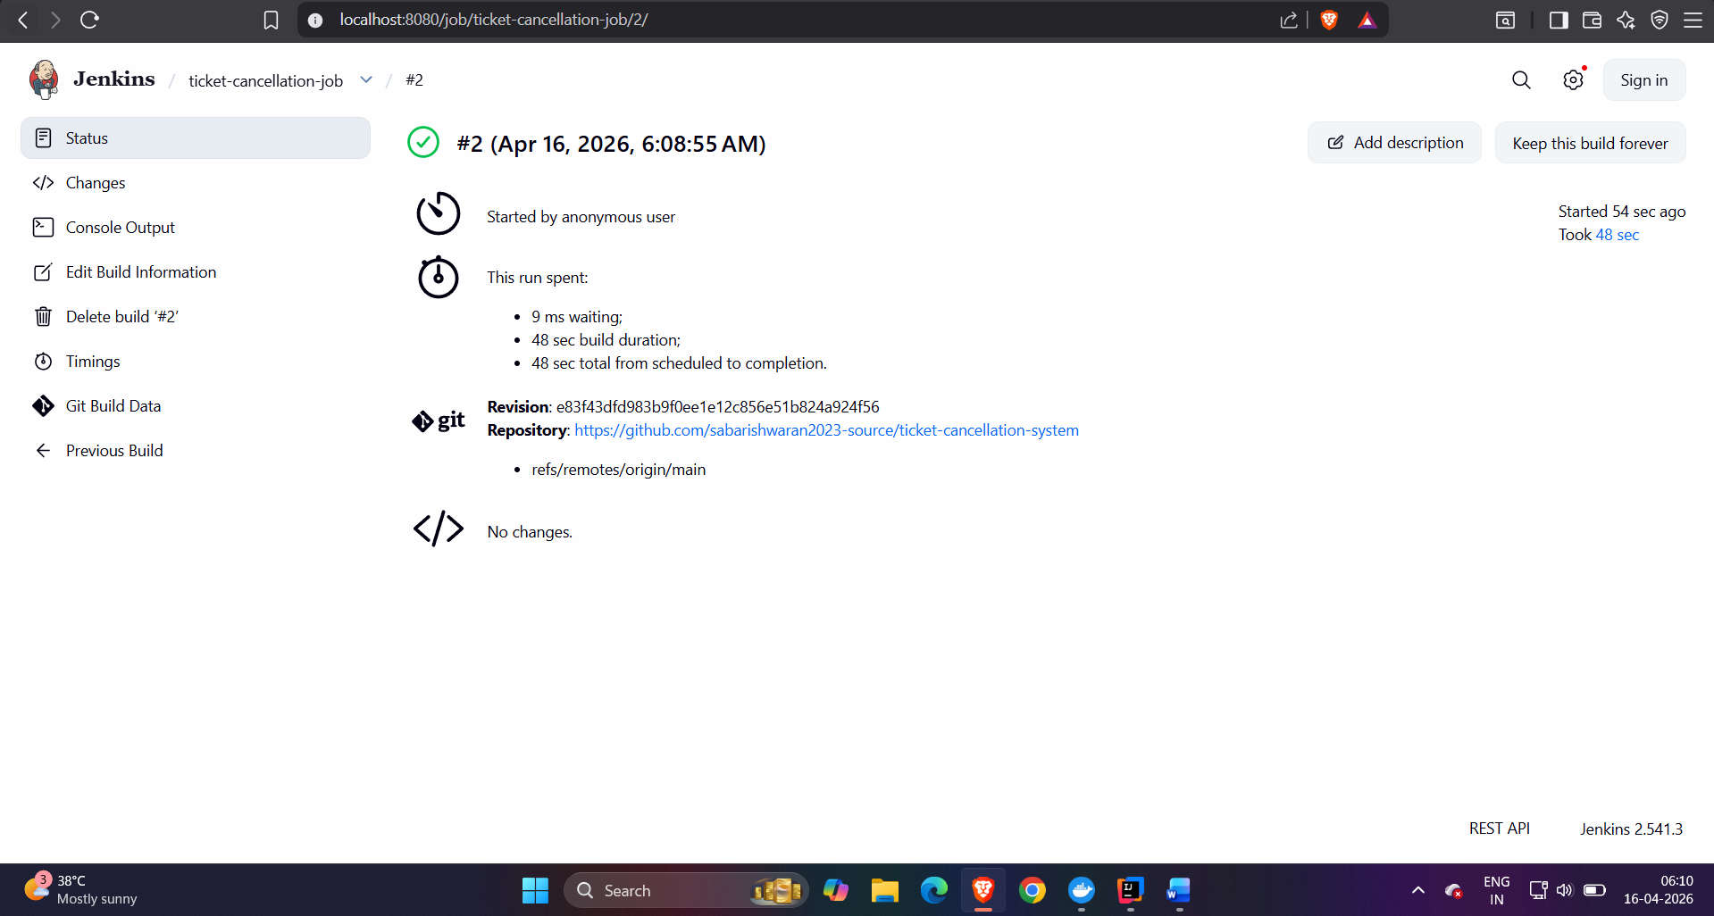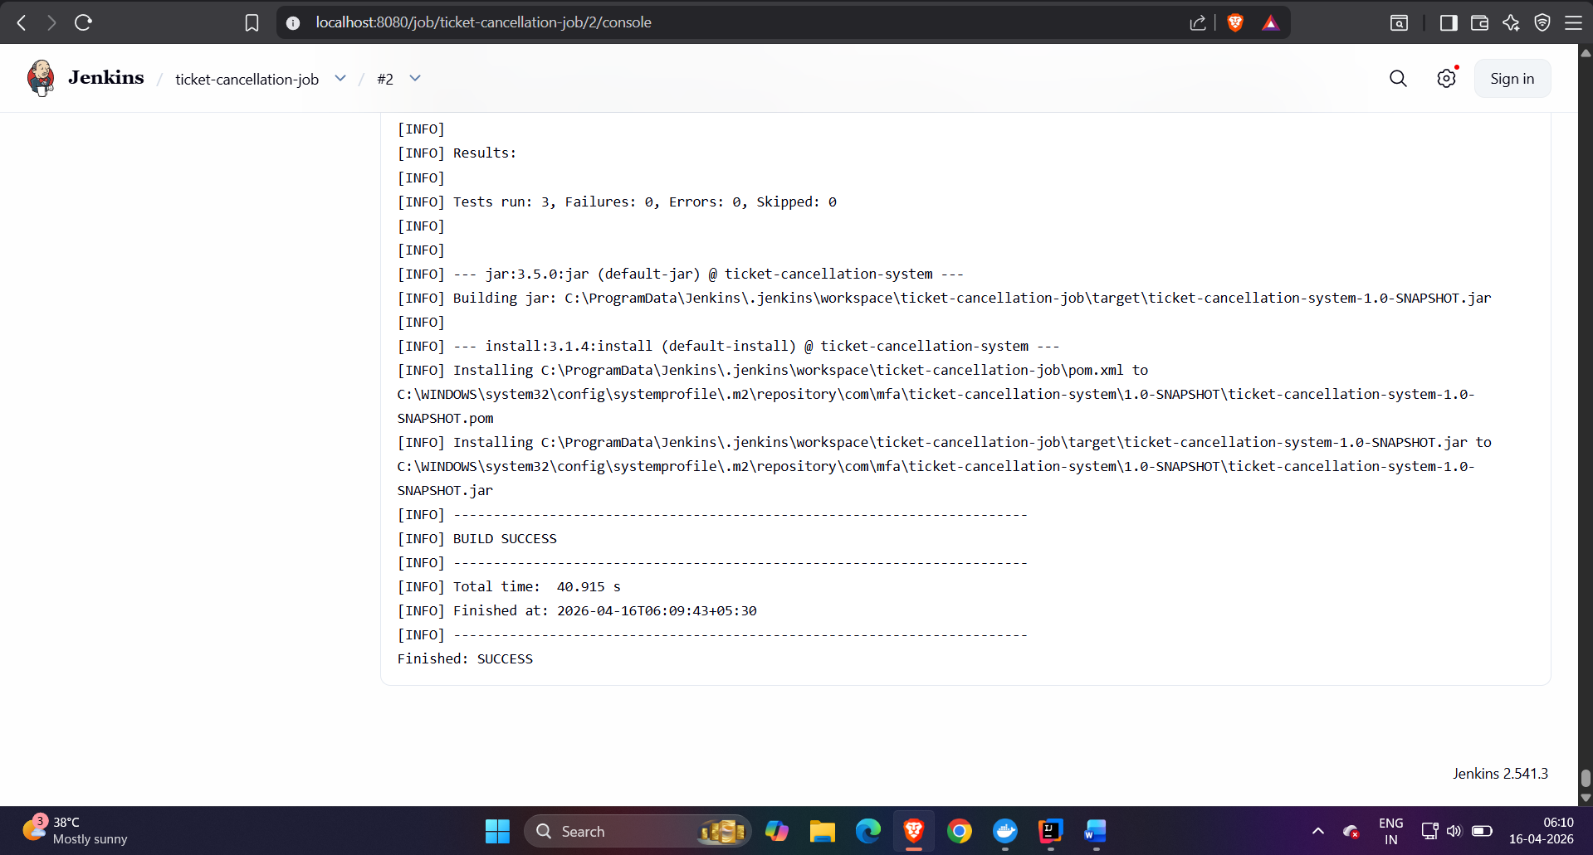

Docker file and its Output :
docker build -t ticket-app .
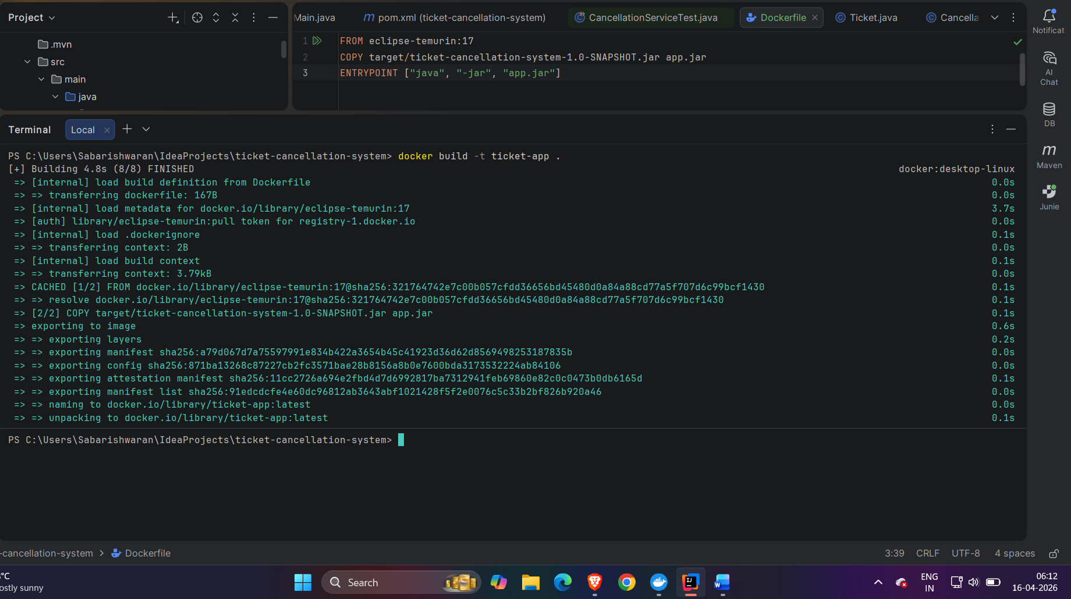Docker Image Created Successfully (docker images)
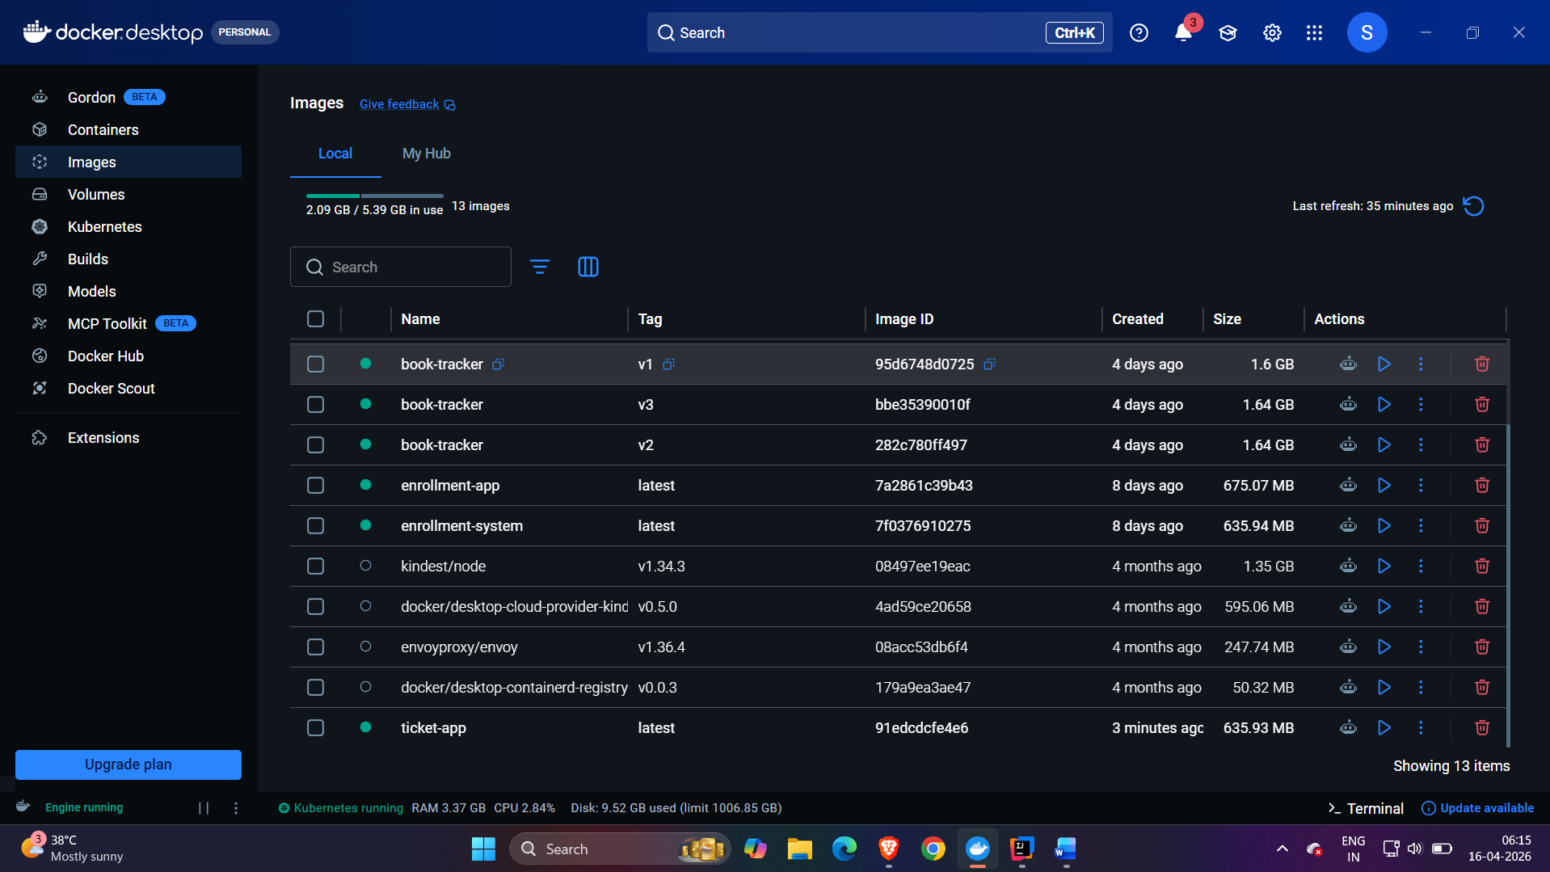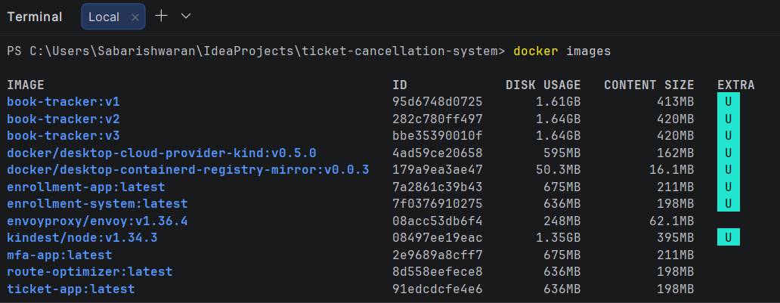

Successful Execution of Application inside Docker Container
docker run ticket-app
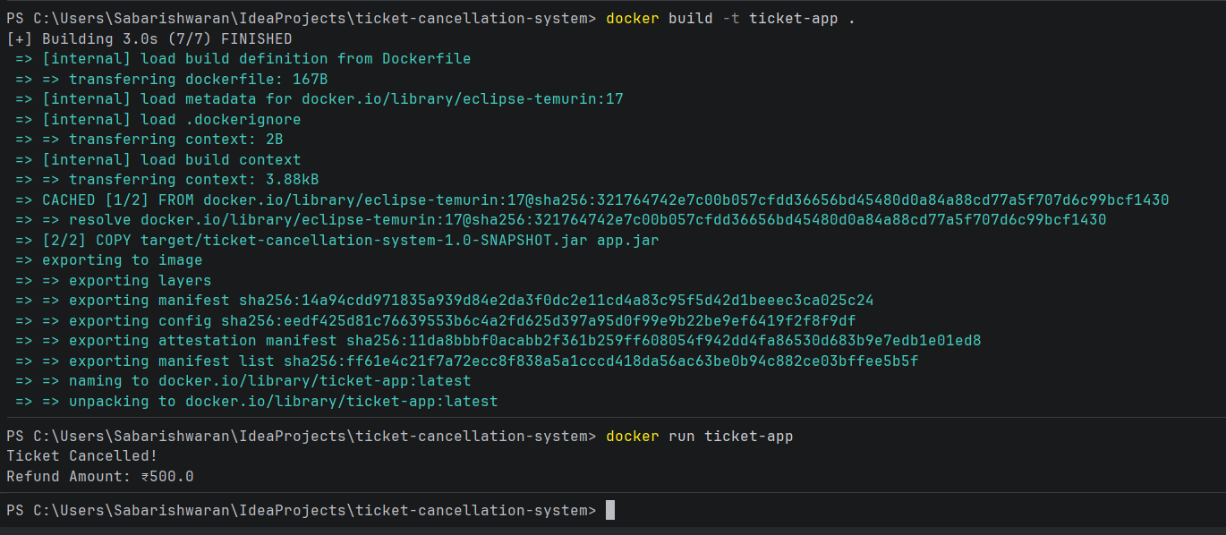
Kubernetes Deployment Configuration File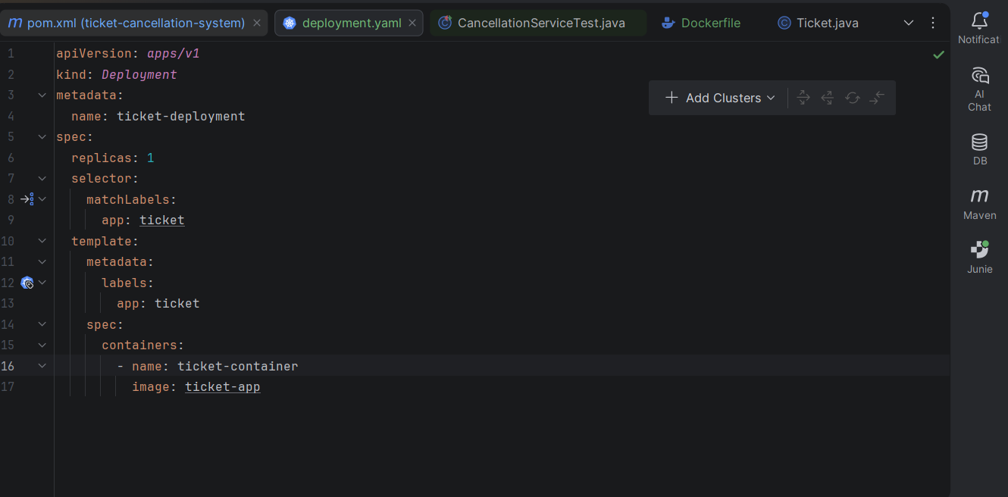

Kubernetes Pod Status (Running/Completed)
kubectl apply -f k8s/deployment.yaml
kubectl get pods
