dtk-tools in python 3.6 installation guide

… that does not conflict with existing python 2.7 installations

* Pre-requirement:
  + GitHub account (User name and password) which has access to Dtk-Tools repo and HIV-Analyzers repo.

1. Install python 3.6
   1. Navigate here: <https://www.python.org/downloads/release/python-365/>
   2. Click the link: [Windows x86-64 web-based installer](https://www.python.org/ftp/python/3.6.5/python-3.6.5-amd64-webinstall.exe)
   3. Run the .exe file that downloads
   4. Select ‘Custom installation’, leave checkboxes as noted.

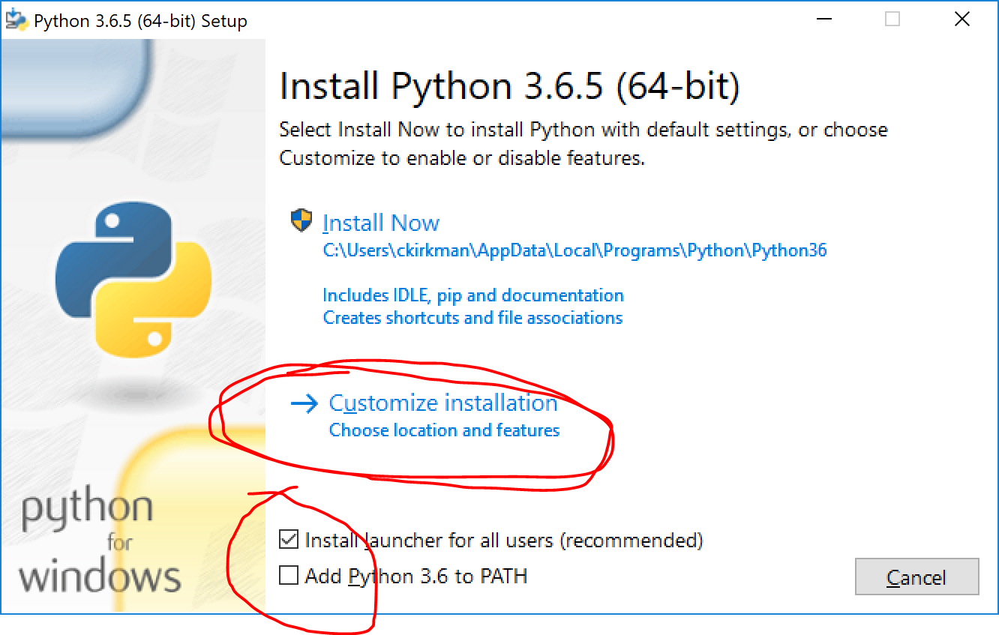

* 1. Make selections as follows, click ‘Next’:

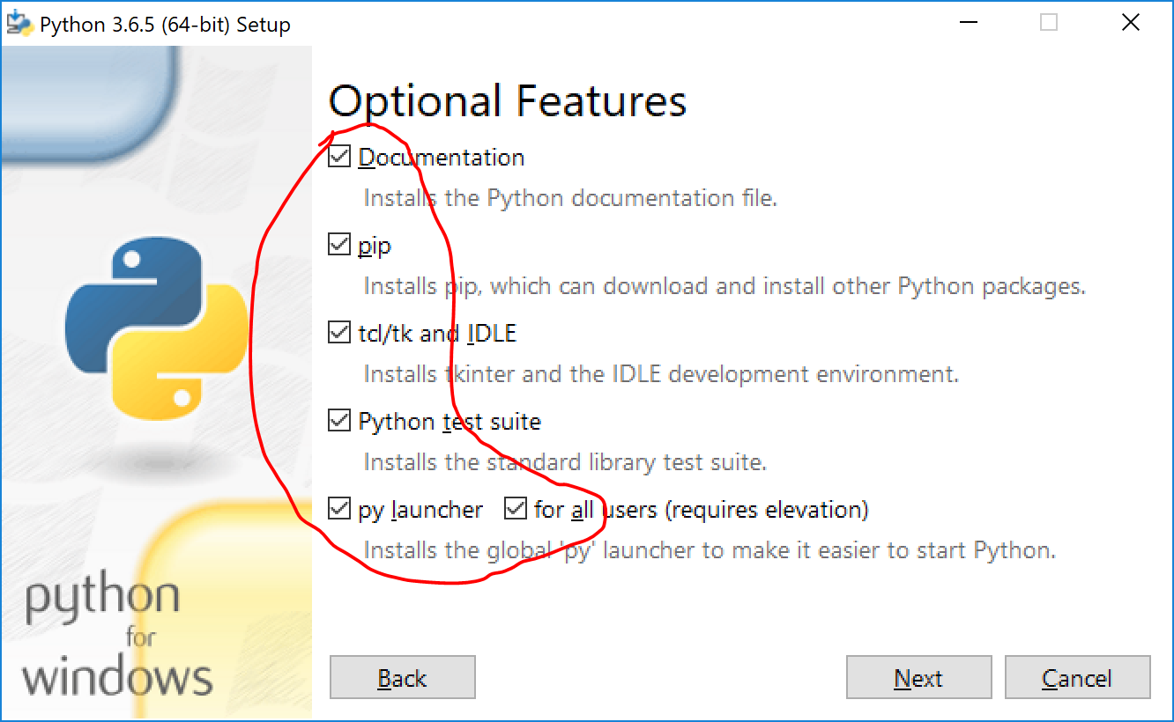

* 1. Make selections as follows (select drive to use, c in this example), click ‘Install’

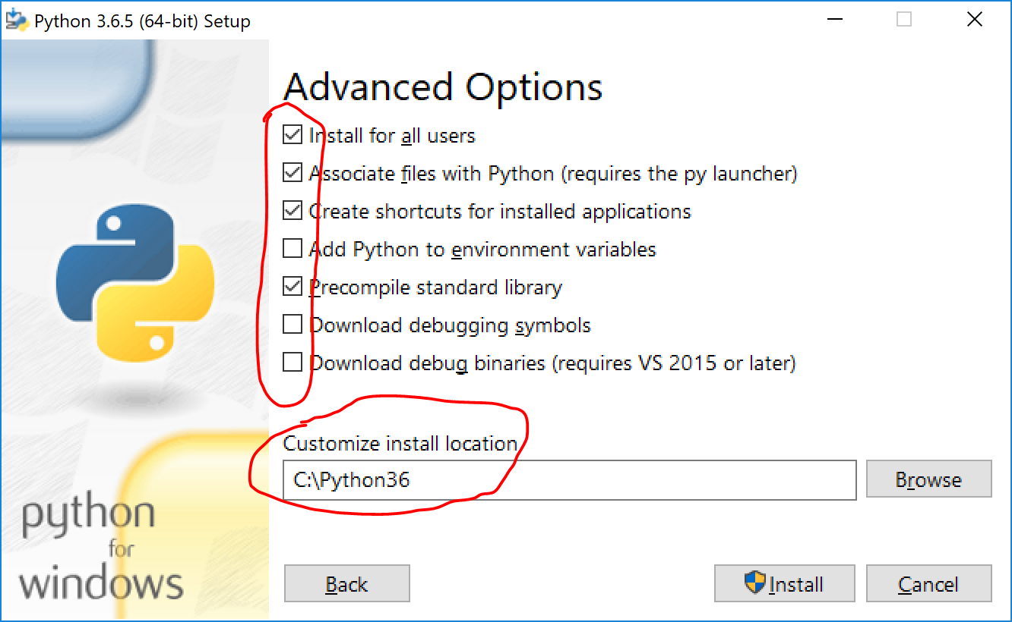

* 1. If the option is available, disable the Windows path length limit by clicking the notated button below.

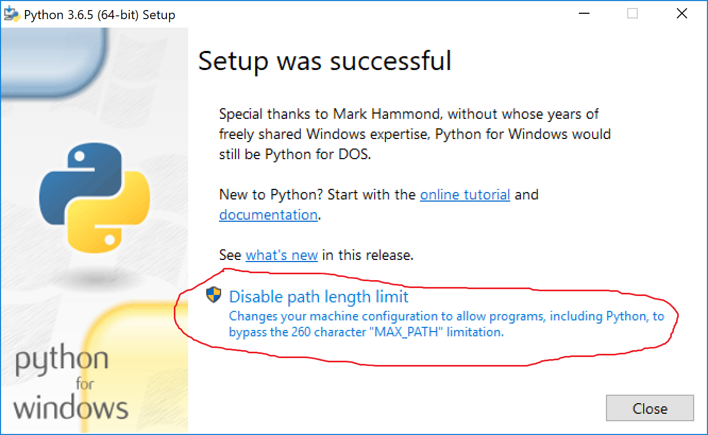

1. Install git
   1. Navigate here: <https://git-scm.com/download/win>
   2. Run the .exe file that auto-downloads(You can use the default setting and click “Next” a few times and then click “Install”)
2. Setup and activate a virtual environment for python 3.6
   1. Run git bash (windows key, type in gitbash, click it)

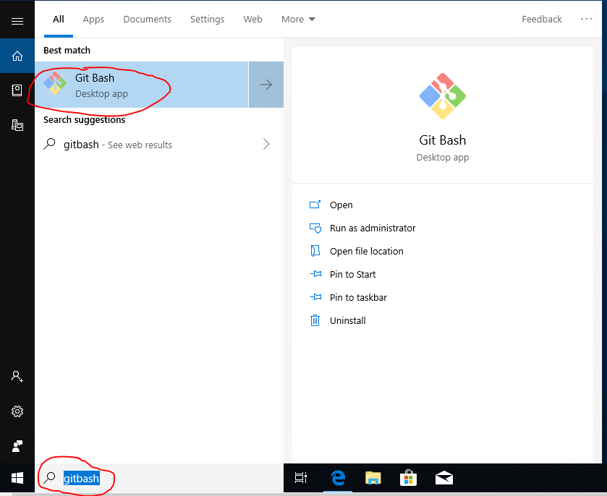

* 1. Run the following commands in gitbash, one at a time, **using an appropriate windows drive letter** (c in this example).

/c/Python36/Scripts/pip install virtualenv

mkdir -p $HOME/environments

/c/Python36/Scripts/virtualenv -p /c/python36/python.exe $HOME/environments/dtk-tools-p36

echo -e "export environments=\$HOME/environments\nsource \$environments/dtk-tools-p36/Scripts/activate" > .bashrc

mv .bashrc ~/

* 1. Now close your gitbash window. Every time you launch gitbash it will use the virtual environment just created.



1. Install dtk-tools
   1. Reopen gitbash (windows key, type in gitbash, click it)
      1. Run the following commands in gitbash, one at a time:

mkdir $HOME/dtk-tools-p36

cd $HOME/dtk-tools-p36

git clone https://github.com/InstituteforDiseaseModeling/dtk-tools.git .

* + 1. Enter your github username or email and password in this pop up window.

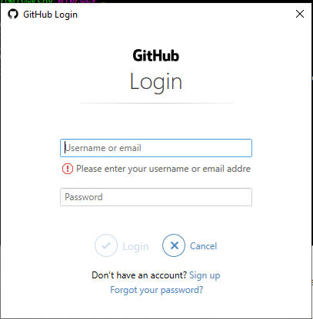

* + 1. Once git finished cloning the dtk-tools files. run the this command in gitbash

python setup_manual.py



* + 1. To test if dtk-tools is correctly installed on your machine run this command:

dtk -h

If the command succeeds and presents you with the details of the dtk command you are all set!

1. Install HIV package
   1. Run the following commands:

cd ~

winpty dtk get_package HIV -v HEAD

You will need to provide your GitHub UserName and Password:



You are all set. Now you can run dtk-tools with HIV package in gitbash window or in Windows command prompt(cmd). If you want to run it in Windows command prompt, please run the following command every time after you launch Windows command prompt. **Using an appropriate windows drive letter**:

%USERPROFILE%\environments\dtk-tools-p36\Scripts\activate