# Transmission dynamics in the universal test and treat era in Rakai, Uganda: A mathematical modeling study

**OVERVIEW**

Significant declines in HIV incidence have been observed with scale-up of antiretroviral therapy (ART) and voluntary medical male circumcision (VMMC) programs as part of the Rakai Community Cohort Study (RCCS), an open, population-based cohort of 15 to 49 year-olds in 30 communities in Rakai, Uganda. Disaggregating the relative contribution of different interventions to declines in incidence is challenging using standard statistical approaches since interventions were scaled simultaneously. Mathematical modelling provides an alternative approach. The proposed mathematical modeling project aims to assess the dynamics of HIV incidence in the era of large-scale combination HIV treatment and prevention in the Rakai Community Cohort Study (RCCS). Two individual-based mathematical models will be used to simulate the local HIV epidemic and estimate the effects of various prevention efforts, including scale-up of antiretroviral therapy (ART) and of voluntary medical male circumcision (VMMC), as observed in the RCCS between 1999 and 2019. Using calibration endpoints of HIV prevalence by age, sex, and year, models will estimate incidence trajectories to date compared to three counterfactuals: 1) no scale-up of VMMC; 2) no scale-up of ART; and 3) no scale-up of either VMMC or ART. Further modeling will aim to estimate the effects of changing sexual risk behavior on changes in incidence. Preliminary results from a joint modeling effort using data from RCCS through 2016 to calibrate our models are shown below. Our goal in the second phase of this project is to update and recalibrate our models using data through the most recent round of survey (through round 18). We will calibrate our models to HIV prevalence and ART coverage and update structural inputs related to sexual network (age-pairing probabilities by sex) and secular changes in sexual risk behavior (including changes in age of sexual debut, condom use, age-gaps in relationships, concurrency, etc.) from the most recent RCCS survey rounds.

**Modeling topics:**

1. Estimate the absolute and relative contribution of ART and VMMC scale-up (to date) to reductions in incidence considering secular changes in sexual risk behaviour.
   1. Estimate the sensitivity of incidence reductions by scenarios to uncertainty key behavioural, biological, and transmission-specific parameters.
   2. Estimate the cost-effectiveness of various VMMC age-targeting scenarios over time under high ART coverage.
   3. Estimate the increased effectiveness of cascade improvements (decreasing time-to-initiation versus increasing retention-in-care and adherence).
2. To quantify the contribution of major sources of onward transmission by demographic and disease-specific strata (age; sex; time-since-seroconversion; cascade-of-care state, i.e., tested, treated, on ART, ART dropout, reengagement in care; HIV stage)
3. To project the long-term impacts of universal test and treat (UTT) and Dolutegravir scale-up on viral load dynamics and trajectories of resistance

**Data needs:**

Data for the first iteration of this project (through 2016) were provided by Kate Grabowski in the file whopico_modeling_rakaidata.rda and a snapshot of the codebook is shown here:

Summary(whopico_modeling_rakaidata)

studyvisit agegroup fem_el_popsize man_el_popsize fem_pt_popsize

Min. : 6.00 15to19:12 Min. : 292.0 Min. : 201.0 Min. : 201.0

1st Qu.: 8.75 20to24:12 1st Qu.: 490.8 1st Qu.: 526.5 1st Qu.: 367.2

Median :11.50 25to29:12 Median : 990.0 Median : 941.5 Median : 741.0

Mean :11.50 30to34:12 Mean : 998.8 Mean : 912.7 Mean : 696.8

3rd Qu.:14.25 35to39:12 3rd Qu.:1392.5 3rd Qu.:1151.0 3rd Qu.:1002.0

Max. :17.00 40to44:12 Max. :2408.0 Max. :2229.0 Max. :1203.0

45to49:12

man_pt_popsize fem_hivsize man_hivsize fem_artsize man_artsize

Min. : 128.0 Min. : 19.00 Min. : 0.00 Min. : 0.00 Min. : 0.00

1st Qu.: 339.2 1st Qu.: 49.25 1st Qu.: 27.50 1st Qu.: 0.00 1st Qu.: 0.00

Median : 558.5 Median :106.00 Median : 59.50 Median : 3.00 Median : 1.00

Mean : 529.6 Mean :105.87 Mean : 53.04 Mean : 28.46 Mean :10.89

3rd Qu.: 682.0 3rd Qu.:149.25 3rd Qu.: 77.00 3rd Qu.: 43.50 3rd Qu.:16.00

Max. :1211.0 Max. :228.00 Max. :123.00 Max. :181.00 Max. :80.00

man_circsize man_circsize_hivneg man_circsize_hivpos fem_circsize

Min. : 17.0 Min. : 17.0 Min. : 0.00 Mode:logical

1st Qu.: 74.0 1st Qu.: 67.0 1st Qu.: 3.50 NA's:84

Median :113.0 Median : 98.5 Median :10.00

Mean :177.2 Mean :161.5 Mean :15.71

3rd Qu.:254.5 3rd Qu.:220.8 3rd Qu.:25.00

Max. :781.0 Max. :779.0 Max. :63.00

fem_circsize_hivneg fem_circsize_hivpos

Mode:logical Mode:logical

NA's:84 NA's:84

The following additional data elements are requested for the next iteration of modeling:

1. Cascade metrics:
   1. Number tested
   2. Number initiated on ART (first-time initiators)
   3. Number reinitiated on ART
   4. Number with viral suppression (<400 copies/mL or other threshold) among first time initiators versus re-initiators.
2. Partnership formation metrics:
   1. Number of partnerships by age (male) - age (female) in 5-year bins and by sex
3. Behavioural metrics
   1. Age of sexual debut by sex and year
   2. Reported sexual partners in the last 12 months and lifetime by age, sex, and year
   3. Concurrent partnerships (?)

**METHODS**

Micro-simulation modelling will be implemented using the epidemiological modelling software EMOD-HIV (https://github.com/InstituteForDiseaseModeling/EMOD), which is described in detail at www.idmod.org/idmdoc and elsewhere 1. EMOD incorporates data on age-specific fertility, mortality, and sexual relationship formation, and explicitly models the flow of individuals through a configurable HIV cascade of care – including testing, time-variable linkage to care, retention in care, treatment eligibility, and retention on ART 2. EMOD uses three key structural components to simulate the age, gender, and risk-group specific sexual network and the age- and gender- specific scale-up of ART. The first is a sexual partner pair formation algorithm (PFA) described previously 3. The PFA provides a detailed representation of the age-specific structuring of heterosexual networks – a phenomenon that contributes to the age and gender-specific patterns of HIV transmission 5,64. ART is assumed to reduce infectiousness on average by 92% 7, an estimate that incorporates “real-world” barriers to suppression including adherence and undetected drug resistance. The transmission benefit of ART is assumed to grow linearly over the six months after ART initiation, with no impact on transmission on the day of ART initiation, and increasing impact over time until a 92% reduction in transmission is achieved and maintained after six months.

**PRELIMINARY RESULTS**

**Figure 1.** Modelled HIV prevalence by age-group and gender (median and 95% credible intervale shown in blue) with observed prevalence and 95% confidence intervals overlaid in black.

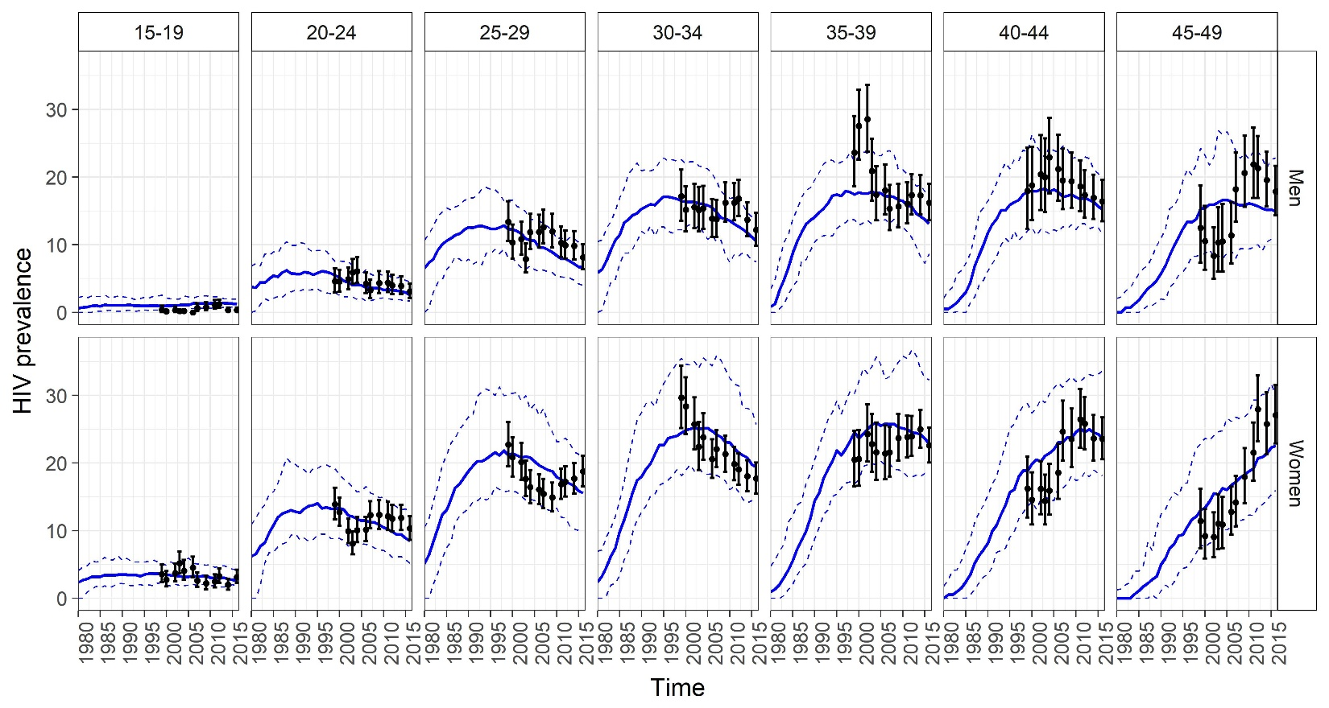

**Figure 2**. Modelled HIV prevalence by gender (median and 95% credible interval shown in blue) with observed prevalence and 95% confidence intervals overlaid in black

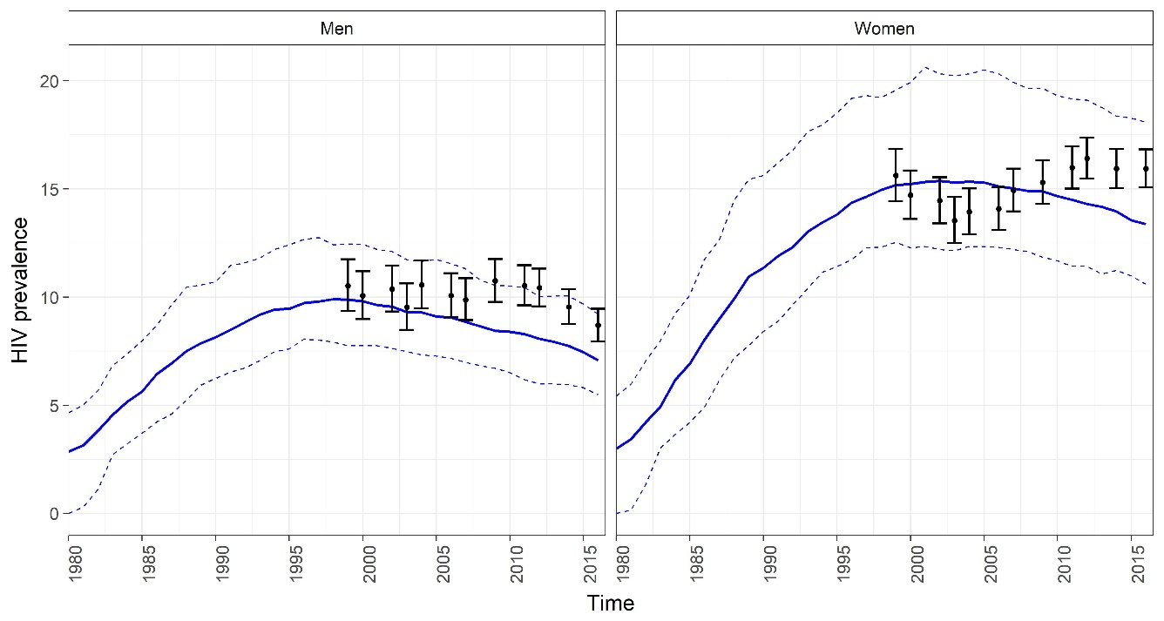

**Figure 3.** Modeled scale-up of male circumcision (MC) over time by age-group (median and 95% credible intervale shown in blue) with observed coverage and 95% confidence intervals overlaid in black.

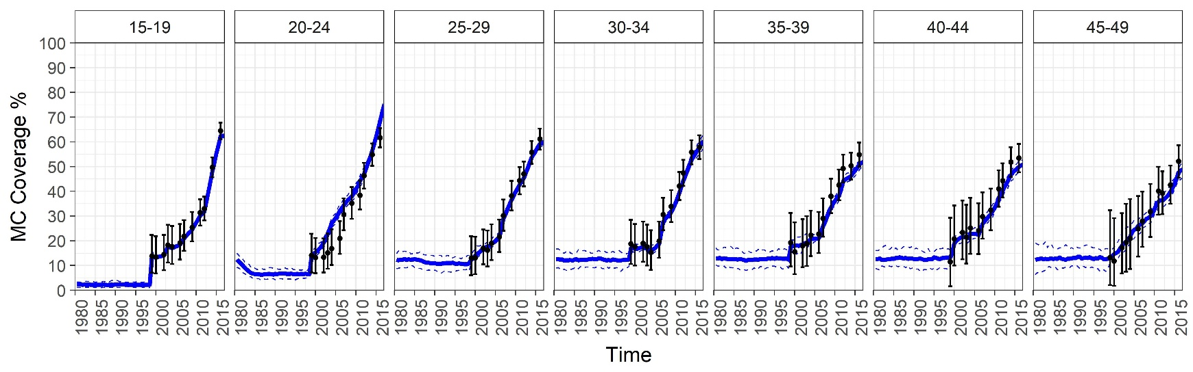

**Figure 4.** Modeled scale-up of ART over time by age-group (median and 95% credible interval shown in blue) with observed coverage and 95% confidence intervals overlaid in black.

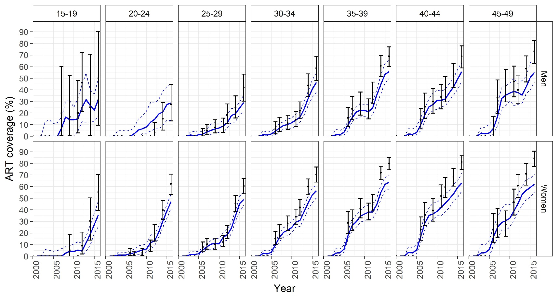

**Figure 5.** Modeled HIV incidence [median of 250 simulations in units of infections per 100 person years (py)] over time by scenario among men and women 15-49. The “baseline” scenario indicates the fitted incidence to actual scale-up of ART and VMMC,

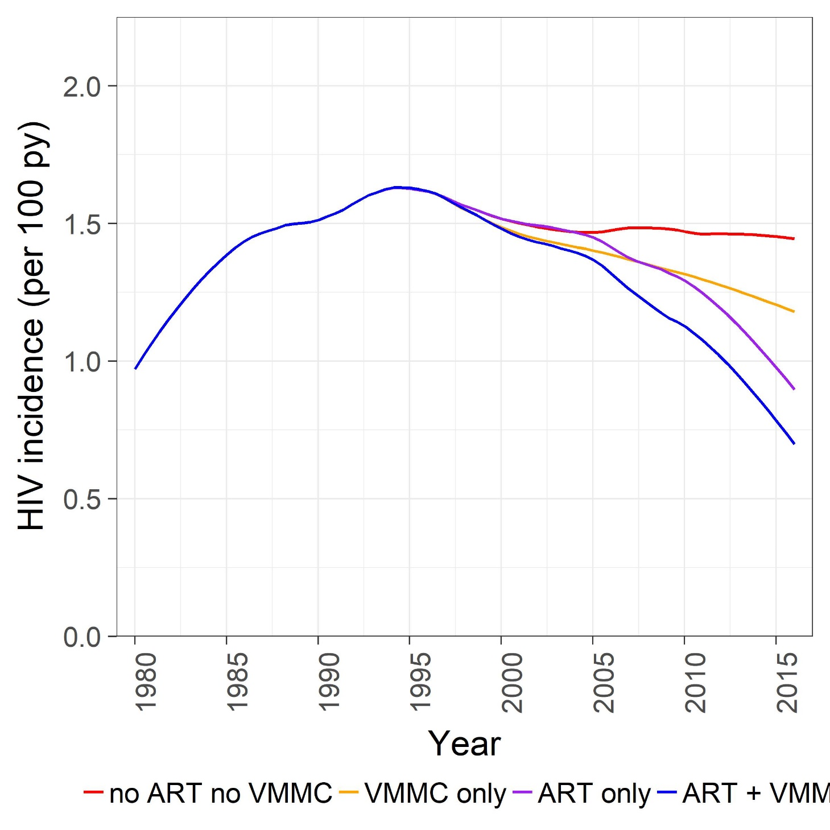

**Figure 6.** Modeled HIV incidence [median of 250 simulations in units of infections per 100 person years (py)] over time by scenario and gender. The “ART+VMMC” scenario indicates the fitted incidence to actual scale-up of ART and VMMC,

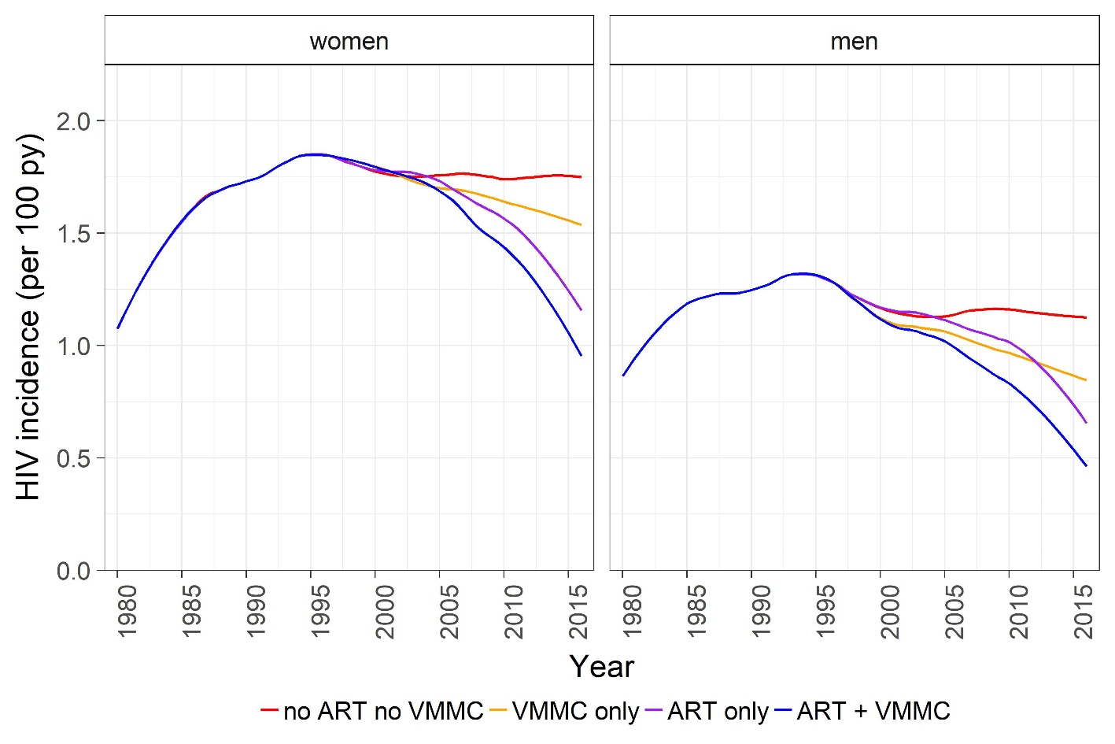

**Table 1**. Attributable risk % (AR%), indicates the percent of incidence reduced with the scale-up of ART only, VMMC only, and the two combined (ART + VMMC), relative to a counterfactual without either (no ART and no VMMC).

|  |  |  |  |  |  |  |  |  |
| --- | --- | --- | --- | --- | --- | --- | --- | --- |
|  |  |  | All |  | Women |  | Men |  |
| Year start | end | scenario | AR% | CI | AR% | CI | AR% | CI |
| 2000 | 2016 | ART + VMMC | 23.1 | (10.4 - 31.2) | 20.2 | (5.6 - 28.8) | 27.0 | (17.2 - 36.6) |
| 2005 | 2016 | ART + VMMC | 28.8 | (15.9 - 37.6) | 25.4 | (12 - 35.5) | 33.9 | (21.6 - 43.1) |
| 2015 | 2016 | ART + VMMC | 49.3 | (32.3 - 63.7) | 44.5 | (25.5 - 61.7) | 54.1 | (35.7 - 71.0) |
| 2000 | 2016 | VMMC only | 9.6 | (-3.9 - 20.8) | 7.3 | (-8.6 - 18.1) | 14.3 | (2.2 - 26.5) |
| 2005 | 2016 | VMMC only | 12.7 | (-5 - 22.1) | 9.1 | (-10.4 - 18.8) | 16.8 | (2.3 - 27.9) |
| 2015 | 2016 | VMMC only | 18.4 | (-5.7 - 34.1) | 15.3 | (-14.1 - 31.8) | 23.3 | (-15.5 - 47.0) |
| 2000 | 2016 | ART only | 13.2 | (6.1 - 21.0) | 12.8 | (4.3 - 21.6) | 13.4 | (4.3 - 22.0) |
| 2005 | 2016 | ART only | 17.2 | (7.7 - 26.9) | 17.0 | (6.7 - 26.7) | 17.8 | (7.8 - 28.9) |
| 2015 | 2016 | ART only | 35.7 | (16.2 - 51.5) | 35.0 | (9.4 - 50.3) | 38.1 | (7.9 - 56.5) |

1. Bershteyn A, Gerardin J, Bridenbecker D, et al. Implementation and applications of EMOD, an individual-based multi-disease modeling platform. *Pathogens and disease* 2018.

2. Klein DJ, Bershteyn A, Eckhoff PA. Dropout and re-enrollment: implications for epidemiological projections of treatment programs. *Aids* 2014; **28 Suppl 1**: S47-59.

3. Bershteyn A, Klein DJ, Eckhoff PA. Age-dependent partnering and the HIV transmission chain: a microsimulation analysis. *J R Soc Interface* 2013; **10**(88): 20130613.

4. Akullian A, Bershteyn A, Klein D, Vandormael A, Barnighausen T, Tanser F. Sexual partnership age-pairings and risk of HIV acquisition in rural South Africa: a population-based cohort study. *Aids* 2017.

5. Ott MQ, Bärnighausen T, Tanser F, Lurie MN, Newell M-L. Age-gaps in sexual partnerships: seeing beyond ‘sugar daddies’. *AIDS (London, England)* 2011; **25**(6): 861-3.

6. Harling G, Tanser F, Mutevedzi T, Bärnighausen T. Assessing the validity of respondents’ reports of their partners’ ages in a rural South African population-based cohort. *BMJ Open* 2015; **5**(3).

7. Donnell D, Baeten JM, Kiarie J, et al. Heterosexual HIV-1 transmission after initiation of antiretroviral therapy: a prospective cohort analysis. *Lancet* 2010; **375**(9731): 2092-8.