Estimating the relative population-level impacts of voluntary medical male circumcision and antiretroviral therapy on HIV incidence in a declining epidemic: Results from Rakai, Uganda

William Probert1, Adam Akullian2, Rafael Sauter1, Kate Grabowski3,5, Anna Bershteyn2, Ronald H Gray3, Maria J Wawer3, David Serwadda4, Joseph Kagaayi5, Godfrey Kigozi3, Gertrude Nakigozi3,5, Christophe Fraser1

1 Big Data Institute, University of Oxford, Oxford, UK

2 Institute for Disease Modeling, University of Washington, Bellevue, USA

3 Johns Hopkins University Bloomberg School of Public Health, Baltimore, USA

4 Makerere University, Kampala, Uganda

5 Rakai Health Sciences Program, Rakai, Uganda

**Background**

Significant declines in HIV incidence have been observed with scale-up of antiretroviral therapy (ART) and voluntary medical male circumcision (VMMC) programs as part of the Rakai Community Cohort Study (RCCS), an open, population-based cohort of 15 to 49 year-olds in 30 communities in Rakai, Uganda. Disaggregating the relative contribution of different interventions to declines in incidence is challenging using standard statistical approaches since interventions were scaled simultaneously. Mathematical modelling provides an alternative approach.

**Methods**

Two individual-based models of HIV transmission from two independent teams were fitted to age- and gender-stratified data from the RCCS from 1999 to 2016. To estimate the relative contribution of ART and VMMC scale-up to declines in incidence, four scenarios of HIV epidemics were simulated: 1) including both interventions, a baseline that matches historical scale-up of ART and VMMC by age and gender; 2) VMMC only (no ART); 3) ART only (no VMMC scale-up); 4) No interventions. Results are reported as a percent by which risk is reduced from each scenario relative to the counterfactual scenario with no interventions.

**Results**

In the period 2015-16, among women, ART had a larger impact on incidence reductions (model A: 35.0%, model B: 33.6%) than VMMC (model A: 15.0%, model B: 18.8%). In the same period, among men, VMMC had a similar impact (model A: 23.3%, model B: 35.0%) as ART (model A: 38.1%, model B: 34.4%) on incidence reductions. Simulation results from the two models were largely concordant (figure 1). The effects of the interventions appear to be additive.

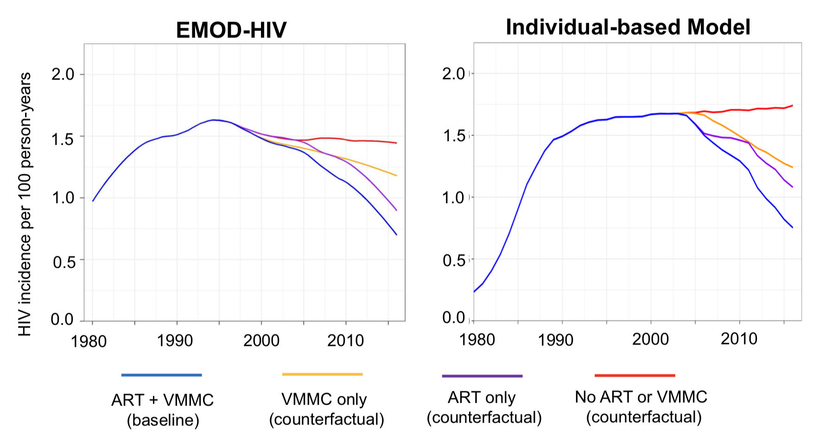

Figure 1: Simulated HIV incidence trends from two individual-based models of HIV transmission (panels) in Rakai, Uganda under a baseline (blue line) and three counterfactual scenarios (yellow, purple, red lines).

**Conclusions**

Our results suggest that ART and VMMC both had an impact on population-level HIV incidence in both genders, and the impact of VMMC is realised more quickly in men than women.