**ONLINE CAR RENTAL SYSTEM**

**OBJECTIVE:**

The goal of this project is to connect the users to a rental system where they can rent items as per their desire. Such system saves cost for the owner of the application and increases convenience to the users.

**ABSTRACT:**

This Car Rental System project is designed to help the car rental organization to enable renting cars through an online system. It helps the clients to select for available cars view profile and book the cars for the time period. It has an easy to understand interface which helps the client to check for cars and rent them for the period determined. They could likewise make payment on the online. The rental cars will be ordered into an economy, premium and so forth. Based on a type of car required by the client, the client will have able to make bookings. The utilization of internet technology has made it simple for the clients to rent a car anytime and anywhere.

**EXISTING SYSTEM:**

“Primary research is the process of collecting data from people directly connected to the topic being discussed.” It involves use of techniques and method in order to collect data from different categories of people. It is necessary to collect data from these groups of people in order to get accurate information about the system to be built. The reason behind it is to know as much as possible about the liking of the users going to use the system and the precise requirements. Primary research is conducted in order to gather information for further analysis.

**DISADVANTAGES:**

* Manually selecting cars.
* Renters might not have all the required items.
* It is not effective method to communicate with all customers.
* Difficult to scale up.
* You must return the vehicle to an acceptable state, according to the normal condition.

**PROPOSED SYSTEM:**

This Car Rental System task will enable the client to rent a vehicle. The client will log in to the system and check for the availability of cars. The client indicates a kind of car and the journey date and time. The Car Rental System will check for the availability of the car and rent the car to the client. The client can make payment on the online. Every one of the information with respect to the rental cars are stored in MySQL database. The client needs to enter his name, address, phone details and check for the cars available for rent. The main advantage is that the client will have the ability to pick a car depending upon his budget.

**BLOCK DIAGRAM:**

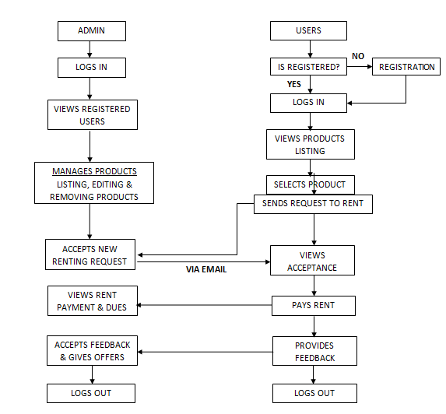

**ADVANTAGES:**

* Can select products online.
* It is an effective method to communicate with all customers.
* Book the cars for the time period.
* You are planning for a road trip.
* It saves time and labor.
* choose a car depending on his budget

**APPLICATIONS:**

* Car rental system require a temporary vehicle.
* A type of car and the journey date and time.
* Travelling by renting your cheap and beat self drive cars.

**SYSTEM SPECIFICATIONS**

**SOFTWARE REQUIREMENS**

* Operating System : Windows 7+
* Server side Script : HTML, CSS & JS
* IDE : PyCharm
* Libraries Used : Pandas, Numpy, os, Pillow, Mysql.

**HARDWARE REQUIREMENTS**

# Processor - I3/Intel Processor

# RAM - 4GB (min)

* Hard Disk - 128 GB
* Key Board - Standard Windows Keyboard
* Mouse - Two or Three Button Mouse