Balaji Fast Food Sales
A Sales Analysis for a Fast-Food Stall Owner
Prepared by Aalaa Jandali · Data: Kaggle (1,000 orders, 2022–2023)

Executive summary
This report analyses 1,000 orders from a fast-food stall to answer four questions any owner would ask: what sells, when it sells, how customers pay, and how the business is trending. Over the two-year period the stall recorded ₹275,230 in revenue across 8,162 items, at an average of ₹275 per order.
The headline findings: a small handful of items drive most of the money, demand is remarkably steady across every part of the day, cash and digital payments are almost evenly split, and — importantly — the sales records thin out sharply after March 2023, which looks like a data-collection gap rather than a real decline in business.
Question | What the data shows | Action for the stall
What sells? | Sandwich, Frankie & Cold coffee lead; Vadapav & Aalopuri lag. | Never stock out of the top 3; review whether the laggards earn their prep time.
When? | Night is the peak, but every time slot sells well. Monday is the strongest day. | Keep staffing steady — there is no dead shift to cut.
Payment? | Roughly 53% cash / 47% online, of recorded payments. | Support both smoothly; fix the 11% of orders with no payment logged.
Trend? | Steady ~₹20k/month in 2022; records fall sharply after Mar 2023. | Almost certainly a logging gap, not a sales crash — fix data capture.

The data & how it was prepared
The raw file had 1,000 rows and ten columns. Three cleaning steps were needed before analysis:
Dates: the date column mixed two formats (e.g. "07-03-2022" and "8/23/2022"). Both were parsed into proper dates so the trend analysis would be reliable.
Missing payments: 107 orders (about 11%) had no payment method recorded. Rather than delete these rows and lose the rest of their data, they were kept and labelled "Unknown", and excluded only from the cash-vs-online split.
Helper columns: month, day-of-week and year were derived from the date to support the time-based questions.

Question 1 — What sells?
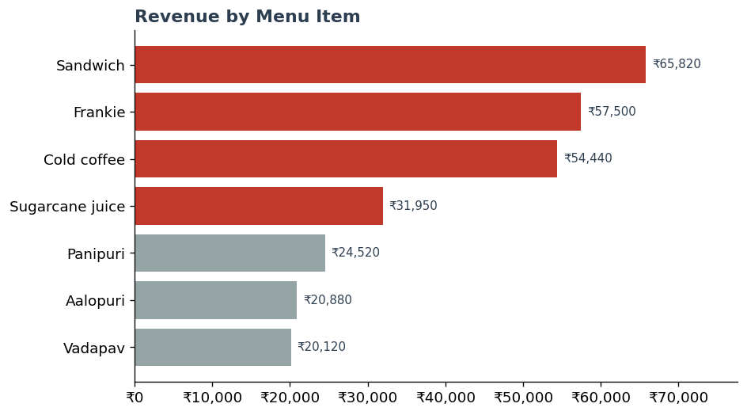
Sandwich (₹65,820), Frankie (₹57,500) and Cold coffee (₹54,440) are the three biggest earners and together account for more than half of all revenue. Vadapav and Aalopuri sit at the bottom of the range. For an owner, the practical takeaway is to protect the top three from ever running out, and to review whether the lowest sellers justify their prep and ingredient costs.

Question 2 — When do we sell?
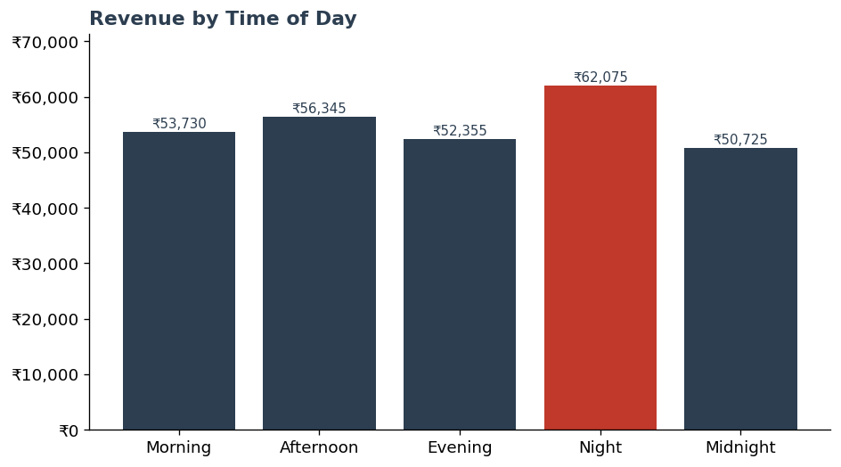
Night is the single strongest slot (₹62,075), but the striking finding is how even demand is: every part of the day — morning through midnight — pulls broadly similar revenue. There is no obvious "dead" shift to trim.
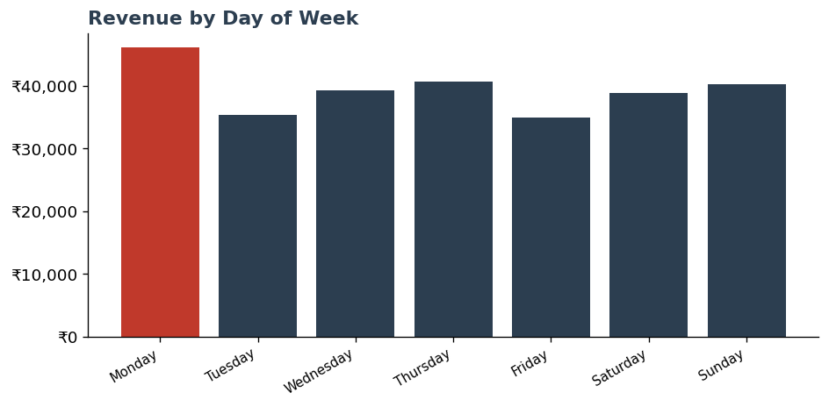
The pattern by day of week is similar. Monday leads, but the week is otherwise flat. Together these suggest staffing can stay steady rather than chasing sharp peaks.

Question 3 — How do customers pay?
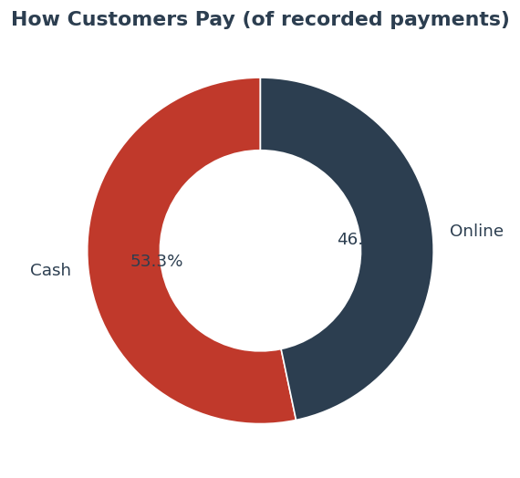
Among the orders where payment was recorded, the split is almost even: about 53% cash and 47% online. Cash still edges ahead, but digital is close behind, so both payment routes need to work smoothly. The 107 orders with no payment recorded are worth flagging — an 11% gap in a single field is the kind of small data-quality issue that quietly undermines reporting over time.

Question 4 — How is the business trending?
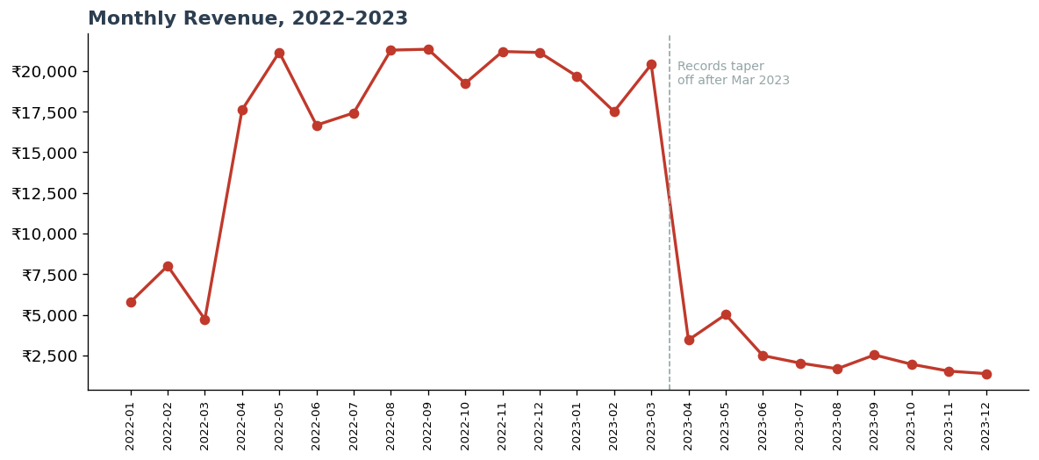
Through 2022 the stall was steady at roughly ₹20,000 per month. From April 2023 onward, recorded revenue falls off a cliff — down to under ₹2,000 in some months.
An honest reading matters here. It is unlikely that real sales dropped by ~90% overnight; the far more probable explanation is that order logging tapered off, so later months are undercounted. A responsible analysis reports this as a likely data-capture problem rather than presenting a dramatic decline as fact. The clear action item is to fix how sales are recorded so future periods can actually be measured.

Conclusion
For a stall owner, the story is encouraging and simple: a few star items carry the menu, business is steady across the whole day and week, and customers are comfortable paying either way. The biggest opportunity is not on the menu at all — it is tightening up how sales are recorded, so the numbers can be trusted going forward.
Scope note: this analysis covers what was recorded in the dataset and does not include costs, profit margins, or weather and local-event factors that would refine the picture in a real operation.

