CRISP-DM

KIDNEY_FAIL PROJECT

Business Understanding

Determining Business Objectives

Create an effective system to help the physicians of the nephrology department to identify patients that are more likely to suffer from kidney complications after a new treatment in the hospital.
- Predict if the patient will develop or not kidney complications after the treatment.
- Determine the most important variables that influence in having such complications.

Business Success Criteria
How we will assess if we have accomplished our goal or not.
- Provide valuable information to the physicians on predicting if a patient will suffer or not from kidney failure complications.
- Find the most important 5-10 variables of our prediction.

Assessing the Situation
- Resource inventory:
  - Data:
    - drugs.csv
    - kiney_fail_dataset_v2.csv

  - Tools:
    - R
    - SPSS Modeler
    - Any other free tool software for Data Analysis.

- Requirements:
  - Done by January 13th at 22:00. (Report, Deployment Manual, File used)

- Risks:
  - Scheduling: Due the load of assignments from different subjects could be possible to do not achieve the deadline.
  - Data: Could be impossible to achieve the results of accuracies wanted.

Determining Data Mining Goals
- Data Mining Goals:
  - Use both datasets to generate a classification model available to predict kidney failure.
  - Analysis of the relation between prediction variables and the target variables to provide most important ones.

- Determining Success Criteria:
  - Accuray >75% with the classification model on a Validation set.
  - Find between 5-10 variables which achieve +-5% of the accuracy than using the whole dataset.

Producing a Project Plan

Data Understanding

Data Preparation

Merging data sets and/or records
- Selecting a sample subset of data
- Aggregating records
- Deriving new attributes
- Sorting the data for modeling
- Removing or replacing blank or missing values
- Splitting into training and test data sets

Selecting Data
Selecting items (rows):
We decided to remove those patients of which we just have information of the height and the weight, since logically thinking, we do not reckon that is possible to give any insight about kidney failure with just these two measures.

Selecting attributes or characteristics (columns):
First of all we will rid off those variables that clearly do not give us any information such as the patient id.
We can advise that some variables are more important than others in different ways, for example with SPSS Modeler we can use the “Feature Selection Option”. This option ranks the importance of the variables in different manners depending its origin. Even though some variables are more important than others for the moment we will keep all of them.

Cleaning Data
Missing data. As we said before on the selection data chapter, we discard those rows with just values for height and weight.
After discarding those patients we have 836 patients remaining. Some of these patients, 164 concretely, do not have the feature “tflr” which we consider an important feature to predict kidney failure. For this reason we consider that a good practice that can increase the performance of our model could be to fill up the null “tlfr” values for some likely realistic values. We have considered different approaches to replace this null values but taking the mean is the one that worked the best for us.
A part from “tlfr” we still have some other features with 3 or 4 values missed so we can also replace these missing values for the mean of each attribute but we have done it and it really does not change anything since 4 patients of one feature represent less than 1% of the whole.

Data errors and measurement errors.
Here its kind of difficult to spot erros in the data since we do not have knowledge of the field and the majority of the fields we do not know what they mean. But it does not the case for the height and weight, creating a scatterplot of both variables we can spot if there is any outlier.
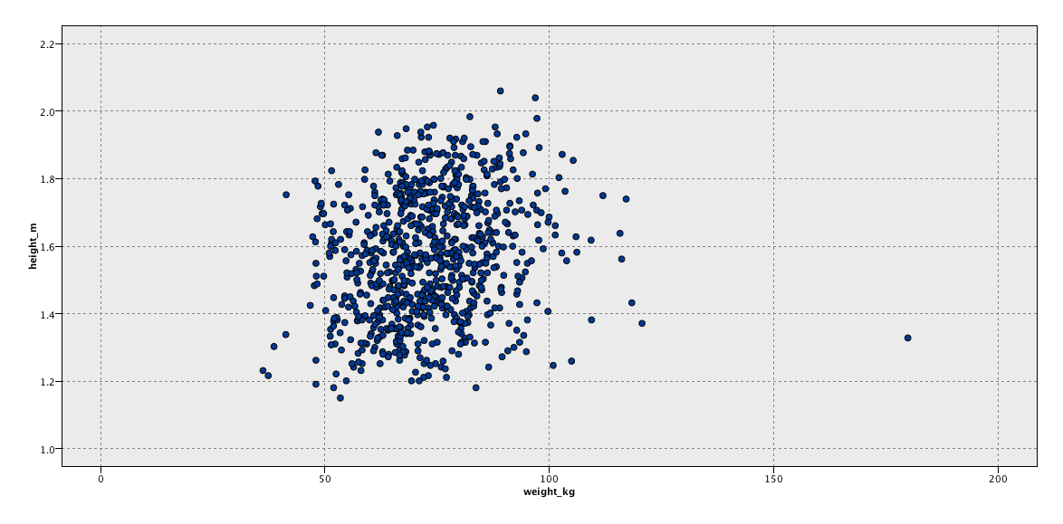

As we can see above there is one clear outlier, cause it almost impossible that someone less than 1,4 m has a weight of more than 179 kg. Rarely, when we nullify the value of the weight for this patient our model decreases in accuracy so for this reason we decided to keep this patient as it was in the dataset.

To spot more outliers we had to take a look at the distribution of the data separately and look for values that were far from the rest, and also, if a priori do we know any relationship between some of our attributes we could spot multidimensional outliers like the one we found before for the weight and height. As we said as we do not know the field at the beginning we are not going to consider any value as outlier, maybe at the end we will do it in case it increases models accuracy.

Constructing New Data
As we said previously, our major knowledge of the variables of the dataset is weight and height, so we can create a new categorical variables that takes into account the relationship between those two.
We create the variable BMI which is highly known. The calculation is the following:

Integrating Data
Explain integration with drugs

