01 Execution Evidence Report
Step-by-step build evidence, screenshots, validation, decisions, and ownership disclosure.
Repository | https://github.com/aalanani2000/al-rouf-ai-integration-assessment
Default branch | main
Latest commit | 653ec552871083dca14498d120d6e6c156ed4f31
Prepared date | 2026-06-24
Assessment | AI Integration Engineer task pack

Assessment Requirements Covered
- Runnable GitHub repository with setup documentation, task folders, screenshots, and report deliverables.
- RFQ to CRM automation using n8n as an equivalent orchestration approach.
- FastAPI quotation microservice with tests, Docker packaging, and OpenAPI documentation.
- Bilingual RAG workflow over sample English and Arabic documents with citations and refusal behavior.
- Explicit notes on error handling, maintainability, security hygiene, trade-offs, validation, and AI assistance.

Work Evidence By Task
Task | Implementation | Validation | Status
Task 1 | n8n RFQ webhook, OpenAI extraction, mock CRM, bilingual reply, alert log. | Successful n8n executions, persisted JSON records, screenshot evidence. | Complete; attachment bytes scoped as future enhancement.
Task 2 | FastAPI quotation API with catalog, pricing tiers, SQLite, Docker, OpenAPI. | Automated pytest suite and OpenAPI screenshot evidence. | Complete.
Task 3 | FastAPI bilingual RAG service over English/Arabic documents with citations and refusal. | Unit tests, integration test path, Arabic question evidence, error-handling screenshot. | Complete.

Task 1 Evidence: RFQ To CRM Automation
- Created a Docker-based n8n environment with a named n8n data volume and a bind-mounted local data folder.
- Built a webhook intake endpoint for RFQ-style JSON payloads.
- Configured an OpenAI node to extract urgency, key requirements, and a concise summary from unstructured RFQ text.
- Merged structured webhook fields with extracted intent and generated CRM metadata.
- Persisted records into a mock CRM JSON file and wrote sales alerts with bilingual reply drafts.
- Debugged n8n sandbox limitations, missing-file behavior, and node-reference mismatches during testing.
- Key trade-off: webhook simulation was used instead of email/IMAP to keep the workflow reproducible without OAuth setup.
- Key limitation: attachment filenames are captured as metadata; real file-byte archiving is documented as a production enhancement.
- Validation: multiple full workflow executions produced successful CRM and alert outputs.
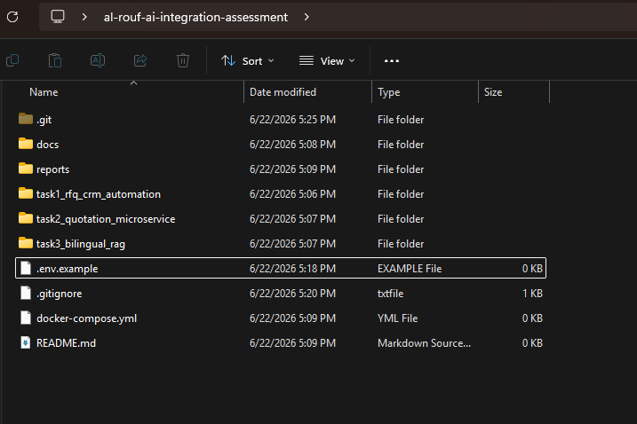
Task 1 evidence: repository structure.png
Task 1 evidence: proof of the volumes being correctly attached.png
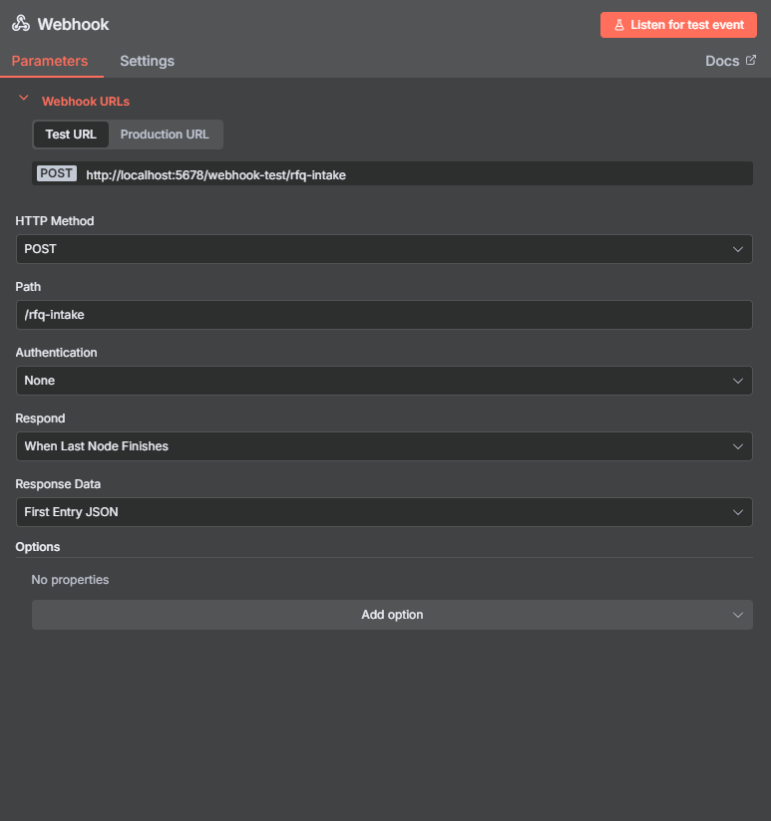
Task 1 evidence: Webhook node.png
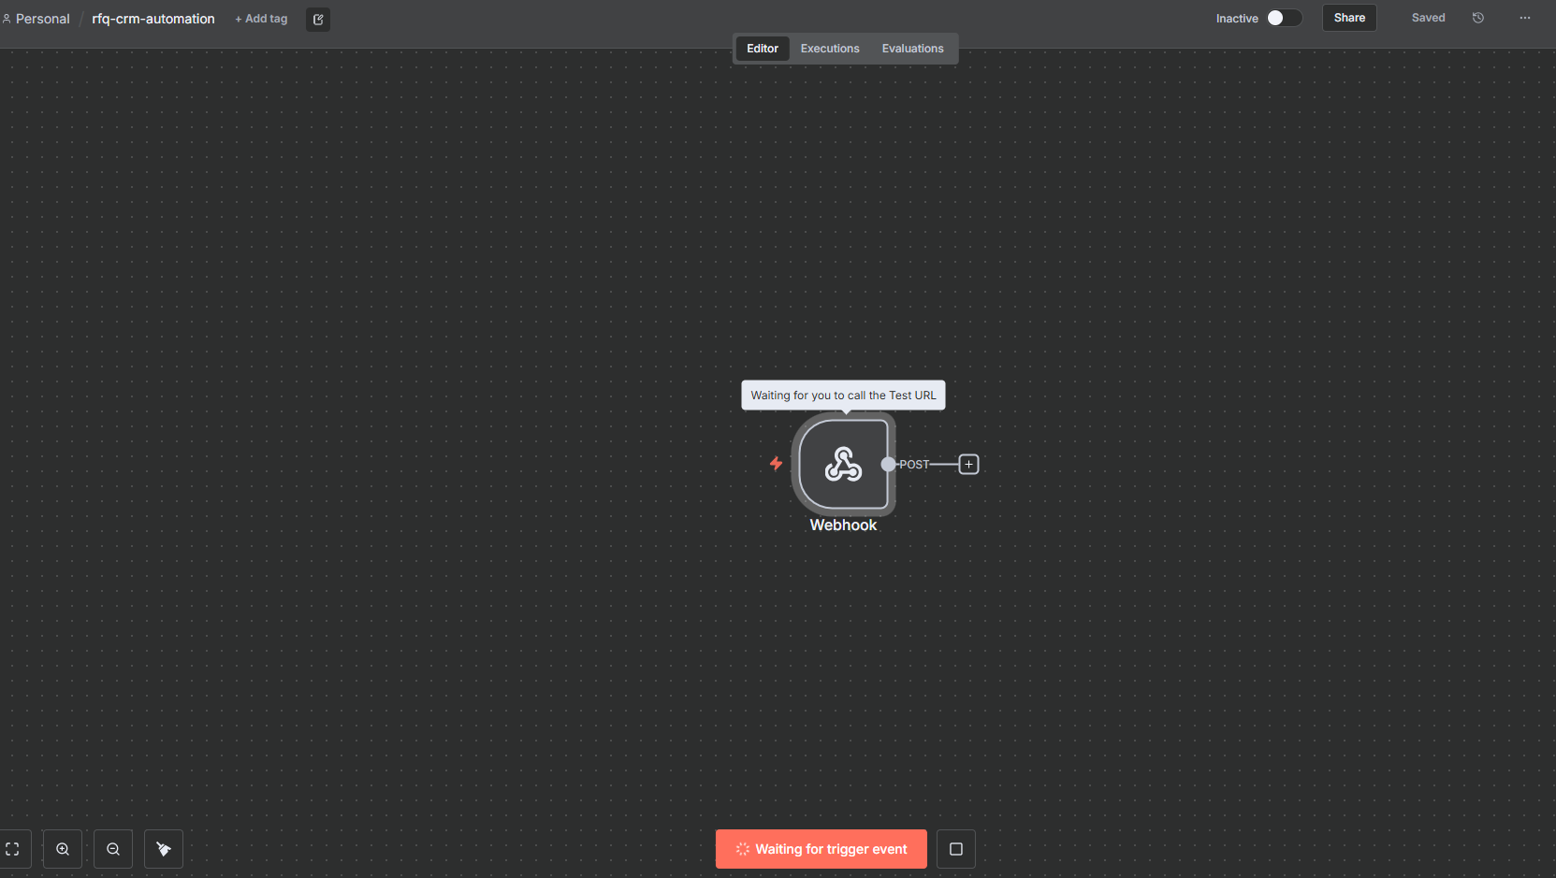
Task 1 evidence: n8n canva.png
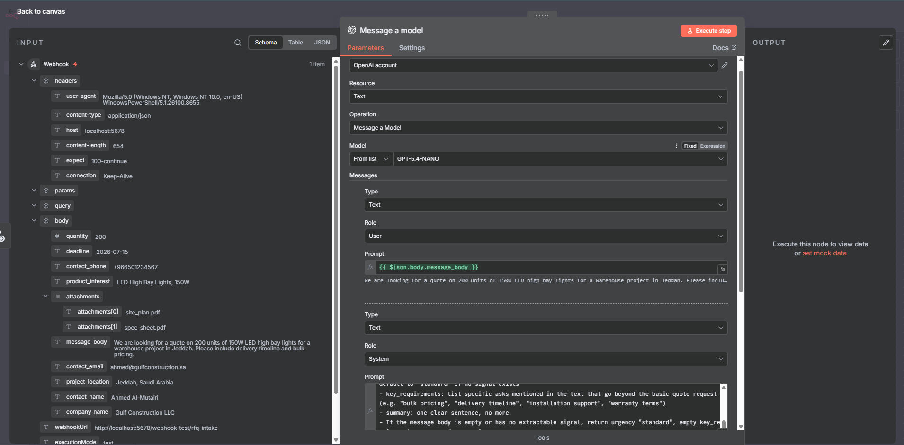
Task 1 evidence: open ai node.png
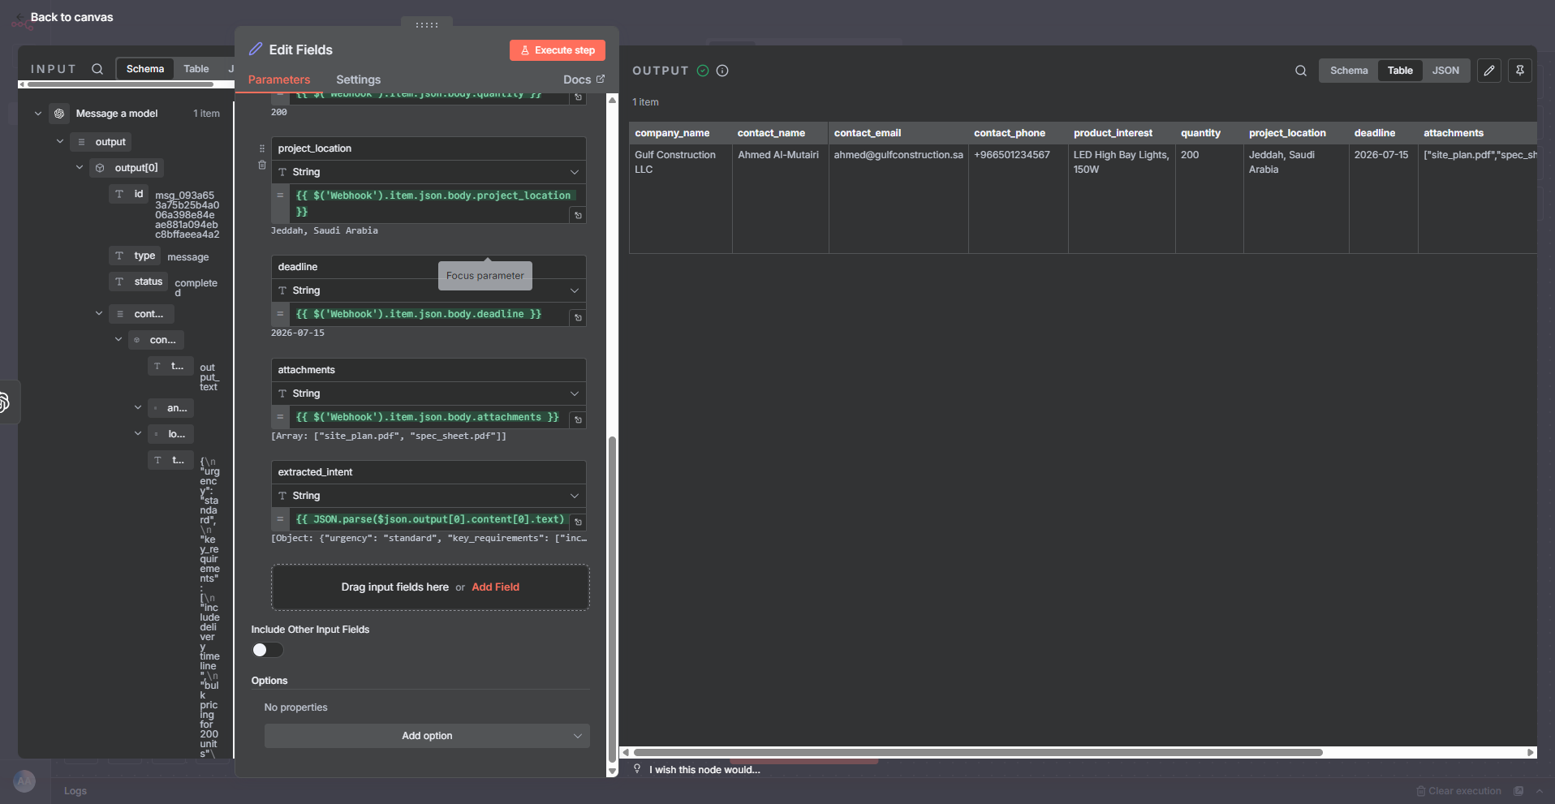
Task 1 evidence: set field.png
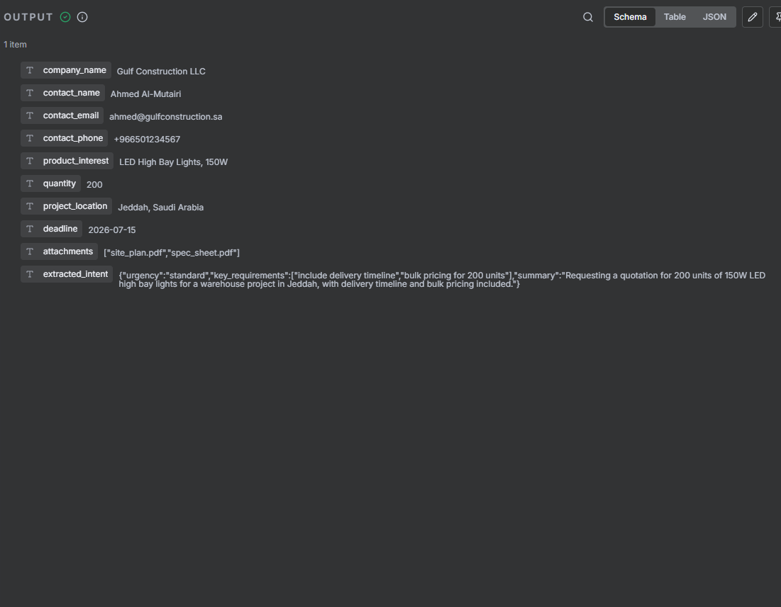
Task 1 evidence: set field output.png
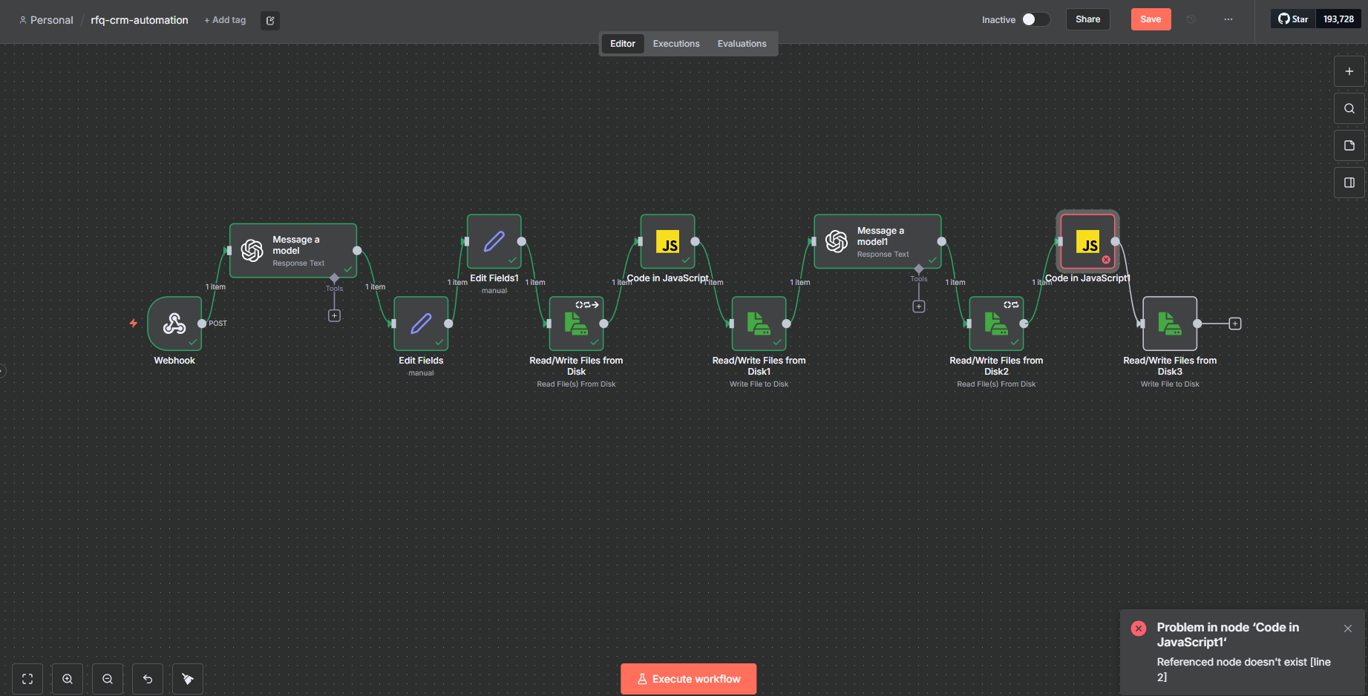
Task 1 evidence: javascript code 1 error .png
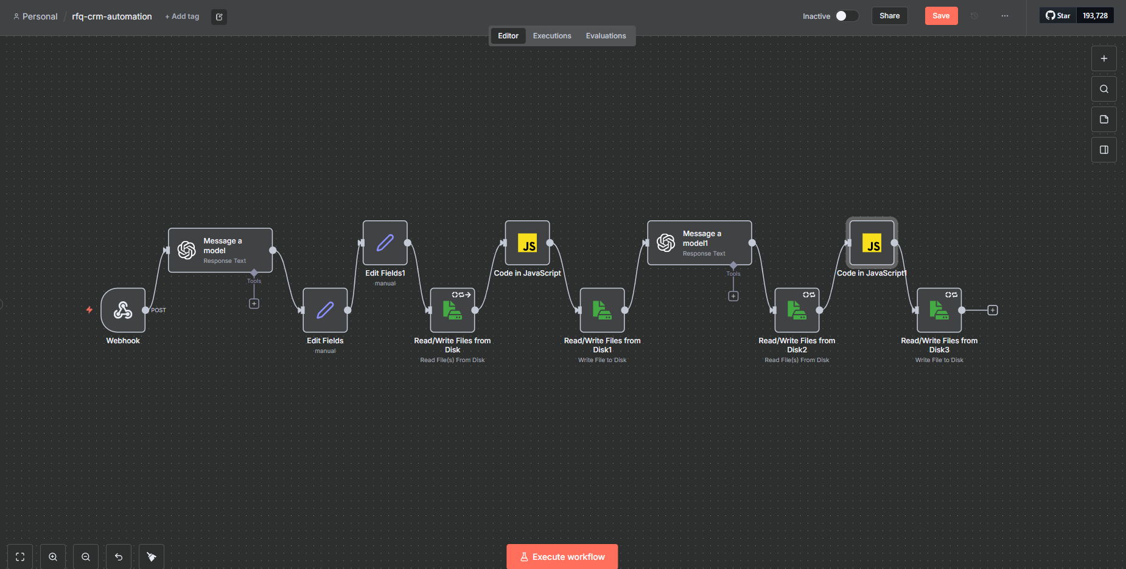
Task 1 evidence: workflow progress .png
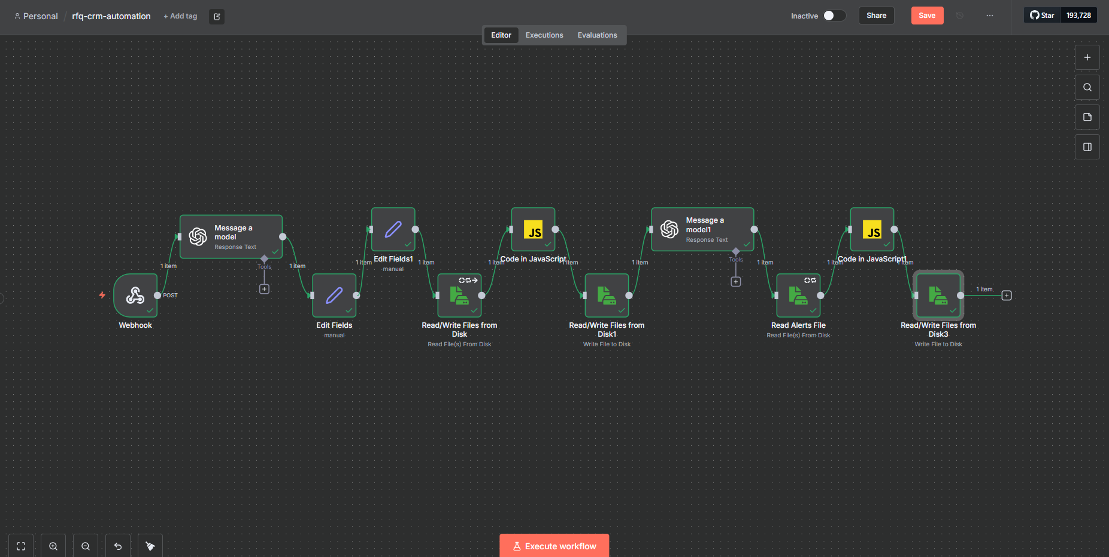
Task 1 evidence: workflow progress 1 .png
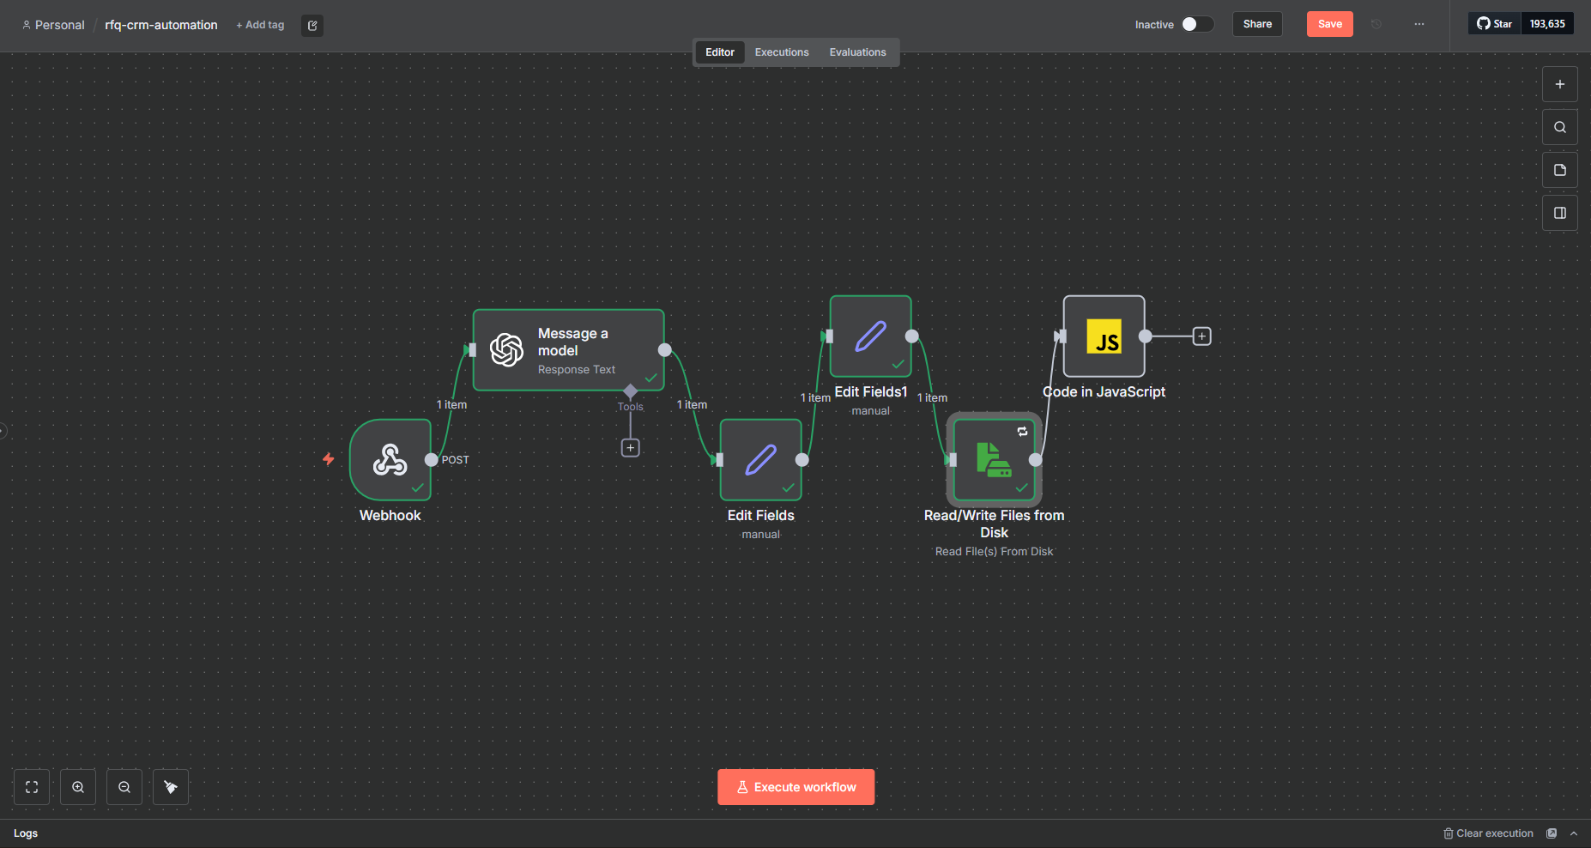
Task 1 evidence: workflow.png
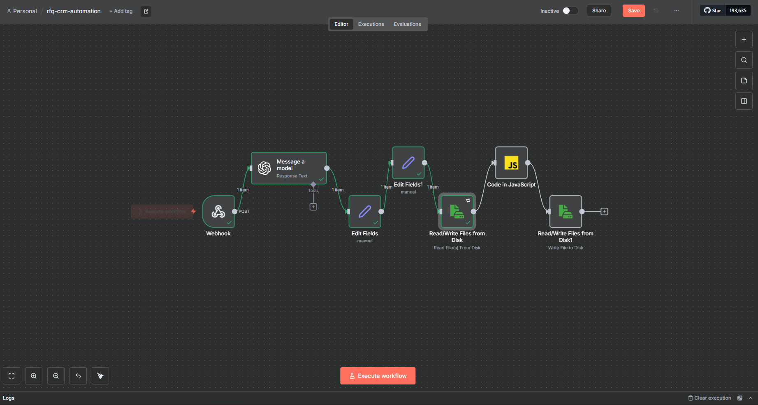
Task 1 evidence: workflow2.png
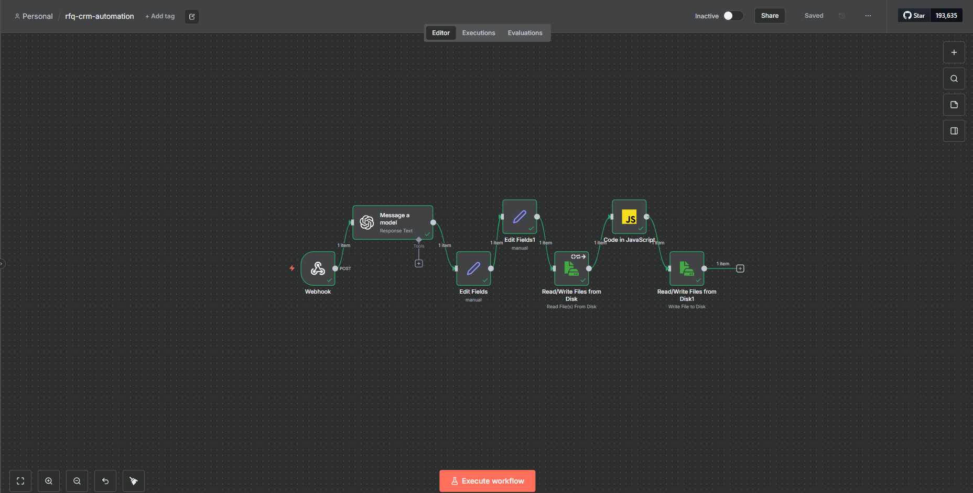
Task 1 evidence: workflow succes.png

Task 2 Evidence: Quotation Microservice
- Built a FastAPI service with `/health`, `/catalog`, `POST /quote`, and `GET /quote/{quote_id}` endpoints.
- Implemented product catalog and bulk-discount pricing logic with offline-friendly mocked data.
- Persisted quotes in SQLite and packaged the service with Docker.
- Added automated tests for health, catalog, quote creation, discount tiers, validation failures, and quote retrieval.
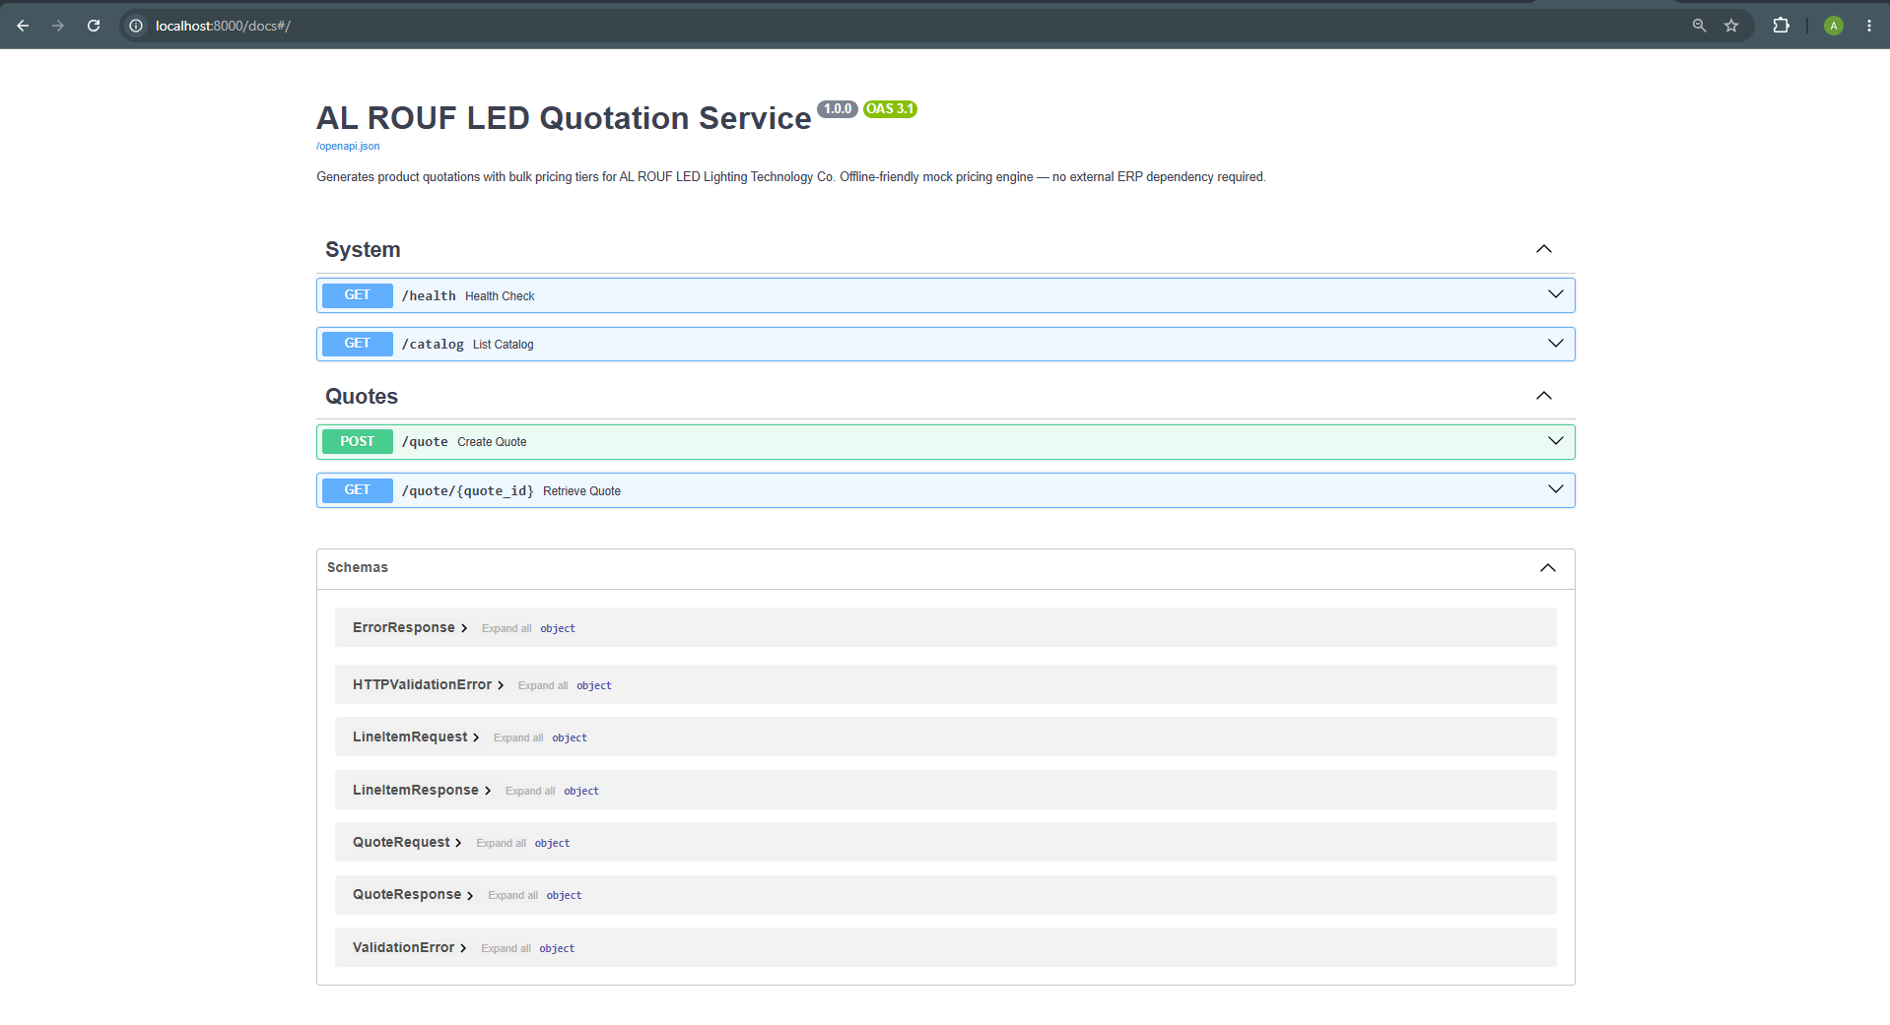
Task 2 evidence: OpenAPI documentation page.

Task 3 Evidence: Bilingual RAG Knowledge Workflow
- Built a FastAPI service that loads 4 sample documents in English and Arabic.
- Embedded document chunks with OpenAI embeddings and cached them locally.
- Retrieved relevant chunks using cosine similarity and refused out-of-scope questions before generation.
- Returned same-language answers with citations, latency, and estimated cost fields.
- Tested Arabic handling, retrieval behavior, refusal logic, and optional OpenAI-backed integration paths.
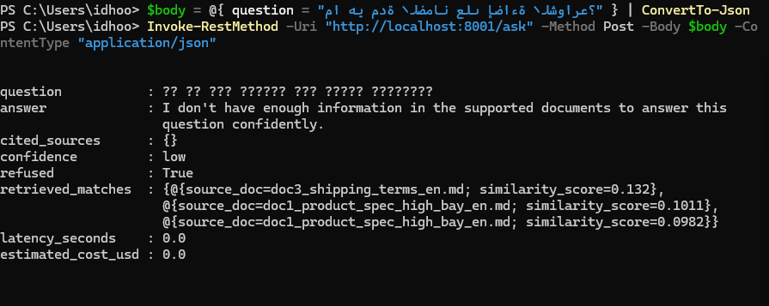
Task 3 evidence: model communication issue captured during testing.
Additional Task 3 evidence is stored at docs/screenshots/Task 3/testing the RAG on arabic question.pdf.

Validation Summary
- Task 1 was validated through end-to-end n8n executions and persisted mock output files.
- Task 2 includes a pytest suite documented in its README; OpenAPI evidence confirms the interactive API surface.
- Task 3 includes offline tests for document loading, chunking, search, and refusal behavior, plus integration tests gated by `OPENAI_API_KEY`.
- Docker packaging is included for all runtime services that require containers.

Ownership And AI Assistance Disclosure
AI assistance was used as a technical mentor and documentation partner for architecture discussion, starter logic, debugging support, and final writing polish. The candidate personally completed the hands-on implementation work: n8n node setup, Docker execution, API implementation, test execution, screenshot collection, environment configuration, validation, and final engineering decisions.

