OPEN BLENDER ( Minimum version 2.75)
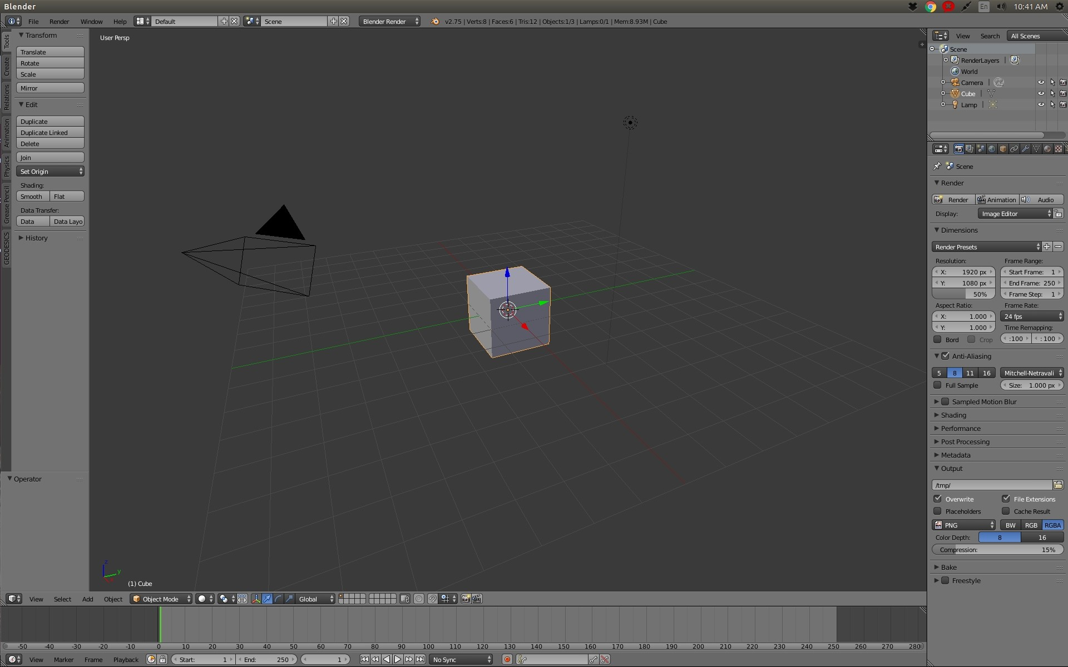

Open User preferences
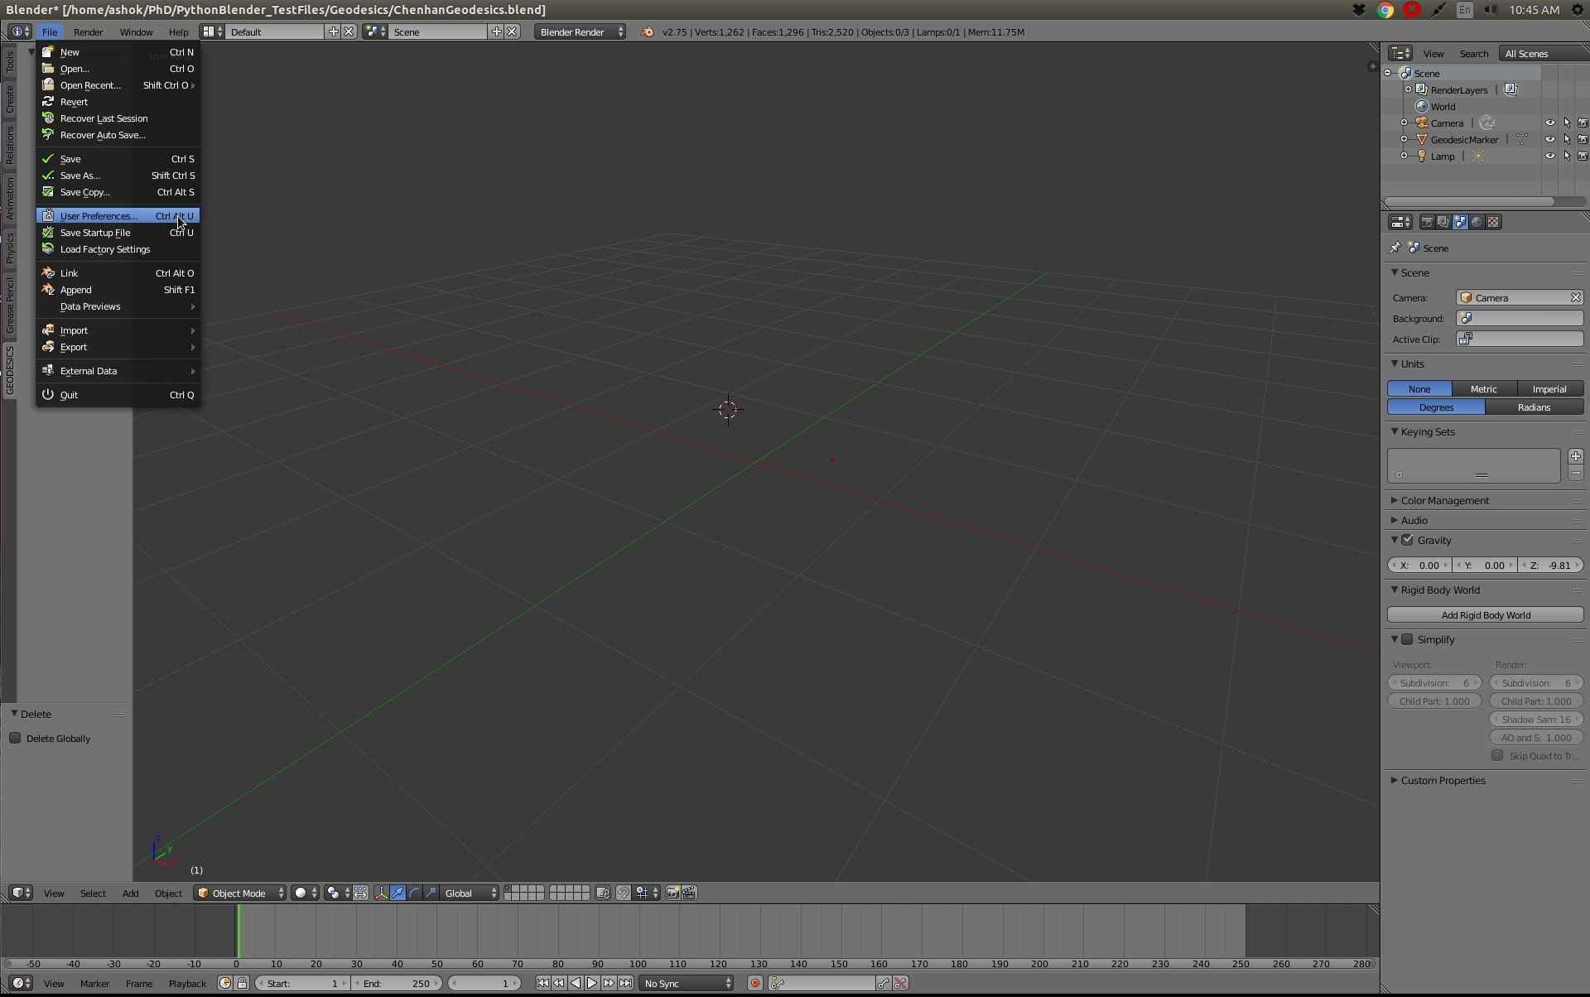

Click Install From File
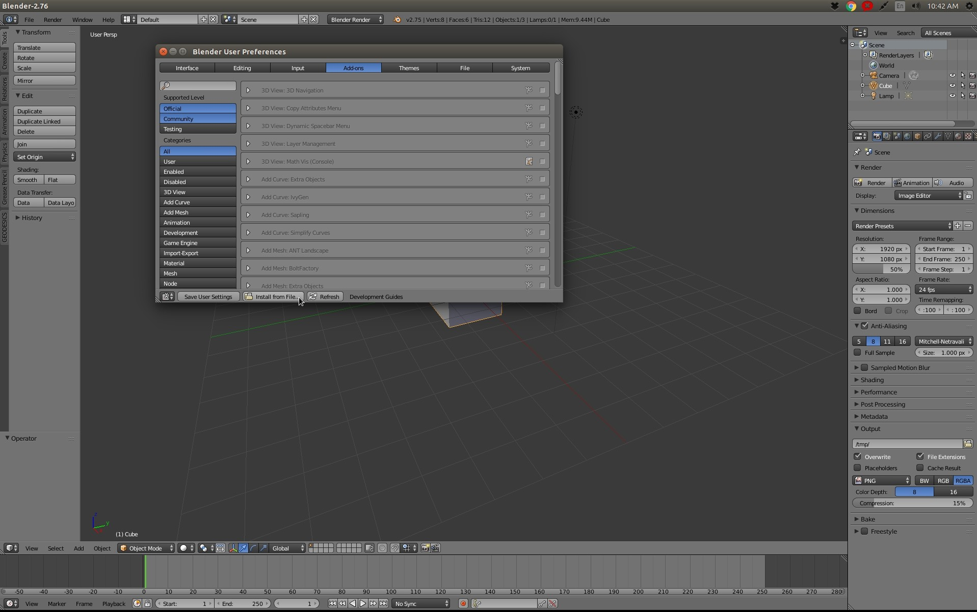

Select the zip file from the location where it was downloaded to
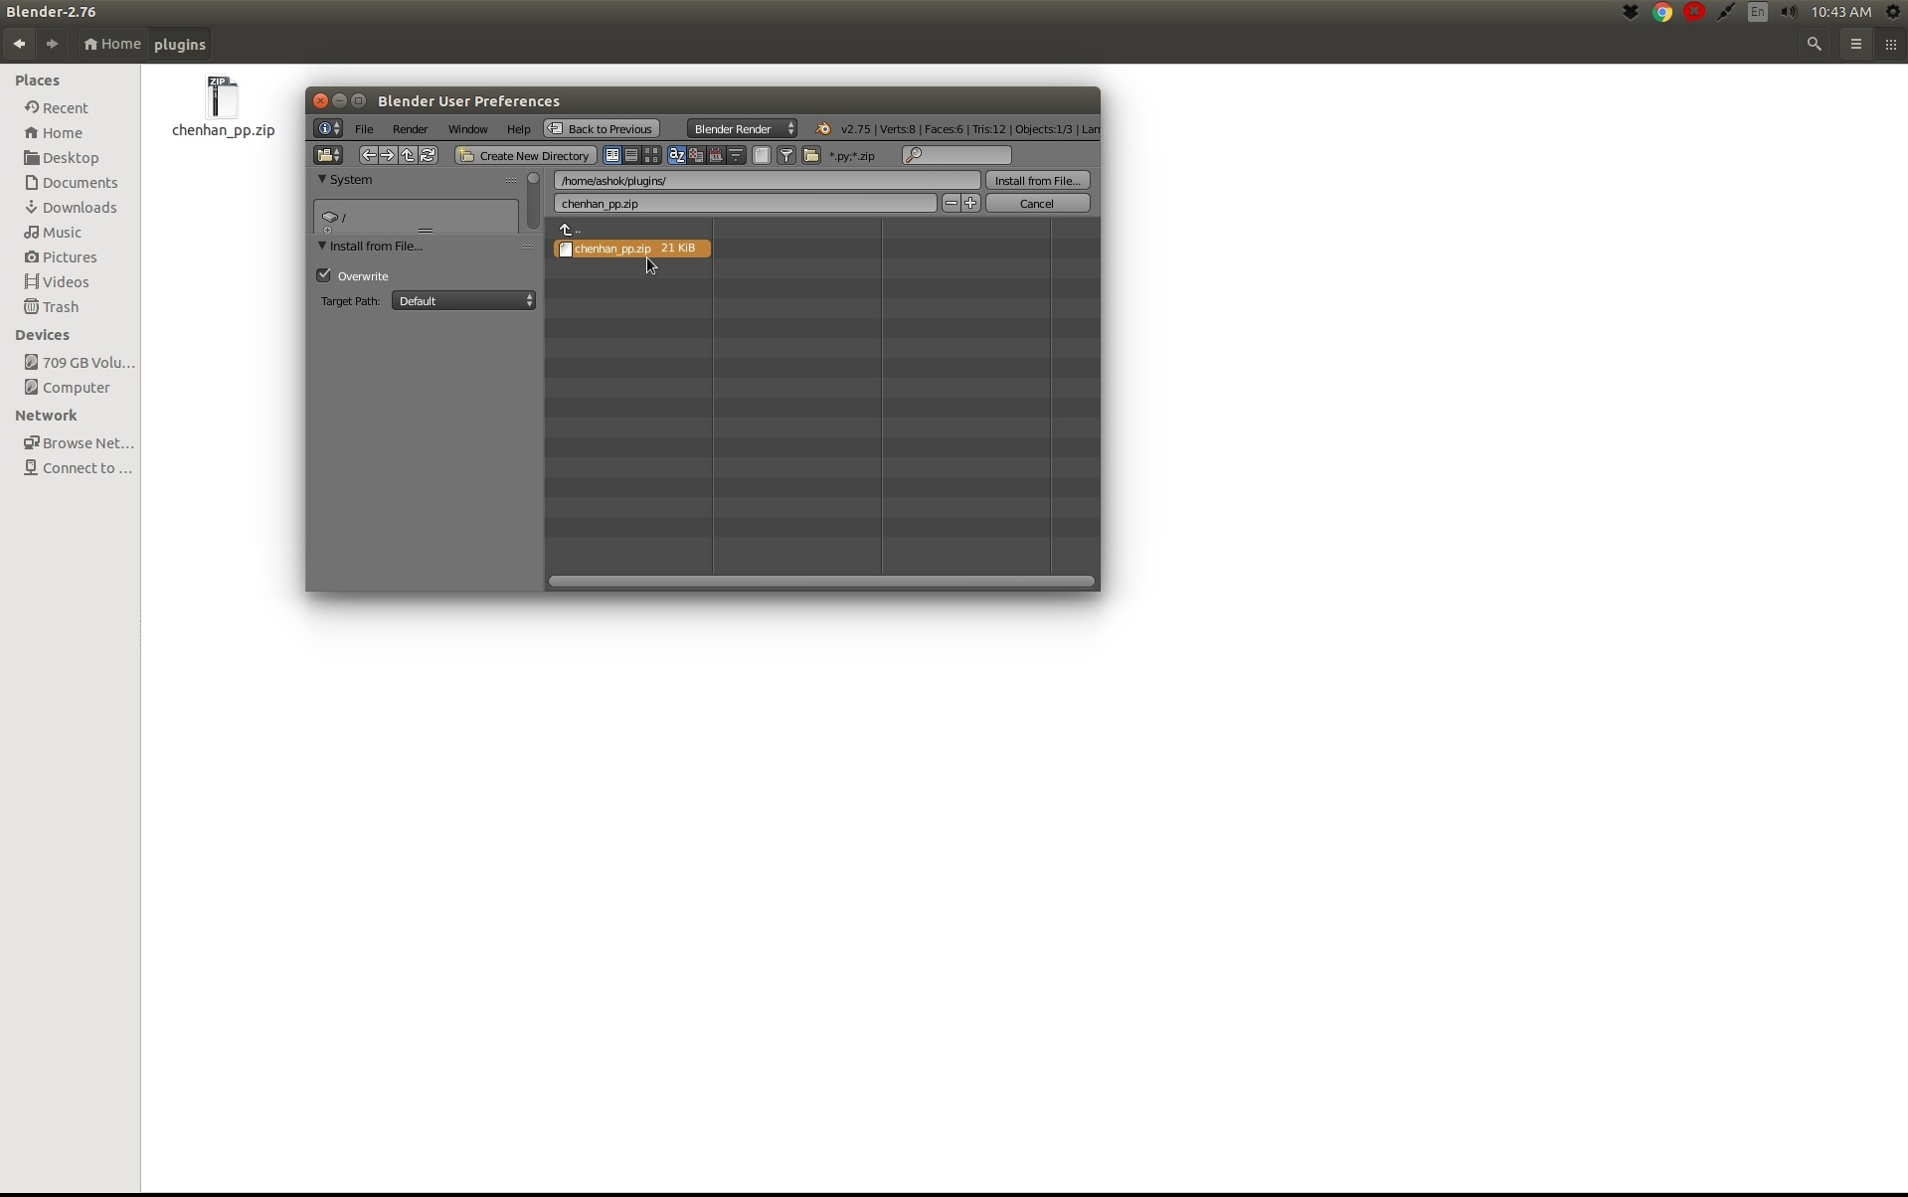

Select the file and click Install from File button
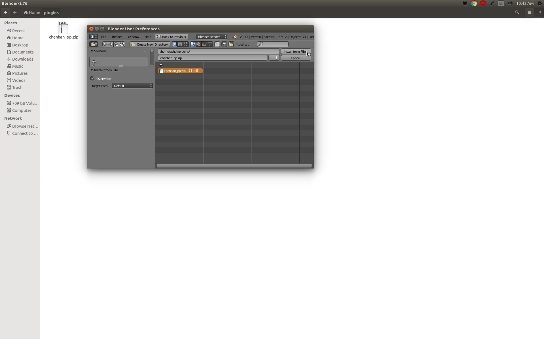

Save the User settings
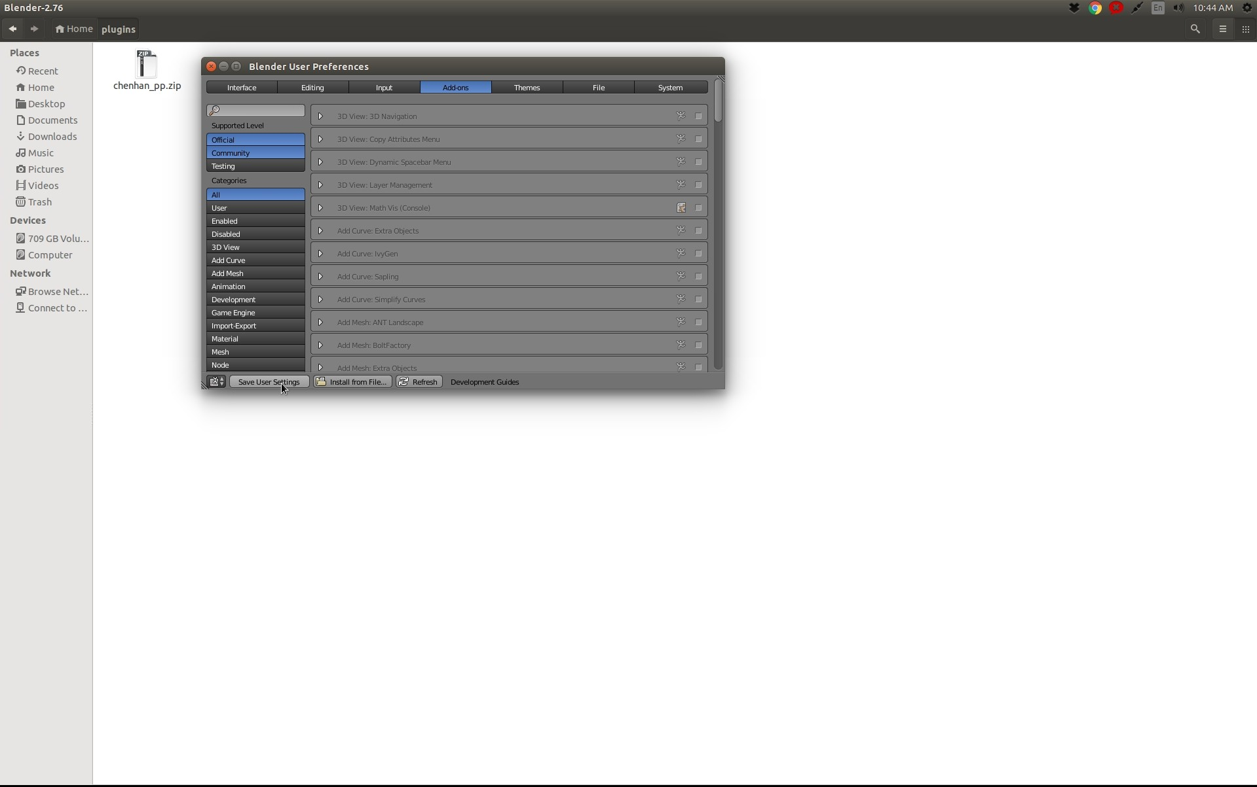

Click the User tab, and enable the plugin
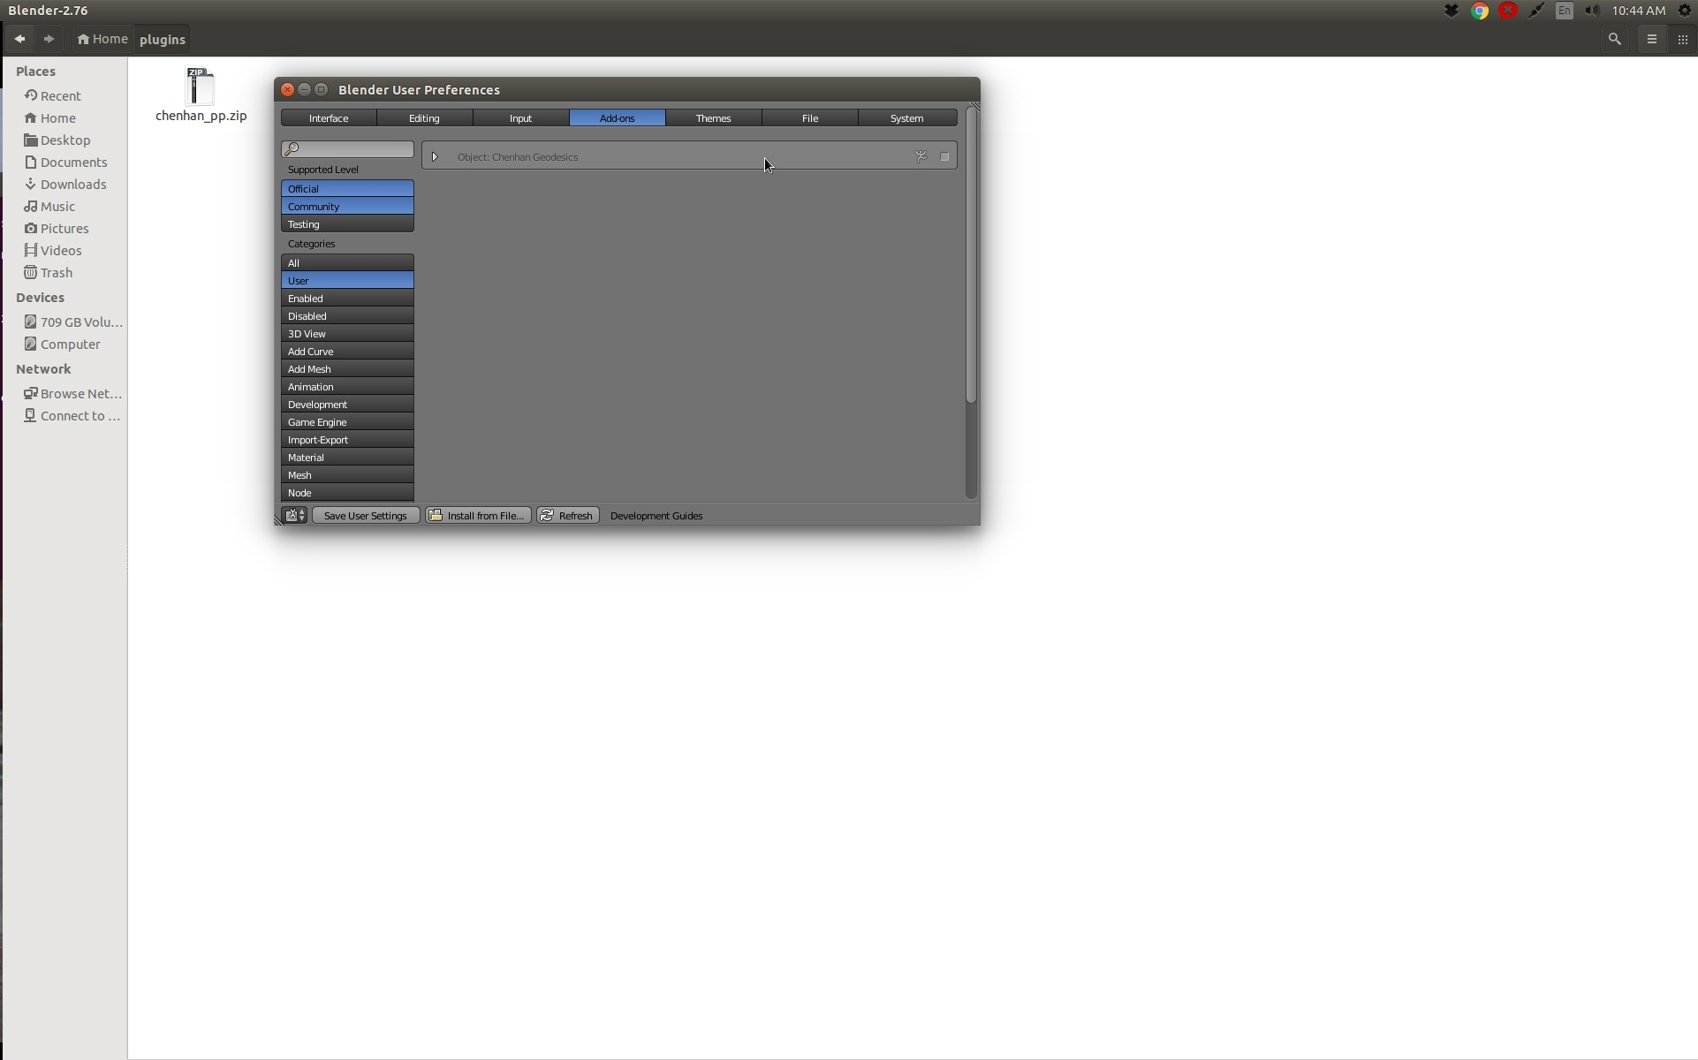

Enabling can be done by clicking the checkbox next to the plugin
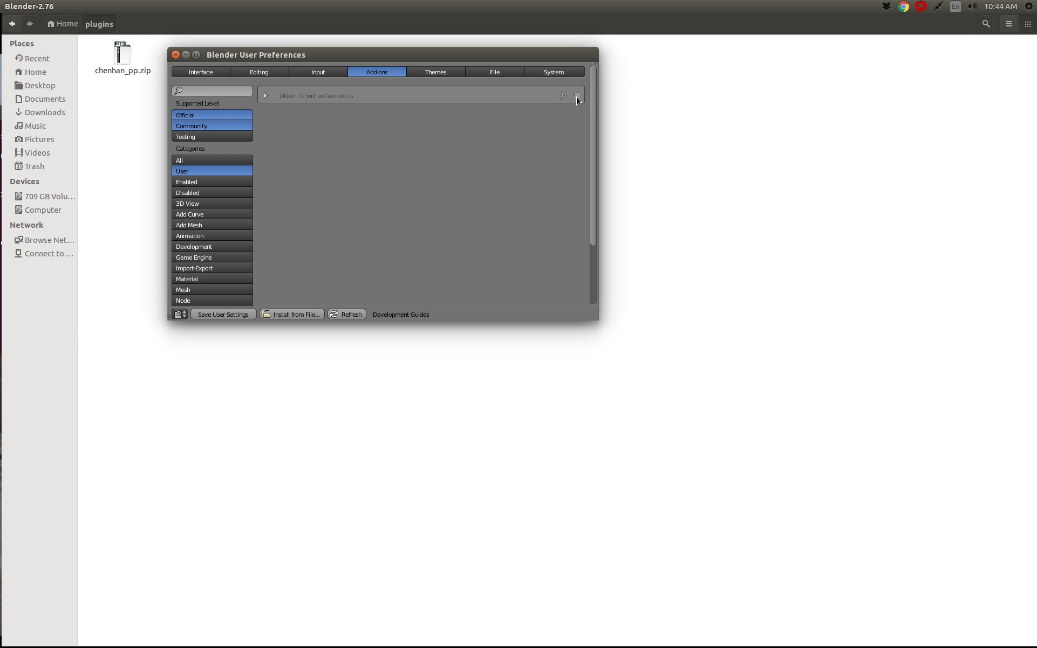

You will see the plugin now enabled
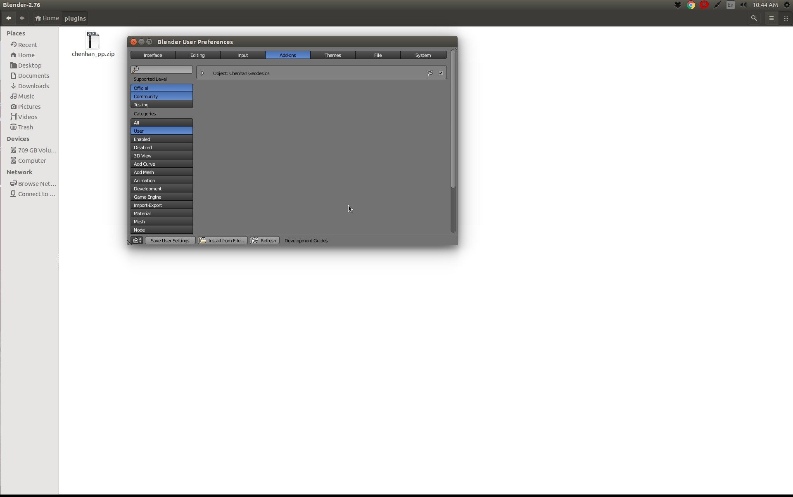

Save User settings again
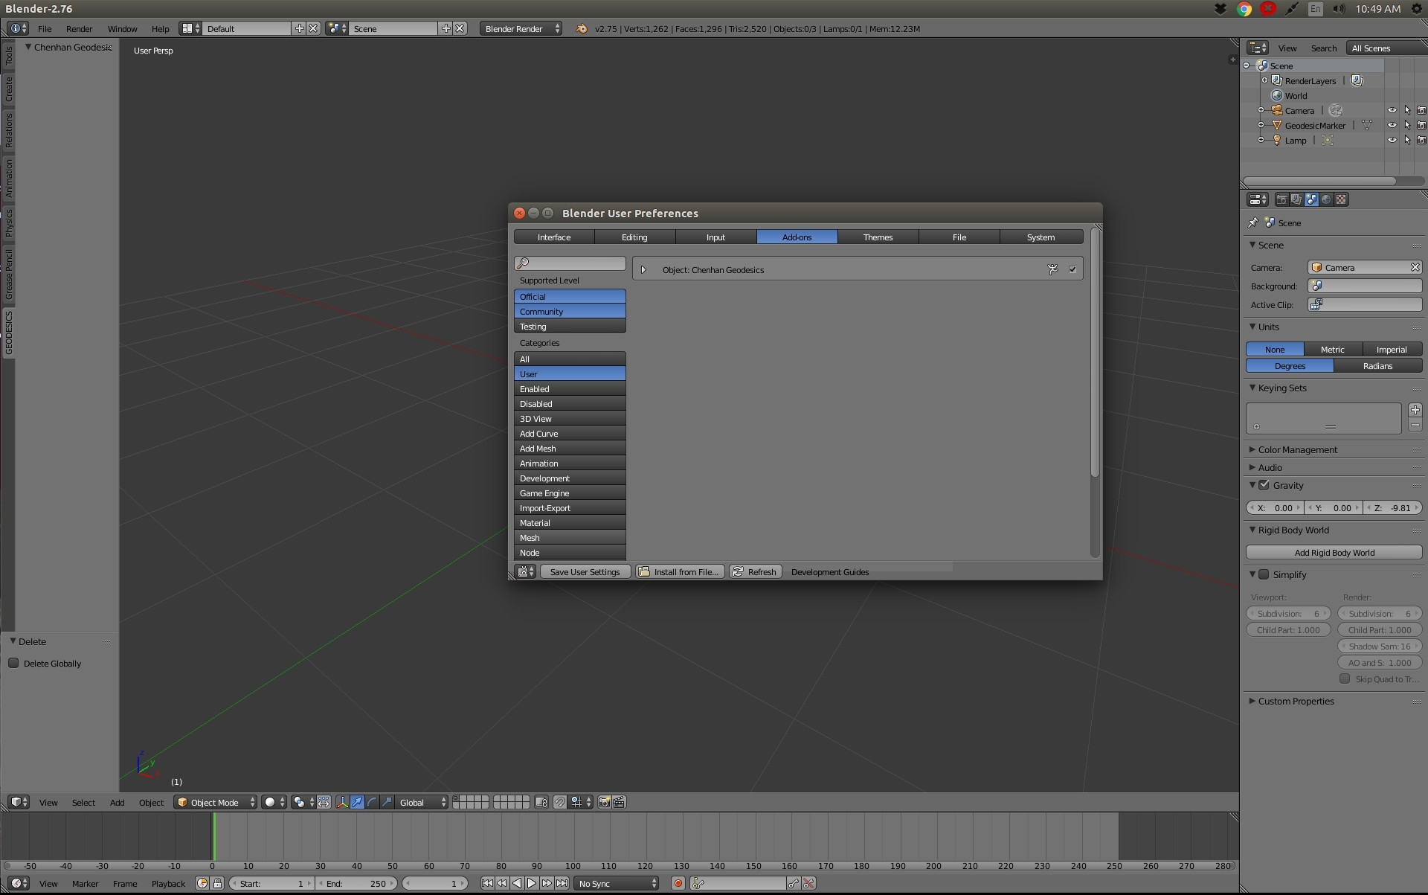

Close the User settings window
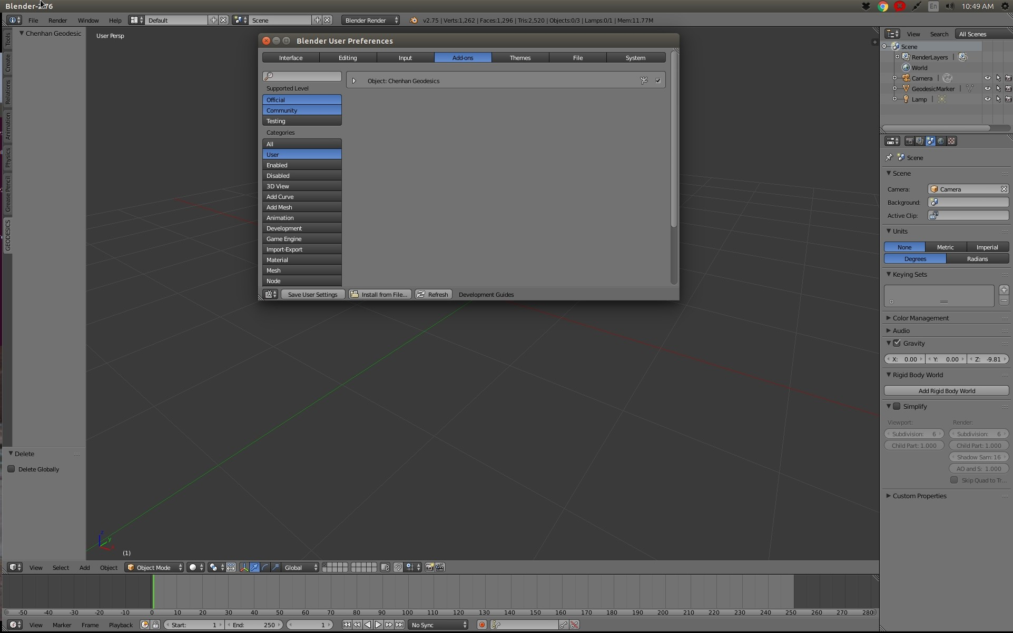

Now add an UV sphere to the blender scene
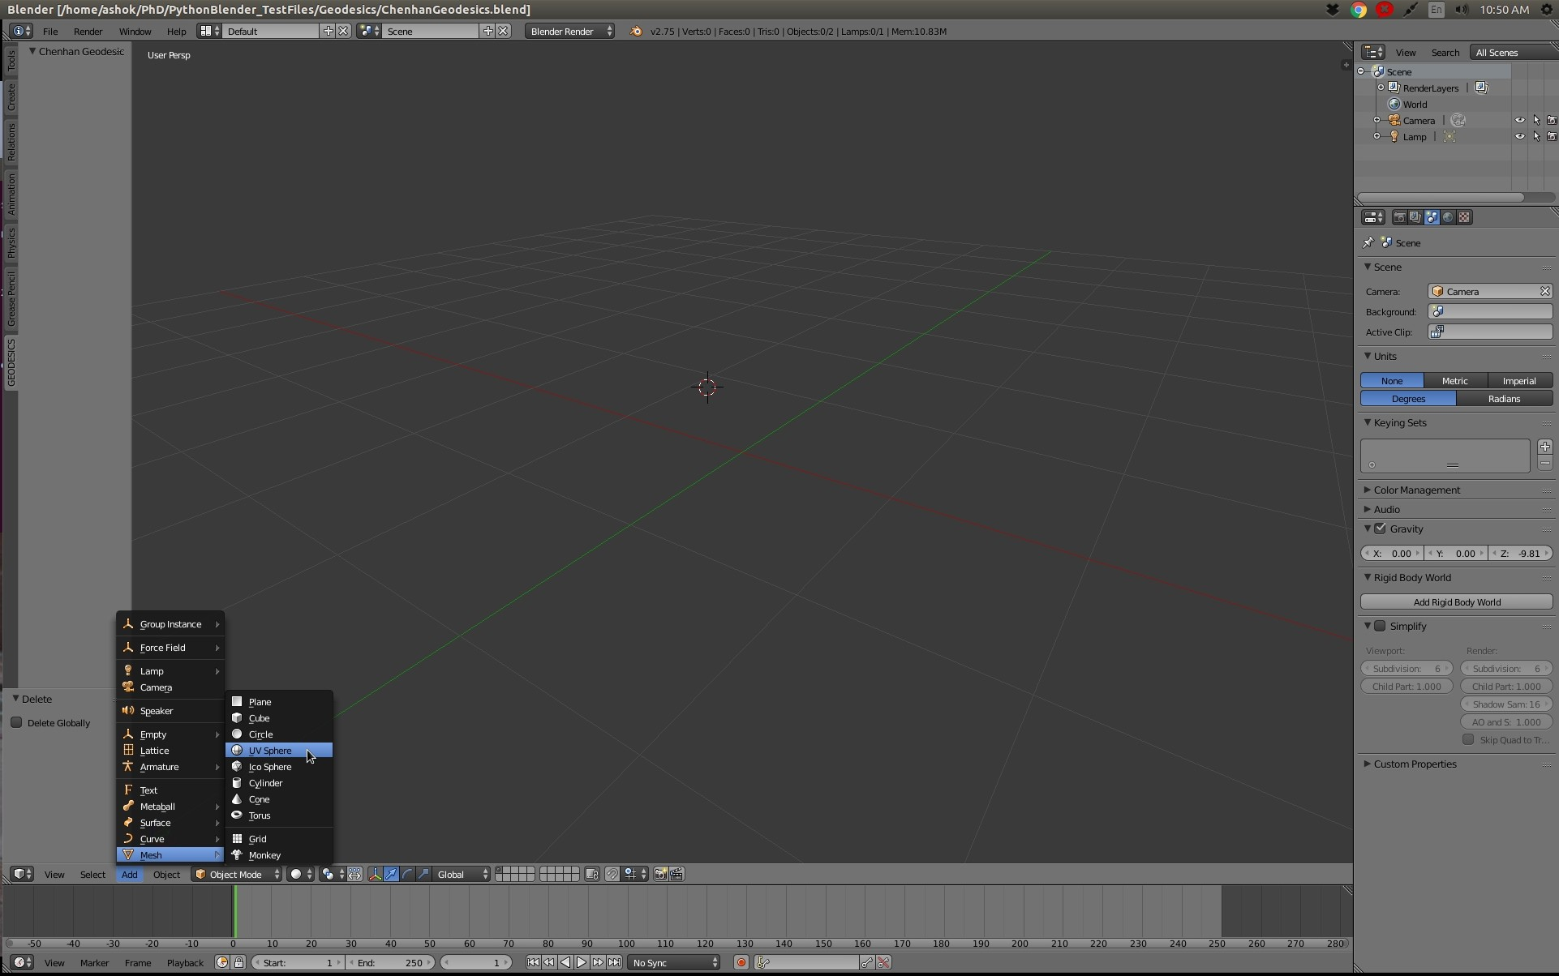

You will see that a sphere is added, but wait it still is in QUAD mode
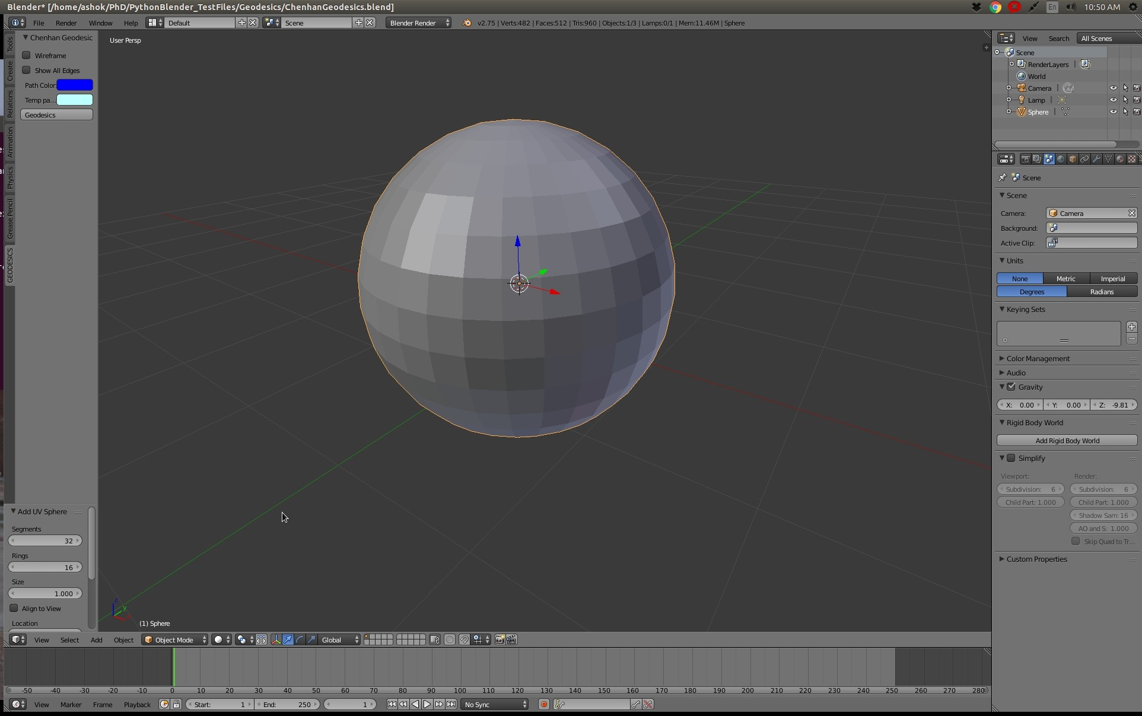

Though Chenhan-Shiqing works in QUAD too, it is much good to see in Triangulated ones

Click the Modifiers tab to triangulate the Sphere
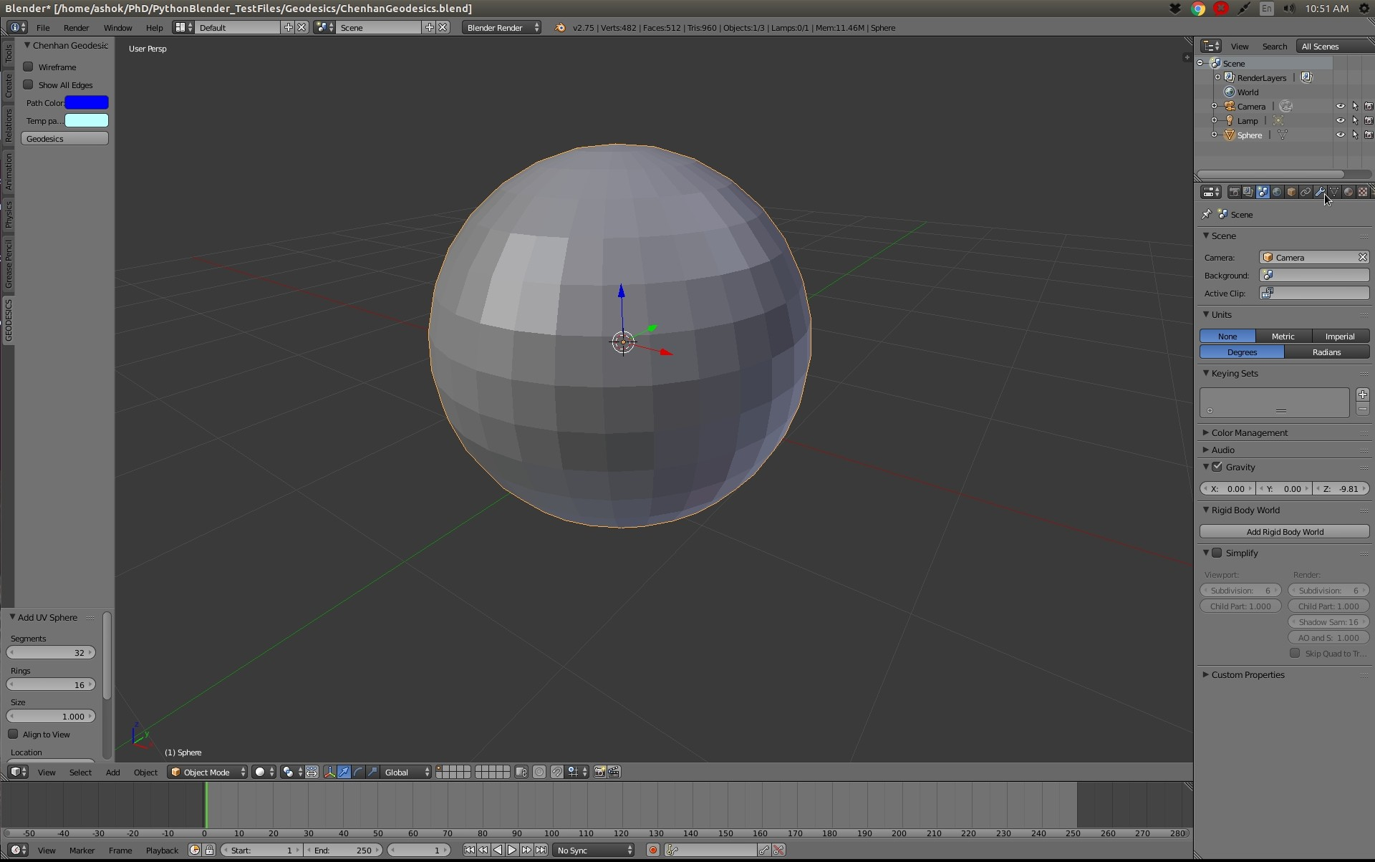

Add the Triangulate Modifier, and select the Triangulate option

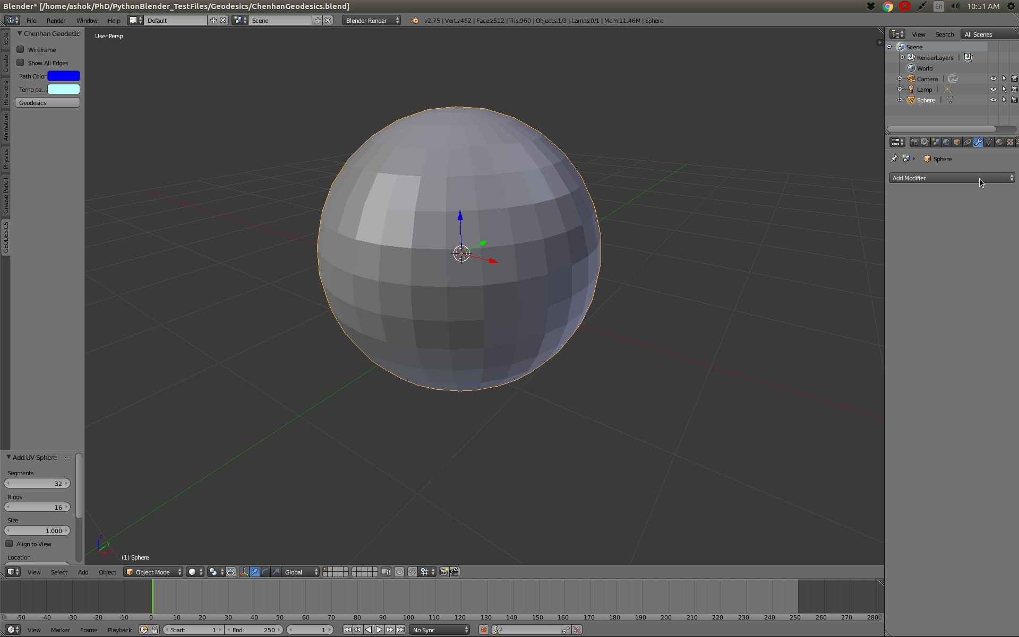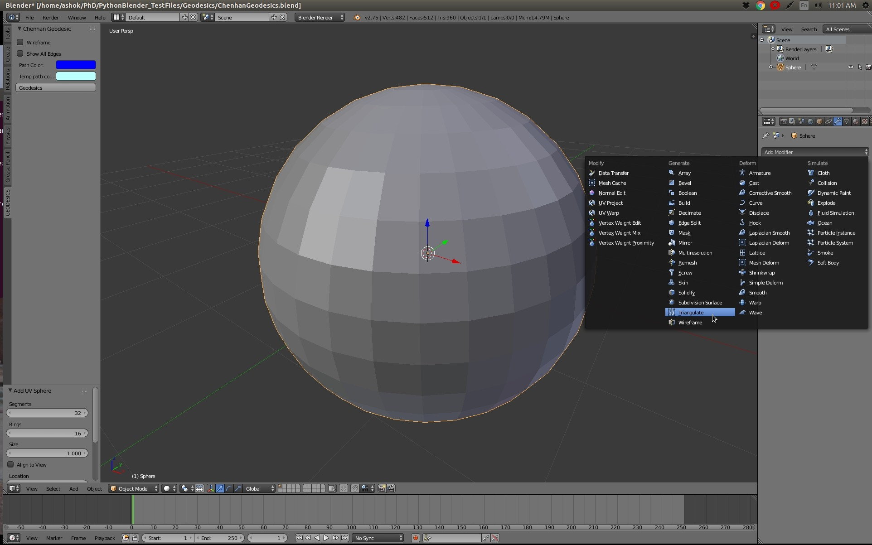

Now its time to apply that Modifier
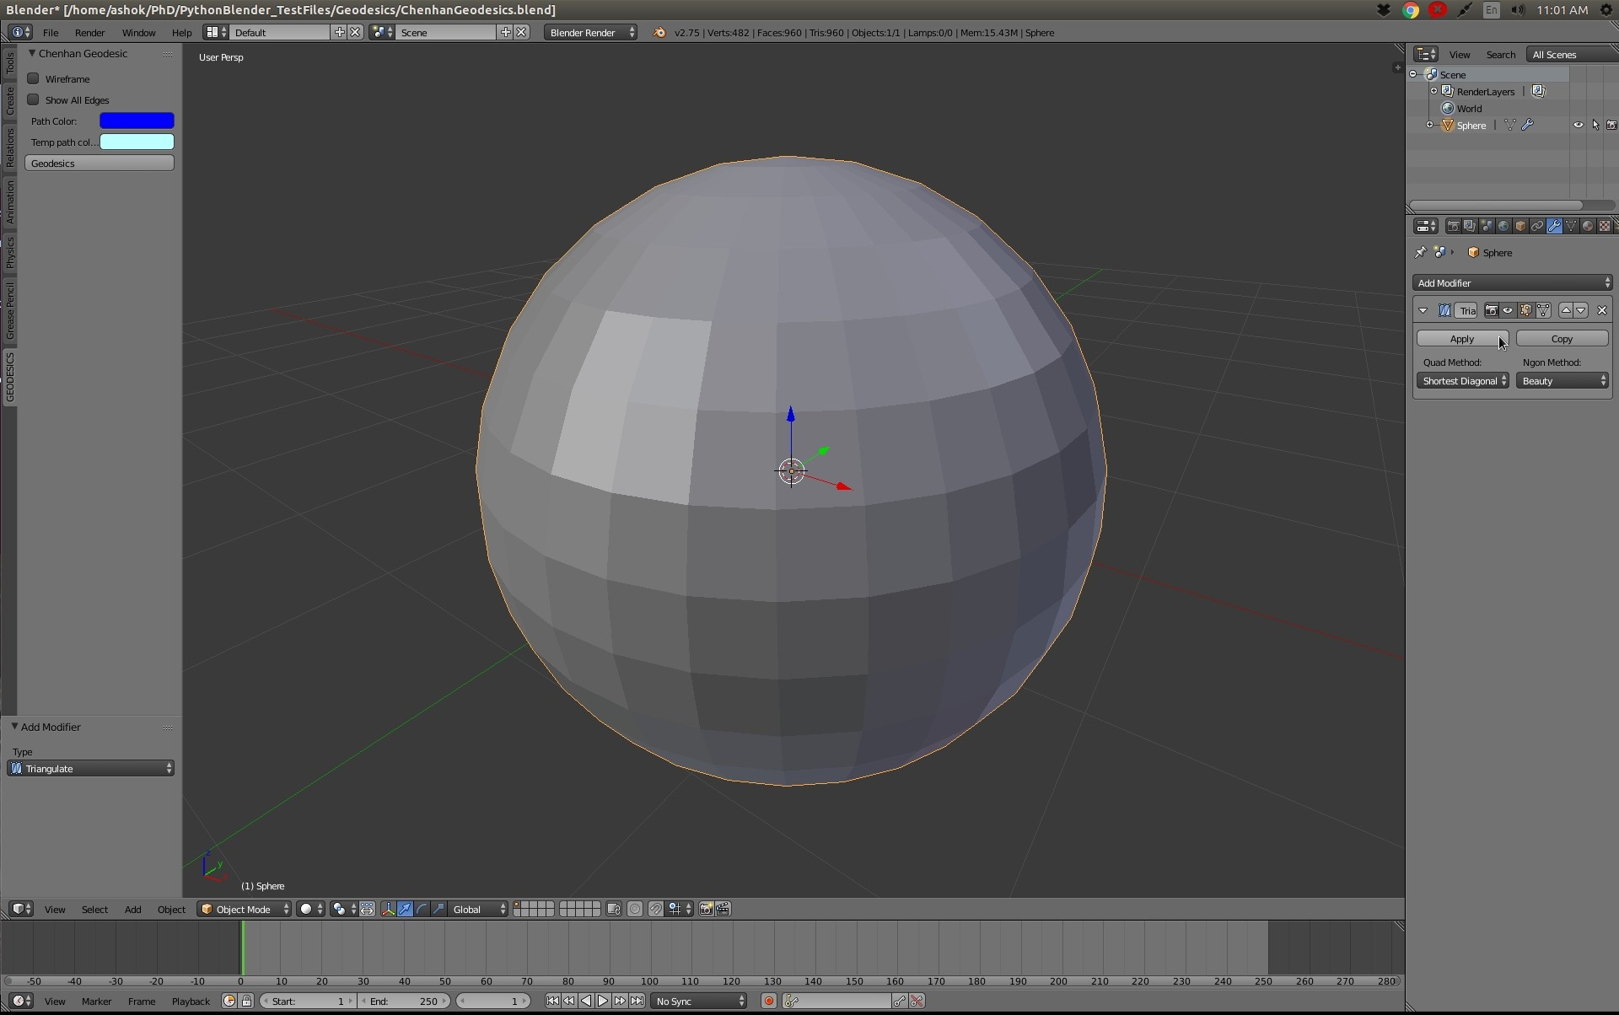

Let us now test the Geodesic paths, Select the Geodesic tab on the screen as shown,
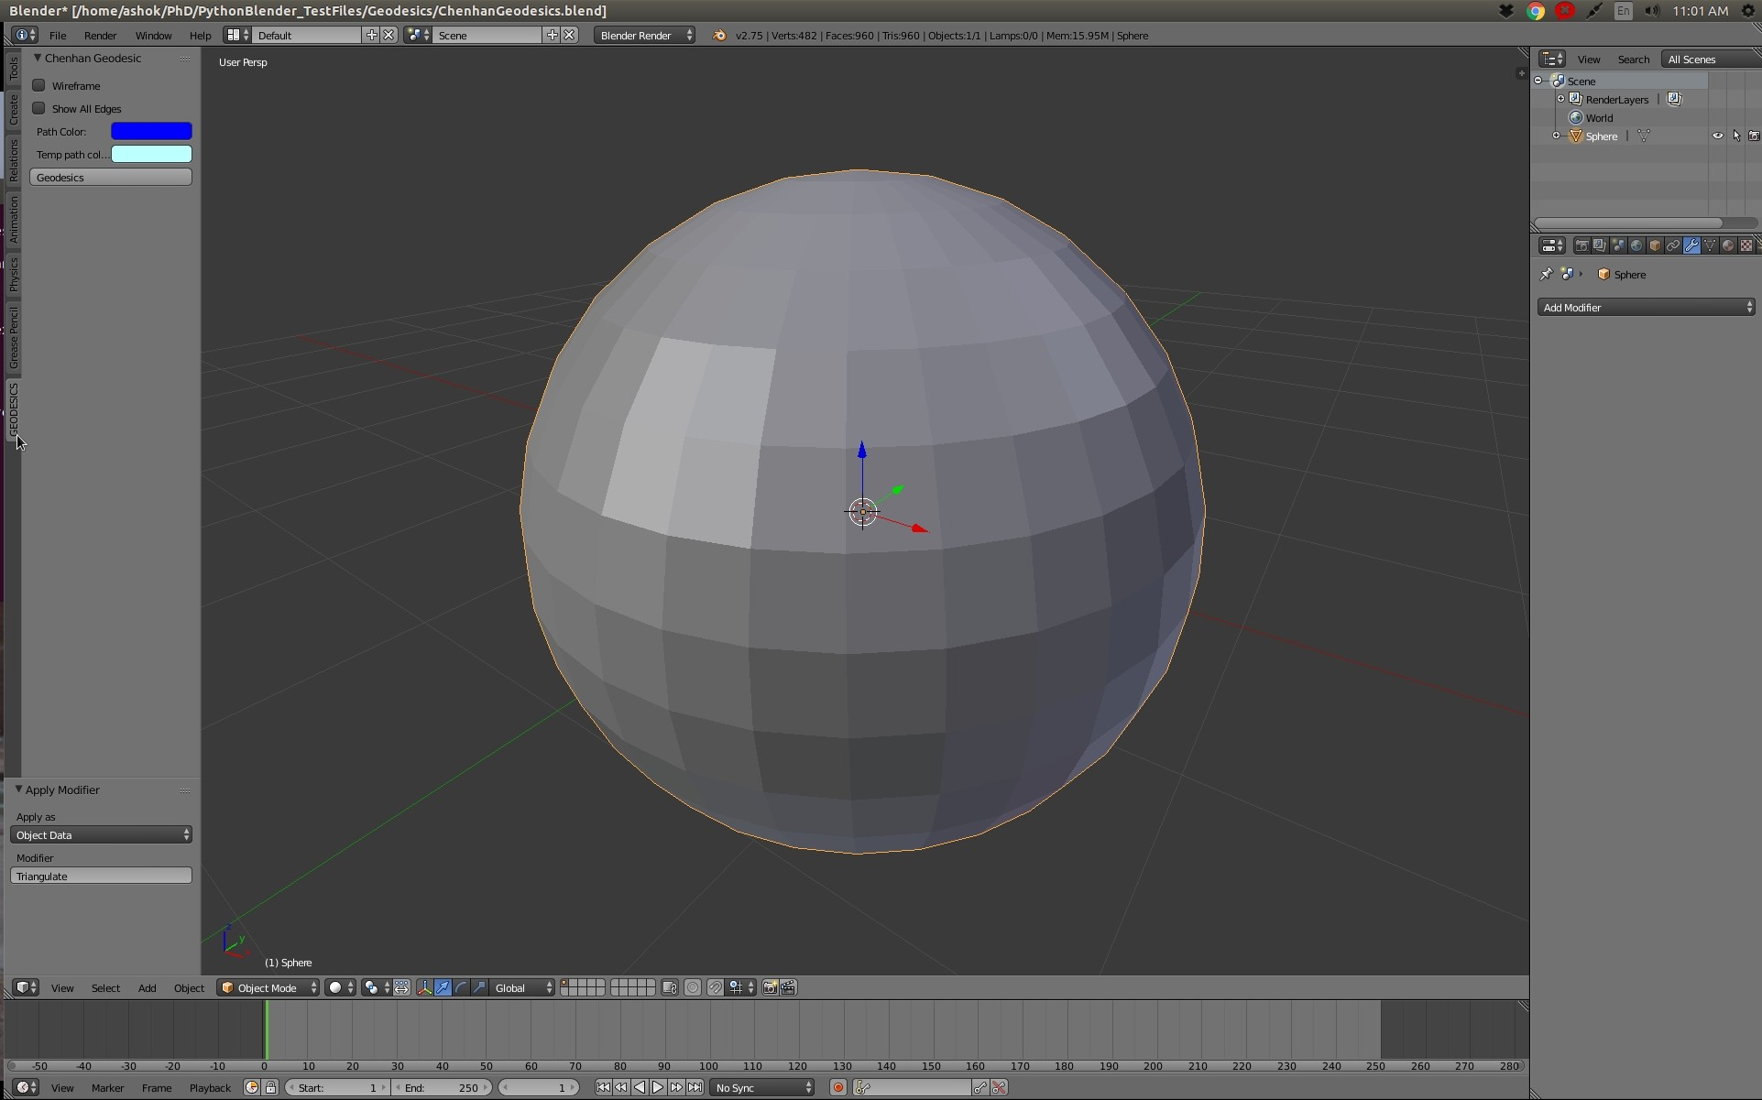

Select the Chenhan Geodesics button
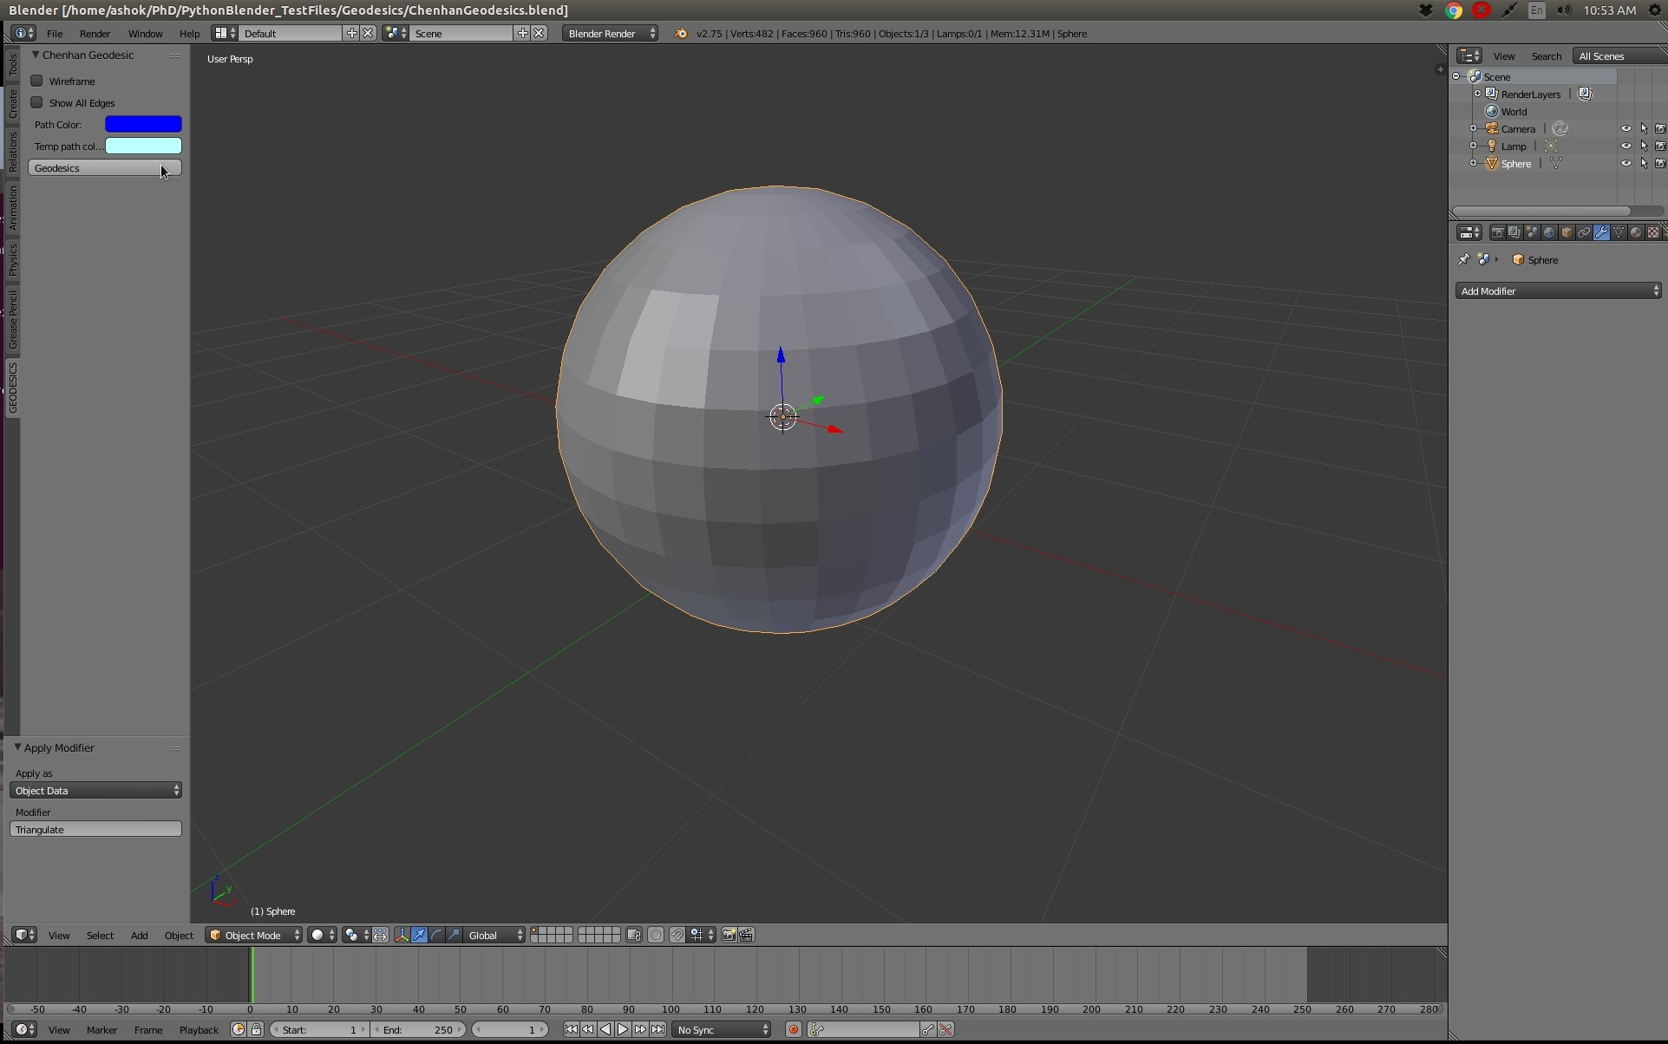

Click to add a seed point
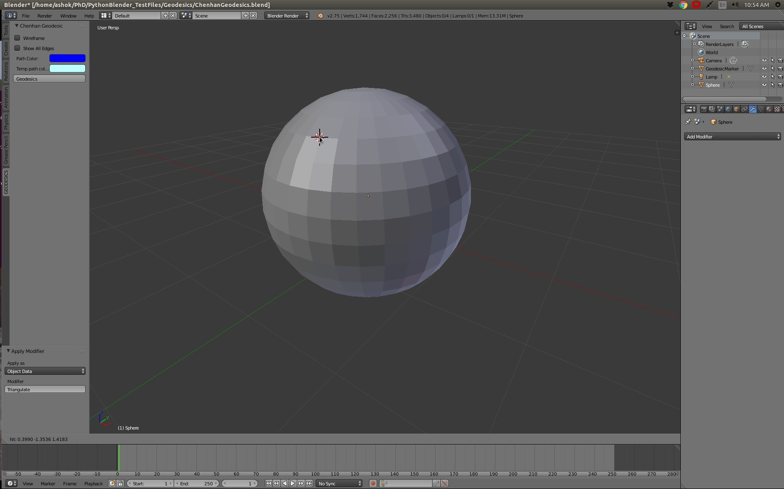

Move the mouse over the mesh to see the path from the seed
