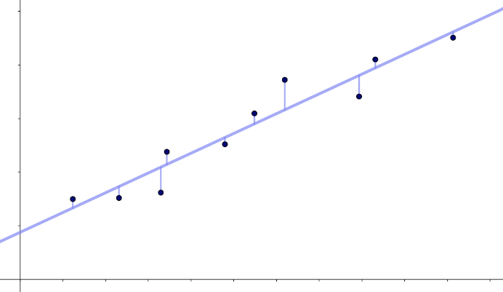
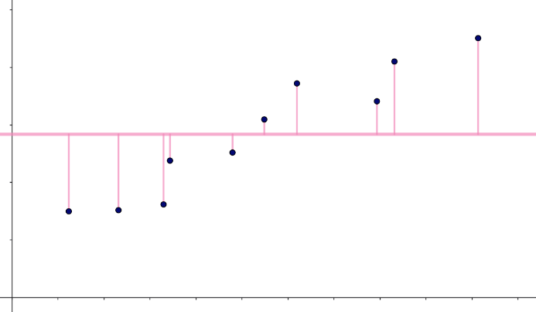

$$\int_{-4}^{0}{\frac{1}{2}x^{2}-\left(2+w·x\right)dx}=8·w+\frac{8}{3}$$

$$8·w+\frac{8}{3}=0$$
$⇕$ Ligningen løses for w vha. WordMat.
$$w=-\frac{1}{3}$$

$$\int_{-4}^{w·\frac{4}{3}}{\frac{3}{4}·x^{2}-w·x dx+ \int_{w·\frac{4}{3}}^{0}{w·x-\frac{3}{4}·x^{2}dx}}=-\frac{16·w^{3}}{27}+8·w+16$$
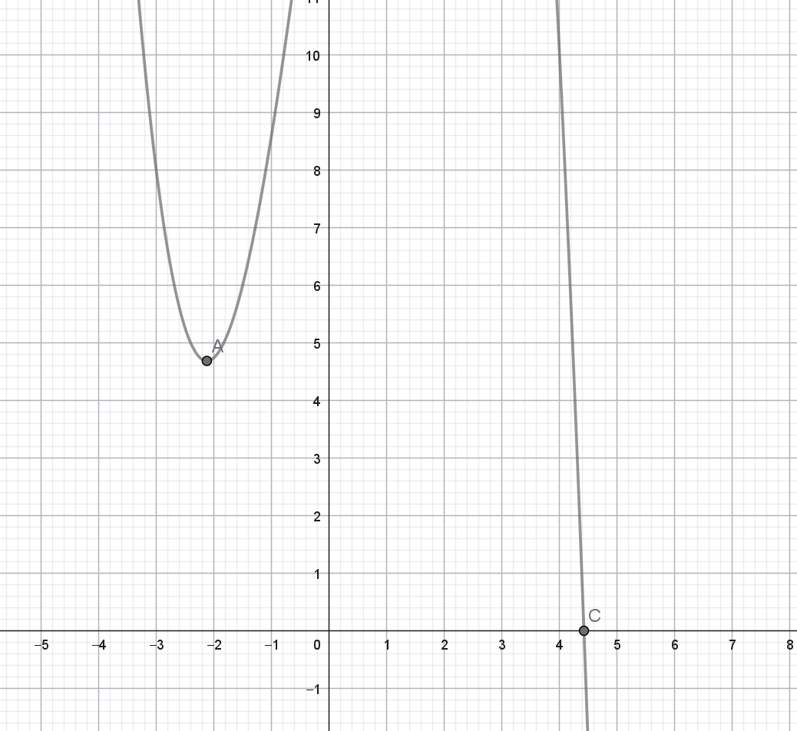
$$h\left(w\right)≔-\frac{16·w^{3}}{27}+8·w+16$$

$$h^{'}\left(w\right)=0$$
$⇕$ Ligningen løses for w vha. WordMat.
$$w=-\frac{3}{\sqrt{2}} ∨ w=\frac{3}{\sqrt{2}}$$

