MotifBench
A Systematic Evaluation of Classic vs. Modern Motif-Discovery Algorithms Under Varying Motif Strength, Background Models, and Pseudocounts
Final Project Report
CS4054: Bioinformatics
Name | Roll number | Role
Aaleen Fatima | 23L-0652 | Algorithms
Laiba Amjad | 23L-0642 | Data and experiment pipeline
Mariyam Pasha | 23L-0809 | Evaluation and analysis

National University of Computer and Emerging Sciences, Lahore
November 2026
Code and data: github.com/aaleenfatima/MotifBench

Abstract
Transcription factors regulate genes by binding short, variable DNA patterns called motifs, and finding these motifs computationally is a classic hard problem. The textbook algorithms (Greedy Motif Search, Randomized Motif Search and Gibbs Sampling) are widely taught, but their accuracy depends on modelling choices that are rarely tested together. We built MotifBench, a reproducible benchmark that plants motifs sampled from eight JASPAR 2026 matrices into 50 × 500 bp DNA sequences at seven controlled strength levels (20–100 % of the original information content) and three background compositions (uniform, AT-rich and a CpG-depleted Markov chain), plus real JASPAR binding sites embedded in synthetic flanks. Every algorithm was run with and without Laplace pseudocounts and with a uniform or shuffled-sequence background model, with STREME (MEME Suite) as a modern reference: 26,550 runs on 1,770 datasets. Results were scored with Hamming distance, profile entropy, Pearson correlation with the true matrix and site-recovery rate, and compared with paired Wilcoxon tests (Holm-corrected).
The background model is the largest single factor: on AT-rich DNA, scoring against a uniform background drops Randomized and Gibbs to under 1 % site recovery, while a shuffled-sequence background raises it by about 0.5 (rank-biserial r ≥ 0.99). Pseudocounts help every algorithm and are essential for Greedy (+0.31). Together the two fixes take the classic algorithms from 4–11 % to about 50 % site recovery, above STREME's 38 % on synthetic data, and to 0.79–0.88 against STREME's 0.80 on real binding sites, with the caveat that the classic algorithms were given the true motif width. Below about 60 % of the original information content, even the true matrix cannot reliably locate the planted sites, which sets a hard ceiling for any method.

Contents
Abstract 1
1. Introduction 3
2. Background and Related Work 3
3. Methods 4
3.1 Ground-truth motifs 4
3.2 Controlling motif strength 4
3.3 Synthetic datasets 5
3.4 Real binding-site datasets 5
3.5 Classic algorithms 6
3.6 STREME and reference baselines 6
3.7 Evaluation metrics 7
3.8 Statistical analysis 7
3.9 Implementation and reproducibility 7
4. Results 7
4.1 Overview 7
4.2 The background model is the largest single factor 8
4.3 Pseudocounts help every algorithm and rescue Greedy 9
4.4 Closing the gap to STREME 9
4.5 When is each algorithm reliable? 10
4.6 Real binding sites 10
4.7 Profile quality and over-confidence 11
4.8 Search or scoring? 13
5. Discussion 14
6. Limitations 14
7. Conclusion 15
Contributions 15
References 15
Appendix: Reproducing the results 16

1. Introduction
Transcription factors (TFs) are proteins that switch genes on and off by binding specific DNA sites, so locating these sites is a basic step in understanding gene regulation. The task is difficult for three reasons: the sites are short (typically 6–20 bp), no two copies are identical, and they are hidden in far longer stretches of unrelated background DNA. A motif is therefore described not by a single string but by a position probability matrix (PPM): a 4 × k table giving the probability of each base at each of the k positions.
Greedy Motif Search, Randomized Motif Search and Gibbs Sampling attack the problem through profile-guided greedy choice, random restarts with iterative improvement, and Markov-chain Monte Carlo sampling respectively [2, 3]. They are standard teaching material and easy to understand, but their results depend heavily on small modelling decisions: how the background nucleotide frequencies are modelled, and whether pseudocounts are added so that unseen bases do not receive zero probability. In class these algorithms are usually met one at a time, and a controlled comparison of when each works, when it fails, and how far it falls behind a modern tool is rarely seen.
This project builds that comparison as a single, repeatable benchmark. We ask three questions:
- Reliability. At what motif strength does each classic algorithm become reliable?
- Gap. How far behind a modern tool, STREME [7], are they?
- Explanation. How much of that gap comes down to two cheap fixes: Laplace pseudocounts and the background model?
We answer them with 26,550 runs over planted-motif datasets of controlled strength and composition, plus real JASPAR binding sites, scored with four complementary metrics and paired statistical tests.

2. Background and Related Work
Motif finding has been studied as a combinatorial search problem since Pevzner and Sze [1] posed the planted (l, d) motif challenge, and as a probabilistic one since Lawrence et al. [2] introduced Gibbs sampling for detecting weak shared signals in unaligned sequences. The versions of Greedy, Randomized and Gibbs search used here follow Compeau and Pevzner [3]. Das and Dai [4] survey the field from word enumeration to probabilistic methods such as expectation maximisation and Gibbs sampling, and note that most tools perform well on simpler organisms but much worse on higher ones.
Benchmarks consistently find that accuracy depends on the data. Tompa et al. [5] compared thirteen tools on real binding-site data and found generally low accuracy that varied strongly between datasets. Castellana et al. [6] tested sixteen classic tools on twenty-nine synthetic planted-motif datasets, a setup close to ours on a larger scale. Vorontsov et al. [9] compared ten tools across five experimental platforms and found that each tool struggles on some protein and platform combinations, which motivates testing under several controlled conditions.
As the modern reference we use STREME [7], which indexes the input sequences in a generalised suffix tree and reports better accuracy and speed than MEME, DREME and HOMER. Raditsa et al. [8] showed that the choice of background sequences changes motif-discovery results on ChIP-seq data; this is the main reason we treat the background model as an experimental variable. Ground-truth motifs come from JASPAR 2026 [10], the latest release of the open-access database of curated TF binding profiles.

3. Methods
The benchmark is a pipeline of three parts that share fixed interfaces: datasets (FASTA plus a JSON file holding the ground truth), algorithms (a common find_motif(seqs, k, background, pseudocount, seed) signature returning positions and a 4 × k profile), and a single evaluation function that scores every run identically and writes one CSV row. The nucleotide order is A, C, G, T throughout.

3.1 Ground-truth motifs
We selected eight JASPAR 2026 matrices of varied width (10–17 bp) and information content (IC). IC is measured in bits as the sum over columns of 2 minus the column's Shannon entropy, so each fully conserved position contributes 2 bits and a random one 0 bits.
Table 1. The eight JASPAR 2026 motifs used. IC = total information content at full strength.
JASPAR ID | Transcription factor | Width (bp) | IC (bits) | Real-site data
MA0001.3 | AGL3 | 10 | 11.41
MA0002.2 | Runx1 | 11 | 10.40
MA0003.4 | TFAP2A | 14 | 11.65 | yes
MA0007.3 | Ar | 17 | 18.66
MA0009.2 | TBXT | 16 | 18.96
MA0014.3 | PAX5 | 12 | 11.08 | yes
MA0017.2 | NR2F1 | 13 | 13.34
MA0018.4 | CREB1 | 13 | 11.55 | yes

3.2 Controlling motif strength
Motif strength was controlled by blending each matrix P with the uniform distribution,
P′ = (1 − α) · P + α · 0.25,
and choosing α by bisection so that the blended matrix keeps a target fraction of the original IC: 20, 40, 60, 70, 80, 90 and 100 %. Because strength is defined relative to each motif, we report the actual IC values (Table 2) rather than α. Figure 1 shows the effect on MA0001.3.
Table 2. Actual information content (bits) of each planted motif at each strength level.
Motif | 20 % | 40 % | 60 % | 70 % | 80 % | 90 % | 100 %
MA0001.3 | 2.28 | 4.56 | 6.84 | 7.98 | 9.13 | 10.27 | 11.41
MA0002.2 | 2.08 | 4.16 | 6.24 | 7.28 | 8.32 | 9.36 | 10.40
MA0003.4 | 2.33 | 4.66 | 6.99 | 8.16 | 9.32 | 10.49 | 11.65
MA0007.3 | 3.73 | 7.47 | 11.20 | 13.06 | 14.93 | 16.80 | 18.66
MA0009.2 | 3.79 | 7.59 | 11.38 | 13.28 | 15.17 | 17.07 | 18.96
MA0014.3 | 2.22 | 4.43 | 6.65 | 7.75 | 8.86 | 9.97 | 11.08
MA0017.2 | 2.67 | 5.34 | 8.01 | 9.34 | 10.67 | 12.01 | 13.34
MA0018.4 | 2.31 | 4.62 | 6.93 | 8.08 | 9.24 | 10.39 | 11.55

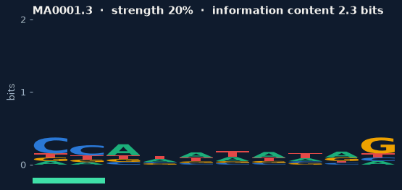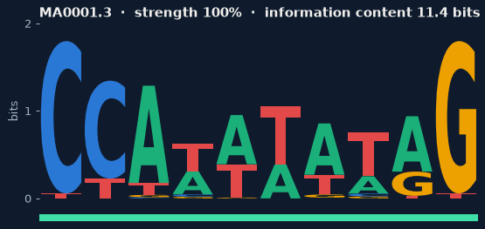
Figure 1. Sequence logos of JASPAR MA0001.3 (AGL3) at 20 % (left) and 100 % (right) of its information content. Letter height is the information each position carries; at 20 % the motif is barely distinguishable from background.

3.3 Synthetic datasets
Each synthetic dataset contains 50 sequences of 500 bp. Background DNA was generated from one of three first-order Markov chains: uniform (25 % each base), AT-rich (A = T = 35 %, C = G = 15 %, independent positions) and Markov, a chain with CpG depletion (the C→G transition reduced to 0.10). Non-uniform backgrounds are essential: if the DNA were uniform, a uniform and an estimated background model would be nearly identical and the background variable could show nothing. In each sequence one site was sampled column-by-column from the (blended) matrix and written over the background at a uniformly random position, keeping the length fixed; the positions and sampled sites were stored as ground truth. With 8 motifs × 7 strengths × 3 backgrounds × 10 replicates this gives 1,680 synthetic datasets. Every dataset has a deterministic seed derived from its name, so any dataset can be regenerated exactly.

3.4 Real binding-site datasets
To check that conclusions hold outside simulation we used the real binding-site FASTA files distributed with JASPAR 2026 for MA0003.4 (TFAP2A), MA0014.3 (PAX5) and MA0018.4 (CREB1). These files contain only the sites themselves, which would make motif finding trivial, so for each dataset 50 sites were drawn without replacement and embedded in 500 bp synthetic flanks of each background type (3 motifs × 3 flank types × 10 replicates = 90 datasets). These datasets have no strength levels: the motif is as strong as nature made it.

3.5 Classic algorithms
All three algorithms follow Compeau and Pevzner [3] and are vectorised with NumPy. They are given the true motif width k. The textbook versions score a motif set by its consensus score; to include a background model, we replaced this with a log-odds score. For a set of chosen k-mers with profile P and counts c, the score is
score = Σ_j Σ_b c[b, j] · log( P[b, j] / bg[b] ),
and a single window x is scored by Σ_j log( P[x_j, j] / bg[x_j] ). Higher is better.
- Greedy Motif Search tries every k-mer of the first sequence as a seed, extends through the remaining sequences by choosing the highest-scoring k-mer under the profile built so far, and keeps the best-scoring set. It is deterministic.
- Randomized Motif Search starts from one random k-mer per sequence, then alternates between building the profile and picking each sequence's best window until the score stops improving; this is repeated for 200 restarts.
- Gibbs Sampling starts from random k-mers and, at each step, removes one sequence's k-mer, rebuilds the profile from the rest and resamples that sequence's window with probability proportional to P(window)/bg(window). It runs 40 restarts × 2,000 iterations and returns the best set seen.

Pseudocounts
With pseudocounts on, the profile is built with Laplace add-one smoothing, P[b, j] = (c[b, j] + 1) / (n + 4). With pseudocounts off, P = c / n, so any base not yet observed at a position has probability 0 and log-odds −∞. These cases are handled explicitly: terms with zero count contribute 0 to the set score, a window containing an impossible base scores −∞, and when every window of a sequence scores −∞ the first window is chosen (Greedy, Randomized) or a window is sampled uniformly (Gibbs).

Background model
With the uniform background, bg = 0.25 for every base. With the shuffled background, bg is estimated from a randomly shuffled copy of the input sequences. Shuffling preserves base composition, so this amounts to using the input's own mononucleotide frequencies as the background. The background estimate uses its own random generator, so uniform and shuffled runs with the same seed start the search from identical random numbers, making the comparison paired.

3.6 STREME and reference baselines
STREME from a local MEME Suite installation was run on every dataset with default settings, except that the maximum motif width was raised to 20 (--maxw 20) because two of our motifs are wider than STREME's default limit of 15. We always took STREME's top-ranked motif, never the one closest to the truth. Because STREME does not return one site per sequence, we scanned every sequence (both strands) with its matrix, using log-odds against STREME's reported background, and took the best window. This gives one predicted site per sequence, as for the classic algorithms.
Two baselines bracket every result. The ceiling (oracle_scan) scans each sequence with the true matrix and takes the best window: no method can locate the planted sites better than the true motif itself. The chance floor (random) picks random sites.

3.7 Evaluation metrics
A found motif can be shifted by a few bases, lie on the opposite strand, or (for STREME) have a different width from the true one. Every profile-based metric therefore slides the found motif along the true one on both strands and keeps the best placement, requiring at least 75 % of the shorter motif to overlap.
- Hamming distance between the found and true consensus at the best alignment: mismatches in the overlap plus true positions left uncovered, reported as a fraction of the true width (0 = perfect).
- Profile entropy: mean Shannon entropy per position of the found profile (0 = every position fully specific, 2 bits = random). It is compared with the entropy of the true motif.
- Pearson correlation between the found and true matrices at the best offset and strand, computed on the flattened overlapping columns. Because the strength blending is a linear rescaling, correlation with the blended matrix equals correlation with the original JASPAR matrix on synthetic data.
- Site-recovery rate: the share of the 50 planted sites the method located. A site counts as found when the predicted site covers at least 50 % of it (overlap rate, our main metric). An exact-start variant is also reported, but only for the classic algorithms, since STREME's own width and offset mean its start never coincides with the planted start even when it is correct.
A method that reports no motif receives zero recovery rather than being dropped, so failures count in the averages.

3.8 Statistical analysis
Every configuration runs on the same datasets, so comparisons are paired: each claim (for example "pseudocounts improve Gibbs") is tested with a Wilcoxon signed-rank test on per-dataset differences, which removes the large variation between strong and weak motifs and makes no normality assumption about these bounded, skewed metrics. Effect size is the matched-pairs rank-biserial correlation r (|r| ≈ 0.1 small, 0.3 medium, ≥ 0.5 large). P-values are Holm-corrected across all claims in a family. Figures show means over 8 motifs × 10 replicates with 95 % confidence intervals.

3.9 Implementation and reproducibility
Everything is in Python (NumPy, pandas, SciPy, Biopython, matplotlib) with 92 unit tests. Each result row stores its seed, and the run configuration (search budgets, software versions and code commit) is saved next to the results. The full grid, 12 classic configurations plus STREME and the two baselines on every dataset, gives 26,550 runs and took about 43 CPU-hours. A Jupyter notebook (notebooks/MotifBench_analysis.ipynb) regenerates every figure, table and test in this report from the results file.

4. Results

4.1 Overview
Table 3 summarises every method on synthetic data, averaged over all motifs, strengths, backgrounds and replicates. Figure 2 breaks site recovery down by strength and background.
Table 3. Mean performance on the 1,680 synthetic datasets. Textbook = pseudocounts off, uniform background; both fixes = pseudocounts on, shuffled background. Higher is better except Hamming.
Method | Site recovery | Exact start | Pearson r | Hamming | Entropy | Time (s)
Ceiling (true motif) | 0.625 | 0.594 | 1.000 | 0.000 | 1.34 | –
STREME | 0.377 | – | 0.653 | 0.421 | 0.85 | 3.8
Gibbs, both fixes | 0.503 | 0.350 | 0.736 | 0.291 | 1.33 | 14.7
Randomized, both fixes | 0.502 | 0.340 | 0.723 | 0.301 | 1.30 | 4.6
Greedy, both fixes | 0.463 | 0.278 | 0.711 | 0.317 | 1.33 | 2.0
Gibbs, textbook | 0.108 | 0.034 | 0.348 | 0.530 | 1.08 | 14.6
Randomized, textbook | 0.114 | 0.037 | 0.357 | 0.528 | 1.07 | 4.0
Greedy, textbook | 0.038 | 0.008 | 0.281 | 0.578 | 1.18 | 2.0
Chance (random sites) | 0.029 | 0.002 | 0.221 | 0.607 | 1.93 | –

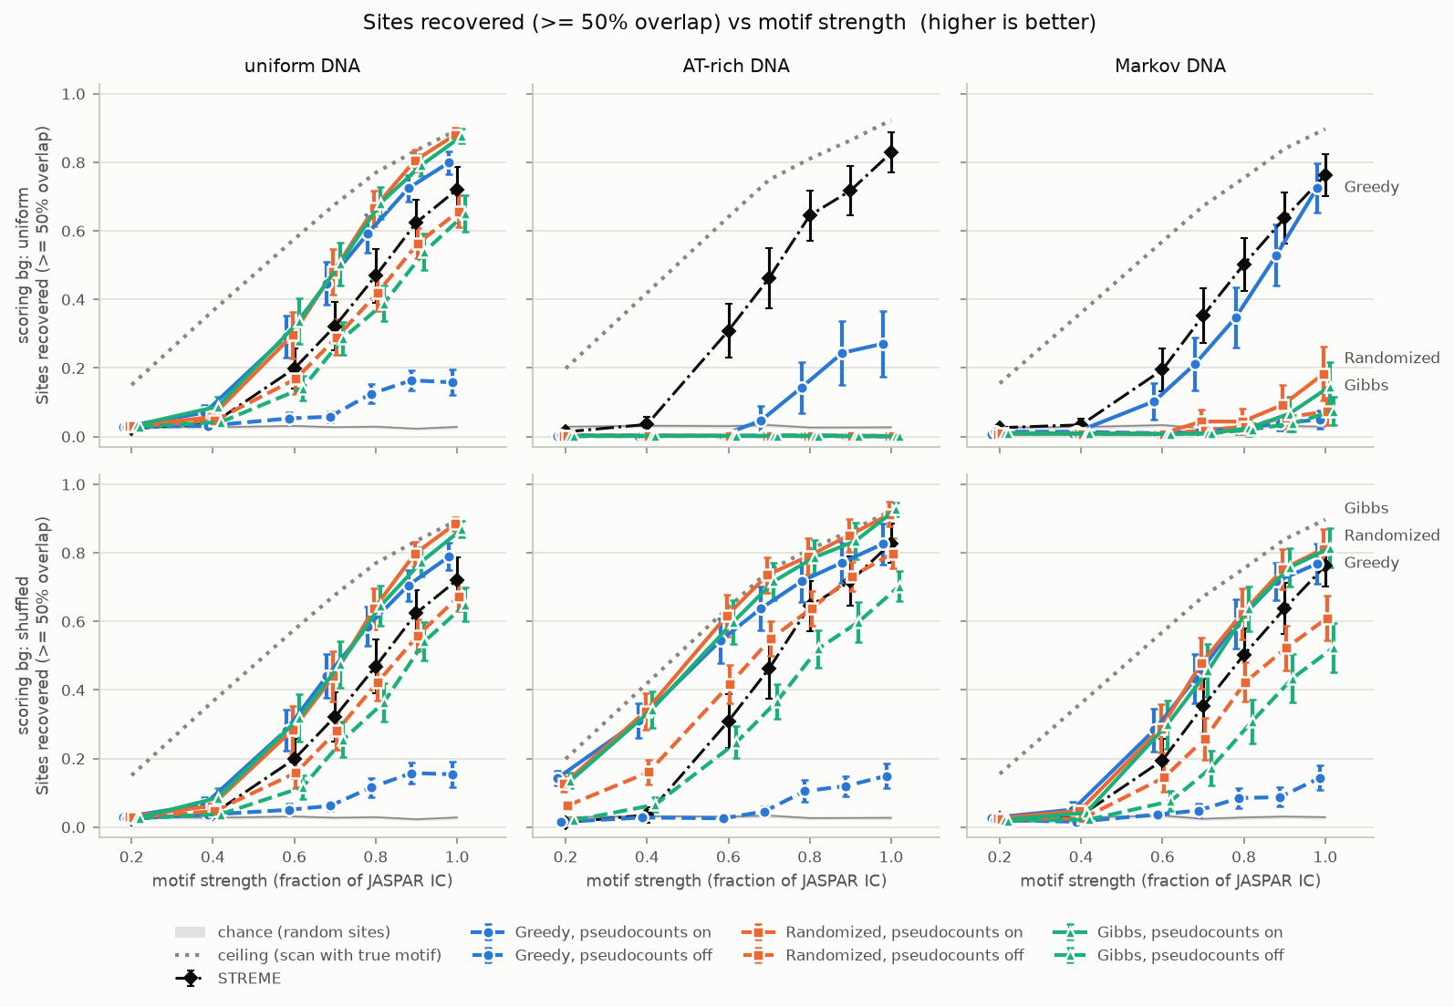
Figure 2. Site recovery (≥ 50 % overlap) against motif strength. Columns: how the DNA was generated; rows: the background the algorithm assumed when scoring. Solid lines = pseudocounts on, dashed = off. Black dash-dot = STREME; grey dotted = ceiling (scanning with the true motif); grey band = chance. Points are means over 8 motifs × 10 replicates with 95 % confidence intervals.

4.2 The background model is the largest single factor
On uniform DNA the two background models behave the same, as they should (top and bottom rows of Figure 2 match; |Δ| ≤ 0.02). On AT-rich DNA, scoring against a uniform background is catastrophic for Randomized and Gibbs: their site recovery falls to 0.2 % and 0.2 %, at every strength. Switching to the shuffled background raises it to 0.55 and 0.49 respectively. On Markov DNA the effect is smaller but still large (Table 4). Every one of these effects has a rank-biserial r of at least 0.9, meaning the shuffled background wins on almost every single dataset.
Table 4. Effect of the shuffled background on site recovery (synthetic data). Δ = shuffled − uniform; paired Wilcoxon, Holm-corrected.
Algorithm | DNA | Uniform bg | Shuffled bg | Δ | r | p (Holm)
Randomized | AT-rich | 0.002 | 0.552 | +0.550 | 1.00 | 1e-174
Gibbs | AT-rich | 0.002 | 0.490 | +0.489 | 1.00 | 2e-166
Greedy | AT-rich | 0.052 | 0.317 | +0.265 | 0.97 | 1e-130
Randomized | Markov | 0.042 | 0.360 | +0.317 | 0.92 | 2e-130
Gibbs | Markov | 0.032 | 0.327 | +0.296 | 0.90 | 3e-118
Greedy | Markov | 0.150 | 0.237 | +0.087 | 0.64 | 3e-54
Randomized | uniform | 0.385 | 0.379 | −0.006 | −0.04 | 0.32 (n.s.)
Greedy | uniform | 0.255 | 0.250 | −0.005 | −0.10 | 0.12 (n.s.)
Gibbs | uniform | 0.385 | 0.370 | −0.015 | −0.16 | 9e-5

The same pattern holds for profile quality: on AT-rich DNA the shuffled background raises Pearson correlation with the true matrix from 0.16 to 0.77 for Randomized and from 0.16 to 0.73 for Gibbs.

4.3 Pseudocounts help every algorithm and rescue Greedy
Laplace pseudocounts improve site recovery for all three algorithms (Table 5). The effect is by far the largest for Greedy, whose recovery without pseudocounts stays near 0.04–0.07 regardless of motif strength (dashed blue lines in Figure 2).
Table 5. Effect of pseudocounts on site recovery (synthetic data, all backgrounds). Δ = on − off.
Algorithm | Off | On | Δ | Wins / losses / ties | r | p (Holm)
Greedy | 0.056 | 0.365 | +0.309 | 2147 / 412 / 801 | 0.89 | < 1e-300
Gibbs | 0.198 | 0.337 | +0.139 | 1913 / 427 / 1020 | 0.83 | 7e-264
Randomized | 0.236 | 0.337 | +0.101 | 1838 / 425 / 1097 | 0.82 | 8e-252

4.4 Closing the gap to STREME
With textbook settings the classic algorithms recover 4–11 % of planted sites, far behind STREME's 38 %. Adding both fixes raises them to 46–50 %, which closes the entire gap and passes STREME (Table 6). The advantage is significant for all three algorithms on synthetic data (Gibbs and Randomized r = 0.70, Greedy r = 0.43; all p < 1e-40). It also holds for profile quality: with both fixes, mean Pearson correlation is 0.71–0.74 against STREME's 0.65, and the advantage is largest at intermediate strengths (0.67–0.71 vs 0.56 at 60 % strength).
Table 6. Site recovery: textbook settings vs both fixes vs STREME.
Algorithm | Data | Textbook | Both fixes | STREME | Gap closed
Greedy | synthetic | 0.038 | 0.463 | 0.377 | all, +0.086 ahead
Randomized | synthetic | 0.114 | 0.502 | 0.377 | all, +0.124 ahead
Gibbs | synthetic | 0.108 | 0.503 | 0.377 | all, +0.126 ahead
Greedy | real sites | 0.035 | 0.786 | 0.802 | 98 %
Randomized | real sites | 0.192 | 0.876 | 0.802 | all, +0.074 ahead
Gibbs | real sites | 0.178 | 0.881 | 0.802 | all, +0.079 ahead

Important caveat. The classic algorithms were given the true motif width; STREME had to discover it. The comparison is otherwise identical (same datasets, same evaluation), but the result that the classic algorithms beat STREME holds only under this condition. The finding that the two fixes account for essentially the whole gap is robust to it.

4.5 When is each algorithm reliable?
Table 7 gives the lowest strength at which mean site recovery reaches 50 % and 80 %. The ceiling row sets the limit: even the true matrix reaches 50 % only at 60 % of the original IC, because at lower strengths random background windows outscore the planted sites. Poor results below that point are therefore a property of the data, not of the algorithms.
Table 7. Lowest strength (fraction of JASPAR IC) at which mean site recovery reaches 50 % / 80 %. "never" = not reached at full strength. Classic algorithms shown with both fixes.
Method | Uniform DNA | AT-rich DNA | Markov DNA
Ceiling (true motif) | 0.6 / 0.9 | 0.6 / 0.8 | 0.6 / 0.9
Gibbs | 0.8 / 1.0 | 0.6 / 0.9 | 0.8 / 1.0
Randomized | 0.8 / 1.0 | 0.6 / 0.9 | 0.8 / 1.0
Greedy | 0.8 / never | 0.6 / 1.0 | 0.8 / never
STREME | 0.9 / never | 0.8 / 1.0 | 0.8 / never
Any algorithm, pseudocounts off, uniform bg | 0.9 / never* | never / never | never / never

*Gibbs and Randomized only; Greedy without pseudocounts never reaches 50 %.
Difficulty also depends strongly on the motif itself. Averaged over all conditions, the best classic configuration (Gibbs, both fixes) recovers 0.72–0.73 of sites for the two high-IC motifs MA0007.3 and MA0009.2 (about 19 bits at full strength) but only 0.25–0.31 for MA0001.3 and MA0002.2 (10–11 bits). STREME and the ceiling follow the same order.

4.6 Real binding sites
On the 90 real binding-site datasets (Figure 3) every conclusion repeats, usually more strongly. Pseudocounts raise Greedy's recovery from 0.06 to 0.61 (r = 0.99); the shuffled background raises Randomized and Gibbs on AT-rich flanks from 0.00 to 0.87 and 0.81, winning on all 60 of 60 paired datasets. With both fixes Gibbs (0.88) and Randomized (0.88) significantly exceed STREME (0.80; p < 1e-5), and Greedy (0.79) is statistically indistinguishable from it (p = 0.12).
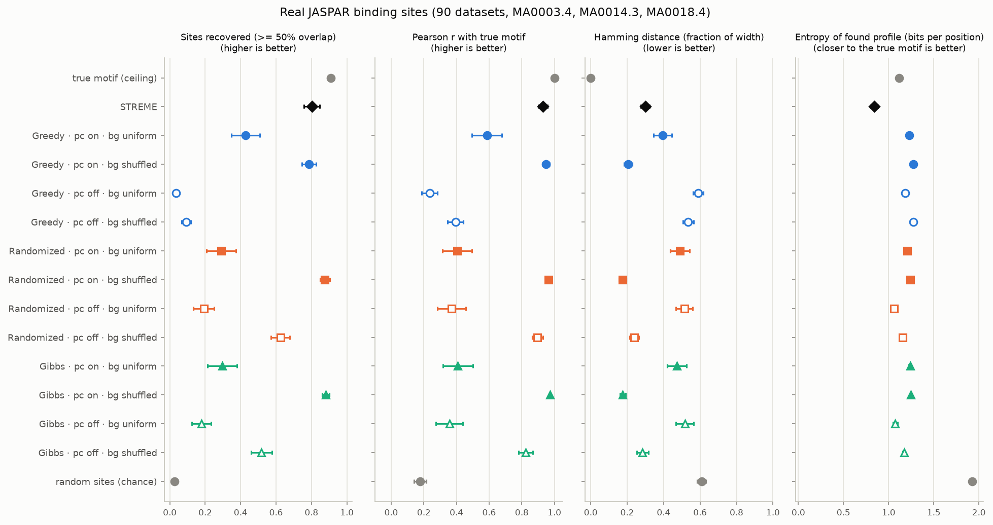
Figure 3. Real JASPAR binding sites (MA0003.4, MA0014.3, MA0018.4) in synthetic flanks: mean ± 95 % CI over 90 datasets. Filled markers = pseudocounts on, hollow = off.

4.7 Profile quality and over-confidence
Figures 4 and 5 show that Pearson correlation and Hamming distance tell the same story as site recovery. Profile entropy (Figure 6) reveals something extra. At weak strengths the true motif has high entropy (about 1.8 bits per position at 20 % strength), yet the classic algorithms return profiles of 1.1–1.5 bits per position: they report motifs that look more conserved than the truth, because the search locks onto chance patterns that happen to agree. STREME's profiles are the sharpest of all (about 0.85 bits per position at every strength), so its low entropy reflects its own modelling rather than the data.
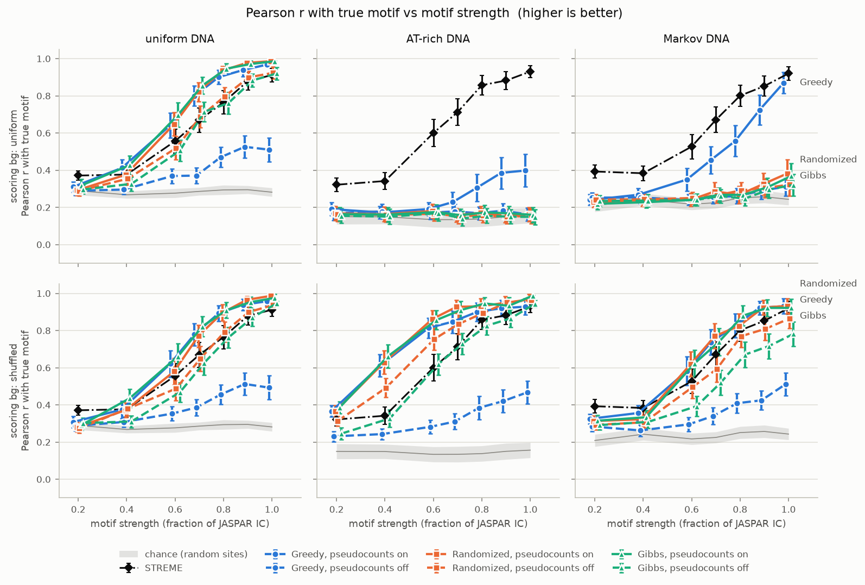
Figure 4. Pearson correlation between the found and true matrices at the best offset and strand. Layout as in Figure 2.
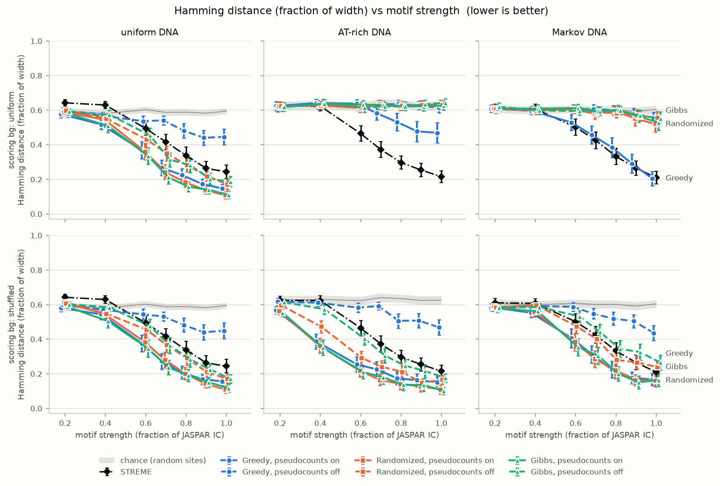
Figure 5. Hamming distance between found and true consensus at the best alignment, as a fraction of motif width (lower is better).
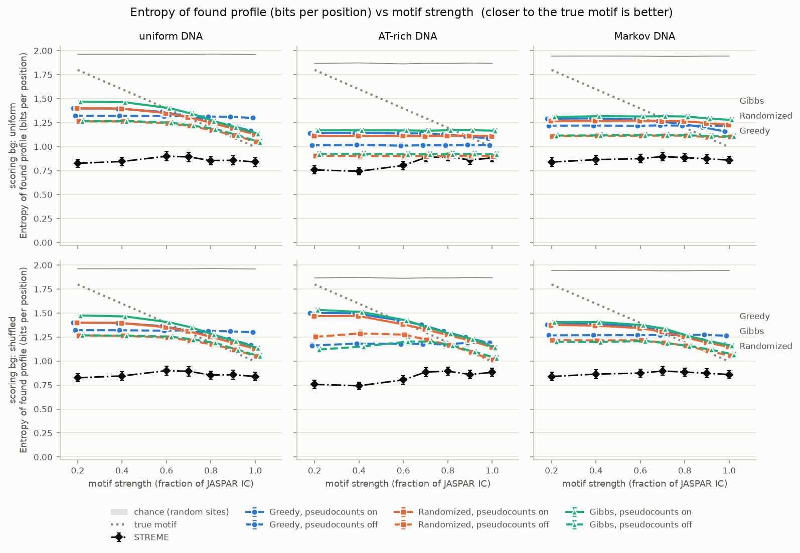
Figure 6. Mean entropy per position of the found profile. Grey dotted line = the true motif; values below it mean the method reports a motif that is more conserved than the truth.

4.8 Search or scoring?
A failure can mean the search gave up too early or that the scoring model rewards the wrong answer. A separate budget study reran Randomized and Gibbs on 12 datasets with increasing budgets and recorded how often the found motif scored at least as well as the planted sites under the algorithm's own score (Table 8). For Randomized at the budget we used (200 restarts) this already happens in 88 % of runs, so more search would add little and its remaining errors come mainly from the scoring model. For Gibbs at our budget (80,000 steps) it happens in only 58 % of runs and recovery is still rising, so the Gibbs results are a lower bound. Gibbs is also the slowest method (about 15 s per dataset against 2–5 s for the others).
Table 8. Budget study (12 datasets): mean site recovery and share of runs whose found motif scores at least as high as the planted sites (search_ok). Bold = budget used in the main experiment.
Algorithm | Budget | Site recovery | search_ok
Randomized | 25 restarts | 0.120 | 0.42
Randomized | 100 restarts | 0.312 | 0.67
Randomized | 200 restarts | 0.433 | 0.88
Randomized | 400 restarts | 0.493 | 0.92
Gibbs | 5,000 steps | 0.032 | 0.13
Gibbs | 20,000 steps | 0.148 | 0.21
Gibbs | 80,000 steps | 0.368 | 0.58

5. Discussion
Why the uniform background fails on AT-rich DNA. With bg = 0.25, the log-odds score rewards every A or T in a window, because these bases are far more common in the data than the model expects. In AT-rich sequences the highest-scoring windows are therefore simply the most AT-rich ones, and the algorithms converge to poly-A/T "motifs" such as AAATAAAAAT instead of the planted site. Estimating the background from the input itself, which is what the shuffled-sequence background does for single-base frequencies, cancels this bias. On uniform DNA the estimate equals 0.25 within noise and the two models coincide, which is exactly what we observe. This agrees with Raditsa et al. [8], who found that the background choice systematically changes motif-discovery results.
Why Greedy needs pseudocounts. Greedy builds its profile from very few sequences in its first steps: after one sequence, every unseen base has probability zero. Without pseudocounts almost every window in the next sequence then scores −∞, the first window is chosen by default, and the error propagates through the remaining sequences. Randomized and Gibbs build profiles from all or all-but-one sequences, so zeros are rarer and the damage smaller, but still significant.
The gap to STREME is mostly about modelling, not the algorithms. The textbook versions lose to STREME by a wide margin, but nearly all of that gap disappears with two changes that each take a line of code. With the caveat about the given width, a well-configured Gibbs or Randomized search is competitive with a modern tool on planted single-site data, at similar (Randomized) or higher (Gibbs) cost. STREME's advantages, such as finding the width itself and handling zero or multiple sites per sequence, are not exercised by this benchmark.
Practical recommendation. Always use pseudocounts. Always estimate the background from the data unless the DNA is known to be compositionally uniform, since doing so costs essentially nothing on uniform DNA and is decisive otherwise. Prefer Randomized or Gibbs over Greedy. Treat any motif found at low information content with suspicion: its profile may look more conserved than the real motif, and below about 60 % of a typical JASPAR motif's IC the sites cannot be located reliably by any method.

6. Limitations
- Only eight motifs were studied, and real binding sites were embedded in synthetic rather than genomic flanking DNA.
- Each sequence contains exactly one site. Real data has sequences with zero or several sites, where STREME's model is expected to have an advantage.
- The classic algorithms were given the true motif width, which STREME had to discover.
- STREME was run with default settings (apart from the maximum width), not tuned.
- The shuffled background preserves only single-base composition; a higher-order background (for example a Markov model of dinucleotides) could help further on the Markov DNA.
- The Gibbs search budget was not saturated, so Gibbs results are a lower bound.
- The ceiling baseline scans with a uniform background, so on AT-rich DNA it is slightly conservative and the best configurations come close to it.

7. Conclusion
MotifBench compared the three classic motif-finding algorithms against STREME over 26,550 controlled runs. The answer to our first question is that reliability depends on motif strength and on the motif itself: with good settings, Randomized and Gibbs locate half of the planted sites at 60–80 % of the original information content and 80 % at 90–100 %, close to the hard limit set by the data. To the second and third questions: with textbook settings the classic algorithms are far behind STREME, but that gap is explained almost entirely by two modelling choices. A background model estimated from the data is the decisive one on non-uniform DNA, and Laplace pseudocounts are essential for Greedy and helpful for all. With both fixes, and given the motif width, the classic algorithms match or exceed STREME on both synthetic and real binding-site data.

Contributions
Table 9. Division of work.
Member | Contribution
Aaleen Fatima | Greedy, Randomized and Gibbs search with log-odds scoring, pseudocount and background options; search budgets; algorithm tests; budget study
Laiba Amjad | JASPAR download and loading; strength control; synthetic and real-site dataset generation; STREME setup and runs; parallel experiment runner
Mariyam Pasha | Evaluation metrics and alignment; STREME output conversion; baselines; figures; statistical analysis; analysis notebook; results and discussion

References
[1] Pevzner, P. A., & Sze, S.-H. (2000). Combinatorial approaches to finding subtle signals in DNA sequences. Proceedings of the 8th International Conference on Intelligent Systems for Molecular Biology (ISMB), 269–278.
[2] Lawrence, C. E., Altschul, S. F., Boguski, M. S., Liu, J. S., Neuwald, A. F., & Wootton, J. C. (1993). Detecting subtle sequence signals: a Gibbs sampling strategy for multiple alignment. Science, 262(5131), 208–214. https://doi.org/10.1126/science.8211139
[3] Compeau, P., & Pevzner, P. (2018). Bioinformatics Algorithms: An Active Learning Approach (3rd ed., Vol. 1, Ch. 2). Active Learning Publishers.
[4] Das, M. K., & Dai, H.-K. (2007). A survey of DNA motif finding algorithms. BMC Bioinformatics, 8(Suppl 7), S21. https://doi.org/10.1186/1471-2105-8-S7-S21
[5] Tompa, M., Li, N., Bailey, T. L., et al. (2005). Assessing computational tools for the discovery of transcription factor binding sites. Nature Biotechnology, 23(1), 137–144. https://doi.org/10.1038/nbt1053
[6] Castellana, S., et al. (2021). A comparative benchmark of classic DNA motif discovery tools on synthetic data. Briefings in Bioinformatics, 22(6), bbab303. https://doi.org/10.1093/bib/bbab303
[7] Bailey, T. L. (2021). STREME: accurate and versatile sequence motif discovery. Bioinformatics, 37(18), 2834–2840. https://doi.org/10.1093/bioinformatics/btab203
[8] Raditsa, V. V., Tsukanov, A. V., Bogomolov, A. G., & Levitsky, V. G. (2024). Genomic background sequences systematically outperform synthetic ones in de novo motif discovery for ChIP-seq data. NAR Genomics and Bioinformatics, 6(3), lqae090. https://doi.org/10.1093/nargab/lqae090
[9] Vorontsov, I. E., et al. (2025). Cross-platform motif discovery and benchmarking to explore binding specificities of poorly studied human transcription factors. Communications Biology, 8, 1545. https://doi.org/10.1038/s42003-025-08909-9
[10] Ovek Baydar, D., et al. (2026). JASPAR 2026: expansion of transcription factor binding profiles and integration of deep learning models. Nucleic Acids Research, 54(D1), D184–D193. https://doi.org/10.1093/nar/gkaf1209

Appendix: Reproducing the results
From the repository root, after pip install -r requirements.txt:
python data/generate.py # 1,680 synthetic datasets
python data/generate_real.py # 90 real-site datasets
python data/run_streme.py --workers 4 # STREME (Linux / WSL)
python -m experiments.run_experiments --workers 4 # all 26,550 runs
python -m evaluation.plots results/results.csv # figures + summary table
python -m evaluation.stats results/results.csv # statistical tests
python -m pytest -q # 92 tests

The notebook notebooks/MotifBench_analysis.ipynb reproduces every figure, table and test in this report from results/results.csv.

