class04.R

aaronleung

2025-01-16

x <- 1:50  
plot(x, sin(x))

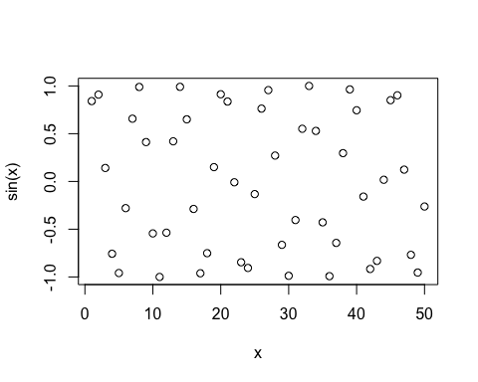

# Make this nicer  
plot(x, sin(x), col="blue", type="l", lwd=3)

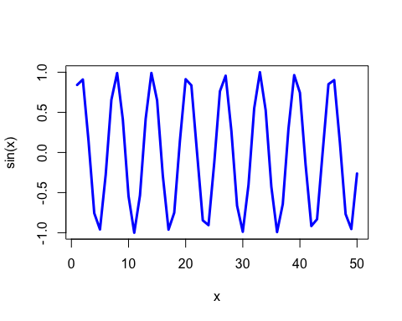

x[x>5]

## [1] 6 7 8 9 10 11 12 13 14 15 16 17 18 19 20 21 22 23 24 25 26 27 28 29 30  
## [26] 31 32 33 34 35 36 37 38 39 40 41 42 43 44 45 46 47 48 49 50