Tema 3

1) (1p) Modificati un element legat de miscare in codul sursa 03_05_animatie.cpp (de exemplu deplasarea este de-a lungul axei Oy, se schimba sensul rotatiei patratului rosu, etc.)
/* O mini-animatie.
Elemente de noutate:
- functii specifice pentru miscare (glTranslate, glRotate, glScale)
- stivele de matrice (GL_MODELVIEW, GL_PROJECTION) si manevrarea acestora (glPush, glPop)
- trebuie "incarcata" matricea identica in vf. stivei (glLoadIdentity())
- importante: glutPostRedisplay(); glutIdleFunc() - pentru "tranzitii" line
*/
#include<windows.h>
#include <GL/freeglut.h>
#include <stdlib.h>
#include <math.h>

static GLdouble i = 0.0;
static GLdouble j = 0.0;
static GLdouble alpha = 0.1;
static GLdouble step = 0.1;
void init(void)
{
glClearColor(1.0, 1.0, 1.0, 0.0);
gluOrtho2D(0.0, 800.0, 0.0, 600.0);
}

void dreptunghi(void)
{
glClear(GL_COLOR_BUFFER_BIT);

glMatrixMode(GL_MODELVIEW);
glLoadIdentity(); // in varful stivei este incarcata matricea identica

glTranslated(200.0, i, 0.0); // modificat: miscarea se face pe axa oy, nu ox

glPushMatrix(); // in stiva: 2 matrice, ambele T

glRotated(-j, 0.0, 0.0, 1.0); // modificat: rotatia dreptunghiului rosu este inversata

glColor3f(1.0, 0.0, 0.0);
glRecti(-5, 30, 5, 40); // dreptunghiul rosu (asupra sa actioneaza rotatie, apoi translatie)
glPopMatrix(); // in varful stivei: T
glColor3f(0.0, 0.0, 1.0);
glRecti(-20, -12, 20, 12); // dreptunghiul albastru, asupra sa actioneaza translatie
glPopMatrix();
glutSwapBuffers();

glFlush();
}

void dreptunghi2(void)
{
glClear(GL_COLOR_BUFFER_BIT);
glMatrixMode(GL_MODELVIEW);
glLoadIdentity(); // comentati(!)
// glPushMatrix ( );
glTranslated(i, 200.0, 0.0); // generata o matrice 4x4 T, corespunzatoare translatiei
glPushMatrix(); // in stiva: 2 matrice, ambele T
glRotated(j, 0.0, 0.0, 1.0); // generata o matrice 4x4 R, corespunzatoare rotatiei
// in stiva: varf: T*R, pozitia 2: T
glColor3f(1.0, 0.0, 0.0);
glRecti(-5, 30, 5, 40); // dreptunghiul rosu (asupra sa actioneaza rotatie, apoi translatie)
glPopMatrix(); // in varful stivei: T

glColor3f(0.0, 0.0, 1.0);
glRecti(-20, -12, 20, 12); // dreptunghiul albastru, asupra sa actioneaza translatie
glPopMatrix();
glutSwapBuffers();
glFlush();
}

void reshape(int w, int h)
{
glViewport(0, 0, (GLsizei)w, (GLsizei)h);
glMatrixMode(GL_PROJECTION);
glLoadIdentity();
glOrtho(-20.0, 780.0, 0.0, 600.0, -1.0, 1.0);
glMatrixMode(GL_MODELVIEW);
glLoadIdentity();
}

void miscad(void)
{
i = i + step;

if (i > 550.0) // modificat: limite pentru miscarea verticala

step = -alpha;
else if (i < 0.0)
step = alpha;
j = j + step;
glutPostRedisplay();
}

void miscas(void)
{
i = i + step;
if (i < 0.0)
step = alpha;

else if (i > 550.0) // modificat: limita superioara

step = -alpha;
j = j + step;
glutPostRedisplay();
}

void mouse(int button, int state, int x, int y)
{
switch (button) {
case GLUT_LEFT_BUTTON:
if (state == GLUT_DOWN)
step = -alpha; glutIdleFunc(miscas);
break;
case GLUT_RIGHT_BUTTON:
if (state == GLUT_DOWN)
step = alpha; glutIdleFunc(miscad);
break;
default:
break;
}
}

void main(int argc, char** argv)
{
glutInit(&argc, argv);
glutInitDisplayMode(GLUT_DOUBLE | GLUT_RGB);
glutInitWindowSize(800, 600);
glutInitWindowPosition(100, 100);
glutCreateWindow("Dreptunghi cu satelit");
init();
glutDisplayFunc(dreptunghi);
//glutDisplayFunc(dreptunghi2);
glutReshapeFunc(reshape);
glutMouseFunc(mouse);
glutMainLoop();
}
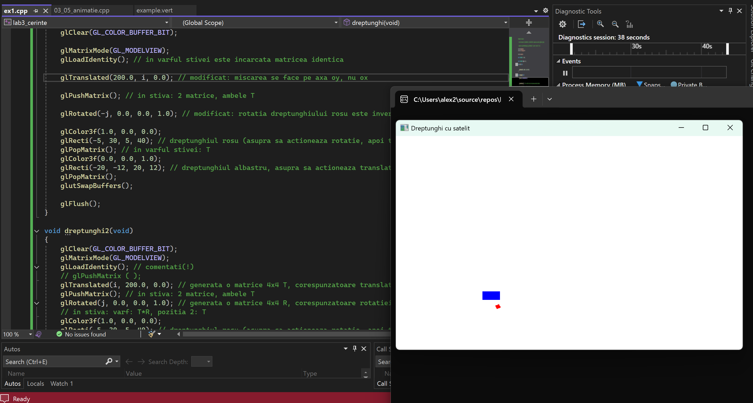
2) (1p) Desenati un patrat care se rostogoleste de-a lungul unei axe. Model in fisierul atasat.
#include <windows.h>
#include <GL/freeglut.h>
#include <math.h>

// pozitia patratului pe axa ox
float x_pos = 50.0f;

// unghiul de rotatie
float angle = 0.0f;

// viteza miscarii
float speed = 0.08f;

// latura patratului
float side = 50.0f;

// indicator daca animatia a inceput sau nu
bool started = false;

void init(void)
{
// culoarea de fundal: alb
glClearColor(1.0, 1.0, 1.0, 0.0);
}

void reshape(int w, int h)
{
// zona de desenare
glViewport(0, 0, w, h);

glMatrixMode(GL_PROJECTION);
glLoadIdentity();

gluOrtho2D(0.0, 800.0, 0.0, 600.0);

glMatrixMode(GL_MODELVIEW);
glLoadIdentity();
}

void display(void)
{
glClear(GL_COLOR_BUFFER_BIT);
glLoadIdentity();

// axa care trece prin centrul patratului
glColor3f(0.0f, 0.0f, 0.0f);
glLineWidth(3.0f);
glBegin(GL_LINES);
glVertex2f(0.0f, 100.0f);
glVertex2f(800.0f, 100.0f);
glEnd();

glPushMatrix();

// translatie: mutam patratul pe axa ox
glTranslatef(x_pos, 100.0f, 0.0f);

// rotim patratul in jurul centrului
glRotatef(angle, 0, 0, 1);

glColor3f(1.0f, 0.0f, 0.0f);

// desenam patratul
glBegin(GL_QUADS);
glVertex2f(-side / 2, -side / 2);
glVertex2f(side / 2, -side / 2);
glVertex2f(side / 2, side / 2);
glVertex2f(-side / 2, side / 2);
glEnd();

glPopMatrix();

glutSwapBuffers();
}

void idle(void)
{
// daca animatia nu a inceput, nu facem nimic
if (!started) return;

// deplasare pe axa ox
x_pos += speed;

// daca iese din ecran, revine din partea opusa
if (x_pos > 850) x_pos = -50;
if (x_pos < -50) x_pos = 850;

// rotatia sincronizata cu miscarea
angle -= speed * (360.0f / (4.0f * side));

glutPostRedisplay();
}

void mouse(int button, int state, int x, int y)
{
// actiune doar la apasare
if (state != GLUT_DOWN) return;

// primul click porneste animatia spre dreapta
if (!started)
{
started = true;
speed = fabs(speed); // directie spre dreapta
glutIdleFunc(idle);
}
else
{
// click-urile urmatoare inverseaza directia
speed = -speed;
}
}

int main(int argc, char** argv)
{
glutInit(&argc, argv);
glutInitDisplayMode(GLUT_DOUBLE | GLUT_RGB);
glutInitWindowSize(800, 600);
glutInitWindowPosition(100, 100);
glutCreateWindow("Patrat rostogolit pe axa Ox");

init();
glutDisplayFunc(display);
glutReshapeFunc(reshape);
glutMouseFunc(mouse);

glutMainLoop();
return 0;
}
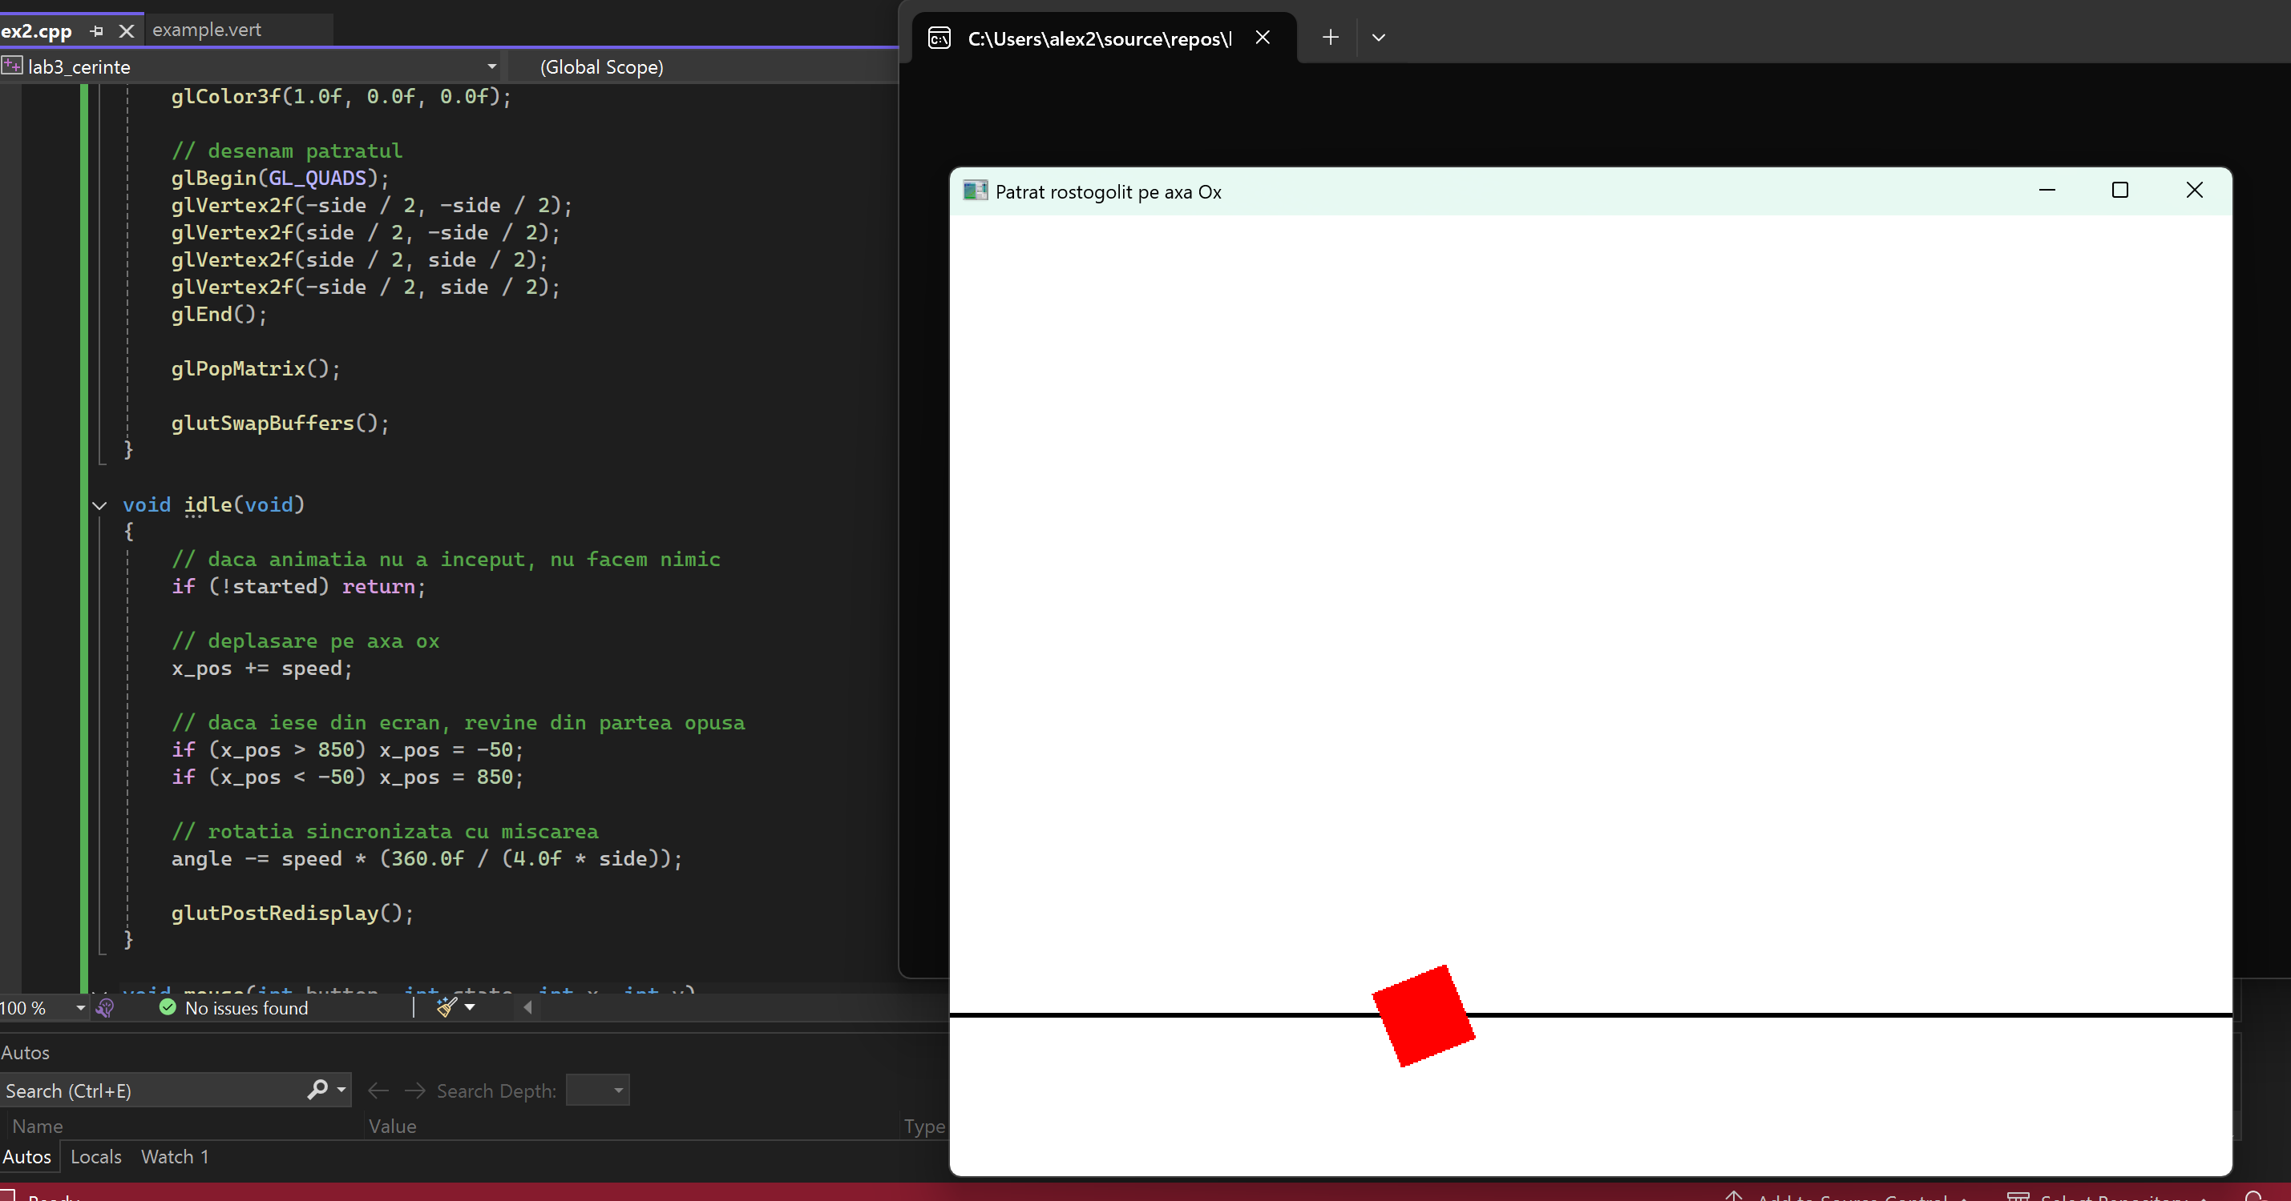
3) (2p) Folositi liste de display (codul sursa 02_04_hexagon.cpp) si codul sursa „dreptunghi cu satelit” (03_05_animatie.cpp) pentru a crea un minisistem solar (stea / planeta / satelit).
#include <windows.h>
#include <GL/freeglut.h>
#include <math.h>

// liste de display
GLuint disp_star;
GLuint disp_planet;
GLuint disp_moon;

// unghiurile de rotatie
float rot_planet = 0.0f;
float rot_moon = 0.0f;

// initializare obiecte in liste de display
void init(void)
{
glClearColor(0.0, 0.0, 0.0, 0.0);

// lista pentru stea (un disc simplu)
disp_star = glGenLists(1);
glNewList(disp_star, GL_COMPILE);
glColor3f(1.0, 1.0, 0.0);
glBegin(GL_POLYGON);
for (int i = 0; i < 40; i++)
{
float a = i * 2 * 3.14159 / 40;
glVertex2f(30 * cos(a), 30 * sin(a));
}
glEnd();
glEndList();

// lista pentru planeta (disc albastru)
disp_planet = glGenLists(1);
glNewList(disp_planet, GL_COMPILE);
glColor3f(0.2, 0.4, 1.0);
glBegin(GL_POLYGON);
for (int i = 0; i < 40; i++)
{
float a = i * 2 * 3.14159 / 40;
glVertex2f(20 * cos(a), 20 * sin(a));
}
glEnd();
glEndList();

// lista pentru satelit (disc gri mic)
disp_moon = glGenLists(1);
glNewList(disp_moon, GL_COMPILE);
glColor3f(0.6, 0.6, 0.6);
glBegin(GL_POLYGON);
for (int i = 0; i < 40; i++)
{
float a = i * 2 * 3.14159 / 40;
glVertex2f(8 * cos(a), 8 * sin(a));
}
glEnd();
glEndList();

glMatrixMode(GL_PROJECTION);
glLoadIdentity();
gluOrtho2D(-300, 300, -300, 300);
}

void display(void)
{
glClear(GL_COLOR_BUFFER_BIT);

glMatrixMode(GL_MODELVIEW);
glLoadIdentity();

// steaua (centrul sistemului)
glPushMatrix();
glCallList(disp_star); // steaua ramane fixa
glPopMatrix();

// planeta care orbiteaza steaua
glPushMatrix();
glRotatef(rot_planet, 0, 0, 1); // rotatie in jurul stelei
glTranslatef(150, 0, 0); // raza orbitei planetei
glCallList(disp_planet);

// satelitul care orbiteaza planeta
glPushMatrix();
glRotatef(rot_moon, 0, 0, 1); // rotatie in jurul planetei
glTranslatef(40, 0, 0); // raza orbitei satelitului
glCallList(disp_moon);
glPopMatrix();

glPopMatrix();

glutSwapBuffers();
}

void idle(void)
{
// miscare continua
rot_planet += 0.015f;
rot_moon += 0.015f;

glutPostRedisplay();
}

int main(int argc, char** argv)
{
glutInit(&argc, argv);
glutInitDisplayMode(GLUT_DOUBLE | GLUT_RGB);
glutInitWindowSize(600, 600);
glutCreateWindow("Minisistem solar");

init();

glutDisplayFunc(display);
glutIdleFunc(idle);

glutMainLoop();
return 0;
}

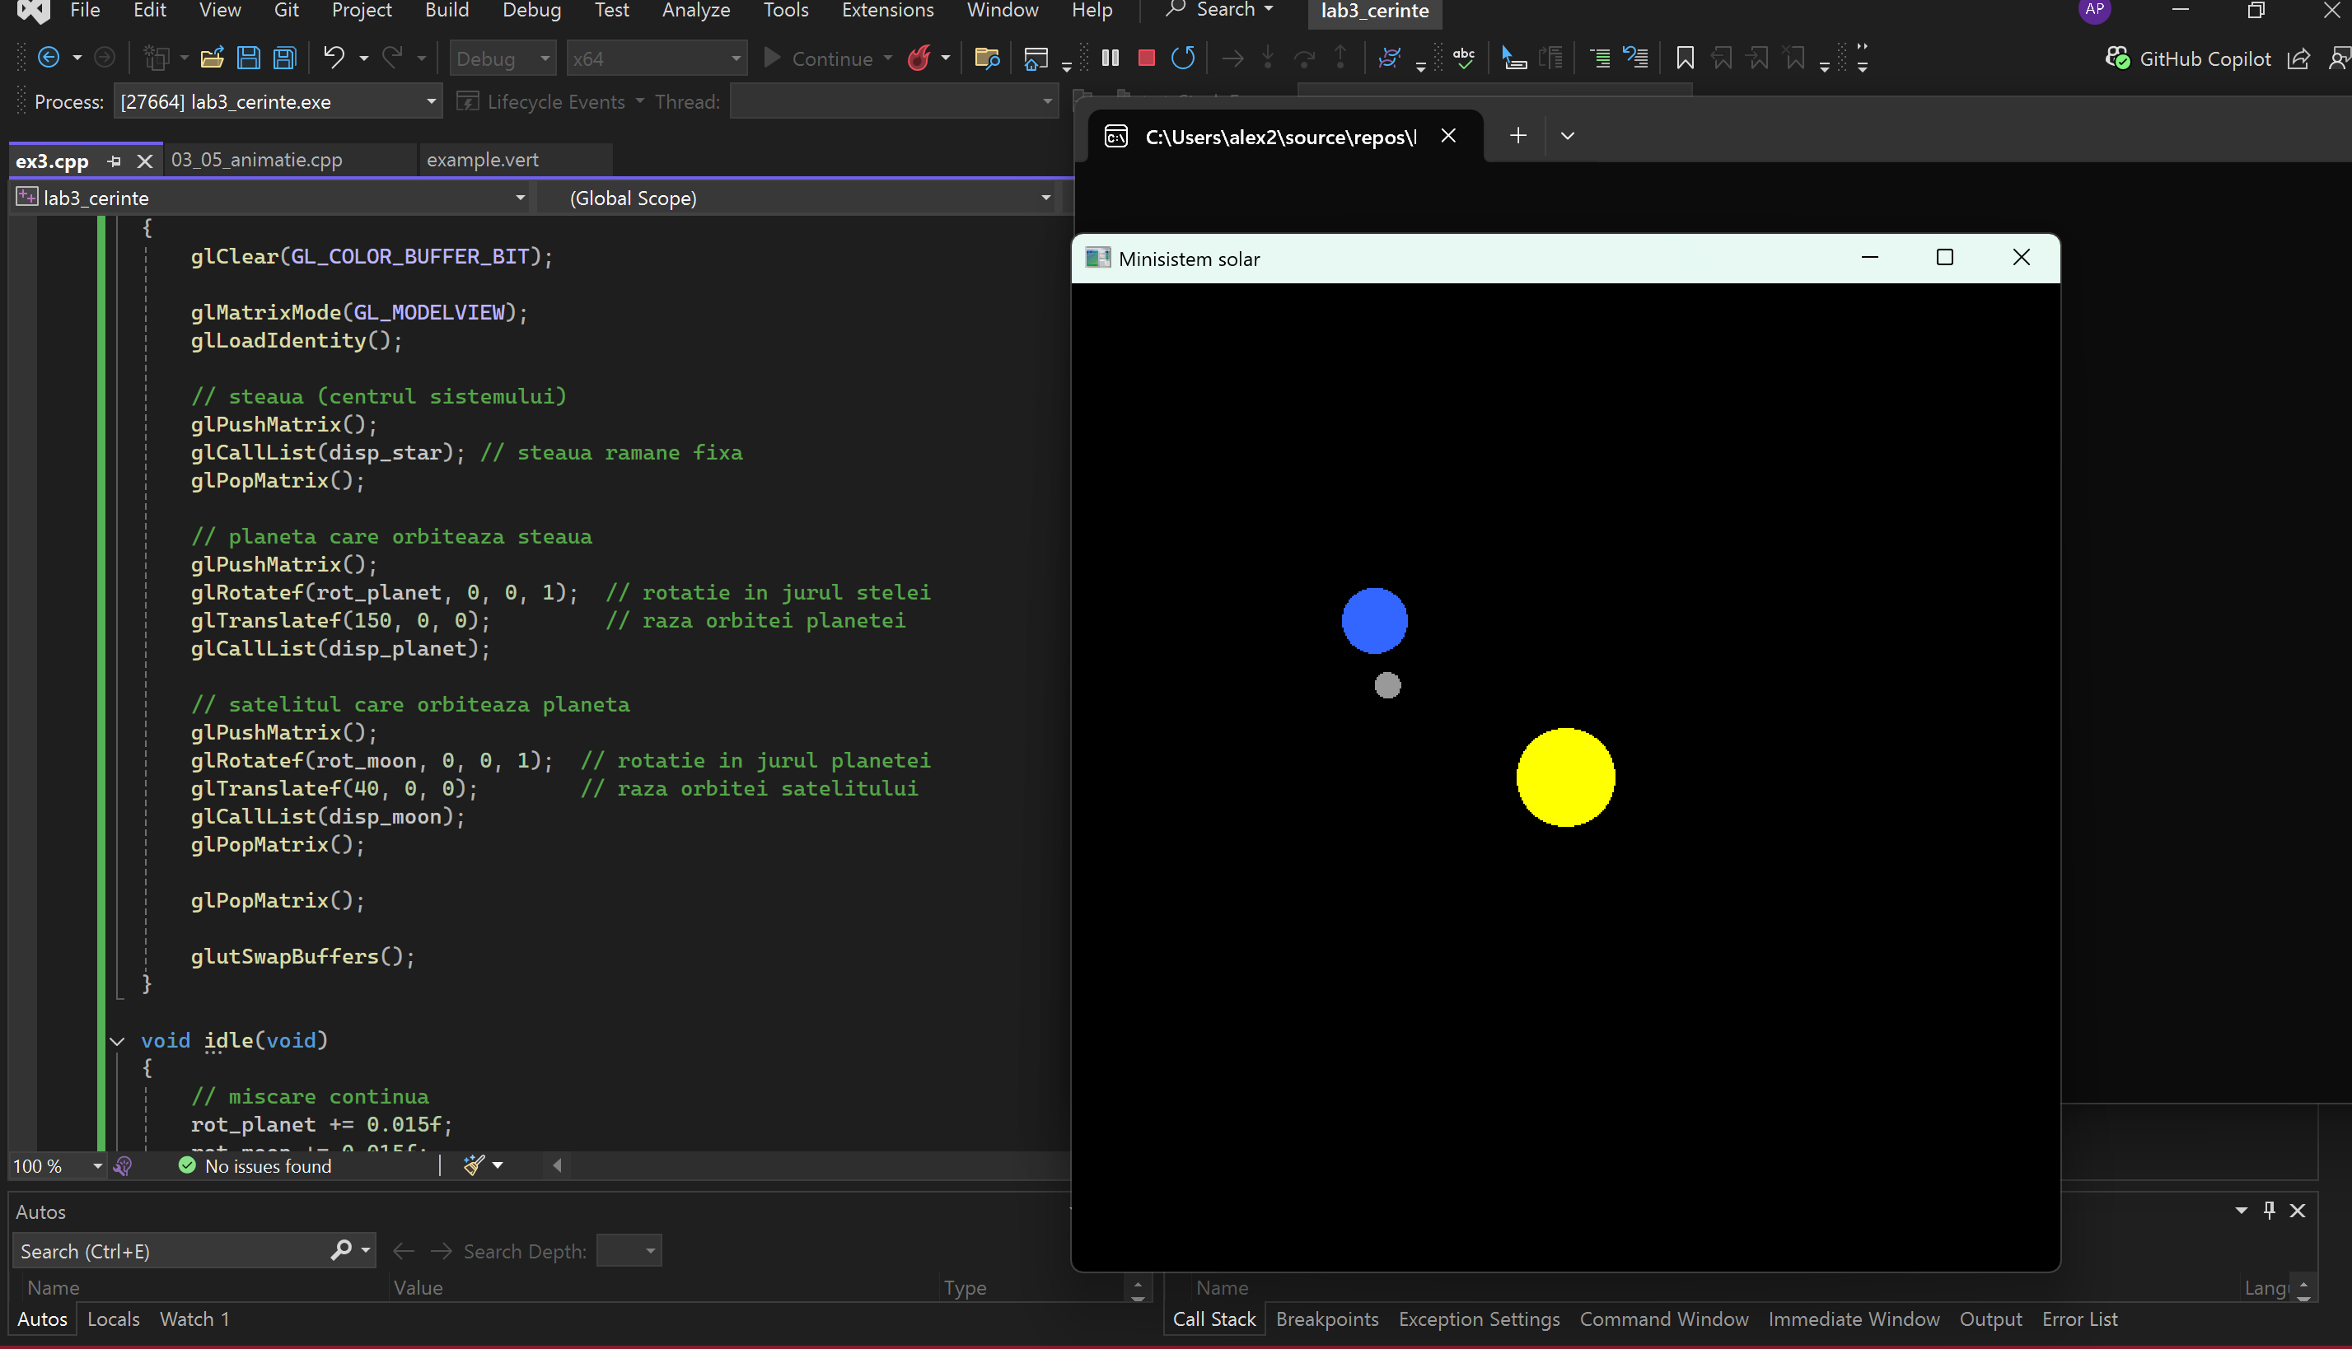
4) (2p, din care 1p pentru ordinea corecta a transformarilor) Desenati un patrat centrat in origine, avand latura egala cu 30. Utilizati apoi o scalare cu factori (2.0, 0.5) si o translatie de vector (100,100). Desenati, in plus, in acelasi desen (atentie la ordinea transformarilor!):
• cu un amestec de culori ceea ce se obtine aplicand intai scalarea, apoi translatia
• texturat ce se obtine aplicand intai translatia, apoi scalarea.
#include <windows.h>
#include <GL/freeglut.h>

#define TEX_SIZE 64
GLuint texID;

void createTexture()
{
// creez o textura de carouri in nuante de mov
unsigned char data[TEX_SIZE][TEX_SIZE][3];

for (int i = 0; i < TEX_SIZE; ++i)
for (int j = 0; j < TEX_SIZE; ++j)
{
int c = ((i / 8) % 2) ^ ((j / 8) % 2);
unsigned char col = c ? 255 : 100;
data[i][j][0] = col; // rosu
data[i][j][1] = 50; // verde
data[i][j][2] = 150; // albastru (rezulta mov)
}

glGenTextures(1, &texID);
glBindTexture(GL_TEXTURE_2D, texID);

glTexParameteri(GL_TEXTURE_2D, GL_TEXTURE_MIN_FILTER, GL_LINEAR);
glTexParameteri(GL_TEXTURE_2D, GL_TEXTURE_MAG_FILTER, GL_LINEAR);

glTexImage2D(GL_TEXTURE_2D, 0, GL_RGB, TEX_SIZE, TEX_SIZE,
0, GL_RGB, GL_UNSIGNED_BYTE, data);
}

void init(void)
{
// culoarea de fundal
glClearColor(1.0, 1.0, 1.0, 1.0);

// setare proiectie ortogonala
glMatrixMode(GL_PROJECTION);
glLoadIdentity();
gluOrtho2D(-300, 300, -300, 300);

// textura mov
createTexture();
}

void drawSquareTextured()
{
// patrat centrat in origine, latura 30, cu textura mov
glBegin(GL_QUADS);
glTexCoord2f(0, 0); glVertex2f(-15, -15);
glTexCoord2f(1, 0); glVertex2f(15, -15);
glTexCoord2f(1, 1); glVertex2f(15, 15);
glTexCoord2f(0, 1); glVertex2f(-15, 15);
glEnd();
}

void drawSquarePlain()
{
// patrat centrat in origine fara textura
glBegin(GL_QUADS);
glVertex2f(-15, -15);
glVertex2f(15, -15);
glVertex2f(15, 15);
glVertex2f(-15, 15);
glEnd();
}

void display(void)
{
glClear(GL_COLOR_BUFFER_BIT);

// patratul original desenat in negru
glColor3f(0, 0, 0);
drawSquarePlain();

// figura obtinuta aplicand mai intai scalarea si apoi translatie
// aceasta figura este colorata (foloseste culoarea alba)
// ordinea apelurilor: scalare apoi translatie
// ordinea aplicata obiectului: translatie * scalare * v
glPushMatrix();

glColor3f(1, 0.6f, 0.0f); // acum este portocaliu real
glTranslatef(100.0f, 100.0f, 0); // translatie dupa scalare
glScalef(2.0f, 0.5f, 1.0f); // scalare in jurul originii

drawSquarePlain();
glPopMatrix();
// figura obtinuta aplicand mai intai translatie si apoi scalarea
// aceasta figura este texturata (textura mov)
// ordinea apelurilor: translatie apoi scalare
// ordinea aplicata obiectului: scalare * translatie * v
glPushMatrix();
glEnable(GL_TEXTURE_2D);
glBindTexture(GL_TEXTURE_2D, texID);

glScalef(2.0f, 0.5f, 1.0f); // scalare care afecteaza si translatie
glTranslatef(100.0f, 100.0f, 0); // translatie

drawSquareTextured();
glDisable(GL_TEXTURE_2D);
glPopMatrix();
glFlush();
}

int main(int argc, char** argv)
{
glutInit(&argc, argv);
glutInitDisplayMode(GLUT_SINGLE | GLUT_RGB);
glutInitWindowSize(600, 600);
glutCreateWindow("ordine transformari si texturare");
init();
glutDisplayFunc(display);
glutMainLoop();
return 0;
}

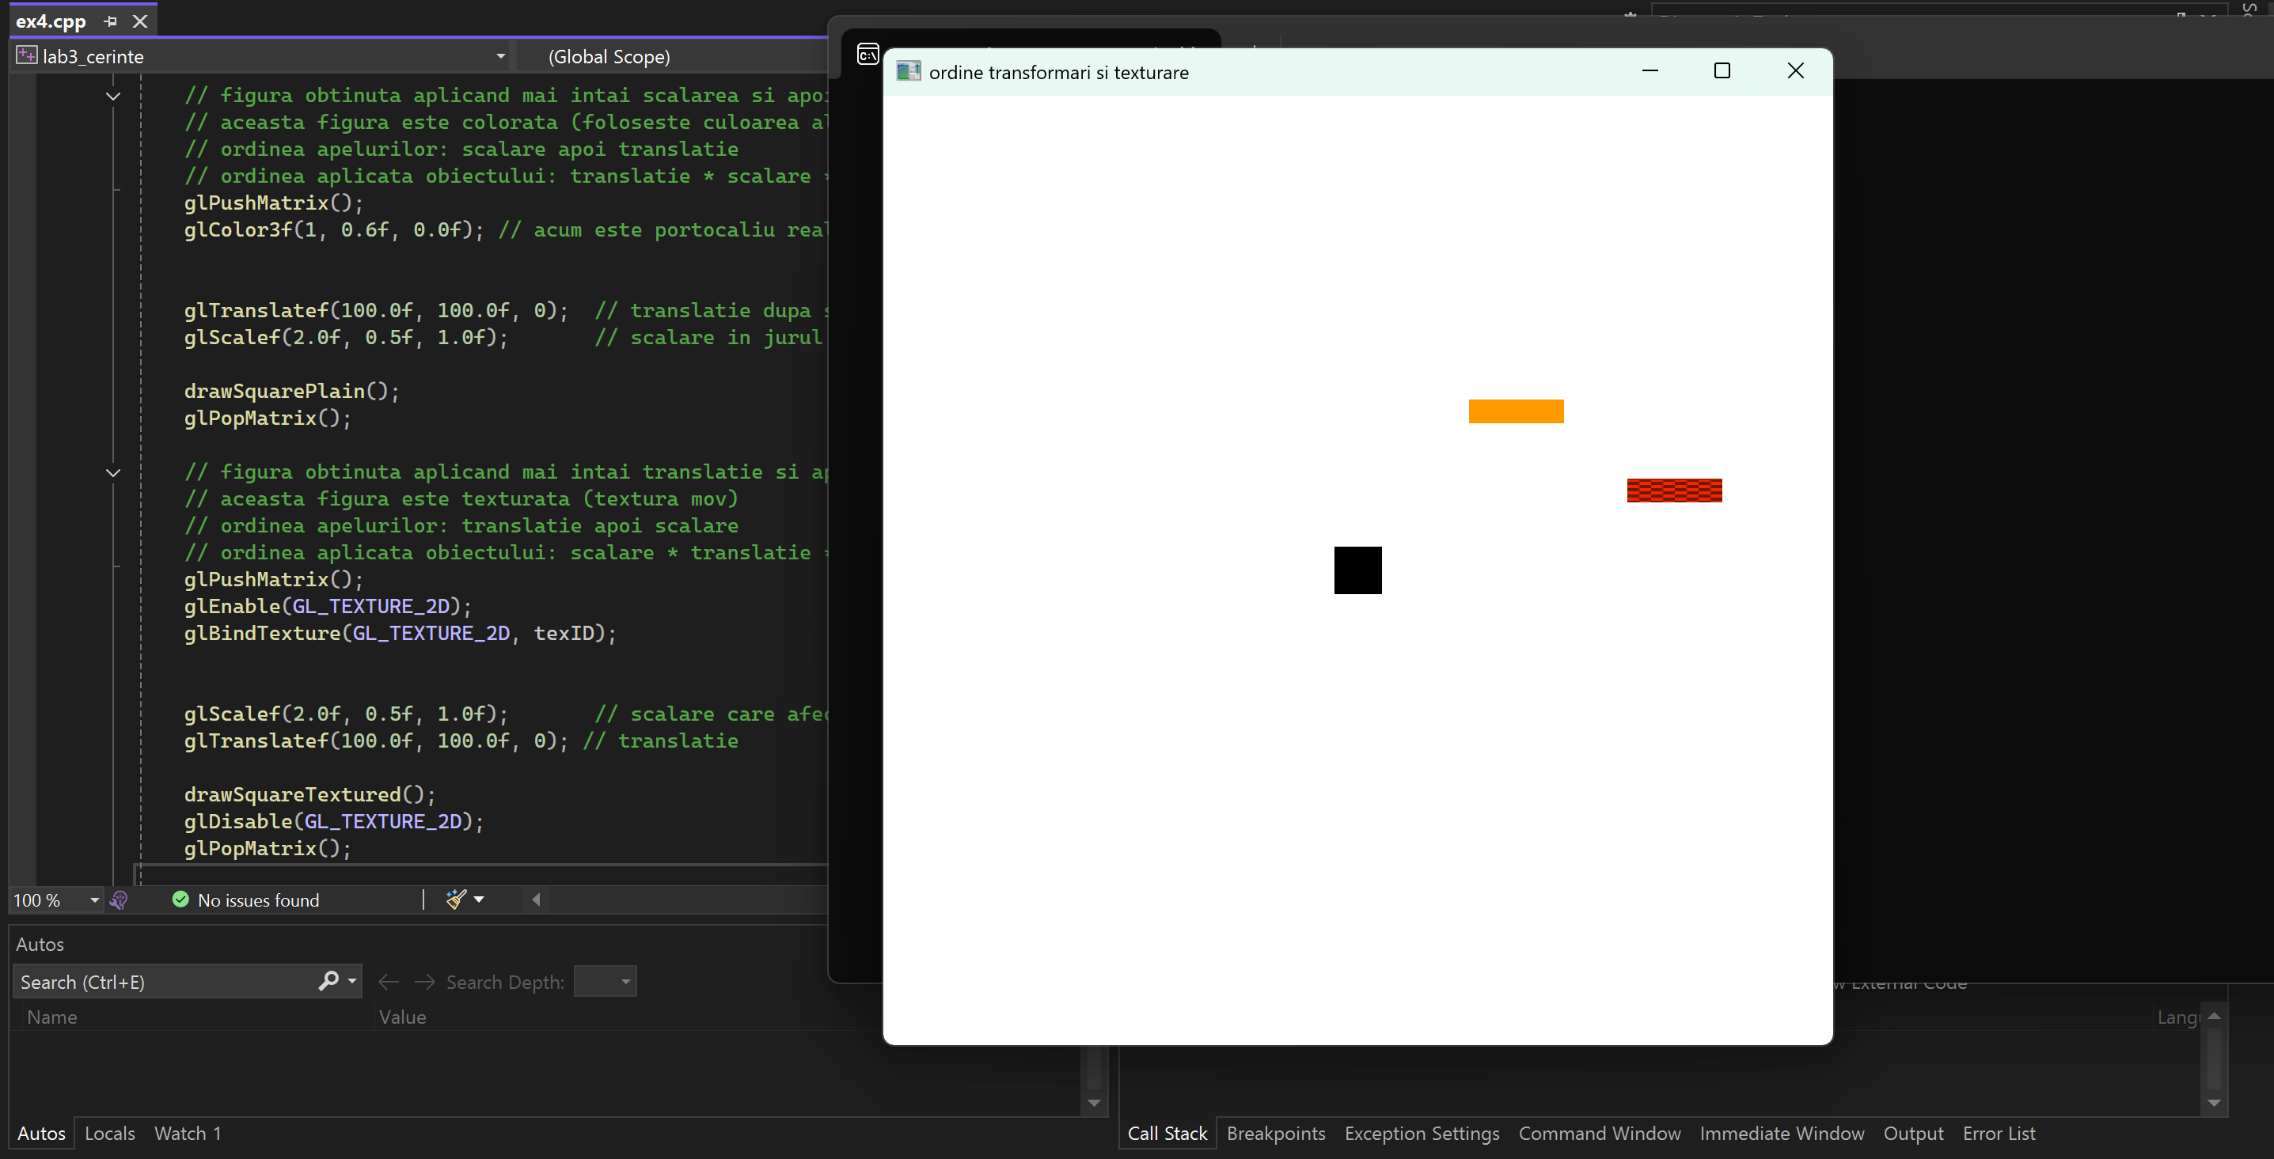
5) (2p/3p) Adaugati o textura intr-unul din desenele realizate la o tema anterioara (se acorda 2p pentru un desen „static”, respectiv 3p pentru un desen „dinamic”).
#include <windows.h>
#include <math.h>
#include <stdlib.h>
#include <GL/freeglut.h>

GLuint casaDL, acoperisDL, fereastraDL, copacDL, copacFrunzeDL;
GLuint soareDL, hornDL, fumDL;

GLuint textureID; /* textura pentru fum */
GLuint texturaFrunzeID; /* textura pentru coroana copacului */

GLfloat rotSun = 0.0f; /* unghi rotatie soare */
GLfloat fumOffset = 0.0f; /* deplasare fum pe verticala */

float texShift = 0.0f; /* deplasare textura fum */

const double TWO_PI = 6.2831853;

unsigned char textura[16][16][3];
unsigned char texturaFrunze[16][16][3];

/* generare textura fum (pattern in patrate 16x16) */
void generareTextura()
{
for (int i = 0; i < 16; i++)
for (int j = 0; j < 16; j++)
{
int c = ((i / 4 + j / 4) % 2) * 180;
textura[i][j][0] = c;
textura[i][j][1] = 200 - c / 3;
textura[i][j][2] = 255;
}

glGenTextures(1, &textureID);
glBindTexture(GL_TEXTURE_2D, textureID);

glTexImage2D(GL_TEXTURE_2D, 0, GL_RGB, 16, 16, 0,
GL_RGB, GL_UNSIGNED_BYTE, textura);

glTexParameteri(GL_TEXTURE_2D, GL_TEXTURE_MIN_FILTER, GL_NEAREST);
glTexParameteri(GL_TEXTURE_2D, GL_TEXTURE_MAG_FILTER, GL_NEAREST);
}

/* generare textura pentru coroana copacului (carouri verzi) */
void generareTexturaFrunze()
{
for (int i = 0; i < 16; i++)
for (int j = 0; j < 16; j++)
{
int c = ((i / 4 + j / 4) % 2);

if (c == 0)
{
texturaFrunze[i][j][0] = 0;
texturaFrunze[i][j][1] = 160;
texturaFrunze[i][j][2] = 0;
}
else
{
texturaFrunze[i][j][0] = 0;
texturaFrunze[i][j][1] = 80;
texturaFrunze[i][j][2] = 0;
}
}

glGenTextures(1, &texturaFrunzeID);
glBindTexture(GL_TEXTURE_2D, texturaFrunzeID);

glTexImage2D(GL_TEXTURE_2D, 0, GL_RGB, 16, 16, 0,
GL_RGB, GL_UNSIGNED_BYTE, texturaFrunze);

glTexParameteri(GL_TEXTURE_2D, GL_TEXTURE_MIN_FILTER, GL_NEAREST);
glTexParameteri(GL_TEXTURE_2D, GL_TEXTURE_MAG_FILTER, GL_NEAREST);
}

void init(void)
{
glClearColor(1.0, 1.0, 1.0, 1.0);

generareTextura();
generareTexturaFrunze();

/* casa */
casaDL = glGenLists(1);
glNewList(casaDL, GL_COMPILE);
glColor3f(0.8, 0.5, 0.2);
glBegin(GL_POLYGON);
glVertex2i(-100, -50);
glVertex2i(100, -50);
glVertex2i(100, 100);
glVertex2i(-100, 100);
glEnd();
glEndList();

/* acoperis */
acoperisDL = glGenLists(1);
glNewList(acoperisDL, GL_COMPILE);
glColor3f(0.7, 0.0, 0.0);
glBegin(GL_TRIANGLES);
glVertex2i(-120, 100);
glVertex2i(120, 100);
glVertex2i(0, 180);
glEnd();
glEndList();

/* fereastra */
fereastraDL = glGenLists(1);
glNewList(fereastraDL, GL_COMPILE);
glColor3f(0.2, 0.7, 1.0);
glBegin(GL_POLYGON);
glVertex2i(-30, 10);
glVertex2i(30, 10);
glVertex2i(30, 60);
glVertex2i(-30, 60);
glEnd();
glEndList();

/* trunchi copac */
copacDL = glGenLists(1);
glNewList(copacDL, GL_COMPILE);
glColor3f(0.5, 0.2, 0.0);
glBegin(GL_POLYGON);
glVertex2i(-15, -50);
glVertex2i(15, -50);
glVertex2i(15, 40);
glVertex2i(-15, 40);
glEnd();
glEndList();

/* coroana copac texturata */
copacFrunzeDL = glGenLists(1);
glNewList(copacFrunzeDL, GL_COMPILE);

glBindTexture(GL_TEXTURE_2D, texturaFrunzeID);

glBegin(GL_TRIANGLE_FAN);
glTexCoord2f(0.5, 0.5);
glVertex2i(0, 100);

for (int k = 0; k <= 20; k++)
{
float a = TWO_PI * k / 20;
float x = 60 * cos(a);
float y = 60 * sin(a) + 40;

glTexCoord2f((x + 60) / 120.0, (y + 20) / 120.0);
glVertex2f(x, y);
}
glEnd();

glEndList();

/* soare */
soareDL = glGenLists(1);
glNewList(soareDL, GL_COMPILE);

glColor3f(1.0, 0.8, 0.0);
glBegin(GL_TRIANGLE_FAN);
glVertex2i(0, 0);
for (int k = 0; k <= 40; k++)
{
float a = TWO_PI * k / 40;
glVertex2f(40 * cos(a), 40 * sin(a));
}
glEnd();

glColor3f(1.0, 0.7, 0.0);
glBegin(GL_LINES);
for (int k = 0; k < 16; k++)
{
float a = TWO_PI * k / 16;
glVertex2f(45 * cos(a), 45 * sin(a));
glVertex2f(70 * cos(a), 70 * sin(a));
}
glEnd();

glEndList();

/* horn */
hornDL = glGenLists(1);
glNewList(hornDL, GL_COMPILE);
glColor3f(0.4, 0.2, 0.1);
glBegin(GL_POLYGON);
glVertex2i(60, 100);
glVertex2i(90, 100);
glVertex2i(90, 150);
glVertex2i(60, 150);
glEnd();
glEndList();

/* fum texturat */
fumDL = glGenLists(1);
glNewList(fumDL, GL_COMPILE);

glBindTexture(GL_TEXTURE_2D, textureID);

glBegin(GL_TRIANGLE_FAN);
glTexCoord2f(0.5, 0.5);
glVertex2i(0, 0);

for (int k = 0; k <= 20; k++)
{
float a = TWO_PI * k / 20;
float x = 20 * cos(a);
float y = 20 * sin(a);

glTexCoord2f((x + 20) / 40.0, (y + 20) / 40.0);
glVertex2f(x, y);
}
glEnd();

glEndList();

glMatrixMode(GL_PROJECTION);
glLoadIdentity();
gluOrtho2D(-350, 350, -350, 350);
}

/* afisare scena */
void displayFcn(void)
{
glClear(GL_COLOR_BUFFER_BIT);

glCallList(casaDL);
glCallList(acoperisDL);
glCallList(fereastraDL);
glCallList(hornDL);

/* copac cu textura pe coroana */
glPushMatrix();
glTranslatef(-200, -30, 0);
glCallList(copacDL);

glEnable(GL_TEXTURE_2D);
glCallList(copacFrunzeDL);
glDisable(GL_TEXTURE_2D);
glPopMatrix();

/* soare */
glPushMatrix();
glTranslatef(200, 200, 0);
glRotatef(rotSun, 0, 0, 1);
glCallList(soareDL);
glPopMatrix();

/* aplicare transformare textura fum */
glMatrixMode(GL_TEXTURE);
glLoadIdentity();
glTranslatef(texShift, 0.0f, 0.0f); /* textura se deplaseaza pe orizontala */
glMatrixMode(GL_MODELVIEW);

/* fum texturat animat */
glEnable(GL_TEXTURE_2D);

glPushMatrix();
glTranslatef(75, 150, 0);

glPushMatrix();
glTranslatef(0, fumOffset, 0);
glCallList(fumDL);
glPopMatrix();

glPushMatrix();
glTranslatef(10, fumOffset + 30, 0);
glScalef(0.8, 0.8, 1);
glCallList(fumDL);
glPopMatrix();

glPushMatrix();
glTranslatef(-10, fumOffset + 60, 0);
glScalef(0.6, 0.6, 1);
glCallList(fumDL);
glPopMatrix();

glPopMatrix();

glDisable(GL_TEXTURE_2D);

/* resetare matrice textura */
glMatrixMode(GL_TEXTURE);
glLoadIdentity();
glMatrixMode(GL_MODELVIEW);

glutSwapBuffers();
}

/* actualizare animatie */
void timerFcn(int value)
{
rotSun += 1.0f;
if (rotSun >= 360) rotSun = 0;

fumOffset += 0.5f;
if (fumOffset > 120) fumOffset = 0;

texShift += 0.01f; /* avansare textura fum */
if (texShift > 1.0f)
texShift = 0.0f;

glutPostRedisplay();
glutTimerFunc(16, timerFcn, 1);
}

void reshapeFcn(int w, int h)
{
glViewport(0, 0, w, h);
glMatrixMode(GL_PROJECTION);
glLoadIdentity();
gluOrtho2D(-350, 350, -350, 350);
glMatrixMode(GL_MODELVIEW);
glLoadIdentity();
}

int main(int argc, char** argv)
{
glutInit(&argc, argv);
glutInitDisplayMode(GLUT_DOUBLE | GLUT_RGB);

glutInitWindowSize(700, 700);
glutCreateWindow("casa cu fum si coroana texturate");

init();

glutDisplayFunc(displayFcn);
glutReshapeFunc(reshapeFcn);
glutTimerFunc(16, timerFcn, 1);

glutMainLoop();
return 0;
}

