Tema 1

2) (1p) Modificati in codul sursa 01_01_exemplu.cpp urmatoarele elemente:
- dimensiunea si pozitionarea ferestrei de vizualizare;
- tipul / culorile primitivelor reprezentate (de exemplu desenati un triunghi);
#include <windows.h> // sunt mentionate fisiere (biblioteci) care urmeaza sa fie incluse
#include <gl/freeglut.h> // nu trebuie uitat freeglut.h (sau glut.h sau gl.h & glu.h)
void init(void) // initializare fereastra de vizualizare
{
glClearColor(1.0, 1.0, 1.0, 0.0); // precizeaza culoarea de fond a ferestrei de vizualizare
glMatrixMode(GL_PROJECTION); // se precizeaza este vorba de o reprezentare 2D, realizata prin proiectie ortogonala
gluOrtho2D(0.0, 400.0, 0.0, 300.0); // sunt indicate coordonatele extreme ale ferestrei de vizualizare
}
void desen(void) // procedura desenare
{
glClear(GL_COLOR_BUFFER_BIT); // curata fereastra de vizualizare
glColor3f(0.0, 0.8, 0.2);// culoarea triunghiului: verde
// se reprezinta un triunghi
glBegin(GL_TRIANGLES);
glVertex2i(100, 50);
glVertex2i(300, 50);
glVertex2i(200, 200);
glEnd();
glFlush(); // proceseaza procedurile OpenGL cat mai rapid
}
void main(int argc, char** argv)
{
glutInit(&argc, argv); // initializare GLUT
glutInitDisplayMode(GLUT_SINGLE | GLUT_RGB); // se utilizeaza un singur buffer | modul de colorare RedGreenBlue (= default)
// modificare: pozitia si dimensiunea ferestrei de vizualizare
glutInitWindowPosition(200, 150); // pozitia initiala a ferestrei (in coordonate ecran)
glutInitWindowSize(900, 700); // dimensiunile ferestrei (largime, inaltime)

glutCreateWindow("Triunghi verde"); // creeaza fereastra, indicand numele ferestrei de vizualizare - apare in partea superioara
init(); // executa procedura de initializare
glClear(GL_COLOR_BUFFER_BIT); // reprezentare si colorare fereastra de vizualizare
glutDisplayFunc(desen); // procedura desen este invocata ori de cate ori este nevoie
glutMainLoop(); // ultima instructiune a programului, asteapta (eventuale) noi date de intrare
}
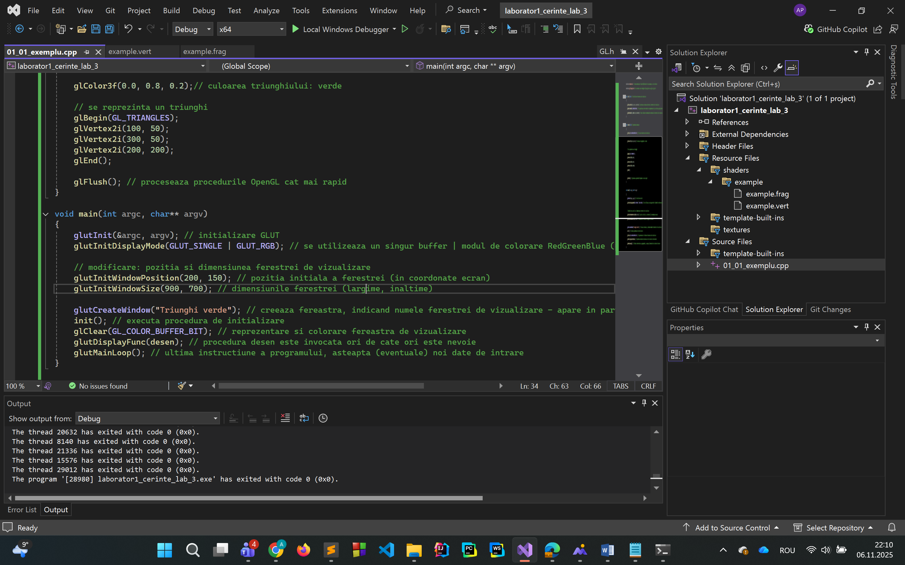
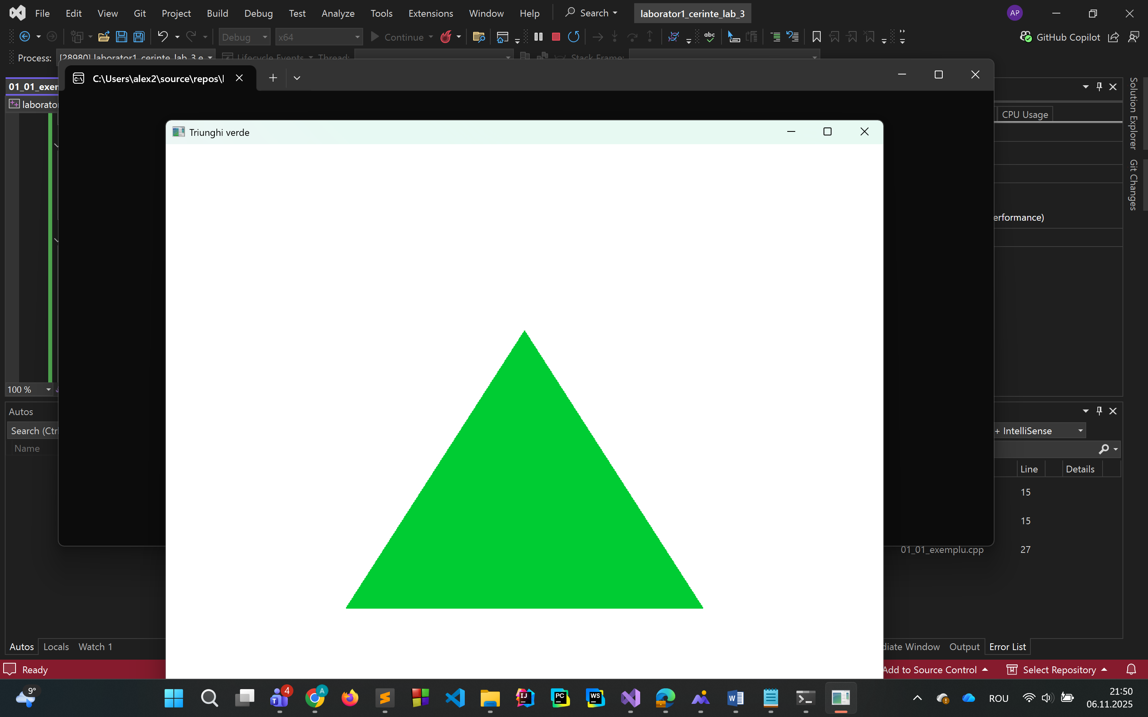
3) (1p) Folositi segmente de dreapta pentru a afisa data / alt text.
#include <GL/glut.h>
#include <ctime>
#include <cstdio>

// dimensiuni segmente
float segLength = 0.08f;
float segWidth = 0.018f;

// configurare cifre (a,b,c,d,e,f,g)
// 7 linii care pot forma orice cifra, ca la ceasul elecronic
int digits[10][7] = {
{1,1,1,1,1,1,0}, // 0
{0,1,1,0,0,0,0}, // 1
{1,1,0,1,1,0,1}, // 2
{1,1,1,1,0,0,1}, // 3
{0,1,1,0,0,1,1}, // 4
{1,0,1,1,0,1,1}, // 5
{1,0,1,1,1,1,1}, // 6
{1,1,1,0,0,0,0}, // 7
{1,1,1,1,1,1,1}, // 8
{1,1,1,1,0,1,1} // 9
};

// segment orizontal
void drawHSegment(float x, float y) {
glBegin(GL_QUADS);
glVertex2f(x, y);
glVertex2f(x + segLength, y);
glVertex2f(x + segLength, y + segWidth);
glVertex2f(x, y + segWidth);
glEnd();
}

// segment vertical
void drawVSegment(float x, float y) {
glBegin(GL_QUADS);
glVertex2f(x, y);
glVertex2f(x + segWidth, y);
glVertex2f(x + segWidth, y + segLength);
glVertex2f(x, y + segLength);
glEnd();
}

// cifra din segmente
void drawDigit(int num, float x, float y) {
glPushMatrix();
glTranslatef(x, y, 0);

if (digits[num][0]) drawHSegment(0, segLength * 2); // a
if (digits[num][1]) drawVSegment(segLength, segLength); // b
if (digits[num][2]) drawVSegment(segLength, 0); // c
if (digits[num][3]) drawHSegment(0, 0); // d
if (digits[num][4]) drawVSegment(0, 0); // e
if (digits[num][5]) drawVSegment(0, segLength); // f
if (digits[num][6]) drawHSegment(0, segLength); // g

glPopMatrix();
}

// separator „/” oblic
void drawSlash(float x, float y) {
glBegin(GL_QUADS);
glVertex2f(x, y);
glVertex2f(x + segWidth, y);
glVertex2f(x + segLength * 0.8f, y + segLength * 2.5f);
glVertex2f(x + segLength * 0.8f - segWidth, y + segLength * 2.5f);
glEnd();
}

// functia de afisare
void display() {
glClear(GL_COLOR_BUFFER_BIT);
glColor3f(0.0f, 0.5f, 0.5f); // teal

// Ddata curenta
time_t t = time(nullptr);
struct tm now;
localtime_s(&now, &t);

int zi = now.tm_mday;
int luna = now.tm_mon + 1;
int an = now.tm_year + 1900;

char buffer[12];
sprintf_s(buffer, sizeof(buffer), "%02d/%02d/%04d", zi, luna, an);

// centrare pe ecran
int len = 0;
for (int i = 0; buffer[i] != '\0'; i++) len++;
float totalWidth = len * 0.23f;
float startX = -totalWidth / 2.0f;
float y = -0.05f;

// se deseneaza fiecare caracter
float x = startX;
for (int i = 0; buffer[i] != '\0'; i++) {
if (buffer[i] == '/') {
drawSlash(x + 0.05f, y); // separator „/” oblic
x += 0.15f;
}
else {
int num = buffer[i] - '0';
drawDigit(num, x, y);
x += 0.23f;
}
}

glutSwapBuffers();
}

// se actualizeaza periodic
void timer(int) {
glutPostRedisplay();
glutTimerFunc(1000, timer, 0);
}

// redimensionare proportionala
void reshape(int w, int h) {
glViewport(0, 0, w, h);
glMatrixMode(GL_PROJECTION);
glLoadIdentity();

float aspect = (float)w / (float)h;
if (aspect >= 1.0f)
gluOrtho2D(-aspect, aspect, -1.0, 1.0);
else
gluOrtho2D(-1.0, 1.0, -1.0 / aspect, 1.0 / aspect);
}

void init() {
glClearColor(0, 0, 0, 1);
glMatrixMode(GL_PROJECTION);
glLoadIdentity();
gluOrtho2D(-1.8, 1.8, -1, 1);
}

int main(int argc, char** argv) {
glutInit(&argc, argv);
glutInitDisplayMode(GLUT_DOUBLE | GLUT_RGB);
glutInitWindowSize(800, 300);
glutCreateWindow("Data curenta");
init();
glutDisplayFunc(display);
glutReshapeFunc(reshape);
glutTimerFunc(0, timer, 0);
glutMainLoop();
return 0;
}
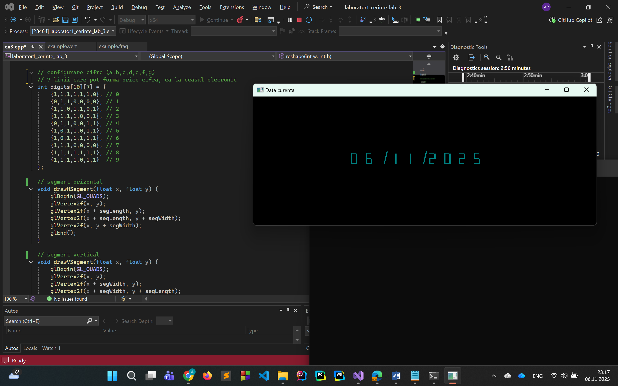
4) (1p, suplimentar) Realizati o reprezentare 2D simplificata a cubului RGB (puteti utiliza si aceasta resursa)
#include <windows.h>
#include <gl/freeglut.h>
#include <string.h>

// functie pentru desenarea textului
void drawText(const char* text, float x, float y)
{
glRasterPos2f(x, y);
for (int i = 0; i < strlen(text); i++)
glutBitmapCharacter(GLUT_BITMAP_HELVETICA_12, text[i]);
}

void init(void)
{
glClearColor(1.0, 1.0, 1.0, 0.0); // culoare de fundal: alb
glMatrixMode(GL_PROJECTION);
gluOrtho2D(0.0, 400.0, 0.0, 400.0); // sistem de coordonate 2D
}

void desen(void)
{
glClear(GL_COLOR_BUFFER_BIT);

// coordonatele varfurilor cubului (proiectie 2D)
int bx = 120, by = 220;
int size = 120;

float x[8] = {
bx, bx + size, bx + size, bx,
bx + 40, bx + size + 40, bx + size + 40, bx + 40
};
float y[8] = {
by, by, by - size, by - size,
by + 40, by + 40, by - size + 40, by - size + 40
};

// desenare muchii cub
glColor3f(0.0, 0.0, 0.0);
glBegin(GL_LINES);
// fata din spate
glVertex2f(x[0], y[0]); glVertex2f(x[1], y[1]);
glVertex2f(x[1], y[1]); glVertex2f(x[2], y[2]);
glVertex2f(x[2], y[2]); glVertex2f(x[3], y[3]);
glVertex2f(x[3], y[3]); glVertex2f(x[0], y[0]);
// fata din fata
glVertex2f(x[4], y[4]); glVertex2f(x[5], y[5]);
glVertex2f(x[5], y[5]); glVertex2f(x[6], y[6]);
glVertex2f(x[6], y[6]); glVertex2f(x[7], y[7]);
glVertex2f(x[7], y[7]); glVertex2f(x[4], y[4]);
// muchii laterale
glVertex2f(x[0], y[0]); glVertex2f(x[4], y[4]);
glVertex2f(x[1], y[1]); glVertex2f(x[5], y[5]);
glVertex2f(x[2], y[2]); glVertex2f(x[6], y[6]);
glVertex2f(x[3], y[3]); glVertex2f(x[7], y[7]);
glEnd();

// culorile
float r[8] = {
0, 1, 1, 0, // spate (Cyan, White, Yellow, Green)
0, 1, 1, 0 // fata (Blue, Magenta, Red, Black)
};
float g[8] = {
1, 1, 1, 1,
0, 0, 0, 0
};
float b[8] = {
1, 1, 0, 0,
1, 1, 0, 0
};

// 0: Cyan -> (0,1,1)
// 1: White -> (1,1,1)
// 2: Yellow -> (1,1,0)
// 3: Green -> (0,1,0)
// 4: Blue -> (0,0,1)
// 5: Magenta -> (1,0,1)
// 6: Red -> (1,0,0)
// 7: Black -> (0,0,0)
r[0] = 0; g[0] = 1; b[0] = 1; // Cyan
r[1] = 1; g[1] = 1; b[1] = 1; // White
r[2] = 1; g[2] = 1; b[2] = 0; // Yellow
r[3] = 0; g[3] = 1; b[3] = 0; // Green
r[4] = 0; g[4] = 0; b[4] = 1; // Blue
r[5] = 1; g[5] = 0; b[5] = 1; // Magenta
r[6] = 1; g[6] = 0; b[6] = 0; // Red
r[7] = 0; g[7] = 0; b[7] = 0; // Black

// desenare puncte colorate
glPointSize(10);
glBegin(GL_POINTS);
for (int i = 0; i < 8; i++) {
glColor3f(r[i], g[i], b[i]);
glVertex2f(x[i], y[i]);
}
glEnd();

// etichete pentru culori
glColor3f(0, 0, 0);
drawText("Cyan", x[0] - 30, y[0] - 10);
drawText("White", x[1] + 10, y[1] - 10);
drawText("Yellow", x[2] + 10, y[2] - 15);
drawText("Green", x[3] - 40, y[3] - 15);
drawText("Blue", x[4] - 30, y[4] + 10);
drawText("Magenta", x[5] + 10, y[5] + 10);
drawText("Red", x[6] + 10, y[6] - 10);
drawText("Black", x[7] - 30, y[7] - 10);

glFlush();
}

int main(int argc, char** argv)
{
glutInit(&argc, argv);
glutInitDisplayMode(GLUT_SINGLE | GLUT_RGB);
glutInitWindowPosition(200, 100);
glutInitWindowSize(500, 500);
glutCreateWindow("Cub RGB 2D");
init();
glutDisplayFunc(desen);
glutMainLoop();
return 0;
}

