Amazon Sales Prediction Project Report
Full-stack machine learning application
Report date: 22 September 2026

1. Executive summary
This project delivers an end-to-end Amazon sales prediction application. It loads order-level sales data, prepares numeric and categorical features, trains a Random Forest regression model, exposes predictions through a Flask REST API, and presents business insights through a Streamlit dashboard.

2. Dataset overview
Measure | Value
Source file | amazon_cleaned.csv
Usable records | 121,149
Dataset columns | 23
Target variable | Amount (INR)
Total sales | INR 78,574,007.30
Average order amount | INR 648.57
Maximum order amount | INR 5,584.00
The data preparation step standardizes column names, converts Amount and Qty to numeric values, removes invalid target rows, fills missing categorical values, and derives order month and day-of-week features from Date.

3. Technical architecture
The application is organized into reusable modules so the frontend, backend, and training workflow share the same feature preparation and model pipeline.
Layer | Implementation
Data | pandas with amazon_cleaned.csv
Preprocessing | Median imputation, StandardScaler, OneHotEncoder
Model | RandomForestRegressor, 180 estimators
Backend | Flask endpoints: health, dataset, model_info, predict
Frontend | Streamlit overview, prediction, and model insights pages
Persistence | joblib model.pkl and metrics.pkl artifacts

4. Model performance
Metric | Result | Interpretation
MAE | INR 118.12 | Average absolute prediction error
RMSE | INR 181.57 | Penalizes larger errors
R2 | 0.5814 | Explained variance on the test split
The model uses an 80/20 train-test split with random_state=42. Predictions are clipped at zero because a sales amount cannot be negative.
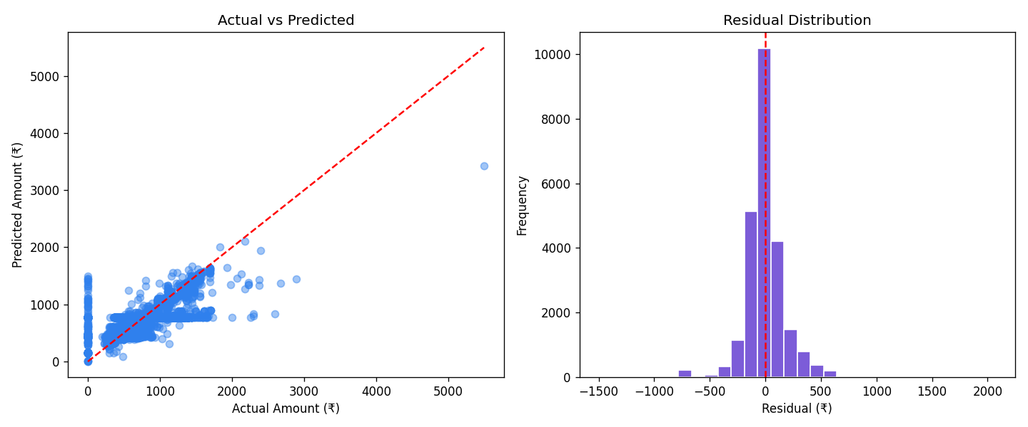
Figure 1. Actual versus predicted values and residual distribution.

5. User interface output
The Streamlit interface contains three views: Overview, Predict sales, and Model insights. The Overview page reports total sales, average order value, order count, monthly sales, category performance, and recent records. The Predict sales page accepts order attributes and displays an estimated amount in INR. Model insights displays the metrics and diagnostic plots.
Sample input | Value
Qty | 1
Status | Shipped
Fulfilment | Amazon
Sales Channel | Amazon.in
ship-service-level | Expedited
Category | Top
Size | M
Courier Status | Shipped
ship-state | MAHARASHTRA
B2B | False
order_month | 5
order_day_of_week | 2
Sample UI/API prediction: INR 489.62
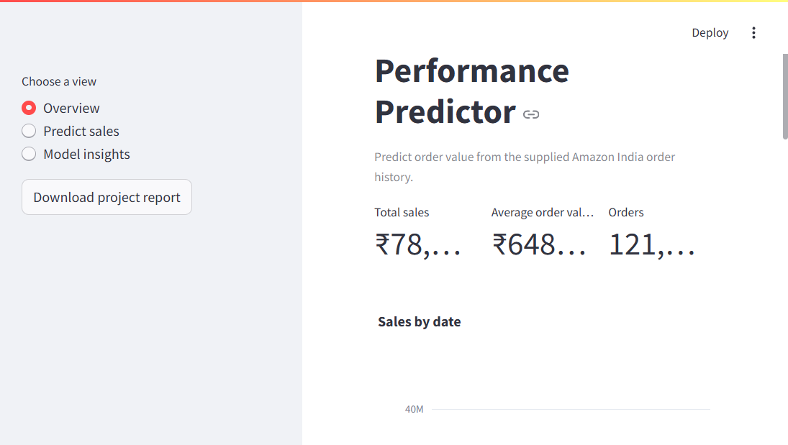
Figure 2. Live Streamlit overview page.

6. API output
POST /predict returns a JSON response in this format:
{
"predicted_amount": 489.62,
"currency": "INR"
}

7. Project structure and execution
data/amazon_cleaned.csv
model/model.pkl, metrics.pkl, diagnostics.png
backend/app.py
frontend/ui.py
ml_pipeline.py
train_model.py
generate_report.py
requirements.txt
README.md
Run the application with:
python train_model.py
python backend\app.py
streamlit run frontend\ui.py

8. Conclusion
The completed solution provides a reproducible machine-learning workflow and a practical business-facing interface for Amazon sales analysis. The modular structure makes it straightforward to retrain the model, extend the API, or add further dashboard visualizations.

