Cache Design
Extra Credit: Two-Way Set Associative Cache with LRU
VHDL Code and Simulation
CMPE 413 / CMPE 640 — Custom VLSI Design, UMBC

Student: Asif Ali
Reg No: RE16458
aali12@umbc.edu
Code and report: https://github.com/aali12-eng/CMPE413-Cache-Chip-2Way
October 29, 2026

Index

1 Description of the submission
This submission contains the VHDL design and simulation of the extra credit of the CMPE 413/640 project specification: "a two-way set associative cache i.e. instead of a 16 byte cache you have a 32 byte cache implementing 2 sets. For block replacement implement a least recently used (LRU) scheme." Everything else follows the main specification: byte addressable, 4-byte blocks, a 6-bit address (2-bit tag, 2-bit block offset, 2-bit byte offset), write through with no write allocate, the same chip interface, and the same timing (read hit 2 clocks, write hit or write miss 3 clocks, read miss 19 clocks).
The cache holds 2 ways (the specification's 2 sets) of 4 blocks of 4 bytes. The block offset of the address selects one block in each way, and the tag of the address is compared with the tags of both. A read miss fills an invalid way if there is one, otherwise the least recently used way; every hit and every fill makes its way the most recently used. The design reuses the direct mapped chip (the chip design folder) unchanged except for the cache and two control signals of the state machine.

1.1 Design strategy
- Hierarchical, structural design, built bottom-up: the course's primitive cells (dff, Dlatch, tx) and a small gate library form the cache cell, registers, decoders, multiplexers and counter; these form the cache, the hit/miss logic and the state machine; and these form the chip. Every level above the primitives is a netlist of instances, so each VHDL entity maps directly onto a schematic and a layout cell for Submission II.
- The cache storage uses exactly the cache cell of the specification (Figure 1): a positive level sensitive latch for Write Data, a transmission gate for Read Data, and the selector of Figure 2 that turns Chip enable and RD/WR into Write enable and Read enable. Read Data of all cells share bit lines, because a cell's transmission gate is off unless it is read.
- The chip works on the negative edge of the clock, as specified: the CPU and the memory change their signals on the positive edge, and every register of the chip samples them half a clock later. The only positive edge flip-flop makes the cache write signal, which the specification requires to be on for exactly one clock cycle from a positive edge to the next.
- Two ways built from the same cache blocks, sharing the block and byte decoders; one Hit/Miss unit per way; a way-select block that gives the hit, the way that hit and the victim way; and one LRU bit per block offset (exact LRU for two ways). The victim way is latched at the end of the tag compare, because the valid and LRU bits change while a read miss fills the block. While a read miss fills the block, each way holds its tag, valid bit and read byte, and the cache holds its hit/miss output from the end of the tag compare to the next request, so neither shows the cells being written.
- A one-hot state machine (one flip-flop per state) with a 5-bit counter sequences the four operations; its timing was taken from the specification, the desired-waveforms document and the reference output of the course testbench.
- Verification follows the hierarchy: each major block has a self-checking testbench; the chip has an extended self-checking testbench with a CPU model, a memory model and a reference model of the cache; finally the course testbench chip_test.vhd is run unchanged and its output is compared, line by line, with the course's reference output.

1.2 Results at a glance
- 12 of 12 self-checking testbenches pass.
- The course testbench chip_test.vhd runs unchanged (the component in it already matches the chip's ports) and its output matches the reference ncsim.log in all 70 printed clock edges (the only differences are before the first reset edge, where the reference simulator prints X and GHDL prints U for uninitialised flip-flops).
- Read hit 2 clocks, write hit and write miss 3 clocks, read miss 19 clocks, as specified.

2 Specification
Table 1: Specification summary
Item | Value
Organisation | Two-way set associative cache (extra credit)
Data | Byte addressable (8-bit data per location)
Size | 2 ways ("2 sets") × 4 blocks × 4 bytes = 32 bytes
Replacement | LRU, one bit per block offset; an invalid way is filled first
Address | 6 bits: 2-bit tag, 2-bit block offset, 2-bit byte offset
Write policy | Write through with no write allocate
Timing | Read hit 2 clocks; write hit / miss 3 clocks; read miss 19 clocks
Clocking | Inputs change on the positive edge; the chip works on the negative edge
Memory | Enable for one cycle with MA = tag, block offset, 00; first byte on the 8th negative edge after enable, then one byte every 2 cycles (8th, 10th, 12th, 14th)

Table 2: CPU address (CA)
Bits | 5 – 4 | 3 – 2 | 1 – 0
Field | Tag | Block Offset | Byte Offset
Use | Compared with the tags stored in both ways | Selects 1 block in each way | Selects 1 of 4 bytes

Table 3: Chip interface (port names as in the course testbench)
Signal | Port | Dir | Width | Function
CPU Address (CA) | cpu_add | in | 6 | Address from the CPU, with start
CPU Data (CD) | cpu_data | inout | 8 | Write data in; read data out (high impedance otherwise)
Read_Write (RD/WR) | cpu_rd_wrn | in | 1 | 1 = read, 0 = write
Start | start | in | 1 | Start of a CPU request
Busy | busy | out | 1 | Chip is processing a request
Reset | reset | in | 1 | Invalidates all blocks, resets the state machine
Clock | clk | in | 1 | Chip works on its negative edge
Memory Address (MA) | mem_add | out | 6 | Block address (last two bits 00) during enable
Memory Data (MD) | mem_data | in | 8 | Bytes from the memory on a read miss
Enable | mem_en | out | 1 | Memory read request, one clock cycle
Vdd, Gnd | Vdd, Gnd | in | 1 | Supply connections used for constant 1 and 0

3 Design overview

3.1 Hierarchical block diagram
The block diagram below shows the hierarchical breakup of this design (the diagram in the specification is generic and is only a reference). Colours: purple = chip, orange = cache, green = control, blue = building blocks, yellow = gates, grey = course primitives.
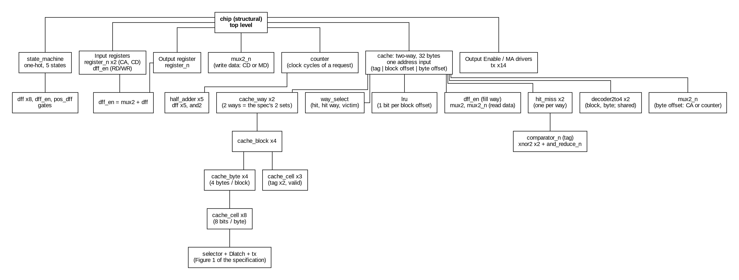
Figure 1: Hierarchical block diagram of the design
The chip connects these blocks: the CPU registers feed the state machine and the cache; the cache and its hit/miss logic tell the state machine whether the request hits; the state machine drives busy, the memory enable, the output register and the cache write signal.
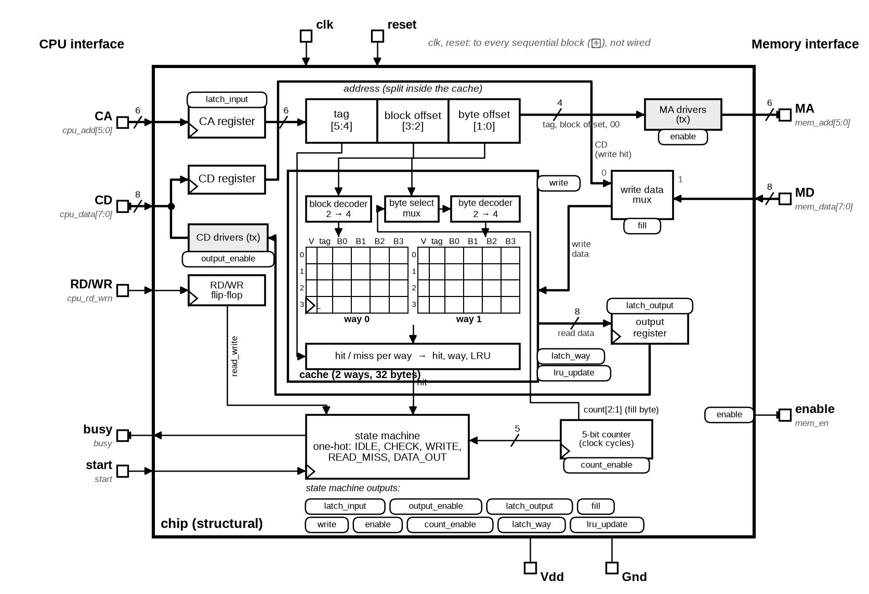
Figure 2: Chip overview: pins and data path
The following chapters describe each part of the design: its function, its testbench and the result. A few key diagrams are shown: the cache cell of the specification, the cache way and the two-way cache, and the control flow of the cache, the state machine and the chip. The VHDL of every part is in the folder code/two_way of the submission.
How to read the block diagrams in this report: grey arrow shapes are module ports; thick lines are buses, labelled with their width; a dot marks where a net branches. A triangle at the bottom-left of a block marks a sequential block, one that stores state (it contains negative edge flip-flops or, with an "L" next to the triangle, level sensitive latches: the cache cells). Blocks without the triangle are combinational. The clock is not drawn; it reaches every sequential block.

3.2 Design styles and why
- Structural VHDL (entity instantiation and generate loops) for every block above the primitives: it describes exactly the gates and cells that will be drawn in the schematic and layout in Submission II, so the schematics can be imported and LVS compared directly.
- Behavioural primitives only where the course provides them (dff, Dlatch, tx) and for the basic gates (y <= a and b after GATE_DELAY), so every gate has a propagation delay. GATE_DELAY = 100 ps, a conservative figure for the 45 nm (gpdk045) process; the longest path in one clock cycle is about 12 gates (1.2 ns) against a 10 ns clock.
- Negative edge registers everywhere: the CPU and memory signals are set up half a clock before they are sampled, which avoids setup time violations (as the specification intends).
- A one-hot state machine: one flip-flop per state, so every state decode is a single flip-flop output and the next-state logic is a few AND/OR gates per state; this is simple to lay out and has no decoding glitches on the outputs.
- Tri-state buses built from transmission gates: the cache cells share bit lines; CD is driven only while output enable is on; MA is driven only while enable is on (as in the reference output).
- Glitch-free cache writes: the cache address and data come from registers (or the memory) and are stable from half a cycle before the write signal until half a cycle after it, and the write signal itself comes straight from a flip-flop.

3.3 Entity / architecture pairs
The code and simulation results in Sections 4 to 7 are given in the same order as this list.
Table 4: Entity / architecture pairs
# | Entity | Architecture | File | Block | Testbench
1 | dff | structural | two_way/primitives/dff.vhd | Course primitive: negative edge D flip-flop | — (primitive)
2 | Dlatch | structural | two_way/primitives/Dlatch.vhd | Course primitive: positive level D latch | — (primitive)
3 | tx | structural | two_way/primitives/tx.vhd | Course primitive: transmission gate | — (primitive)
4 | not_gate, and2_gate, or2_gate, nand2_gate, nor2_gate, xor2_gate, xnor2_gate | rtl | two_way/gates/*.vhd | Basic gates (100 ps delay) | — (primitive)
5 | and3_gate, or3_gate, or4_gate | structural | two_way/gates/*.vhd | Basic gates (from 2-input gates) | — (primitive)
6 | selector | structural | two_way/blocks/selector.vhd | Cache cell: selector (Figure 2) | tb_selector
7 | cache_cell | structural | two_way/blocks/cache_cell.vhd | Cache cell (Figure 1) | tb_cache_cell
8 | mux2, mux2_n | structural | two_way/blocks/mux2*.vhd | Mux (byte offset, write data, way, read data, register load) | — (primitive)
9 | mux4_n | structural | two_way/blocks/mux4_n.vhd | 4:1 mux (LRU bit of the block offset) | — (primitive)
10 | decoder2to4 | structural | two_way/blocks/decoder2to4.vhd | Decoder (block offset, byte offset) | — (primitive)
11 | and_reduce_n, comparator_n | structural | two_way/blocks/*.vhd | Hit/Miss: tag comparator | — (primitive)
12 | dff_en | structural | two_way/blocks/dff_en.vhd | Register bit with load | — (primitive)
13 | register_n | structural | two_way/blocks/register_n.vhd | Registers (CA, CD, output register) | tb_register_n
14 | pos_dff | structural | two_way/blocks/pos_dff.vhd | State machine: write signal flip-flop | — (primitive)
15 | half_adder | structural | two_way/blocks/half_adder.vhd | Counter bit | — (primitive)
16 | counter | structural | two_way/blocks/counter.vhd | Clock cycle counter of every request | tb_counter
17 | cache_byte | structural | two_way/cache/cache_byte.vhd | Cache: one byte (8 cache cells) | — (primitive)
18 | cache_block | structural | two_way/cache/cache_block.vhd | Cache block (valid, tag, 4 bytes) | tb_cache_block
19 | cache_way | structural | two_way/cache/cache_way.vhd | Cache way (4 blocks; 2 per cache) | tb_cache_way
20 | hit_miss | structural | two_way/cache/hit_miss.vhd | Cache: Hit/Miss of one way | tb_hit_miss
21 | way_select | structural | two_way/cache/way_select.vhd | Cache: hit, hit way, victim | tb_way_select
22 | lru | structural | two_way/cache/lru.vhd | Cache: LRU bits | tb_lru
23 | cache | structural | two_way/cache/cache.vhd | Two-way cache (address split, decoders, 2 ways, Hit/Miss, LRU) | tb_cache
24 | state_machine | structural | two_way/control/state_machine.vhd | State Machine | tb_state_machine
25 | chip | structural | two_way/chip.vhd | Top level (the chip) | tb_chip, chip_test

4 Building blocks

4.1 Course primitives: dff, Dlatch, tx
These three cells are the course's useful_vhdl_files, used unchanged: a negative edge triggered D flip-flop, a positive level sensitive D latch and a transmission gate (output high impedance unless sel = 1 and selnot = 0). Testbenches for low level primitive cells are not required.

4.2 Shared package (cache_pkg)
cache_pkg holds the design's constants (address, data, tag and counter widths) and GATE_DELAY, the 100 ps propagation delay of the basic gates. The basic gates (not, and2, or2, nand2, nor2, xor2, xnor2, and3, or3, or4) are one assignment each, or built from 2-input gates; as the lowest level of the design, their code, circuits and waveforms are not repeated here.

4.3 Selector (Figure 2)
The selector of the cache cell implements the truth table of Figure 2 of the specification: Read enable = Chip enable · RD/WR, Write enable = Chip enable · not RD/WR.

Testbench
- All rows of the truth table of Figure 2 (Chip enable 0 with RD/WR 0 and 1; read; write).

Simulation results
Simulation result: PASS — tb_selector: all checks passed, simulation ended at 40 ns.

4.4 Cache cell (Figure 1)
One bit of the cache, exactly as Figure 1 of the specification: Write Data goes into a positive level sensitive latch whose clock is the selector's Write enable; the latch output goes through a transmission gate, opened by Read enable, to Read Data. When the cell is not read, Read Data is high impedance, so many cells can drive one bit line.
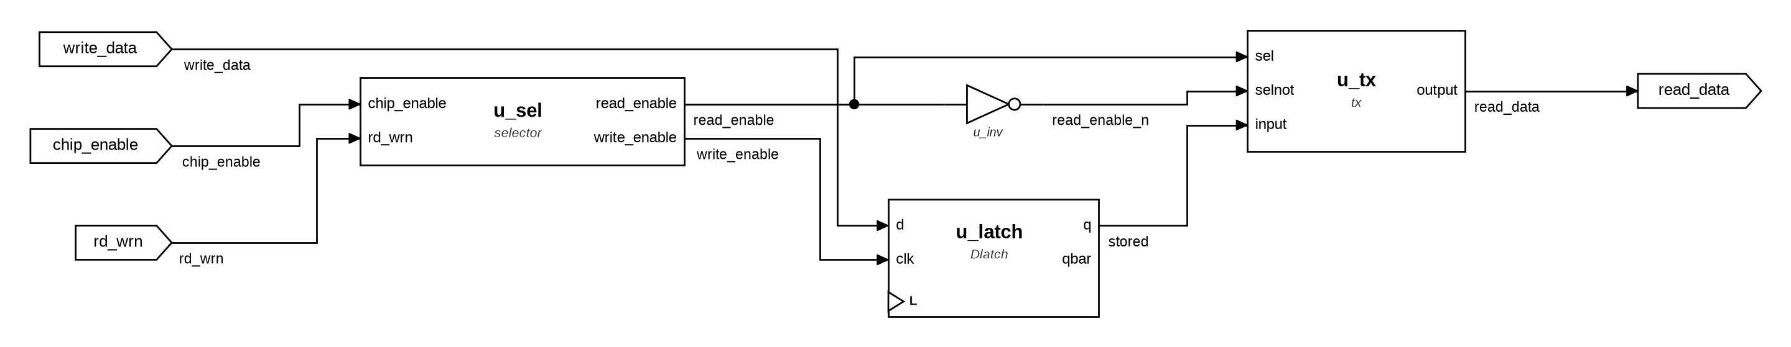
Figure 3: cache_cell: internal structure

Testbench
- Write 1, read it back; write 0, read it back.
- With Chip enable = 0: Read Data is high impedance and a write request does not change the cell.
- As in the chip, RD/WR and Write Data change only while Chip enable is off, so the selector never produces a write glitch.

Simulation results
Simulation result: PASS — tb_cache_cell: all checks passed, simulation ended at 90 ns.

4.5 Decoder, multiplexers and comparator
Low-level combinational blocks built from the basic gates: the 2-to-4 decoder (block offset and byte offset), the 1-bit and N-bit 2:1 multiplexers (cache write address and data, register load), and the N-bit equality comparator used for the tag compare.

Simulation results
Simulation result: PASS — tb_decoder2to4: all checks passed, simulation ended at 80 ns.
Simulation result: PASS — tb_mux2: all checks passed, simulation ended at 80 ns.
Simulation result: PASS — tb_mux2_n: all checks passed, simulation ended at 100 ns.
Simulation result: PASS — tb_mux4_n: all checks passed, simulation ended at 120 ns.
Simulation result: PASS — tb_and_reduce_n: all checks passed, simulation ended at 160 ns.
Simulation result: PASS — tb_comparator_n: all checks passed, simulation ended at 10240 ns.

4.6 Registers
dff_en is a register bit with load: a mux2 feeds back the flip-flop output when load = 0. register_n is N of them; the chip uses one for the CPU address (6 bits), one for the CPU data (8 bits) and one for the output register (8 bits), plus a dff_en for RD/WR.

Testbench
- N = 8: load, hold twice with new data at the input, load again; inputs change on the positive edge and q is checked after the negative edge.

Simulation results
Simulation result: PASS — tb_register_n: all checks passed, simulation ended at 60 ns.
Simulation result: PASS — tb_dff_en: all checks passed, simulation ended at 70 ns.

4.7 Write-signal flip-flop and clock cycle counter
pos_dff is the course dff clocked by the inverted clock, i.e. a positive edge flip-flop; it makes the cache write signal. counter is a 5-bit synchronous counter (half adders and negative edge flip-flops): restart = 1 loads 1, count = 1 counts up, and count = 0 with restart = 0 clears it. The state machine counts the clock cycles of every request with it: the counter starts at 1 on the negative edge that accepts a request and, after the edge where busy goes low, holds 2 (read hit), 3 (write hit or miss) or 19 (read miss).

Testbench
- Clear, count from 1 to 20 (past 19, a read miss) and clear; restart loads 1 and the count runs to 19; restart straight from 19 (a back-to-back request) loads 1 again; then clear.

Simulation results
Simulation result: PASS — tb_counter: all checks passed, simulation ended at 430 ns.
Simulation result: PASS — tb_pos_dff: all checks passed, simulation ended at 35 ns.
Simulation result: PASS — tb_half_adder: all checks passed, simulation ended at 40 ns.

5 Cache

5.1 Cache block
A cache block is 4 bytes (cache_byte, 8 cache cells each), a 2-bit tag and a valid bit, all cache cells. Byte i is enabled by block_select · byte_select(i); the tag and valid cells by block_select. Reset also enables the valid cell, so a single reset pulse clears all four valid bits. The cell outputs drive shared buses (read_data, tag_out, valid_out) that are high impedance when the block is not selected.

Testbench
- Reset clears valid.
- Write the 4 bytes with the tag and valid (as a read miss does), read every byte back.
- A single-byte write (write hit) changes only that byte and not the tag.
- Block not selected: all its buses are high impedance; reset clears valid again.

Simulation results
Simulation result: PASS — tb_cache_block: all checks passed, simulation ended at 165 ns.
Simulation result: PASS — tb_cache_byte: all checks passed, simulation ended at 210 ns.

5.2 Cache way
One way of the cache: 4 cache blocks (16 bytes). The block select and byte select come from the cache's decoders, which both ways share. The way's own write signal writes the selected byte; during a read miss (fill = 1) it also writes the tag and sets the valid bit. The selected byte, tag and valid bit are always read onto the way's buses. During a read miss (fill = 1) a Dlatch on every output (8 data bits, 2 tag bits, the valid bit) holds the values from before the fill: while a tag, valid or data cell is written its Read Data is high impedance, and the byte select steps through the bytes being written, so without the latches the hit/miss logic would see Z and X until the block is complete. The latches pass the cells again as soon as fill = 0, for the read of the requested byte.
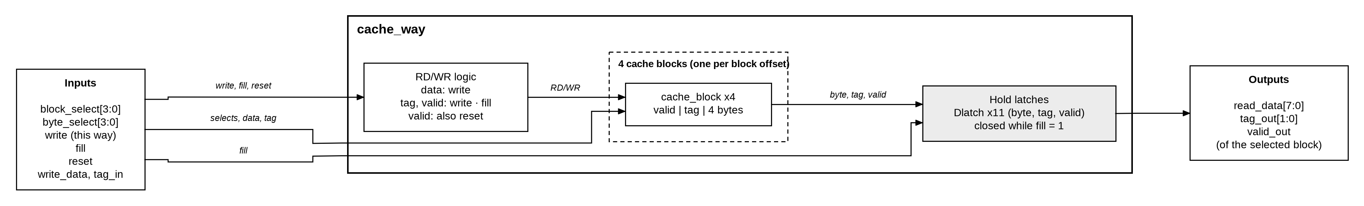
Figure 4: cache_way: block diagram

Testbench
- Reset invalidates every block.
- A read miss into block 1 with tag 10 (4 bytes, tag and valid), read back.
- Other blocks untouched; a write hit to one byte keeps the tag and valid bit; reset again.

Simulation results
Simulation result: PASS — tb_cache_way: all checks passed, simulation ended at 180 ns.

5.3 Hit/Miss
Hit/Miss of one way: hit = valid · (tag of the address = tag stored in the block of that way); miss = not hit. The tag compare is a 2-bit comparator_n. The cache has one per way.

Testbench
- All 32 combinations of address tag, stored tag and valid.

Simulation results
Simulation result: PASS — tb_hit_miss: all checks passed, simulation ended at 320 ns.

5.4 Way select
Combines the two ways: hit = hit0 + hit1, miss = not hit, hit_way = hit1 (the way that holds the block). The victim (the way a read miss fills) is an invalid way first, otherwise the LRU way: victim = valid0 · (not valid1 + lru_way).

Testbench
- All 32 combinations of hit0, hit1, valid0, valid1 and lru_way against a reference model.

Simulation results
Simulation result: PASS — tb_way_select: all checks passed, simulation ended at 320 ns.

5.5 LRU
One LRU bit per block offset, held in negative edge registers: the bit is the way to replace next. When update = 1, the bit of the addressed block offset becomes the other way (lru <= not used_way); a decoder enabled by update loads only that bit. A 4:1 mux reads the bit of the addressed block offset. Reset clears all bits. With two ways one bit gives exact LRU.

Testbench
- Reset; a block used in way 0 then way 1; update = 0 holds; every block offset updated; reset again — every bit read back after each step.

Simulation results
Simulation result: PASS — tb_lru: all checks passed, simulation ended at 100 ns.

Truth tables
Every gate output of lru for all 32 input combinations. bits(i)+ is the value of bit i after the next negative edge of clk; – means the bit holds its value (load(i) = 0), and bi is the present value of bit i.
Table 5: lru: every gate output for every input (bits(3..0)+ after the next negative edge)
reset | update | block offset | used way | set_en(3..0) u_dec | used_n u_inv | rst_n u_rst_n | d u_d | load(3..0) u_load | bits(3..0)+ u_bit | lru_way u_mux
0 | 0 | 00 | 0 | 0000 | 1 | 1 | 1 | 0000 | – – – – | b0
0 | 0 | 00 | 1 | 0000 | 0 | 1 | 0 | 0000 | – – – – | b0
0 | 0 | 01 | 0 | 0000 | 1 | 1 | 1 | 0000 | – – – – | b1
0 | 0 | 01 | 1 | 0000 | 0 | 1 | 0 | 0000 | – – – – | b1
0 | 0 | 10 | 0 | 0000 | 1 | 1 | 1 | 0000 | – – – – | b2
0 | 0 | 10 | 1 | 0000 | 0 | 1 | 0 | 0000 | – – – – | b2
0 | 0 | 11 | 0 | 0000 | 1 | 1 | 1 | 0000 | – – – – | b3
0 | 0 | 11 | 1 | 0000 | 0 | 1 | 0 | 0000 | – – – – | b3
0 | 1 | 00 | 0 | 0001 | 1 | 1 | 1 | 0001 | – – – 1 | b0
0 | 1 | 00 | 1 | 0001 | 0 | 1 | 0 | 0001 | – – – 0 | b0
0 | 1 | 01 | 0 | 0010 | 1 | 1 | 1 | 0010 | – – 1 – | b1
0 | 1 | 01 | 1 | 0010 | 0 | 1 | 0 | 0010 | – – 0 – | b1
0 | 1 | 10 | 0 | 0100 | 1 | 1 | 1 | 0100 | – 1 – – | b2
0 | 1 | 10 | 1 | 0100 | 0 | 1 | 0 | 0100 | – 0 – – | b2
0 | 1 | 11 | 0 | 1000 | 1 | 1 | 1 | 1000 | 1 – – – | b3
0 | 1 | 11 | 1 | 1000 | 0 | 1 | 0 | 1000 | 0 – – – | b3
1 | 0 | 00 | 0 | 0000 | 1 | 0 | 0 | 1111 | 0 0 0 0 | b0
1 | 0 | 00 | 1 | 0000 | 0 | 0 | 0 | 1111 | 0 0 0 0 | b0
1 | 0 | 01 | 0 | 0000 | 1 | 0 | 0 | 1111 | 0 0 0 0 | b1
1 | 0 | 01 | 1 | 0000 | 0 | 0 | 0 | 1111 | 0 0 0 0 | b1
1 | 0 | 10 | 0 | 0000 | 1 | 0 | 0 | 1111 | 0 0 0 0 | b2
1 | 0 | 10 | 1 | 0000 | 0 | 0 | 0 | 1111 | 0 0 0 0 | b2
1 | 0 | 11 | 0 | 0000 | 1 | 0 | 0 | 1111 | 0 0 0 0 | b3
1 | 0 | 11 | 1 | 0000 | 0 | 0 | 0 | 1111 | 0 0 0 0 | b3
1 | 1 | 00 | 0 | 0001 | 1 | 0 | 0 | 1111 | 0 0 0 0 | b0
1 | 1 | 00 | 1 | 0001 | 0 | 0 | 0 | 1111 | 0 0 0 0 | b0
1 | 1 | 01 | 0 | 0010 | 1 | 0 | 0 | 1111 | 0 0 0 0 | b1
1 | 1 | 01 | 1 | 0010 | 0 | 0 | 0 | 1111 | 0 0 0 0 | b1
1 | 1 | 10 | 0 | 0100 | 1 | 0 | 0 | 1111 | 0 0 0 0 | b2
1 | 1 | 10 | 1 | 0100 | 0 | 0 | 0 | 1111 | 0 0 0 0 | b2
1 | 1 | 11 | 0 | 1000 | 1 | 0 | 0 | 1111 | 0 0 0 0 | b3
1 | 1 | 11 | 1 | 1000 | 0 | 0 | 0 | 1111 | 0 0 0 0 | b3

One LRU bit, u_bit(i) (dff_en: a mux2 that keeps q when load = 0, and a negative edge dff):
Table 6: dff_en in lru: one LRU bit
load(i) | d | bits(i) | mux2 output | bits(i)+
0 | x | 0 | 0 | 0
0 | x | 1 | 1 | 1
1 | 0 | x | 0 | 0
1 | 1 | x | 1 | 1

Read, u_mux (mux4_n, combinational): lru_way = bits(block offset).
Table 7: mux4_n in lru: LRU way of the addressed block offset
block offset | lru_way
00 | bits(0)
01 | bits(1)
10 | bits(2)
11 | bits(3)

With the state machine (CHECK cycle): lru_update = CHECK · (hit + RD/WR) and used_way = hit ? hit_way : victim, so the addressed bit becomes not used_way after a read hit, write hit or read miss, and does not change after a write miss.
Table 8: lru update for each kind of access
Access | hit | RD/WR | lru_update | used_way | Addressed bit after
Read hit in way 0 | 1 | 1 | 1 | 0 (hit_way) | 1
Read hit in way 1 | 1 | 1 | 1 | 1 (hit_way) | 0
Read miss, victim way 0 | 0 | 1 | 1 | 0 (victim) | 1
Read miss, victim way 1 | 0 | 1 | 1 | 1 (victim) | 0
Write hit in way 0 | 1 | 0 | 1 | 0 (hit_way) | 1
Write hit in way 1 | 1 | 0 | 1 | 1 (hit_way) | 0
Write miss | 0 | 0 | 0 | x | unchanged

5.6 Two-way cache (32 bytes)
The cache has a single address input, the latched CPU address, and splits it into tag (bits 5–4), block offset (3–2) and byte offset (1–0). The shared decoders select the block and the byte in both ways at once; during a read miss a mux2_n takes the byte offset from fill_byte (the counter). Each way's Hit/Miss compares the tag; way_select gives hit, hit_way and the victim. The cache's hit and miss outputs come through a Dlatch that is open only while latch_way (the CHECK cycle) or reset is 1: the state machine reads the compare at the end of CHECK, and the outputs keep that result until the next request's CHECK; reset clears them.
Replacement: on the negative edge that ends the tag compare, latch_way keeps the victim in the fill_way register (the valid and LRU bits change during the fill), and lru_update makes the way used (the way that hit, or the victim of a read miss) the most recently used. The write signal goes to the way that hit (write hit) or to fill_way (read miss). The byte read comes from the way that hit.
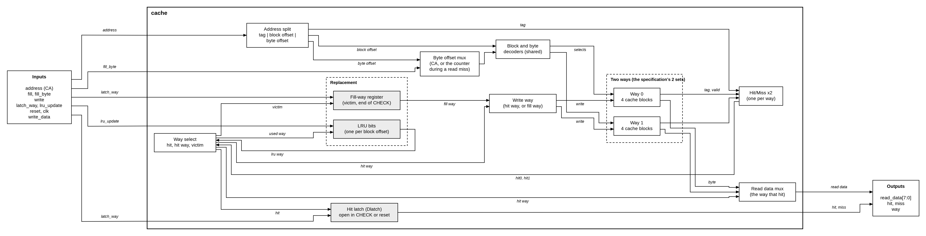
Figure 5: cache: block diagram
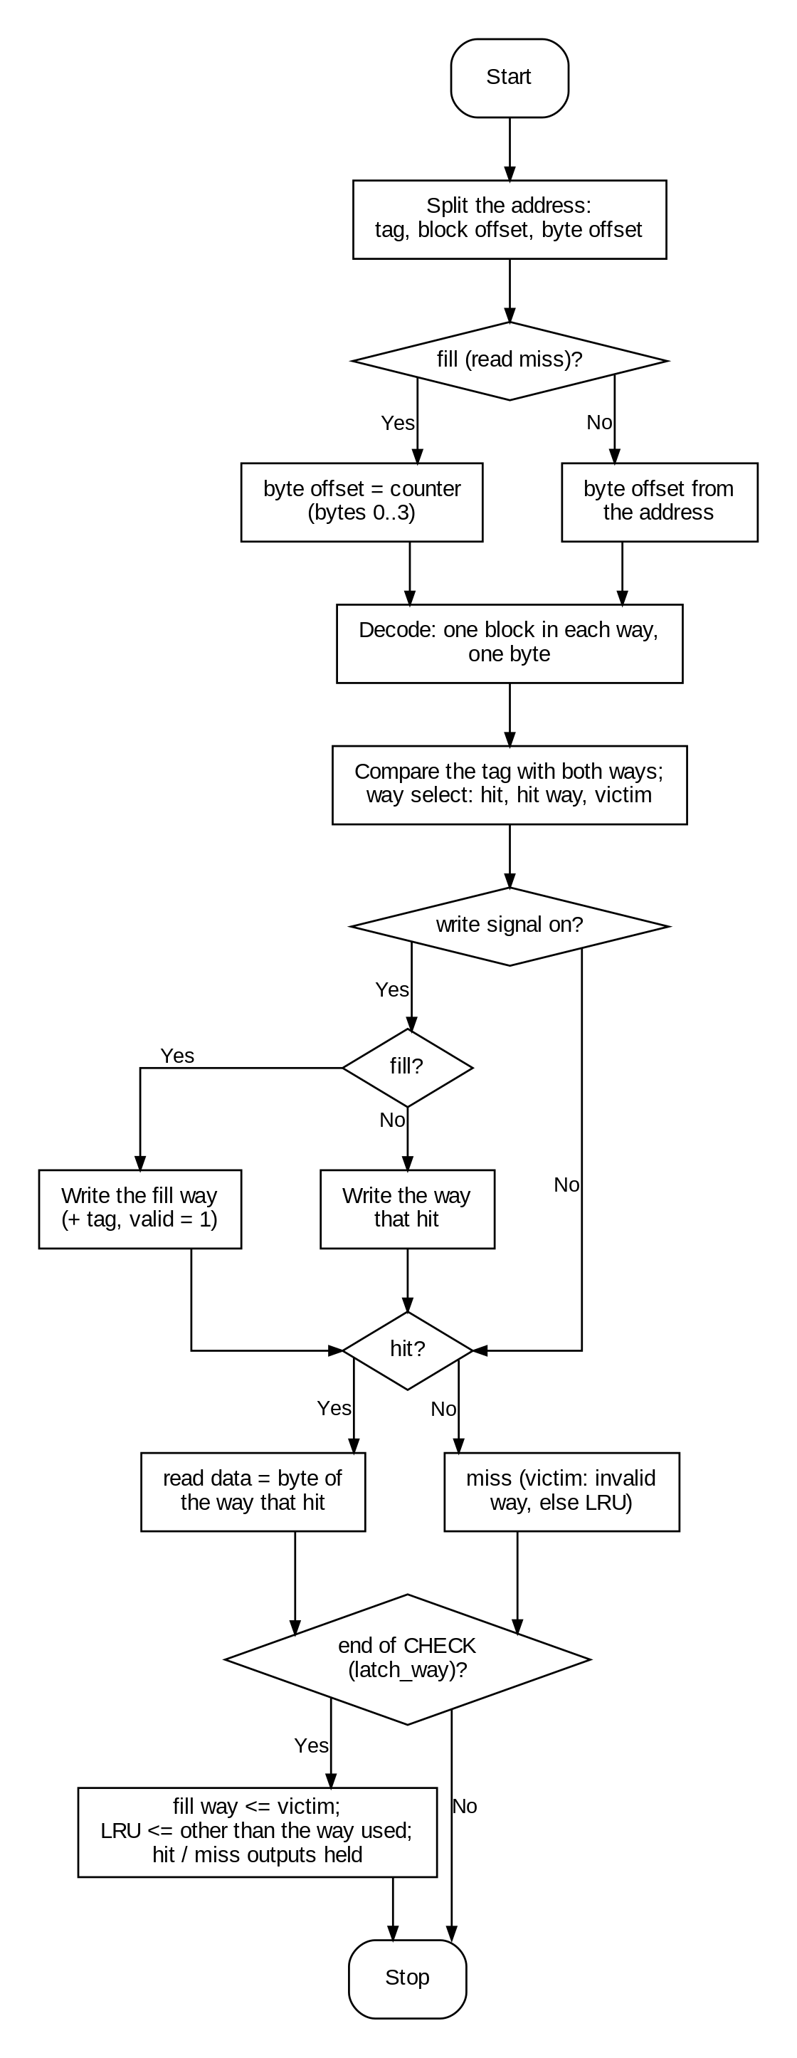
Figure 6: cache: operation flowchart

Testbench
- Reset; A (tag 0, block 1) read miss fills way 0; B (tag 1, same block) fills way 1.
- Both A and B hit, each read from its own way.
- C (tag 2) read miss replaces the LRU way (B); B then misses (a write miss, which does not change the LRU); A and C hit.
- A write hit writes only the way that hit; another block offset misses; reset empties the cache.

Simulation results
Simulation result: PASS — tb_cache: all checks passed, simulation ended at 450 ns.

6 State machine
The state machine is one-hot: five negative edge flip-flops, one per state, with the next-state logic built from gates. The counter gives the clock cycle c of the request: c = 1 after the negative edge that accepts the request (CHECK); it counts in CHECK, WRITE and READ_MISS, and after the edge where busy goes low it holds 2 (read hit), 3 (write) or 19 (read miss). It is cleared on the next negative edge, or started at 1 again by a new request.
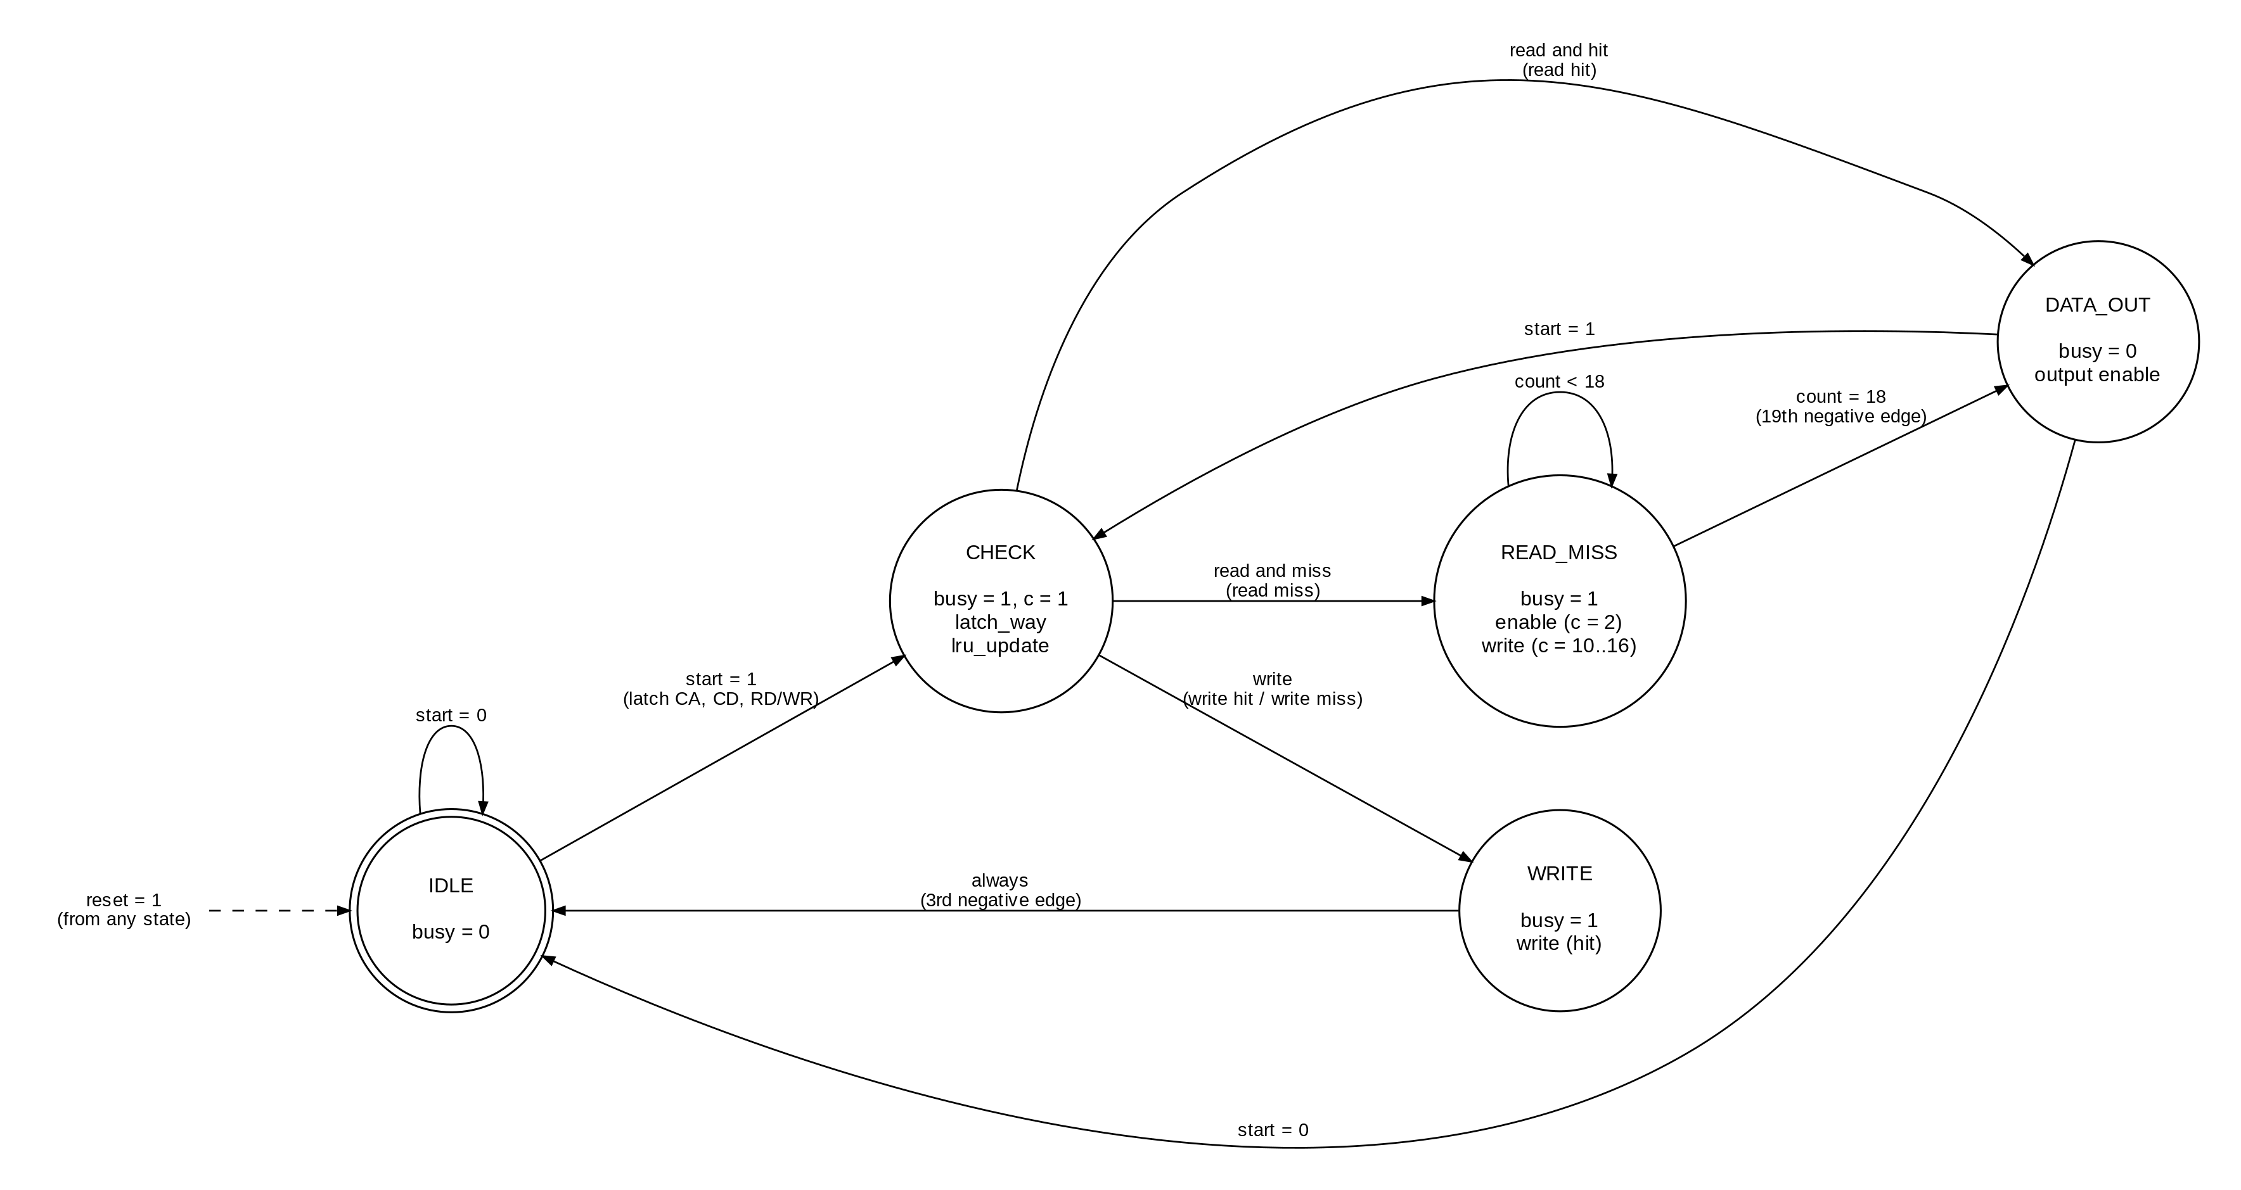
Figure 7: State machine diagram
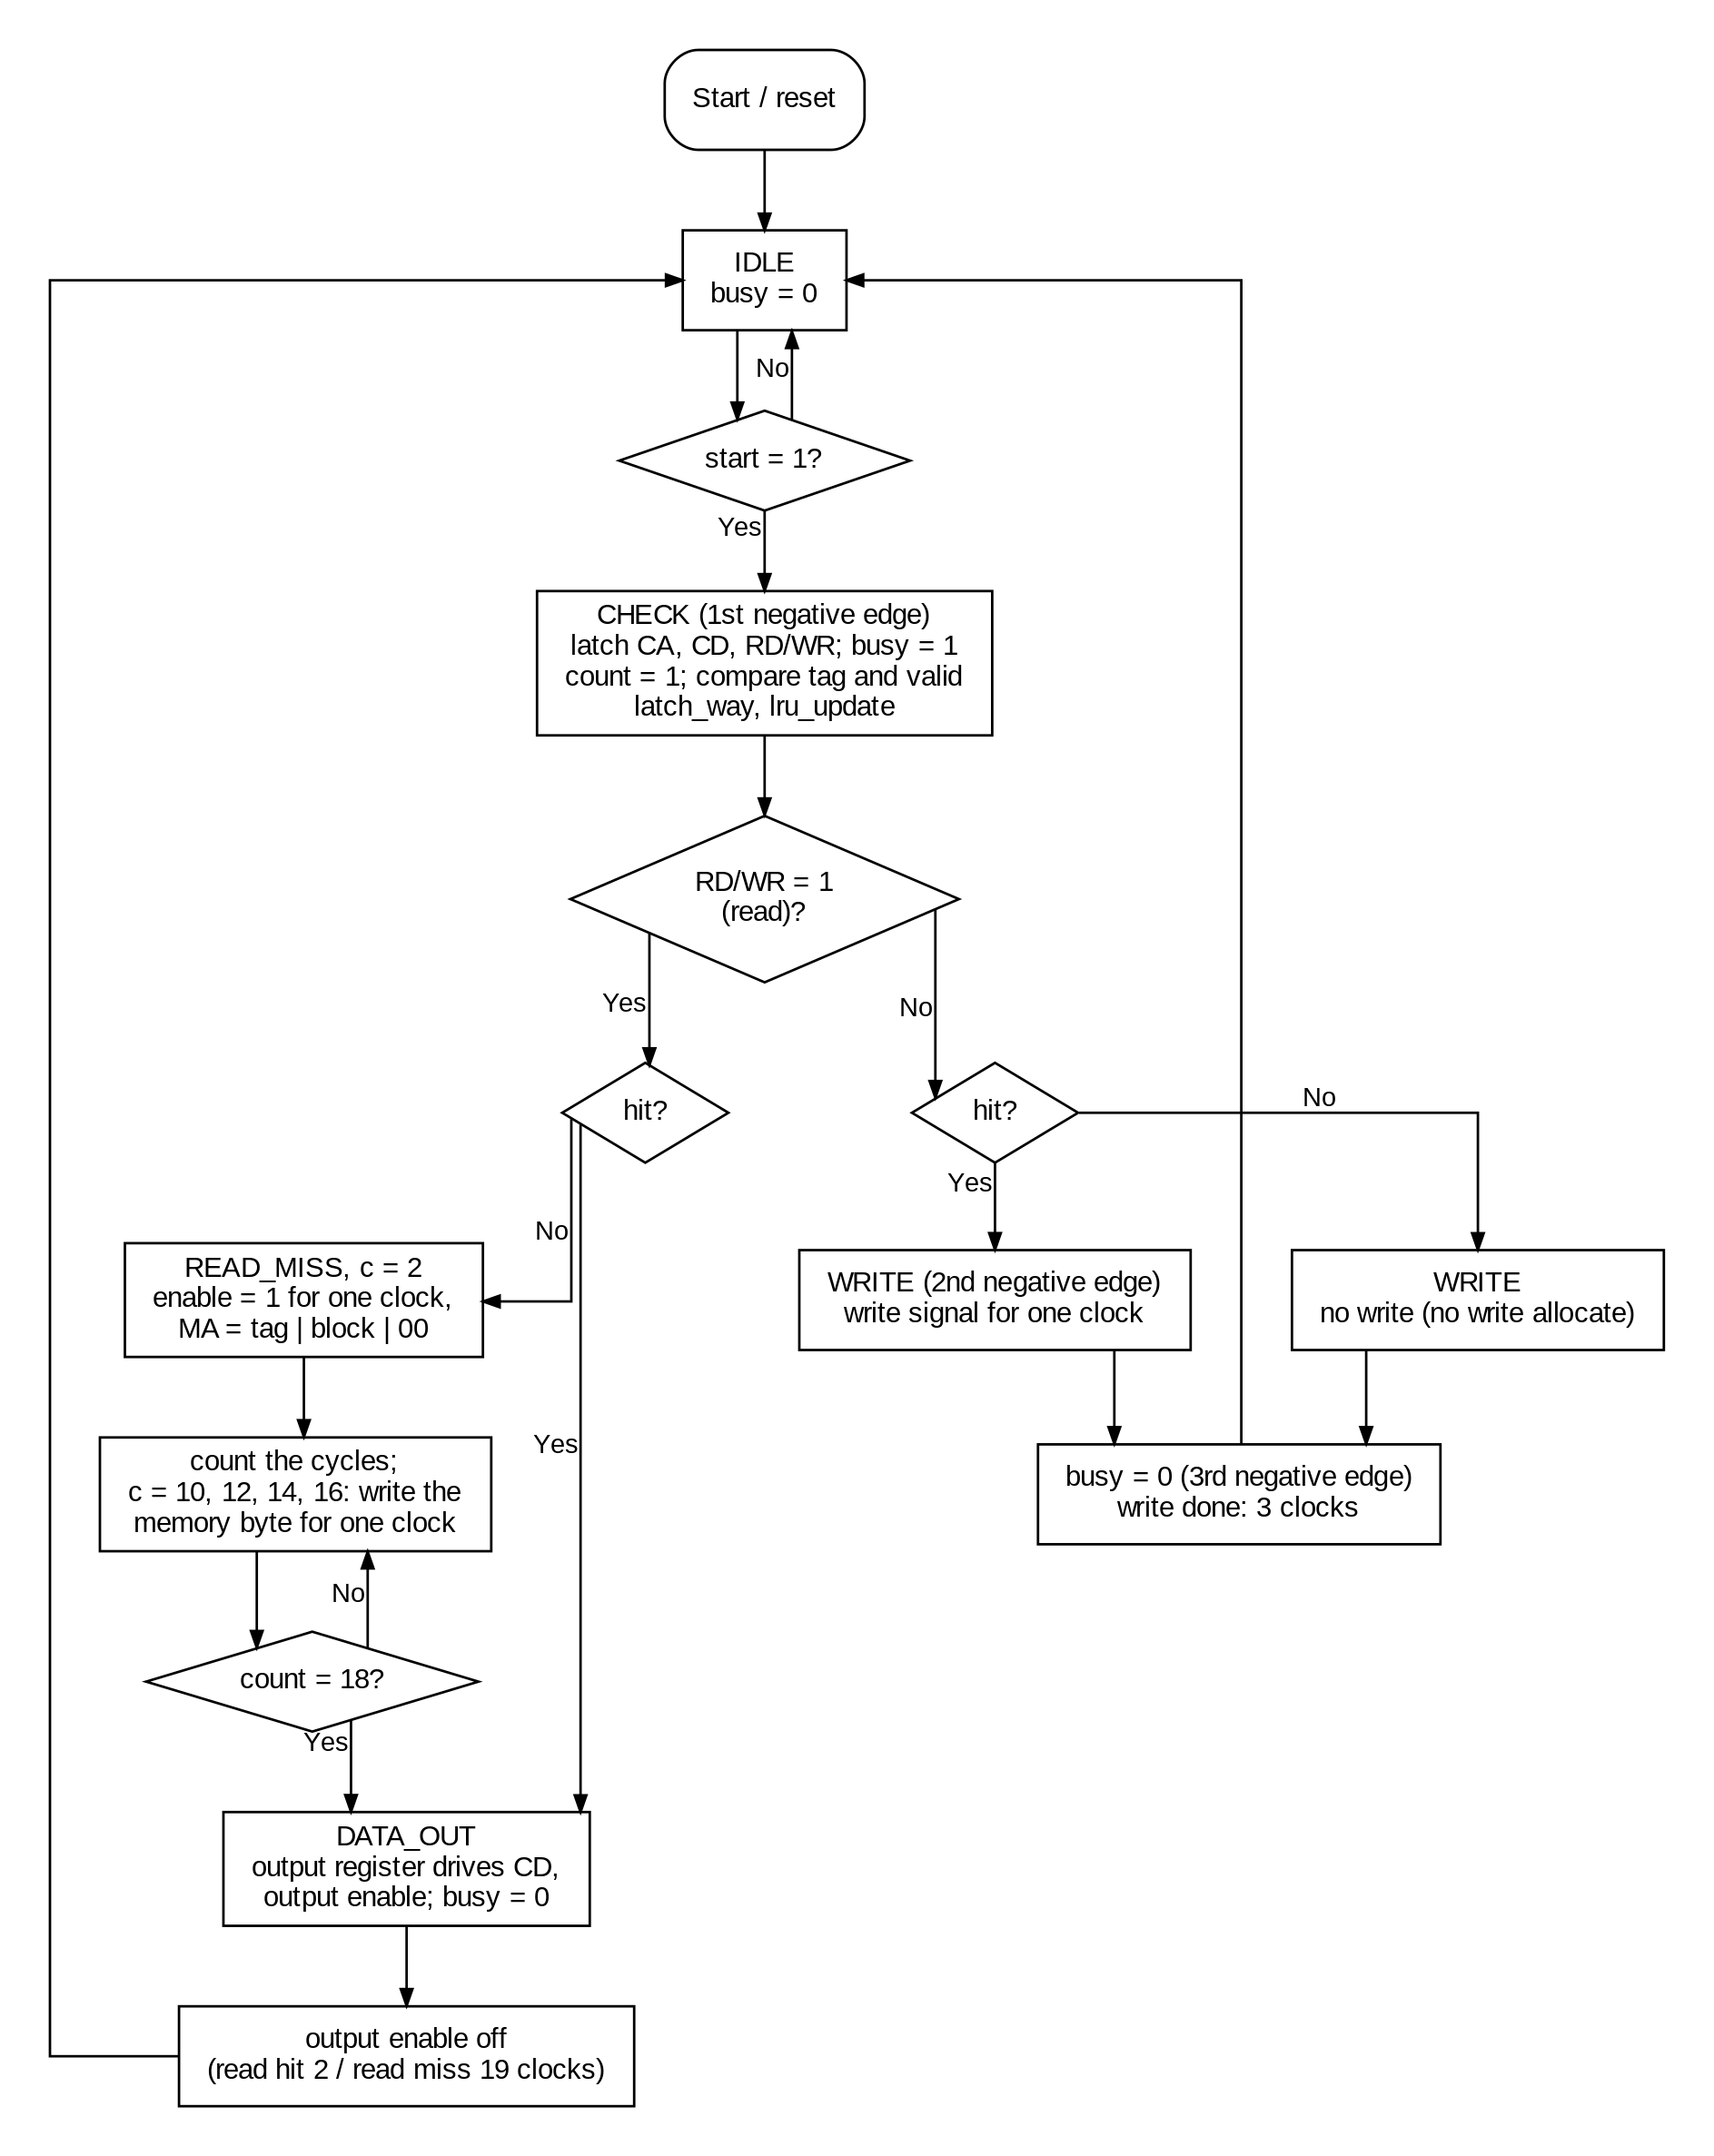
Figure 8: state_machine: operation flowchart

6.1 States
Table 9: States of the state machine
State | What happens | Why it is necessary
IDLE | Waits for start. busy = 0. | Reset state; the chip must not react until a request arrives.
CHECK | Entered on the negative edge after start: CA, CD and RD/WR are latched, busy goes high. During this cycle the addressed block's tag and valid bit and the addressed byte are read and compared (hit/miss) in both ways. On the negative edge that ends CHECK, latch_way keeps the victim way and lru_update marks the way used as most recently used. | The inputs are removed by the CPU on the next positive edge, so they must be latched; the hit/miss decision needs one cycle.
WRITE | Write hit: the write signal writes CD into the addressed byte (positive edge to positive edge). Write miss: nothing is written (no write allocate). busy stays high. | The specification requires 3 clocks for a write hit or miss, with the write on the second negative edge.
READ_MISS | c = 2: enable = 1 with MA = tag, block offset, 00. c = 10, 12, 14, 16: the memory byte is valid, the write signal writes it (bytes 0–3; tag and valid with them). c = 18: the requested byte is read from the cache. The ways hold their tag, valid and read byte while the block is filled. | The memory needs 8 cycles and delivers one byte every 2 cycles; the block must be in the cache before the byte is returned.
DATA_OUT | The output register drives CD (output enable) for one clock; busy = 0. A new start can be accepted here. | The CPU reads the data on the positive edge after output enable; it must stay stable for one cycle.

Next-state equations (· = AND, + = OR):
- CHECK′ = start · (IDLE + DATA_OUT) · not reset
- WRITE′ = CHECK · not RD/WR · not reset
- READ_MISS′ = (CHECK · RD/WR · miss + READ_MISS · not c18) · not reset (c18 = count(4) · count(1))
- DATA_OUT′ = (CHECK · RD/WR · hit + READ_MISS · c18) · not reset
- IDLE′ = reset + (IDLE + DATA_OUT) · not start · not reset + WRITE
- latch_way = CHECK; lru_update = CHECK · (hit + RD/WR) (no LRU change on a write miss)
- count_enable = (CHECK + WRITE + READ_MISS) · not reset; count_restart = CHECK′ (the counter starts at 1 with every request)
- hit_result = the hit of the CHECK cycle (dff_en loaded in CHECK or reset), held until the next request's CHECK

6.2 Timing
Table 10: Timing of each operation
Negative edge after start | Read hit | Write hit / write miss | Read miss
1st | latch inputs, busy = 1 (CHECK) | latch inputs, busy = 1 (CHECK) | latch inputs, busy = 1 (CHECK)
2nd | data → output register, output enable, busy = 0 | WRITE; write signal on next positive edge (hit only) | enable = 1, MA driven (READ_MISS, c = 2)
3rd | output enable off | busy = 0 (IDLE) | enable = 0, MA high impedance
10th, 12th, 14th, 16th |  |  | memory byte 0, 1, 2, 3 valid; written from the next positive edge for one cycle
18th |  |  | requested byte read from the cache (c = 18)
19th |  |  | data → output register, output enable, busy = 0
20th |  |  | output enable off

6.3 Inputs, outputs and connections
Table 11: State machine inputs and outputs
Signal | Dir | Connected to | Function
clk, reset | in | chip ports | Clock (negative edge) and synchronous reset
start | in | chip port | Request from the CPU
read_write | in | dff_en (RD/WR register) | Latched RD/WR of the request
hit | in | cache (its Hit/Miss logic) | Hit of the latched address (the cache holds it from the end of CHECK)
count | in | counter | Clock cycle of the request (1 in CHECK)
busy | out | chip port busy | Handshake to the CPU
enable | out | chip port mem_en; tx gates of MA | Memory read request; drives MA
output_enable | out | tx gates of CD | Drives the output register onto CD for one cycle
latch_input | out | register_n (CA, CD), dff_en (RD/WR) | Latch the CPU request
latch_output | out | register_n (output register) | Latch the byte read from the cache
count_enable | out | counter | Count in CHECK, WRITE and READ_MISS, clear otherwise
count_restart | out | counter | Start the count at 1 when a request is accepted
fill | out | cache; mux2_n (write data) | Read miss: byte offset from the counter, data from MD, write tag and valid
fill_byte | out | cache (byte offset mux) | Read miss: byte of the block being written (from the counter)
hit_result | out | chip (hit, miss) | Hit/miss of the request, kept from the end of CHECK
write | out | cache | Write signal (one clock, positive edge to positive edge)
latch_way | out | cache (fill_way register) | Keep the victim way for a read miss
lru_update | out | cache (lru) | Mark the way used as most recently used
state | out | (observation) | One-hot state, for the waveforms

6.4 Testbench and simulation results
The testbench drives the state machine with the real counter and the same clock as the course testbench and checks busy, enable, output enable and the state after every negative edge, and the write signal after every positive edge (and in the middle of each write pulse), for all four scenarios.
Simulation result: PASS — tb_state_machine: all checks passed, simulation ended at 352 ns.

7 Chip (top level)
The chip connects the blocks: the CA, CD and RD/WR registers (loaded by latch_input), the state machine and counter, the multiplexer that chooses the cache's write data (CPU or memory), the two-way cache (which takes the whole CPU address, reports hit/miss and keeps the LRU state), the output register, and the transmission gates that drive CD (output enable) and MA (enable). MA is tag, block offset and two zeros taken from Gnd. Its ports are exactly those of the component in chip_test.vhd. The hit/miss of a request is decided once, at the end of CHECK: the cache's hit (tag_hit) and the state machine's hit_result both keep it until the next request.
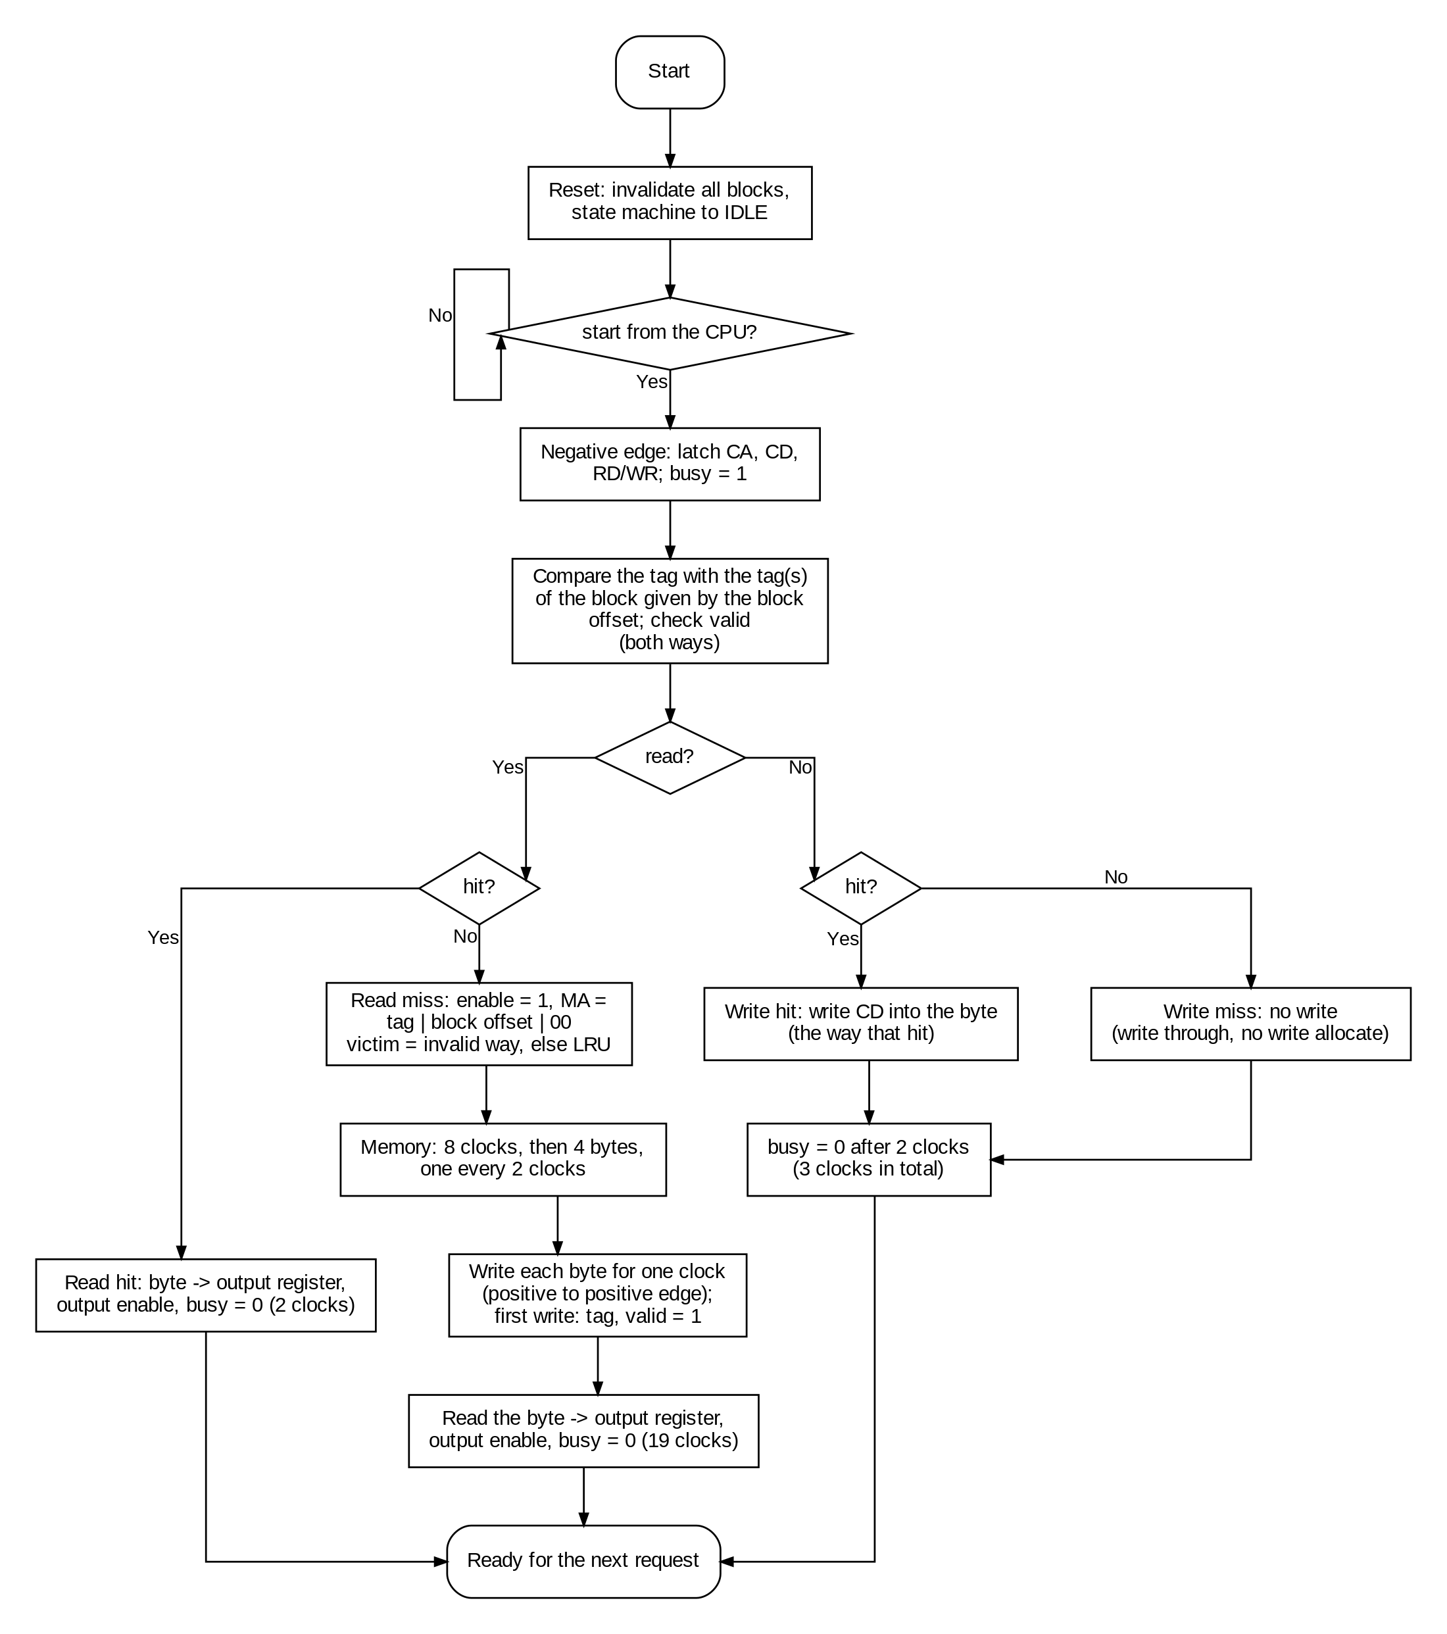
Figure 9: chip: operation flowchart

7.1 Extended chip testbench
- CPU model: drives start, RD/WR, CA (and CD) on a positive edge, removes them on the positive edge after busy, reads CD on the positive edge after busy goes low.
- Memory model: latches MA when enable is high on a positive edge and drives byte i of the block on the (8 + 2i)th negative edge after enable, stable for 2 cycles (byte at address A = 5A + 17).
- Reference model of the two-way cache (valid, tag and data of both ways, one LRU bit per block offset, victim = invalid way first, else LRU) predicts hit or miss and the data of every read; because the expected busy time depends on hit or miss, every hit/miss decision is checked.
- For every request it checks the data read, busy high on the 1st negative edge, busy low on the 2nd (read hit), 3rd (write) or 19th (read miss) negative edge, enable for exactly one cycle with the right MA on a read miss, MA and CD high impedance when not driven, and CD driven for exactly one cycle.
- Directed tests: the course sequence; two tags in block offset 0 kept in the two ways (0x00 and 0x10 both hit afterwards — in the direct mapped chip 0x10 would evict 0x00); a third tag (0x20) replacing the LRU way; the evicted block missing again; a write hit in way 1; write miss with no allocate; back-to-back requests; reset invalidating every block; then 150 random requests.
Simulation result: PASS — tb_chip: all checks passed, simulation ended at 15.22 µs.
Statistics: requests=172 read hits=66 read misses=50 write hits=25 write misses=31
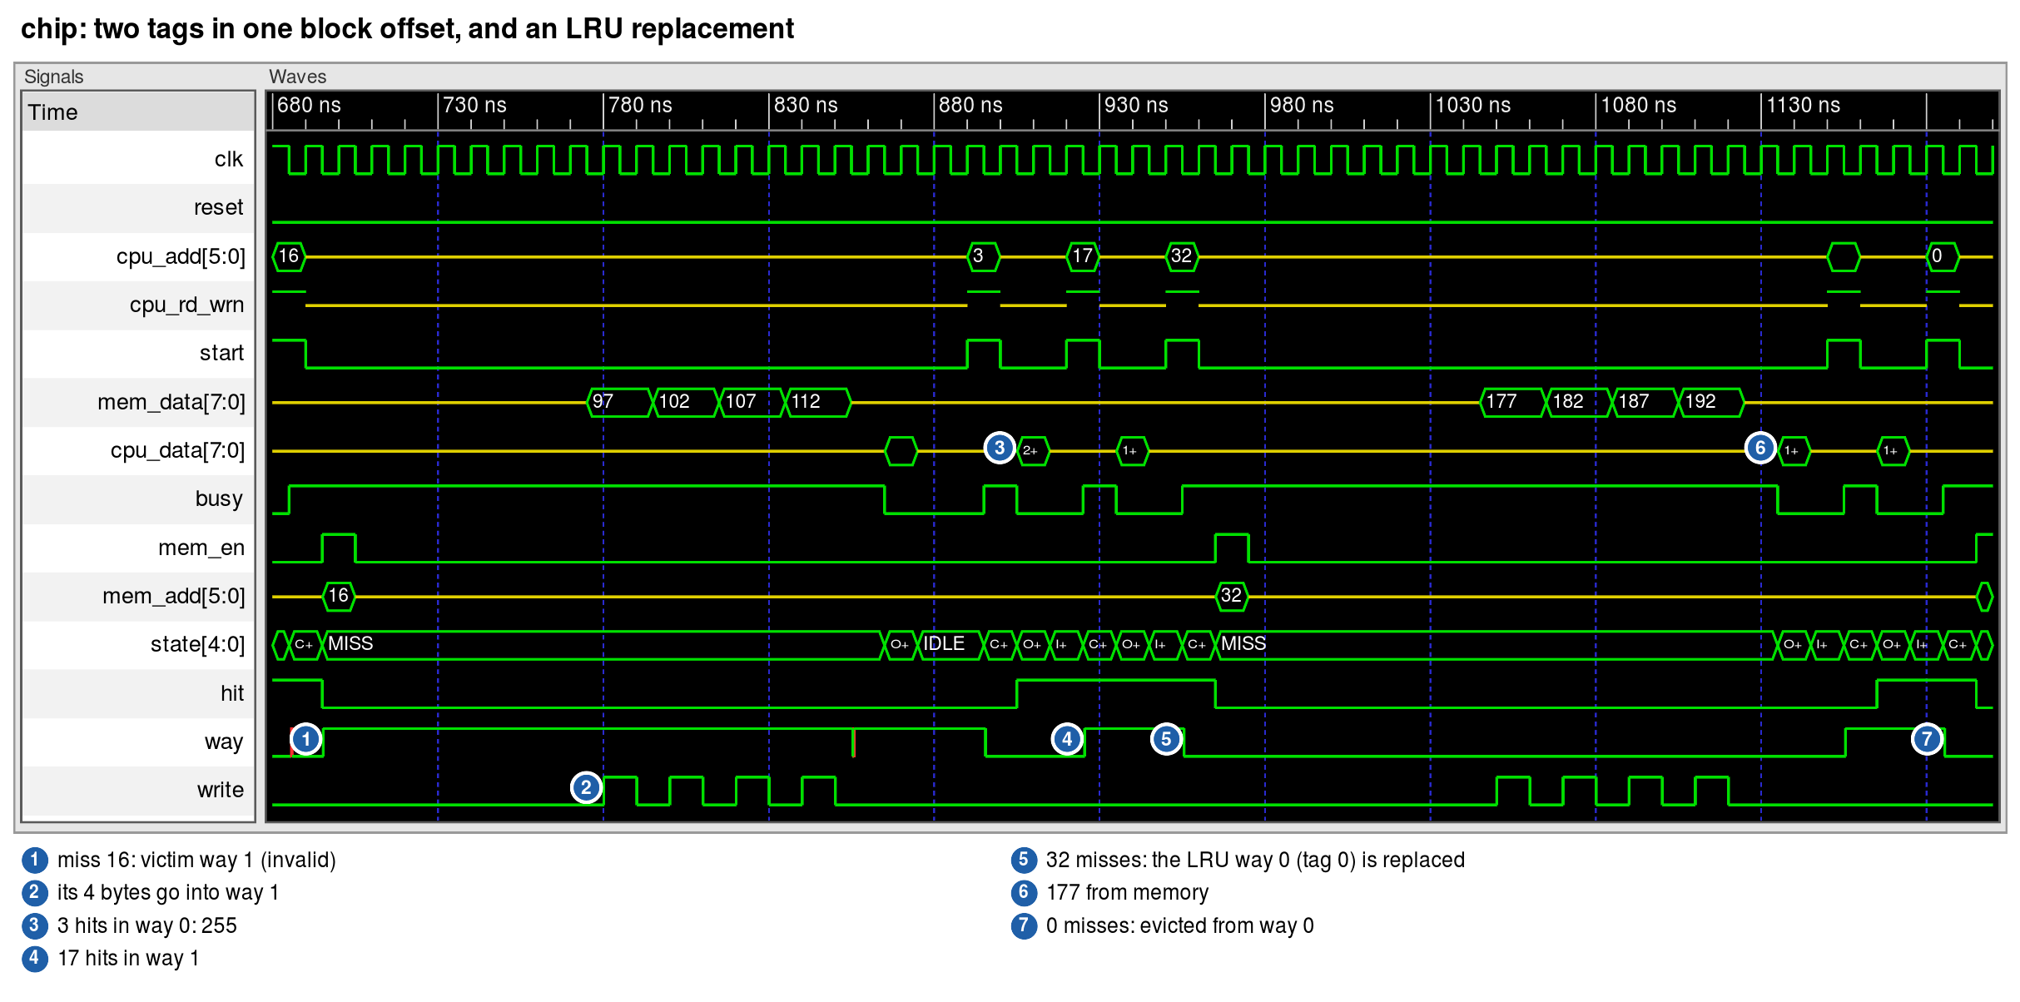
Figure 10: tb_chip: two tags in one block offset, and an LRU replacement
Read 0x10 (tag 01, block offset 0) misses while tag 00 is in way 0: way 1 is invalid, so it is the victim (way = 1 during the fill). Read 0x03 then hits in way 0 (FF, written earlier) and 0x11 hits in way 1 — both blocks of block offset 0 stay in the cache. Read 0x20 (tag 10) misses; both ways are valid and way 0 is the least recently used, so way 0 is filled.

8 Course testbench (chip_test)
The course testbench chip_test.vhd was run without any change: its chip component already has the same port names, types and order as this design's chip entity, and it binds work.chip(structural). It reads chip_in.txt from the run directory and prints the chip's inputs and outputs on every positive and negative clock edge. It was run for 360 ns, as in run.ncsim.

8.1 Sample input
chip_in.txt holds six lines per clock: CA, CD, RD/WR, start and reset (applied on the positive edge) and MD (applied on the negative edge). One row per clock:
Table 12: chip_in.txt (inputs of the course testbench)
Clock | CA | CD | RD/WR | Start | Reset | MD
1 | ZZZZZZ | ZZZZZZZZ | Z | 0 | 1 | ZZZZZZZZ
2 | ZZZZZZ | ZZZZZZZZ | Z | 0 | 1 | ZZZZZZZZ
3 | 000000 | ZZZZZZZZ | 1 | 1 | 0 | ZZZZZZZZ
4 | ZZZZZZ | ZZZZZZZZ | Z | 0 | 0 | ZZZZZZZZ
5 | ZZZZZZ | ZZZZZZZZ | Z | 0 | 0 | ZZZZZZZZ
6 | ZZZZZZ | ZZZZZZZZ | Z | 0 | 0 | ZZZZZZZZ
7 | ZZZZZZ | ZZZZZZZZ | Z | 0 | 0 | ZZZZZZZZ
8 | ZZZZZZ | ZZZZZZZZ | Z | 0 | 0 | ZZZZZZZZ
9 | ZZZZZZ | ZZZZZZZZ | Z | 0 | 0 | ZZZZZZZZ
10 | ZZZZZZ | ZZZZZZZZ | Z | 0 | 0 | ZZZZZZZZ
11 | ZZZZZZ | ZZZZZZZZ | Z | 0 | 0 | ZZZZZZZZ
12 | ZZZZZZ | ZZZZZZZZ | Z | 0 | 0 | 00000000
13 | ZZZZZZ | ZZZZZZZZ | Z | 0 | 0 | 00000000
14 | ZZZZZZ | ZZZZZZZZ | Z | 0 | 0 | 00000001
15 | ZZZZZZ | ZZZZZZZZ | Z | 0 | 0 | 00000001
16 | ZZZZZZ | ZZZZZZZZ | Z | 0 | 0 | 00000010
17 | ZZZZZZ | ZZZZZZZZ | Z | 0 | 0 | 00000010
18 | ZZZZZZ | ZZZZZZZZ | Z | 0 | 0 | 00000011
19 | ZZZZZZ | ZZZZZZZZ | Z | 0 | 0 | 00000011
20 | ZZZZZZ | ZZZZZZZZ | Z | 0 | 0 | ZZZZZZZZ
21 | ZZZZZZ | ZZZZZZZZ | Z | 0 | 0 | ZZZZZZZZ
22 | ZZZZZZ | ZZZZZZZZ | Z | 0 | 0 | ZZZZZZZZ
23 | 000011 | 11111111 | 0 | 1 | 0 | ZZZZZZZZ
24 | ZZZZZZ | ZZZZZZZZ | Z | 0 | 0 | ZZZZZZZZ
25 | ZZZZZZ | ZZZZZZZZ | Z | 0 | 0 | ZZZZZZZZ
26 | ZZZZZZ | ZZZZZZZZ | Z | 0 | 0 | ZZZZZZZZ
27 | 000011 | ZZZZZZZZ | 1 | 1 | 0 | ZZZZZZZZ
28 | ZZZZZZ | ZZZZZZZZ | Z | 0 | 0 | ZZZZZZZZ
29 | ZZZZZZ | ZZZZZZZZ | Z | 0 | 0 | ZZZZZZZZ
30 | 111111 | 10101010 | 0 | 1 | 0 | ZZZZZZZZ
31 | ZZZZZZ | ZZZZZZZZ | Z | 0 | 0 | ZZZZZZZZ
32 | ZZZZZZ | ZZZZZZZZ | Z | 0 | 0 | ZZZZZZZZ
33 | ZZZZZZ | ZZZZZZZZ | Z | 0 | 0 | ZZZZZZZZ
34 | ZZZZZZ | ZZZZZZZZ | Z | 0 | 0 | ZZZZZZZZ
35 | ZZZZZZ | ZZZZZZZZ | Z | 0 | 0 | ZZZZZZZZ

Requests: reset for 2 clocks; read 0x00 (read miss; memory returns 00, 01, 02, 03); write 0xFF to 0x03 (write hit); read 0x03 (read hit, returns FF); write 0xAA to 0x3F (write miss).

8.2 Output and comparison with the reference
The output of this design (two_way/testbench/chip_out.log) was compared field by field with the course's reference ncsim.log. The reference was produced with 8-bit addresses (as its README notes), so only the low 6 address bits are compared. Result: MATCH in all 70 prints (differences only before the first reset edge: X in the reference, U in GHDL). The course sequence never puts two tags in one block offset, so the two-way chip produces exactly the same output as the direct mapped chip, with the same timing.

8.3 Waveforms
The course run is shown one operation per figure (read miss, write hit, read hit, write miss), followed by the clock cycle counter over the four requests. Each figure is drawn from the simulation of chip_test.vhd with the current design, with numbered markers on the events, explained with their clock number (clk_count) in the key under each figure.
All waveform figures in this report are drawn from the GHDL simulation results (VCD files), in the layout of a waveform viewer: a Signals panel with the names and a black Waves panel with a time ruler. Green is a valid 0/1 or bus value (buses in decimal), a red box is U or X, and a yellow line in the middle is Z (bus released); a value too long for its box is cut with a +. The one-hot state is shown with its state name. The chip_test figures use the signal names of chip_test.vhd: clk_count = CLOCK_COUNT, cpu_add = CPU_ADDRESS (CA), cpu_data = CPU_DATA (CD), cpu_rd_wrn = READ_WRITE, mem_add = MEMORY_ADDRESS (MA), mem_data = MEMORY_DATA (MD), mem_en = MEMORY_ENABLE; state, hit, way, write and count are inside the chip.
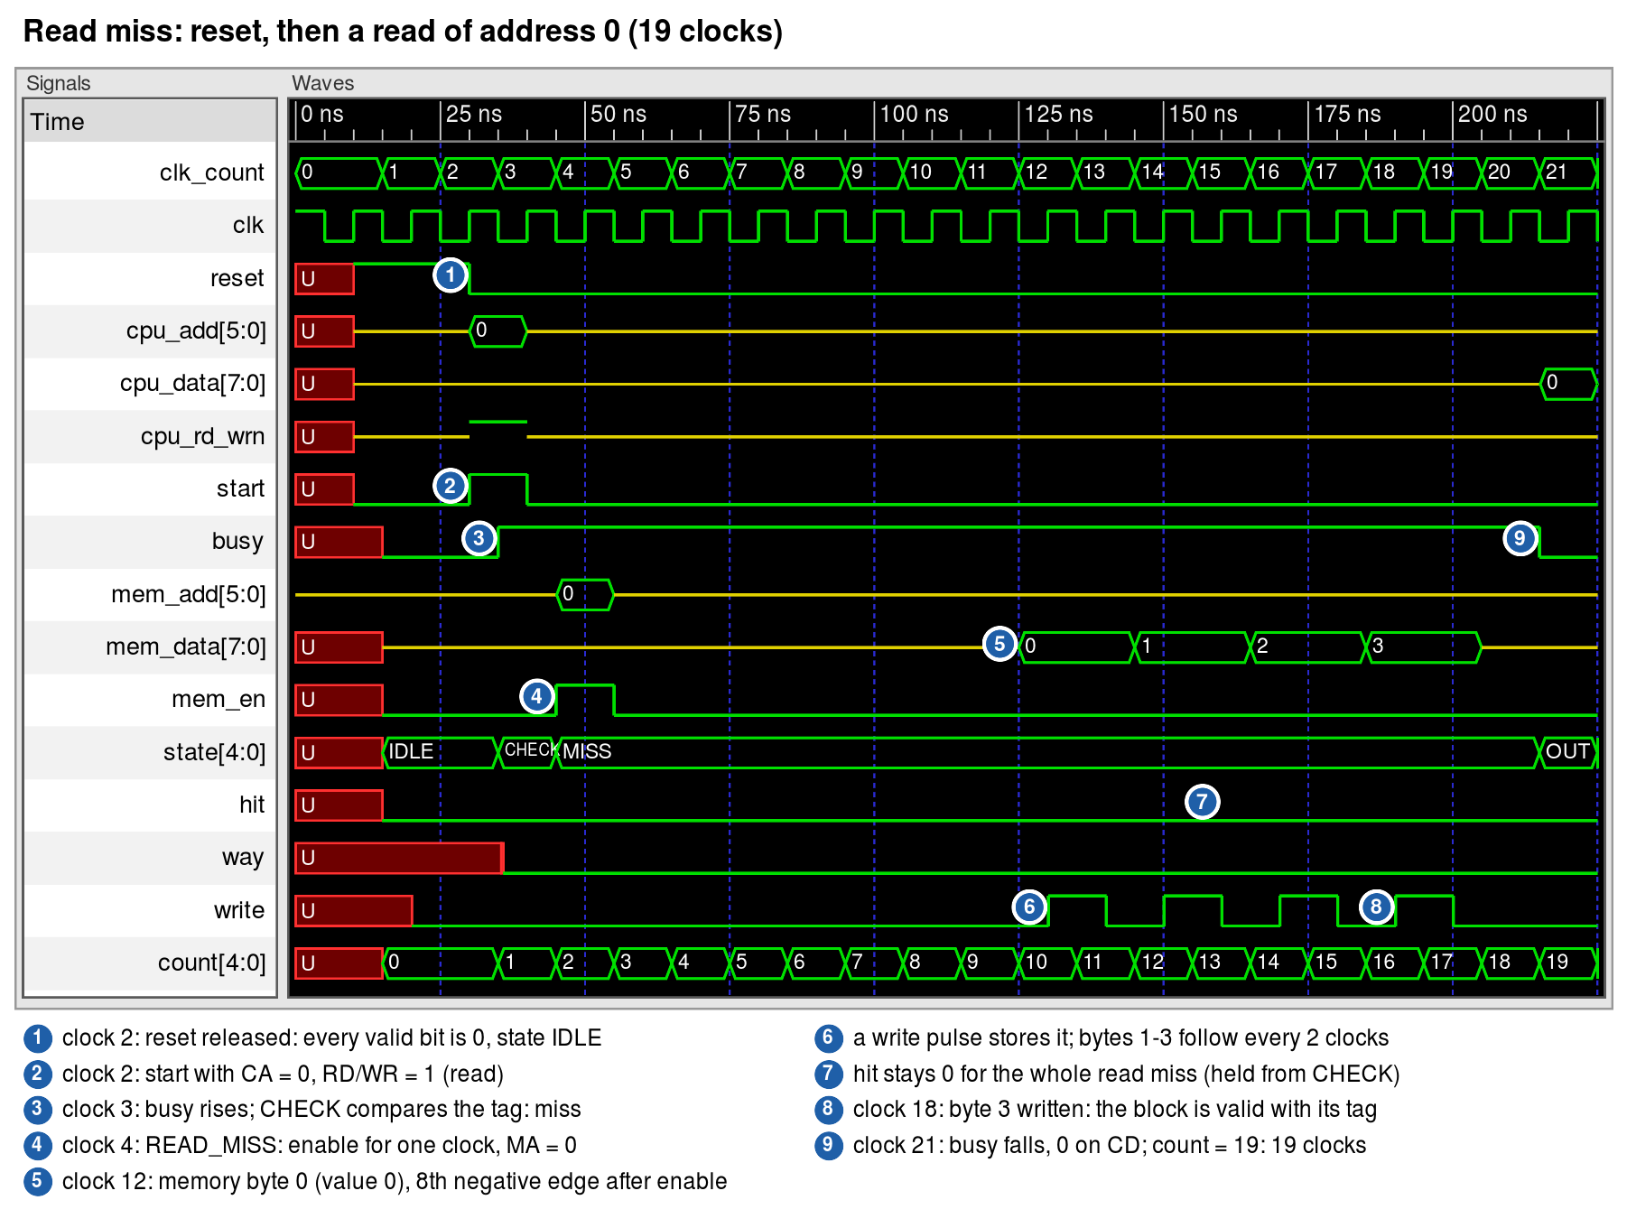
Figure 11: chip_test: read miss (read of 0x00 after reset, 19 clocks)
Reset for two clocks; the read of 0x00 starts on clock 2. busy goes high on the next negative edge (clock 3); on the miss, MEMORY_ENABLE is on for one clock with MEMORY_ADDRESS = 0 (clock 4). The memory returns bytes 0, 1, 2, 3 from clock 12, each for 2 clocks; each is written into block 0 by a one-cycle write pulse (positive edge to positive edge) while it is stable. On clock 21 busy goes low and the data 0 is on CPU_DATA for one clock: 19 clocks (count = 19). hit, the request's hit/miss, stays 0 from the CHECK cycle to the end of the request: the tag and valid cells being written during the fill do not reach it. The four operation figures are the GHDL simulation of the course testbench chip_test.vhd with the course input file. Compared with the course's desired waveforms (cmpe413_project_desired_waveforms.pdf), every event falls on the same clock: busy high on clock 3, memory enable and MA = 00 on clock 4, the memory bytes 00, 01, 02, 03 from clock 12 every 2 clocks, busy low with 00 on CPU data on clock 21 (19 clocks); write hit 3 clocks, read hit 2 clocks with FF, write miss 3 clocks with no memory access (addresses are 6 bits in this design).
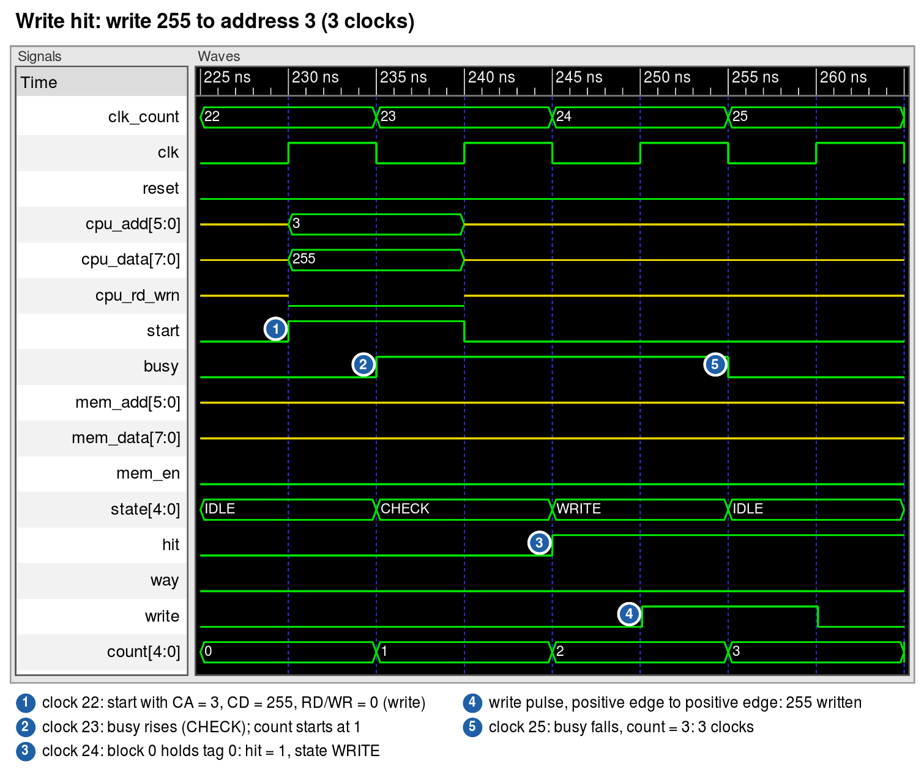
Figure 12: chip_test: write hit (0xFF to 0x03, 3 clocks)
Write 0xFF (255) to 0x03: the block is already in the cache, so CHECK finds hit = 1 and the state machine goes to WRITE; the write signal is on for one clock, from the positive edge after the 2nd negative edge to the next positive edge, and busy goes low on the 3rd negative edge: 3 clocks (count = 3). The counter started again at 1 with this request.
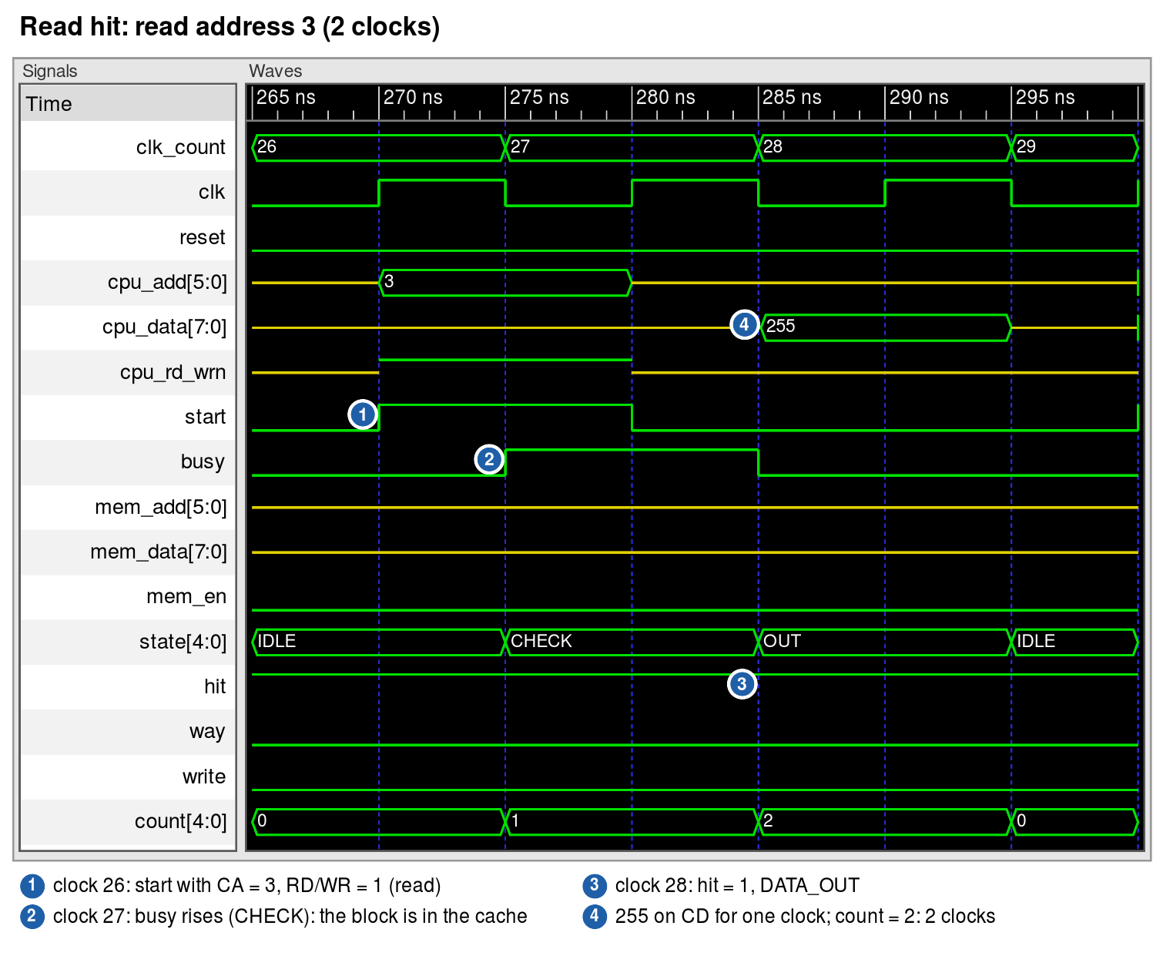
Figure 13: chip_test: read hit (0x03, 2 clocks)
Read 0x03: busy for one clock (CHECK, hit = 1), then DATA_OUT puts 255 (0xFF, written by the write hit) on CPU_DATA for one clock while busy is low: 2 clocks (count = 2).
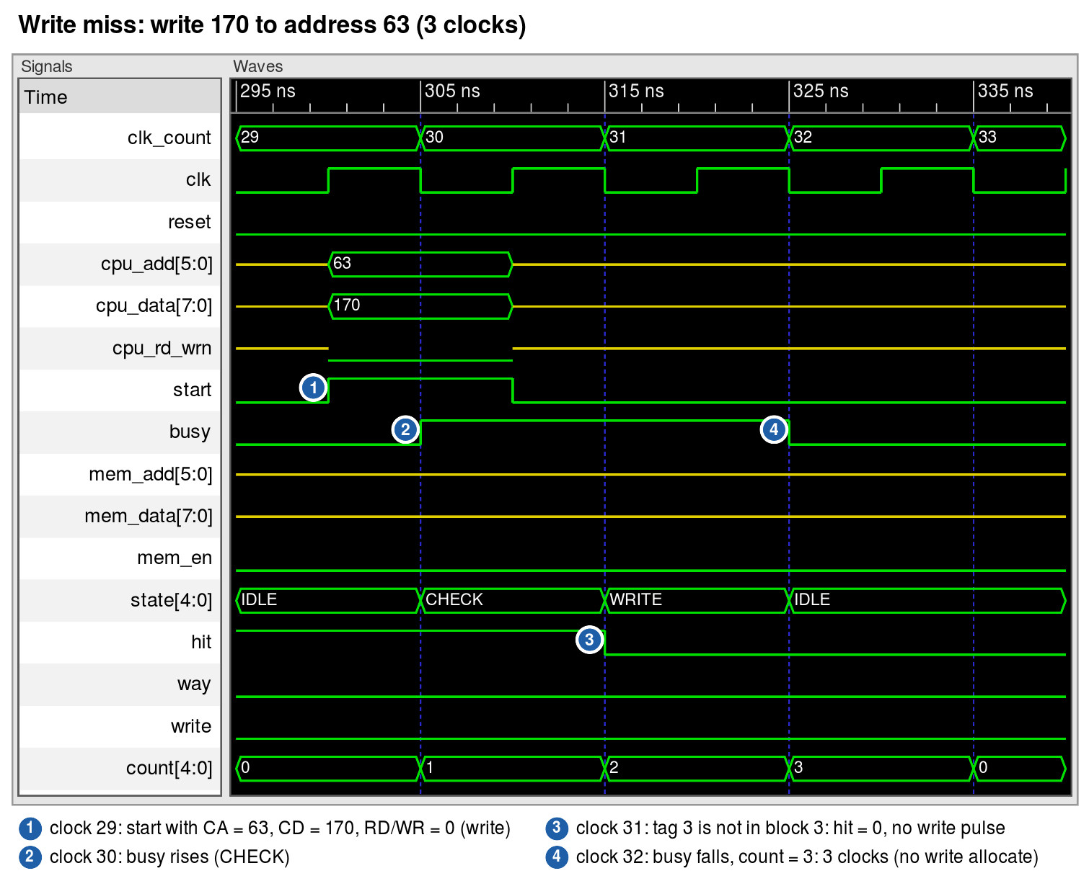
Figure 14: chip_test: write miss (0xAA to 0x3F, 3 clocks)
Write 0xAA (170) to 0x3F (63): tag 11 is not in block 3 of either way, so hit = 0 and no write pulse is made (write through with no write allocate: the cache is not changed); busy for 2 clocks, low on the 3rd negative edge: 3 clocks (count = 3).
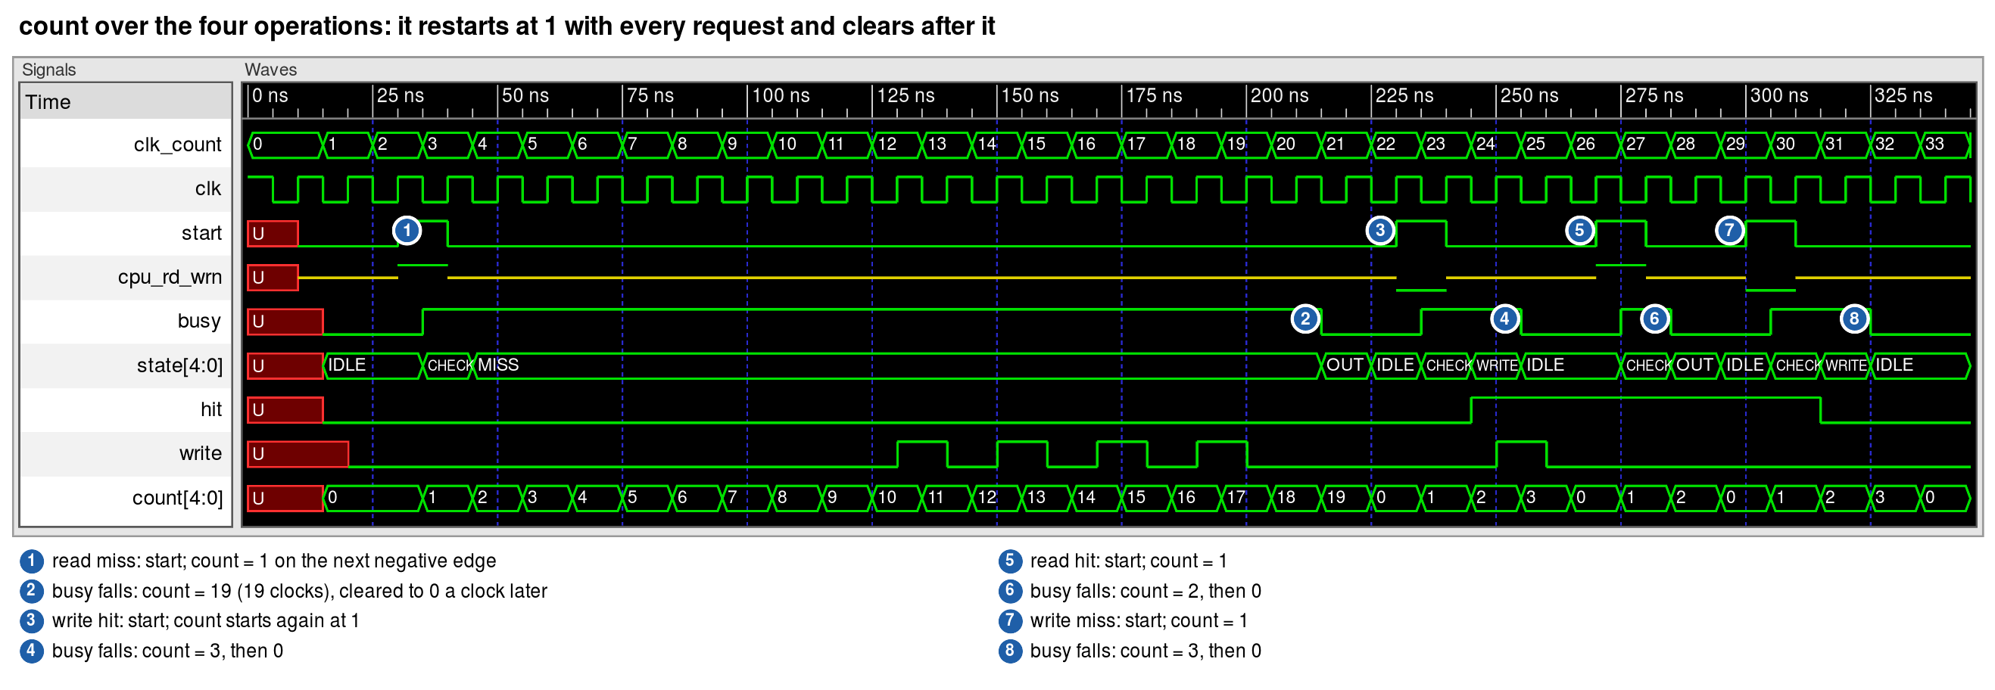
Figure 15: chip_test: the clock cycle counter over the four operations
The same run as the four figures above (chip_test with the course input file). count is started at 1 on the negative edge that accepts a request (busy goes high), counts while busy is high, and after the edge where busy goes low holds the request's length: 19 (read miss), 3 (write hit), 2 (read hit), 3 (write miss). One clock later it is cleared to 0; a request that follows at once starts it at 1 again.

9 Notes for the TA: running the simulations
The design is in the folder code/two_way/ of the submission: the VHDL in primitives/, gates/, blocks/, cache/, control/, cache_pkg.vhd and chip.vhd; the testbenches, the course testbench chip_test.vhd, its input file chip_in.txt and its output chip_out.log in testbench/. The code, this report and a README with these instructions are also on GitHub: https://github.com/aali12-eng/CMPE413-Cache-Chip-2Way . The simulations run in Cadence Xcelium with SimVision, as in the course lab: load the Cadence environment so that xrun is on the PATH, then from code/two_way run the script, or the same steps by hand from code/two_way/testbench. The design is compiled as VHDL-93; chip_test.vhd uses VHDL-87 file declarations, so it is compiled without -v93.
Testbench | Simulates | Input | Output
chip_test (course) | chip | two_way/testbench/chip_in.txt (format: Section 8.1) | printed on every clock edge → chip_out.log
tb_chip | chip | built in (CPU, memory and reference models) | PASS/FAIL report + statistics
tb_state_machine | state_machine + counter | built in | PASS/FAIL report
tb_cache, tb_cache_block, tb_hit_miss | cache blocks | built in | PASS/FAIL report
tb_selector, tb_cache_cell, tb_register_n, tb_counter | building blocks | built in | PASS/FAIL report

9.1 Assumptions
- Write through: the chip interface has no memory write port (MA is driven only with enable, MD is an input), so writes update the cache on a hit and the memory side of write through is outside this chip.
- Gate delay 100 ps (Section 3.2); the course primitives have zero delay, as provided.
- The CPU follows the protocol of the specification: it removes its signals on the positive edge after busy, and starts a new request no earlier than the positive edge after busy goes low.

10 Breakup of work
Table 13: Breakup of work
Task | Asif Ali (RE16458)
Cache cell, cache block, cache | Done
State machine and counter | Done
Chip top level | Done
Testbenches and simulation | Done
Report | Done

