Project: Hospital GN2

Database: MySql [MySql Workbench]

Database Details:

User Name: root

Password: NSinuk@cv4

Schema Name | Database Name: hospital

Table: Doctor

docid int pk

docName varchar(100)

phone int(100)

address varchar(100)

degree varchar(100)

subject varchar(100) (speciality)

password varchar(100)

Table: Patient

name varchar(100)

phone int

address varchar (100)

dob varchar (100)

password varchar (100)

Table: Record

name varchar (100)

phone int

dob varchar(100)

problem varchar (100)

docName varchar (100)

medicine varchar(100)

test varchar (100)

treat int (100) PK

Project Details:

IDE: Netbeans

Technology: J2EE(Java, Servlet, JSP), JDBC(MySql)

Project Name: Hospital_GN2

Modules: TBC

1. Patient Booking

2. Doctor Consultation

3. Display Records

4. Update Records

Design Pattern: MVC

M= Model (Java Class, DBClass, DBQuery Class)

**WebPages**

V= View (JSP, HTML, CSS, JS)

1. Bookings.jsp
2. displayRecords.jsp
3. dlog.jsp
4. doctorAccess.jsp
5. dreg.jsp
6. formstyle.css
7. index.jsp
8. login.jsp
9. patientAccess.jsp
10. plog.jsp
11. preg.jsp
12. register.jsp
13. style.css

**Source Packages**

Controller = com.hospital.controller

1.DAccessServlet.java

2.DlogServlet.java

3.Dreg.Servlet.java

4.LoginServlet.java

5.PlogServlet.java

6.PregServlet

7.RegisterServlet.java

**Java Objects**

Model = com.hospital.model

1. Consultation.java
2. Doctor.java
3. DoctorQuery.java
4. MyConnection.java
5. Patient.java
6. PatientQuery.java
7. Record.java
8. RecordQuery.java

1. Create Web Application Project

1.a.Choose project type

1.b.Set Name and Location

1.c.Set Server Settings and Click Finish

1.d.Click Finish to create new project

Hospital Project Structure

|  |  |  |
| --- | --- | --- |
| Webpages | Controller | Model |
|  |  |  |

2. Design Webpage Design – (use the business logic for the web application to determine navigation and functionality).

[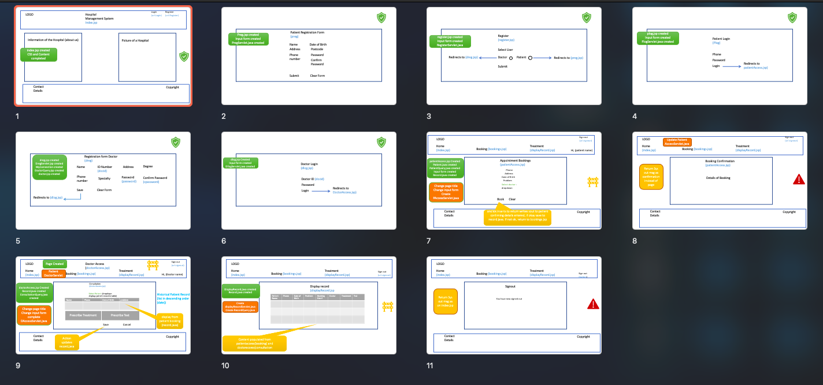](../../../../CME/Hospital-Management-System-TTA-Group-Task/Hospital%20Management%20Designv2.pptx)

3. Create Web Structure – (create the web pages for the web application).

3.a. – right-click on PatientCrud and select html, jsp or Cascading Style Sheet to add each new page

3.b. enter name

3.c. Click finish to add web page to project structure. If you are not using the index page, rename as desired

Java objects folder:

Create Web Pages

Set master page

Create Patient Class object to model

Create Database Connection

Add .jar to Library

Add java Connection Class object to model

