Linoy Pappachan Malakkaran

Abu Dhabi Ports

ATLP Common COMPONENTS

ATLP common components can be used cross all ATLP streams

Contents

1. ATLP Filter 2

2. ATLP global search or ATLP common header 2

3. Rich view milestone 3

4. Hijari calendar 3

5. ATLP pagination 4

4

6. ATLP Payment 4

7. ATLP common confirmation and Dialogs 5

8. ATLP common sidebar 5

9. ATLP Charts 6

10. File upload 7

11. Progress bar 8

12. Form Error calculation 8

13. ATLP Lookup component 9

14. ATLP auto complete 9

15. ATLP Grid with single and multiple selection with filter 10

16. ATLP Snak-bar and toaster 10

17. ATLP star rating 11

18. ATLP FAQ 12

19. ATLP form validators 12

20. ATLP RICH Classic Table 12

Working Demo : 14

Note: 14

# ATLP Filter

ATLP filter is a component can be used cross all ATLP streams, this component contains many features such as:

* Apply Filter.
* Get saved filters.
* Recent Filters.
* Clear Filters.
* Delete Saved Filter.
* Apply Saved Filter.

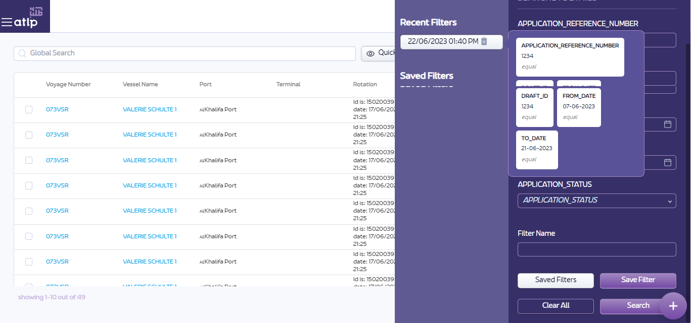

# ATLP global search or ATLP common header

ATLP global search for wild card search for listing



# Rich view milestone

his is a component, we are using it in the selection in the rich view mode

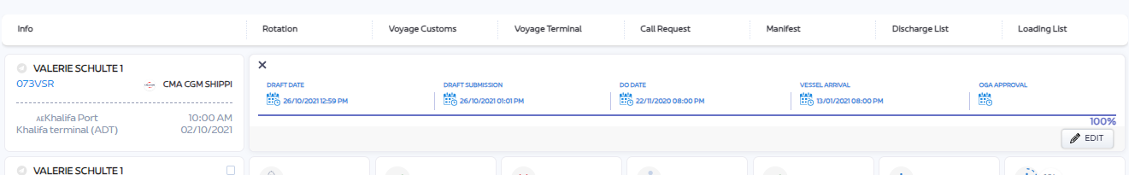

# Hijari calendar

This is for user to view Arabic calender

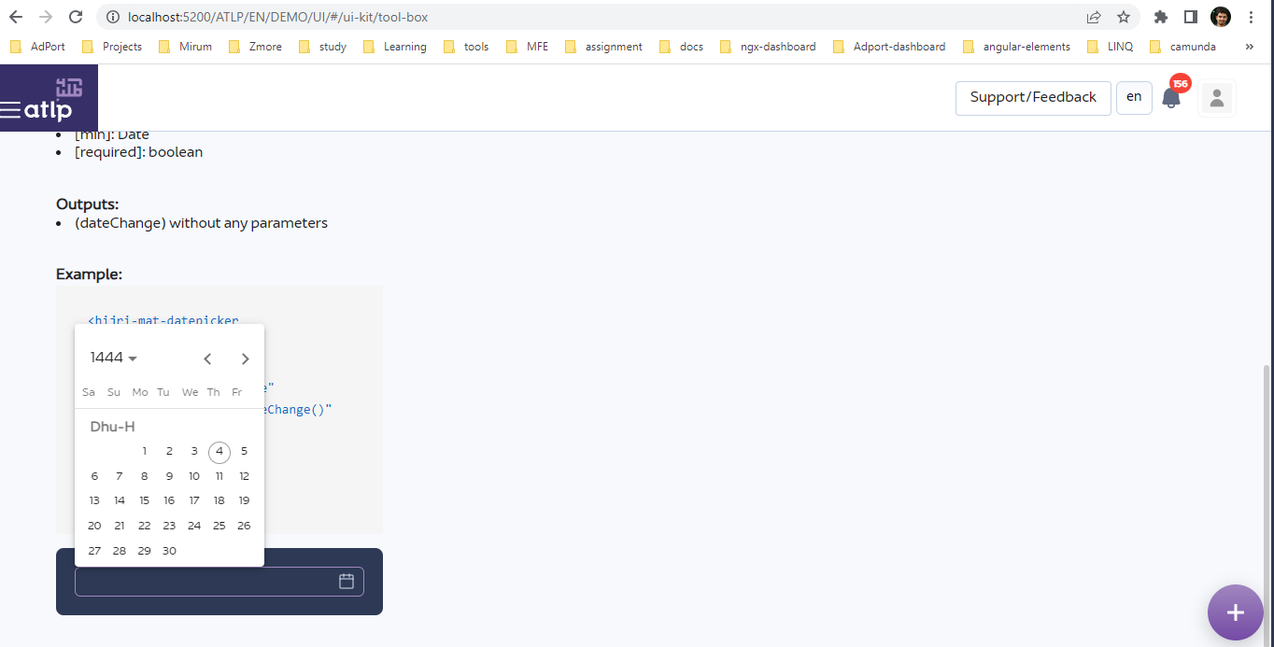

# ATLP pagination

This is the common pagination used for ATLP Rich and classic tables

# 

ATLP sidebar pagination:

This is the pagination used inside ATLP sidebar listing.



# ATLP Payment

ATLP Payment Module is used to process different payment methods using api call back with Mpay Team. The Payment methods which are integrated now are as below:

* Credit card.
* Internet Banking.
* EWallet.
* Cash
* AD Pay

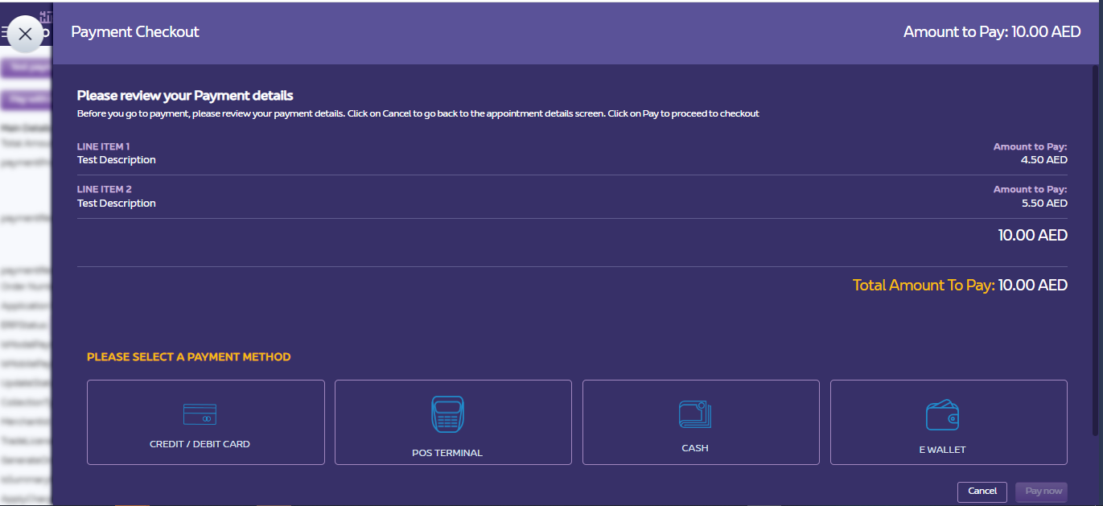

# ATLP common confirmation and Dialogs

Used for Dialog, confirm and common messages for notifying the cusomer



# ATLP common sidebar

ATLP common sidebar for form rendering.

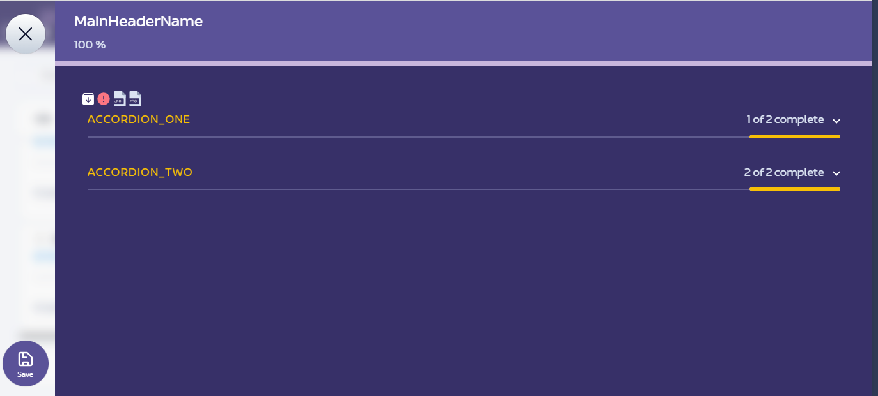

# ATLP Charts

ATLP common charts for dashboard and general purpose.

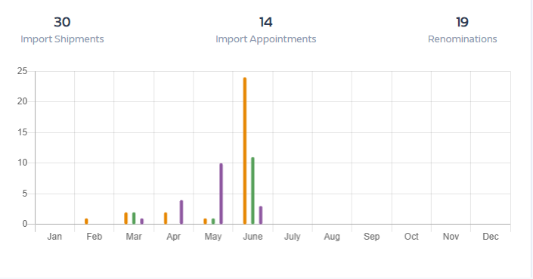

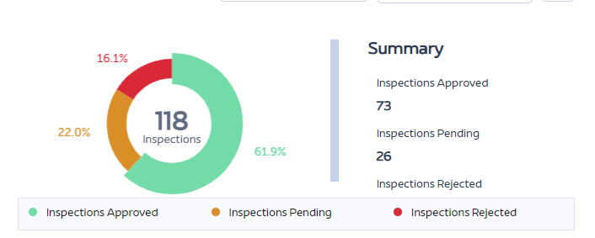

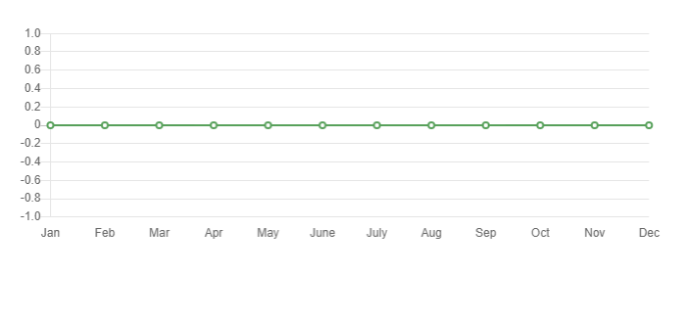

Some more charts all adopted 100%…

# File upload

ATLP File upload component for single and multiple.

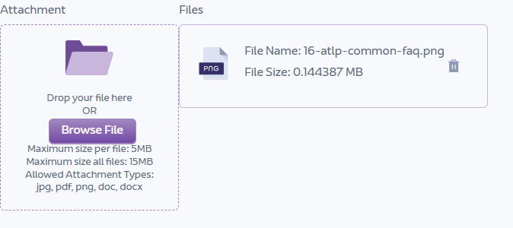

# Progress bar

To show progress status for each accordion and overall accordions progress.

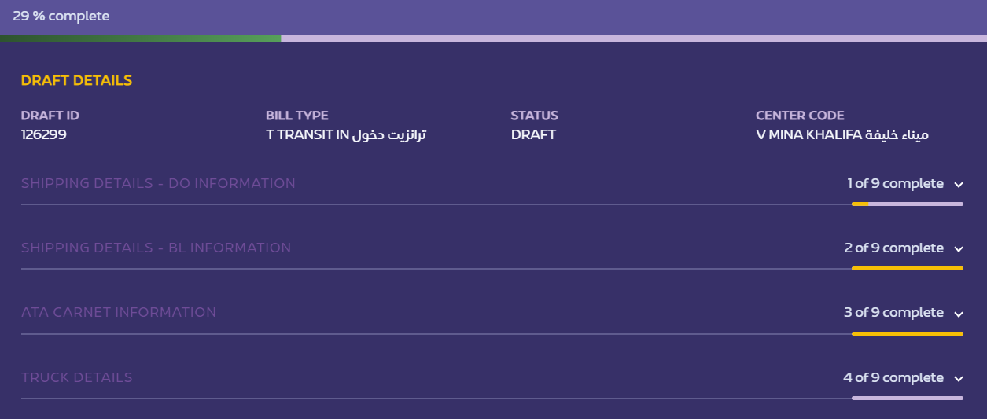

# Form Error calculation

To show navigable error messages inside sidebar form after submitting.

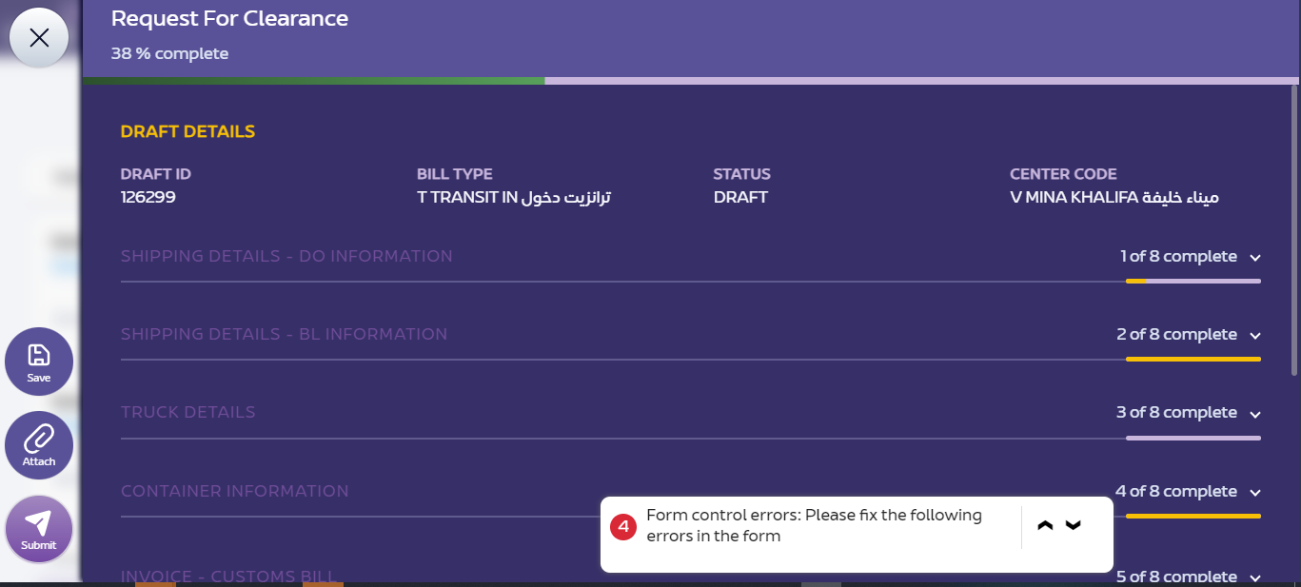

# ATLP Lookup component

ATLP lookup common component working based on configurations

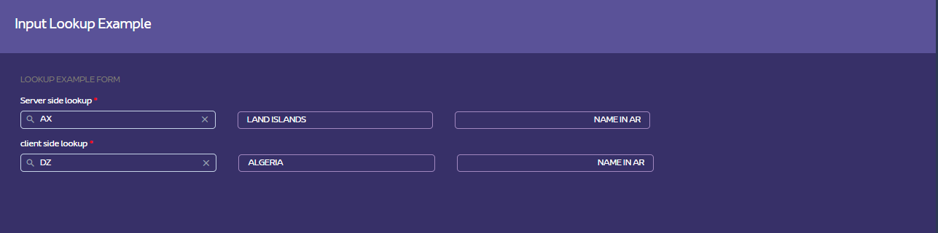

# ATLP auto complete

ATLP auto-complete common component working based on configurations

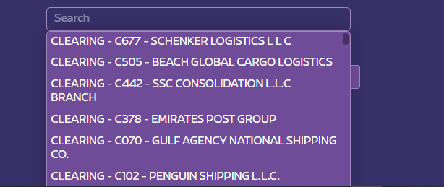

# ATLP Grid with single and multiple selection with filter

ATLP inline grid CRUD operation with client and server side pagination.

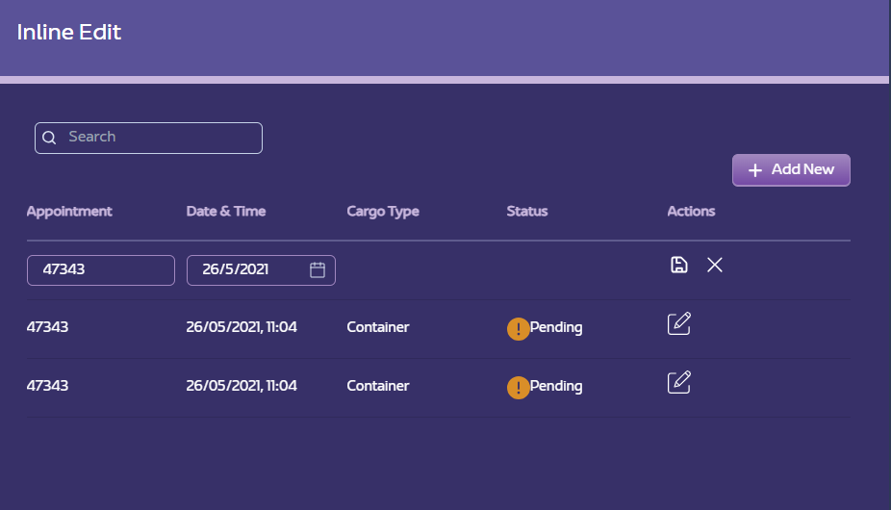

# ATLP Snak-bar and toaster

ATLP common notification for snak-bar and toaster



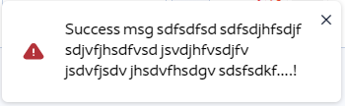

# ATLP star rating

For displaying rating in star rating format.

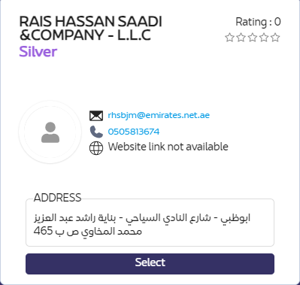

# ATLP FAQ

ATLP common FAQ can be used for all modules under atlp projects.

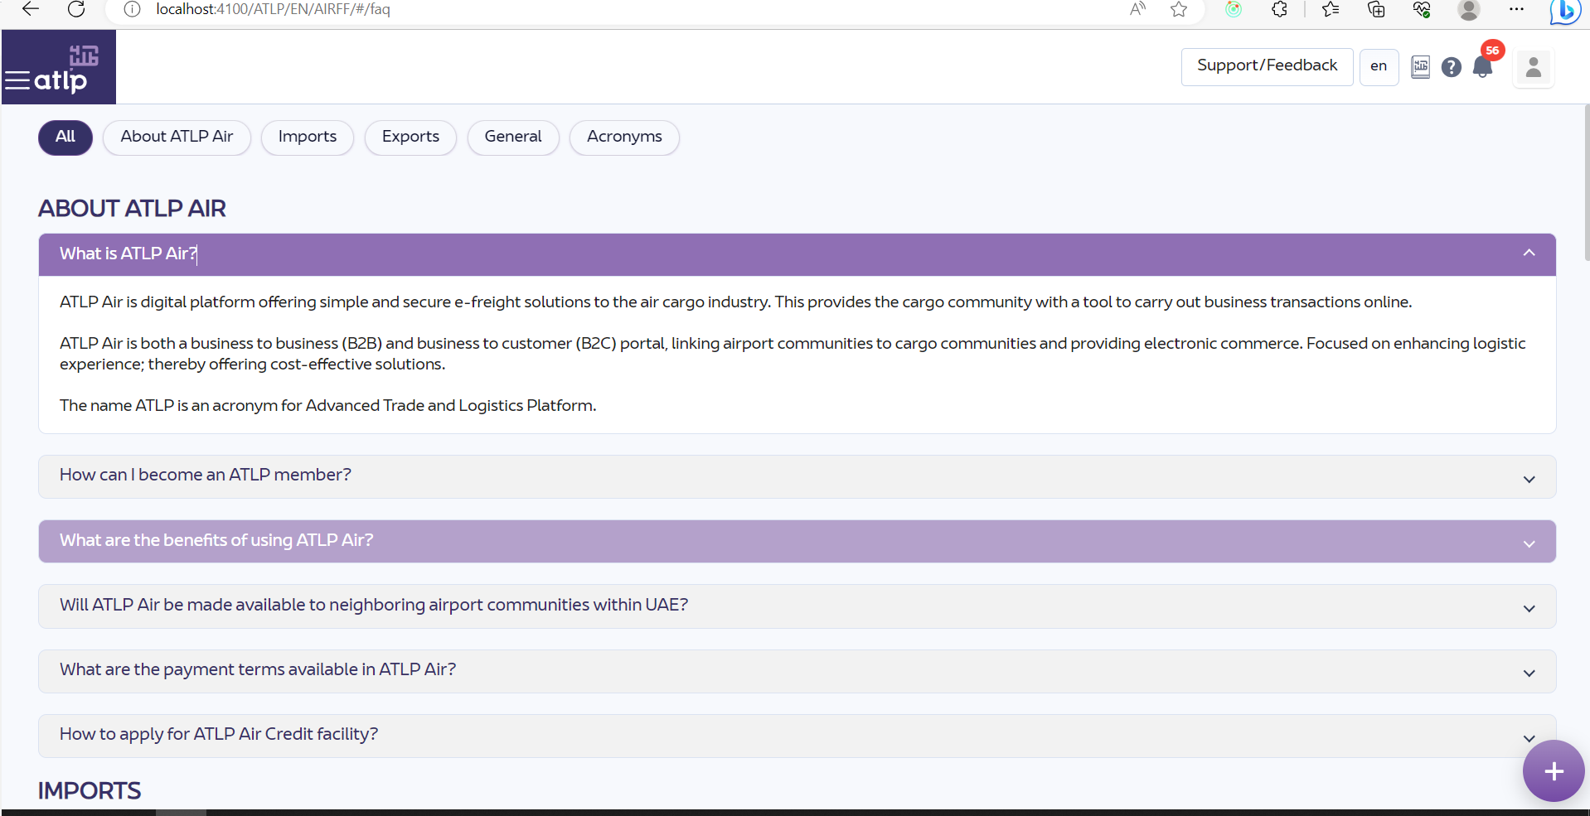

# ATLP form validators

This is common validators for form components

# ATLP RICH Classic Table

ATLP Rich Classic Table Module is used to list the transactions in different Listing modes such as Rich, Classic Rolled and classic Collapsed:

* Rich View.
* Classic Rolled View.
* Classic Collapsed View.
* ATLP Common Sub Header (where controls of each listing will be placed)
* ATLP Pagination used to display client-side and server-side pagination

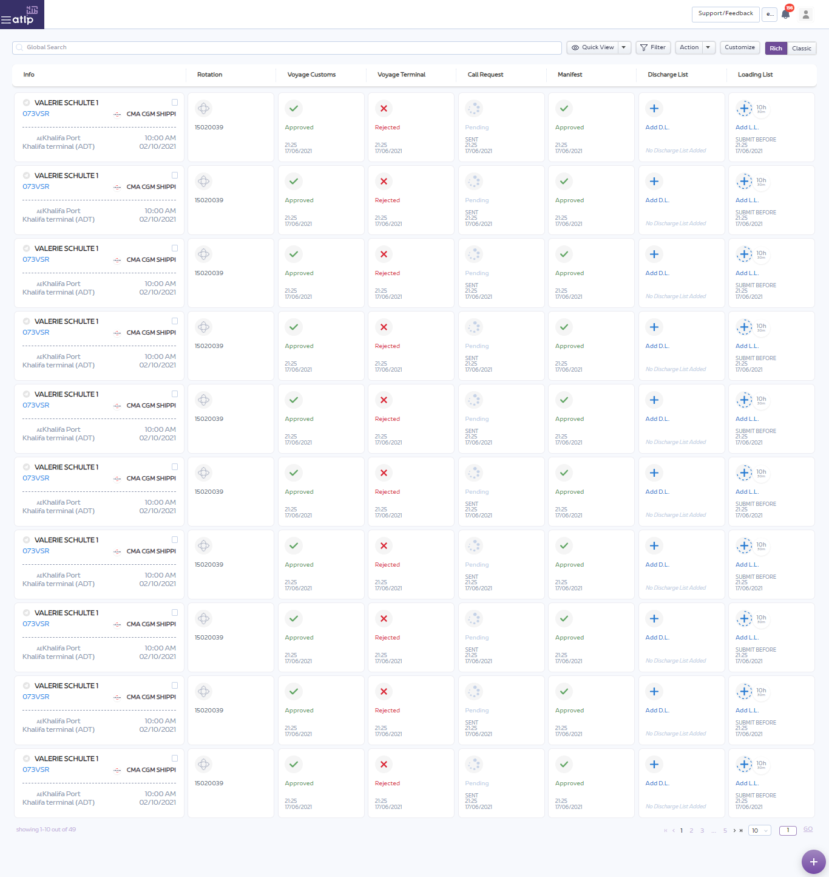

ATLP Classic view

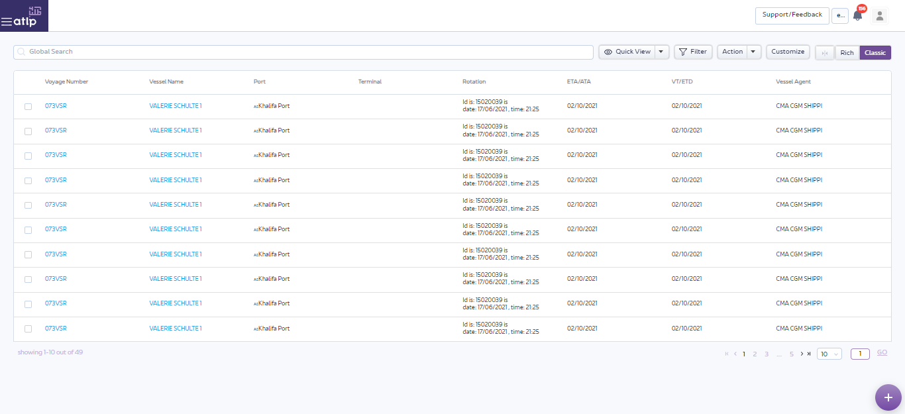

# Working Demo :

Most of the examples are added in DEMO project. So please refer below project code repo for working examples

* Web URL: <http://10.0.131.21/ATLP/EN/DEMO/UI/#/ui-kit/sample-service>
* Source code: <http://10.0.131.131/atlp/atlp_ui/atlp_ui_submodules/atlp-demo-ui>

Documentation page: <http://atlpqa/EN/Docs/Portal/Main/>

# Note:

The documentation provided above are not final and developed based on the best assumptions, feel free to contact **Linoy Pappachan Malakkaran**, **Jessanth Nelson or Anutejaswy Menta** for any suggestions to make it better or fix any issues