ThreatLens — Security Log Analyzer

Project Report
IBM SkillsBuild Cyber Security 2026

Author: Aaliya
Date: October 22, 2026

1. Executive Summary
ThreatLens analyzed 2,000 authentication log events spanning 6 days. Rule-based analysis identified 76 suspicious events matching 7 distinct threat patterns. All detections are based on transparent, explainable rules requiring no machine-learning models or external threat intelligence feeds.
- CRITICAL: 2 event(s)
- HIGH: 8 event(s)
- MEDIUM: 65 event(s)
- LOW: 1 event(s)

2. Dataset Overview
The dataset used in this analysis is a clearly labelled SYNTHETIC authentication log generated by ThreatLens's bundled generator (src/generate_dataset.py). All usernames, IP addresses, and events are fictional. The dataset contains deliberately injected patterns that match each detection rule, so that the rule engine has events to find. It does not represent real user activity.
Dataset Statistics:
Metric | Value
Total Events | 2,000
Date Range | 2025-06-01 → 2025-06-07
Unique Users | 1,969
Unique Source IPs | 1,986
Unique Countries | 10
Login Failures | 344
Login Successes | 1,421
Password Resets | 125

Note: This is a clearly labeled synthetic dataset. All usernames, IP addresses, and session identifiers are fictional. No real user data was used in this project.

3. Detection Rules Applied
ThreatLens applies seven deterministic, rule-based detectors. Each rule has a fixed threshold, a defined time window, and produces a human-readable explanation for every flagged event.
Rule ID | Name | Logic Summary | Severity
R-01 | Brute Force | ≥ 5 failures from same IP within 10 min | HIGH
R-02 | Credential Stuffing | ≥ 3 failures across ≥ 3 users from one IP / 15 min | HIGH
R-03 | Off-Hours Login | Successful login between 22:00–05:00 UTC | MEDIUM
R-04 | Impossible Travel | Same user logs in from locations > 500 km apart / 60 min | CRITICAL
R-05 | Repeated Account Lockout | Same account locked ≥ 3 times within 60 min | MEDIUM
R-06 | VPN Login Without MFA | Successful VPN login without MFA | LOW
R-07 | Password Reset Spike | ≥ 3 resets from same IP within 30 min | MEDIUM

4. Findings
76 events were flagged across 7 rule categories.

Rule ID | Rule Name | Severity | Events Flagged
R-01 | Brute Force | HIGH | 5
R-02 | Credential Stuffing | HIGH | 3
R-03 | Off-Hours Login | MEDIUM | 61
R-04 | Impossible Travel | CRITICAL | 2
R-05 | Repeated Account Lockout | MEDIUM | 2
R-06 | VPN Login Without MFA | LOW | 1
R-07 | Password Reset Spike | MEDIUM | 2

4.1 Top Attacker IPs
Source IP | High/Critical Flags
203.75.32.207 | 4
216.205.10.74 | 4
70.48.153.229 | 1
14.177.88.123 | 1

5. Visualizations
Figure 1: Login Events Over Time
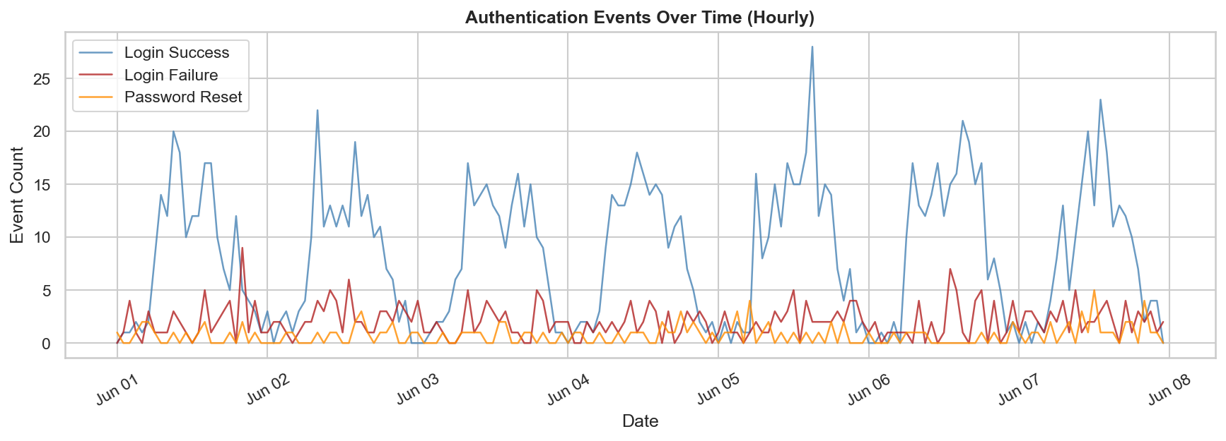

Figure 2: Hourly Login Heatmap (Day of Week vs Hour)
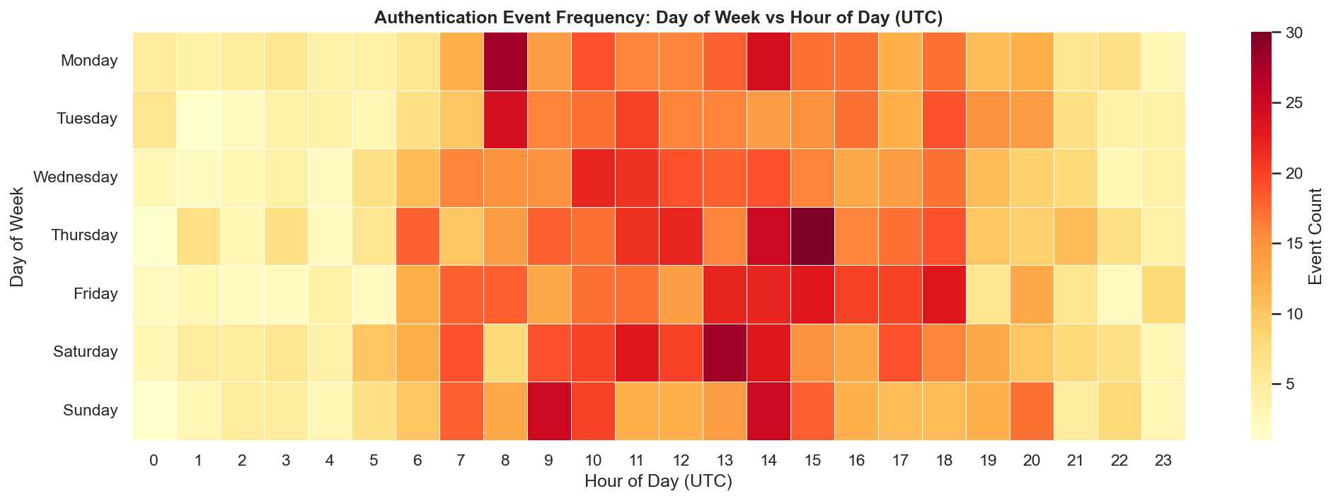

Figure 3: Top 10 Source IPs by Failure Count
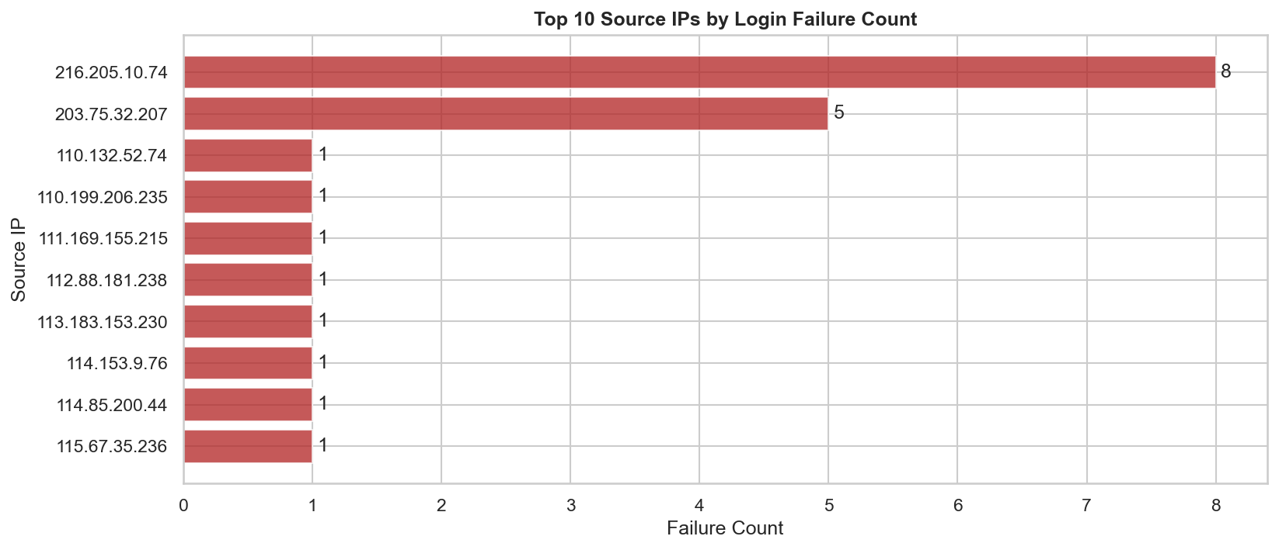

Figure 4: Flagged Events by Severity
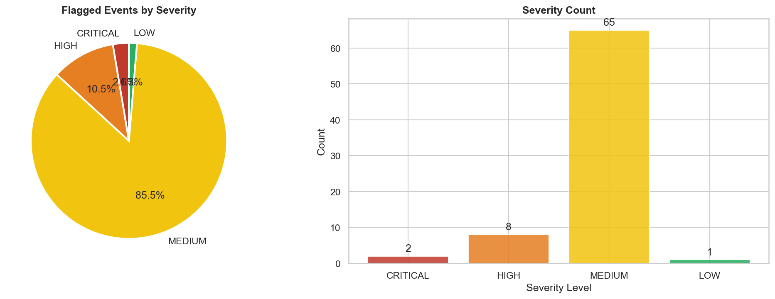

Figure 5: Flagged Events by Rule
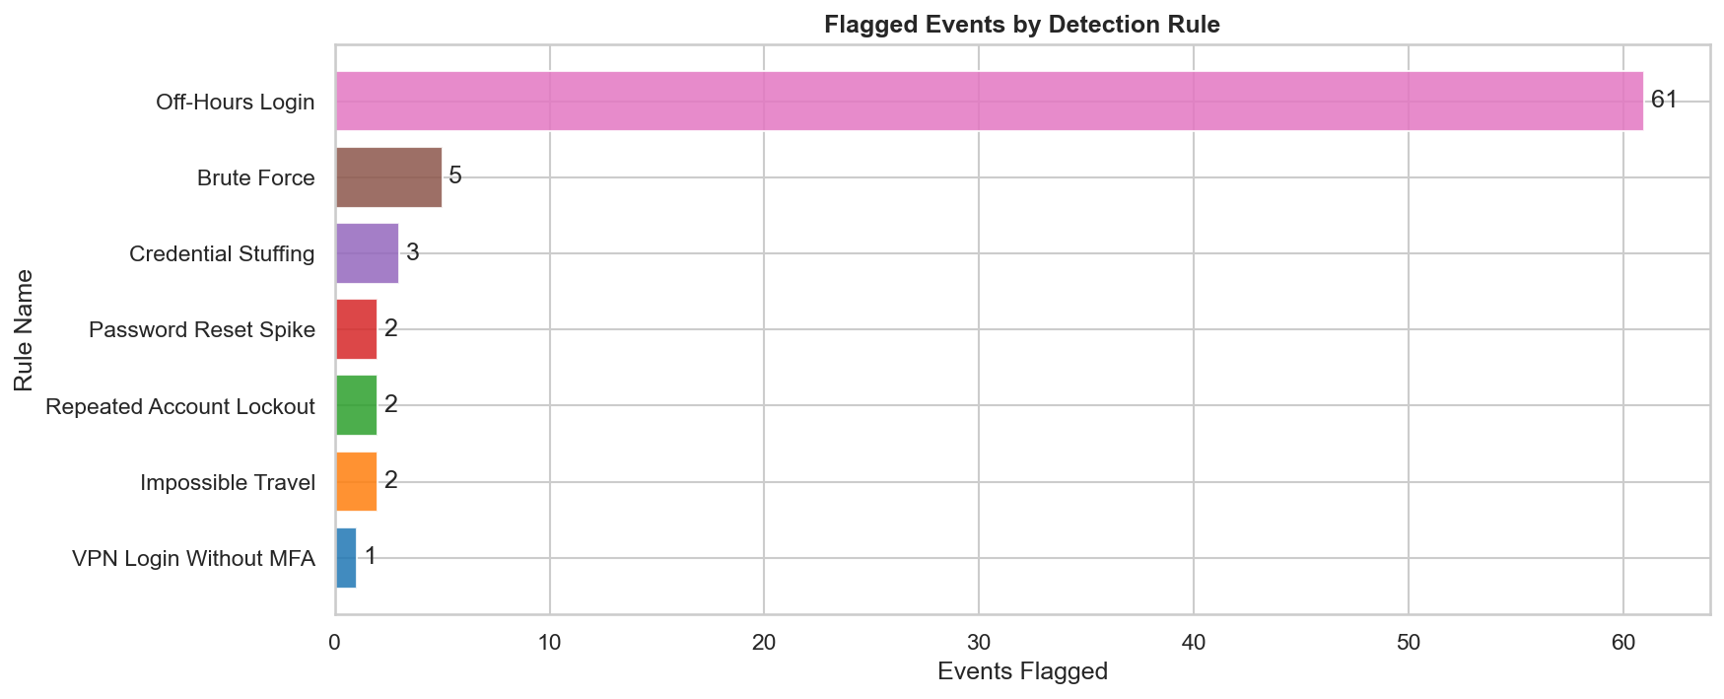

Figure 6: Authentication Method Distribution
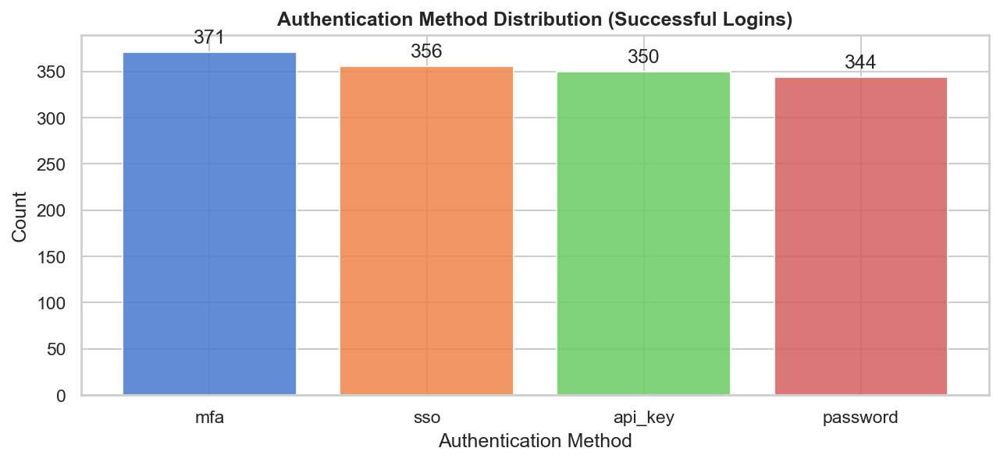

6. Recommendations
- R-01: Enable account lockout policy after 5 failed attempts. Deploy IP-based rate limiting on login endpoints.
- R-02: Implement CAPTCHA and per-IP request throttling. Monitor for known credential-leak databases.
- R-03: Alert SOC team on off-hours logins. Require step-up MFA authentication for non-business-hours access.
- R-04: Suspend session and force re-authentication. Notify user via out-of-band channel (email/SMS).
- R-05: Trigger mandatory password reset workflow. Notify account owner of repeated lockout.
- R-06: Enforce MFA policy for all VPN-originating authentication. Audit VPN ACLs.
- R-07: Rate-limit password reset emails per IP. Add CAPTCHA to password reset flow.
General best practice: Centralise log collection into a SIEM, enforce MFA for all remote access, and review these findings with your security team before taking any automated action.

7. Limitations and Scope
- This analysis is limited to structured authentication log data. Network-layer, endpoint, or application-layer attacks are out of scope.
- Rule thresholds (e.g., 5 failures in 10 minutes) are illustrative. Production deployment requires tuning to the specific environment to reduce false positives.
- The dataset used here is synthetic. Results on real production logs will differ.
- This project does not claim to detect all cyberattacks. It demonstrates a subset of detectable patterns using rule-based methods.
- No automated remediation is performed. All outputs are advisory only.

8. Conclusion
ThreatLens demonstrates that meaningful threat detection can be achieved with transparent, rule-based logic applied to structured authentication logs — without requiring machine learning, paid services, or proprietary tools. The project is reproducible, beginner-accessible, and provides a solid foundation for further expansion into SIEM integration or anomaly-based detection.

ThreatLens · IBM SkillsBuild Cyber Security 2026 · Aaliya · October 22, 2026

