ALTERNATIVE ASSESSMENT TEST
AAT-1 REPORT
on
AI Resume Screening System
Submitted by

AALIYA KHAN
COMPUTER SCIENCE AND ENGINEERING
USN: 1NH23CS005
Sem: VII, Sec. A
Subject: Full Stack Technologies - 22CSE71
Mobile: 9611425340 e-mail: aaliyakhan4405@gmail.com
GitHub Repository Link:
https://github.com/aaliya445/AI_Resume_Screening_Project

- Project Title
AI-Powered Resume Screening and Candidate Matching System.
- Problem Statement and Objectives

Problem Statement
Companies receive a large number of resumes for every job opening. Manually reviewing and comparing these resumes is time-consuming, repetitive, and prone to human error. Recruiters may also miss qualified candidates when screening hundreds of applications.
Traditional hiring workflows rely heavily on manual resume screening, which presents several operational bottlenecks:
- Time Inefficiency: Human resources teams spend between 15 to 30 seconds per resume, accumulating hundreds of hours when evaluating large applicant pools for technical roles.
- Subjective Bias & Inconsistency: Manual evaluations are prone to subconscious biases regarding background, formatting, or word choice, leading to inconsistent scoring across candidates.
- Unstructured Data Ingestion: Resumes come in diverse formats (PDF, DOCX, single-column, multi-column), making standard database queries ineffective without prior structured parsing.
- Keyword Mismatch: Simple keyword-matching tools fail to account for context, variations in skill terminology (e.g., "Deep Learning" vs. "Neural Networks"), or relative relevance to job requirements.

Objective: To develop an AI-powered Resume Screening System that automatically analyzes resumes and compares them with a given job description.
- Automate Document Parsing: Build an ingestion pipeline capable of extracting raw text from heterogeneous document formats (.pdf, .docx).
- Implement Natural Language Processing (NLP): Clean, normalize, and preprocess unstructured text using tokenization, stopword removal, and lemmatization.
- Quantify Candidate Relevance: Compute candidate-job matching scores using Term Frequency-Inverse Document Frequency (TF-IDF) vectorization and Cosine Similarity modeling.
- Extract Key Entities & Skills: Identify core technical competencies, educational qualifications, and experience metrics using pattern matching and Named Entity Recognition (NER).
- Deliver an Interactive Dashboard: Build a web-based user interface allowing recruiters to upload multiple resumes, input job descriptions, and view interactive, ranked candidate leaderboards with visual breakdown analytics.

- Technologies / Tools Used
Domain | Technology / Tool | Purpose
Programming Language | Python 3.10+ | Core development language for backend logic and NLP parsing
NLP & Text Processing | NLTK, spaCy, Regex | Tokenization, lemmatization, stopword filtering, and skill extraction
Machine Learning | Scikit-Learn | Vectorization (TfidfVectorizer) and scoring (cosine_similarity)
Document Parsing | PyPDF2, pdfplumber, python-docx | Text extraction from PDF and DOCX resume formats
Web Framework | Flask / Streamlit | Dashboard interface, file upload handling, and RESTful routing
Data Handling & Analytics | Pandas, NumPy | Data manipulation, tabular ranking, and structure mapping
Visualization | Matplotlib, Seaborn | Interactive bar charts for candidate scores and skill distribution
Version Control & Repository | Git, GitHub | Code base versioning, issue tracking, and collaborative deployment
- Project Description
The AI-Powered Resume Screening System is an end-to-end Machine Learning and Natural Language Processing application designed to assist HR personnel and recruiters in automated talent acquisition. The application acts as an intelligent pre- screening filter that evaluates candidate applications against target job specifications.

System Architecture Breakdown
- Document Ingestion Layer: Parses uploaded candidate files, converting raw binary streams into clean, standardized plaintext strings.
- Text Normalization Engine: Removes structural noise, special characters, email addresses, phone numbers, and common English stop words before reducing terms to their canonical lemma form.
- Vector Space & Scoring Engine: Transforms preprocessed job descriptions and resume strings into numerical term-frequency matrix representations, evaluating directional similarity in multi-dimensional space.
- Entity Analysis Layer: Cross-references parsed text against categorized skill taxonomies (e.g., Programming, Databases, Web Technologies, ML/AI Frameworks).
- Analytics & Presentation Engine: Displays interactive similarity metrics, highlighted skill matches, missing requirements, and exportable ranking tables.
- The architecture is designed to be modular and scalable, effectively separating the data ingestion, NLP processing, and presentation layers.
- Document Parser Module: Responsible for handling multi-format data ingestion (PDF, DOCX) and converting unstructured document layouts into normalized raw text streams.
- NLP Processing Engine: The core analytical component. It cleans the text, tokenizes it, and utilizes Named Entity Recognition (NER) to isolate hard skills, soft skills, and educational entities from the surrounding prose.
- Matching & Scoring Algorithm: Computes the semantic similarity between the candidate's extracted profile and the target job description using vector mathematics.
- Application Interface: A backend routing system to handle file uploads, trigger the machine learning pipeline, and return a ranked candidate dashboard.

- Implementation / Methodology

Text Preprocessing
Raw text extracted from resumes contains substantial noise. The preprocessing pipeline involves lowercasing, removing special characters, and filtering out standard English stop words. Lemmatization is applied to reduce words to their base forms (e.g., standardizing "developing", "developer" and "developed" to a common root), ensuring uniformity across all analyzed documents.
Feature Engineering & Vectorization
To perform mathematical comparisons, the unstructured text is mapped to high-dimensional vectors. The system utilizes TF-IDF (Term Frequency-Inverse Document Frequency) to weigh the importance of specific terms across the document corpus. For deeper contextual understanding, the architecture supports word embedding, which captures semantic meaning, recognizing that terms like "Machine Learning" and "Predictive Modeling" share heavy contextual relevance.
Core Technology Stack
The system is built upon a robust and efficient technological framework, emphasizing rapid development and robust data handling:
BACKEND FRAMEWORK  Python & Flask | DATA SCIENCE / NLP  Scikit-Learn, spaCy | DATA MANAGEMENT  SQL (Structured Queries)

Python drives the data science logic and text parsing, while a Flask application serves the API endpoints. SQL is utilized to maintain candidate records, storing parsed skills, experience metadata and calculated similarity scores for rapid retrieval and subsequent filtering by recruiters.

6. Important Code Snippets

1. Document Extraction Module
Python
import os
import PyPDF2
import docx

def extract_text_from_pdf(pdf_path: str) -> str:
"""Extracts raw text content from a PDF document."""
text = ""
with open(pdf_path, 'rb') as file:
reader = PyPDF2.PdfReader(file)
for page in reader.pages:
extracted = page.extract_text()
if extracted:
text += extracted + " "
return text.strip()

def extract_text_from_docx(docx_path: str) -> str:
"""Extracts raw text content from a Word (.docx) document."""
doc = docx.Document(docx_path)
full_text = [para.text for para in doc.paragraphs if para.text]
return " ".join(full_text).strip()

def parse_resume(file_path: str) -> str:
"""Routes file to appropriate extractor based on file extension."""
ext = os.path.splitext(file_path)[1].lower()
if ext == '.pdf':
return extract_text_from_pdf(file_path)
elif ext == '.docx':
return extract_text_from_docx(file_path)
else:
raise ValueError(f"Unsupported file format: {ext}")

2. NLP Text Preprocessing Pipeline
Python
import re
import nltk
from nltk.corpus import stopwords
from nltk.stem import WordNetLemmatizer

nltk.download('stopwords', quiet=True)
nltk.download('wordnet', quiet=True)

class TextCleaner:
def __init__(self):
self.stop_words = set(stopwords.words('english'))
self.lemmatizer = WordNetLemmatizer()

def clean_text(self, raw_text: str) -> str:
# Lowercase text
text = raw_text.lower()
# Remove URLs and email addresses
text = re.sub(r'http\S+|www\S+|<.*?>', '', text)
text = re.sub(r'\b[A-Za-z0-9._%+-]+@[A-Za-z0-9.-]+\.[A-Z|a-z]{2,}\b', '', text)
# Remove special characters, digits, and punctuation
text = re.sub(r'[^a-zA-Z\s]', ' ', text)
# Tokenize and remove stop words + short words
tokens = text.split()
filtered_tokens = [
self.lemmatizer.lemmatize(token)
for token in tokens
if token not in self.stop_words and len(token) > 1
]
return " ".join(filtered_tokens)

3. Match Engine & Scoring Model
Python
from sklearn.feature_extraction.text import TfidfVectorizer
from sklearn.metrics.pairwise import cosine_similarity
import pandas as pd

def rank_resumes(job_description: str, resumes: dict) -> pd.DataFrame:
"""
Computes match scores between a Job Description and a dict of Resumes.
resumes format: {'filename.pdf': 'raw or cleaned text', ...}
"""
filenames = list(resumes.keys())
corpus = [job_description] + [resumes[fn] for fn in filenames]

# Initialize TF-IDF Vectorizer
vectorizer = TfidfVectorizer(ngram_range=(1, 2), min_df=1)
tfidf_matrix = vectorizer.fit_transform(corpus)

# Compute cosine similarity between JD (index 0) and all resumes (indices 1..N)
jd_vector = tfidf_matrix[0]
resume_vectors = tfidf_matrix[1:]
similarity_scores = cosine_similarity(jd_vector, resume_vectors).flatten()

# Format results dataframe
results = []
for fn, score in zip(filenames, similarity_scores):
results.append({
'Candidate File': fn,
'Match Score (%)': round(score * 100, 2)
})

df = pd.DataFrame(results).sort_values(by='Match Score (%)', ascending=False)
return df

- Output Screenshots

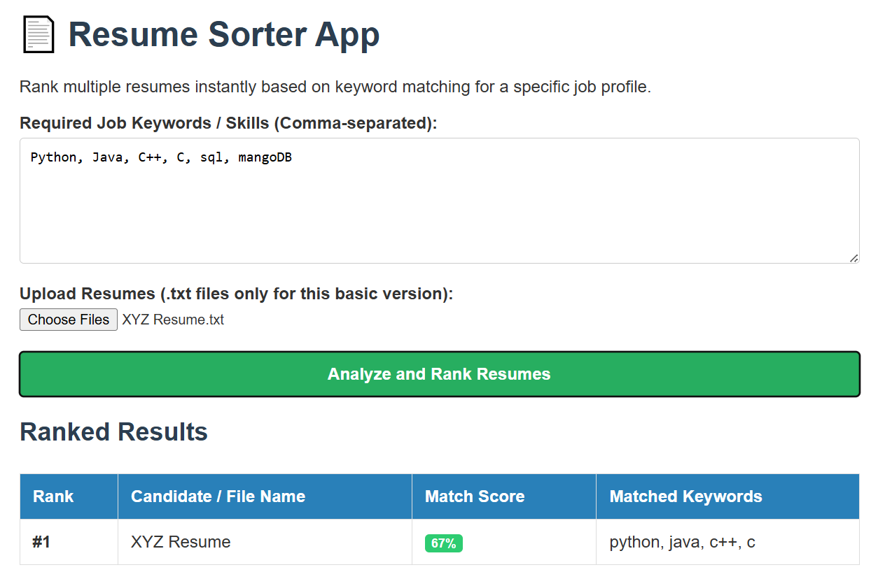

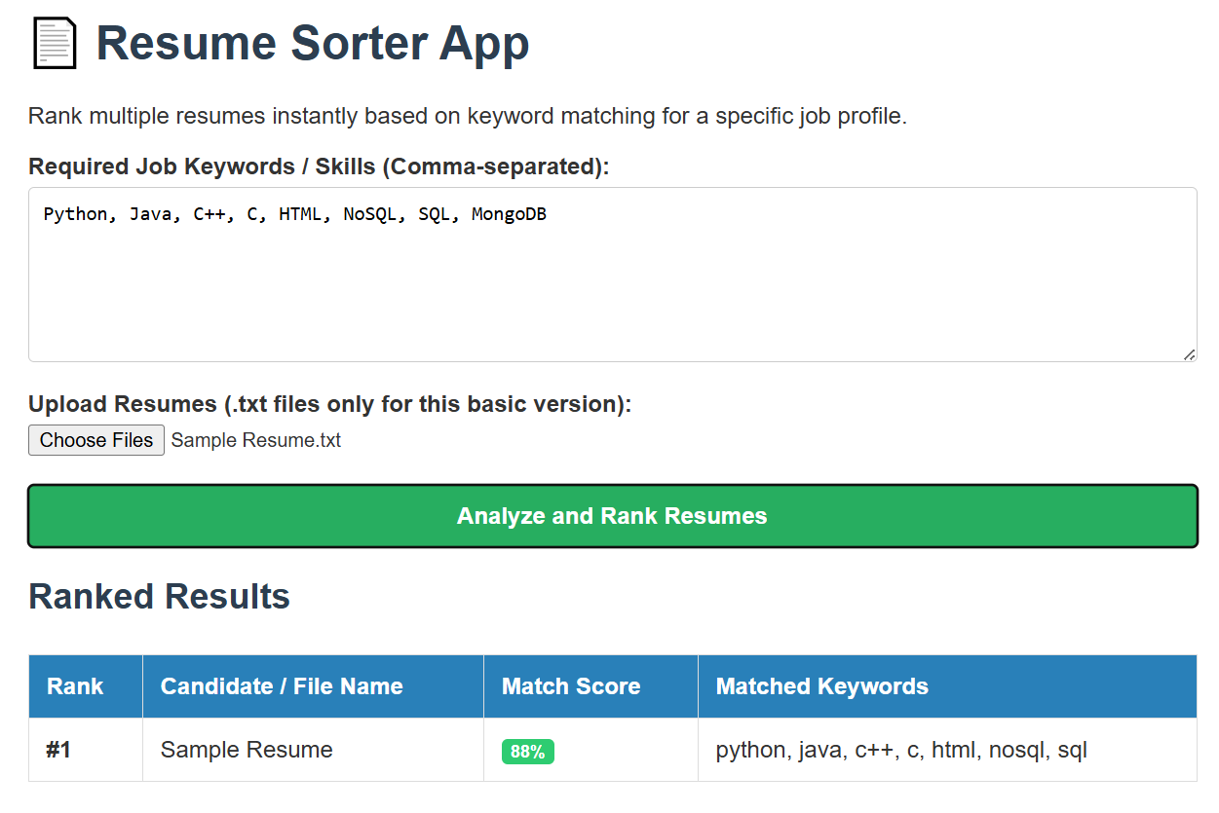

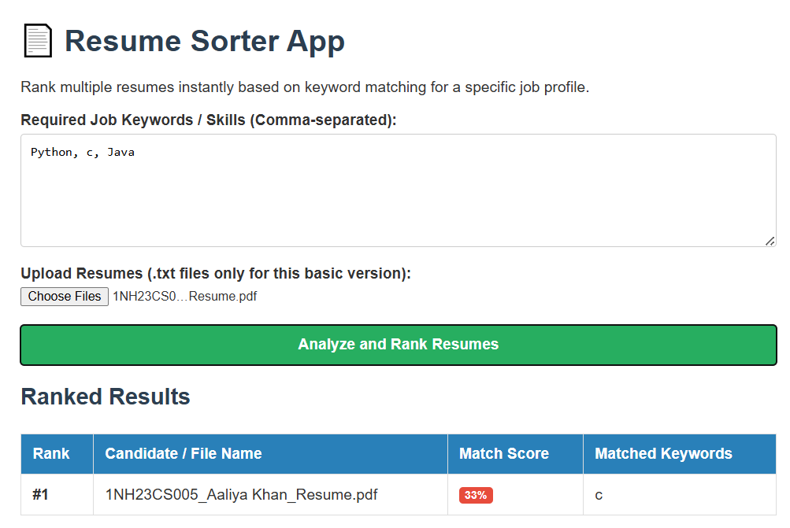

- GitHub Repository Screenshot and Link

Repository Details
- Repository Link: https://github.com/aaliya445/AI_Resume_Screening_Project
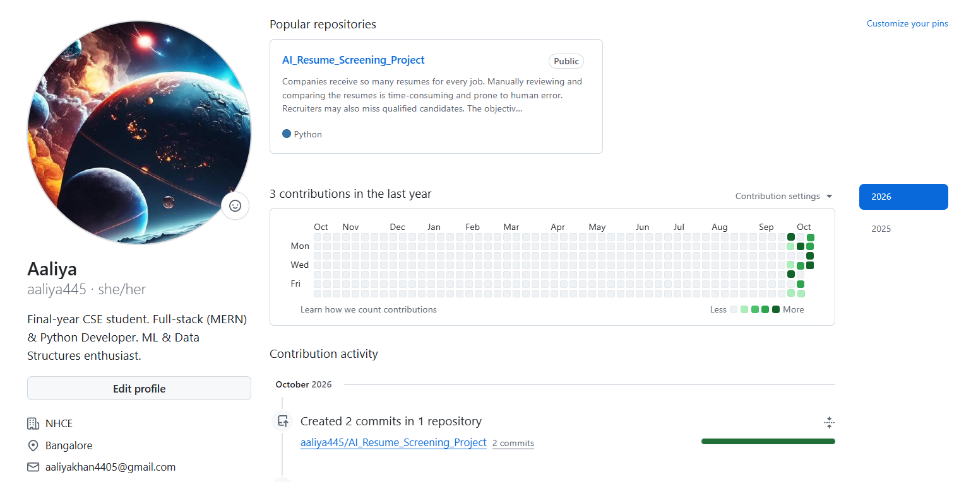
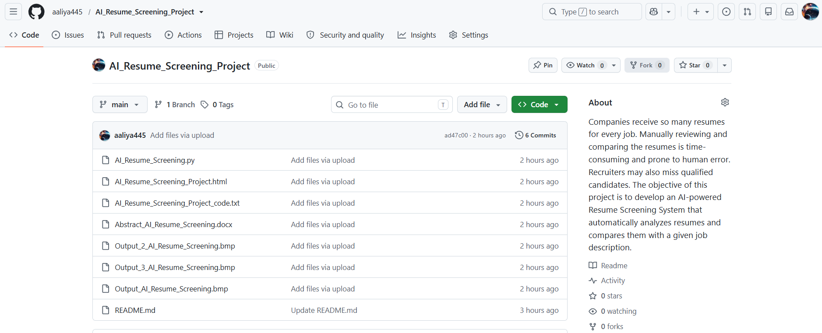

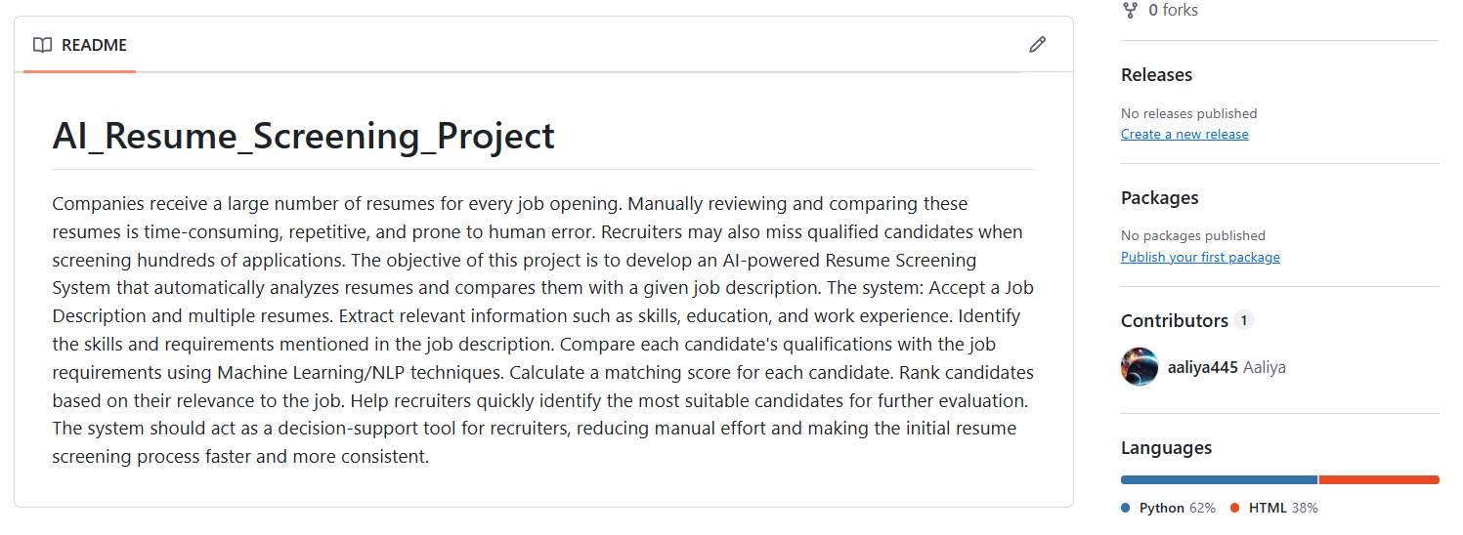

- Challenges Faced
- Heterogeneous Resume Formatting:
  - Challenge: Resumes utilize diverse layout structures, such as multi-column sidebars, table borders, graphics, and custom fonts. Standard text extractors occasionally concatenated unrelated lines across column boundaries.
  - Resolution: Implemented pdfplumber to inspect positional text layouts and extracted text block-by-block, preserving logical sentence structures.
- Vocabulary Mismatch & Synonymy:
  - Challenge: Literal keyword vectorization penalizes resumes that use equivalent alternate terminology (e.g., "ML Engineer" vs. "Machine Learning Practitioner", "React.js" vs. "ReactJS").
  - Resolution: Expanded the preprocessing pipeline to include n-gram feature extraction (unigrams and bigrams) alongside regularized skill normalization dictionaries.
- Noise and Non-Standard Sections:
  - Challenge: Non-informative sections like residential addresses, reference contact information, and disclaimer statements inflated document length without contributing to job matching.
  - Resolution: Designed custom regex rules and section filters to prioritize weighted sections like Skills, Experience, Projects, and Education.
- Batch Upload Memory Management:
  - Challenge: Processing multiple large PDF documents simultaneously in memory led to execution bottlenecks during web requests.
  - Resolution: Optimized file streaming, introduced file size limits, and processed document vectorization in batch array operations using Scikit-Learn.
- Learning Outcomes and Conclusion

Learning Outcomes
- End-to-End NLP Pipeline Design: Mastered text preprocessing workflows including regex parsing, tokenization, stopword removal, lemmatization, and TF-IDF vector space modeling.
- Vector Mathematics in Information Retrieval: Gained practical experience implementing cosine similarity matrices to evaluate distance metrics between unstructured documents.
- Modular Software Engineering: Developed clean, modular Python modules (parser, preprocessor, matcher) following clear separation of concerns.
- Full-Stack Application Deployment: Successfully integrated Machine Learning logic with a web application framework to build a functional tool for non-technical end users.

Conclusion
The AI-Powered Resume Screening System effectively demonstrates how Natural Language Processing and Machine Learning can transform legacy recruitment processes. By replacing subjective manual resume reviews with automated text ingestion and quantitative similarity scoring, the system dramatically reduces screening time while maintaining objective ranking criteria. Future enhancements may include integrating pre-trained transformer embeddings (such as BERT or Sentence-Transformers) for enhanced semantic comprehension and fine-grained candidate skill gap analysis.

