Aaliyah Gutierrez-Cano

BIO5202

Powers

**Using a facet grid to visualize the effects of microcystin production on amoebic grazing**

1. Project Overview

*Microcystis* blooms are most likely to occur in hypertrophic freshwater bodies when temperatures are high. The frequency of algae blooms is expected to increase as climate change intensifies and freshwater bodies become more eutrophic. *Microcystis*-algae blooms can be especially problematic when the *Microcystis* species in bloom produce the hepatotoxin, microcystin, as there will be an increased risk of exposure to the toxin (Van Wichelen et al. 2010). It is evident that there is a need to mitigate *Microcystis* blooms, and using *Microcystis* antagonists, such as *Microcystis*-associated amoeba, has been proposed as one possible strategy.

A diverse population of free-living amoeba, such as some species from the genera *Korotnevella* and *Vanella,* has been found to feed on toxic *Microcystis* (Van Wichelen et al. 2016). However, contradictory research has also demonstrated that microcystin is an effective defensive mechanism against amoebic grazing, even post-ingestion (Xinyao et al. 2006). Therefore, how most amoeboid taxa grow on microcystin-producing *Microcystis* and whether they have strong bloom-reducing capacities remains unknown (Nishibe et al. 2004).

To clarify how amoebic grazing is affected by microcystin production, six amoeba strains were co-cultured with six *Microcystis* strains for 15 days. Three of these *Microcystis* strains produce microcystin, and the remaining three do not. Chlorophyll-a and phycocyanin concentrations were measured twice every few days to quantify changes in *Microcystis* growth. Average chlorophyll-a and phycocyanin concentrations were calculated and used to generate a facet grid in R. R possesses powerful statistical and data visualization capabilities that empower researchers to construct figures illustrating biological relationships, such as the one between amoeba and *Microcystis* (Lai et al. 2023). Observational panel data, such as facet grids, are commonly used to determine the relationship between variables of interest, supporting its use in this tutorial analysis (Mou et al. 2023). The code used to calculate averages, calculate standard deviations, and construct the facet grid can be found below.

Although the facet grid constructed from the data is helpful, it is difficult to understand. Because of this, the facet grid is inadequate to answer the proposed research question. In the future, ratios for changes in chlorophyll-a and phycocyanin concentrations will be calculated and plotted.

1. Code

# Clearing Workspace

rm(list = ls ())

#Installing and Loading Packages

install.packages("tidyverse")

install.packages("ggthemes")

install.packages("readr")

install.packages("janitor")

library(ggplot2)

library(tidyverse)

library(ggthemes)

library(readr)

library(janitor)

#Reading CSV File

mc_v_amoeba <- read_csv("[https://raw.githubusercontent.com/aaliyahgc24/5202work/refs/heads/main/mc_amoeba_3.csv"](https://raw.githubusercontent.com/aaliyahgc24/5202work/refs/heads/main/mc_amoeba_3.csv%22))

view(mc_v_amoeba)

#Calculating Average Pigment Concentrations

mc_v_amoeba$Avg <- rowMeans(mc_v_amoeba[, c("rd1_new", "rd_2_new")], na.rm = TRUE)

#Calculating Standard Deviation

mc_v_amoeba$STDEV <- apply(mc_v_amoeba[, c("rd1_new", "rd_2_new")], 1, sd, na.rm = TRUE)

#Constructing a Facet Grid

ggplot(mc_v_amoeba, aes(x = Date, y = Avg, group = Amoeba, color = Amoeba, fill = Amoeba)) + geom_point(aes(color = Amoeba), size = 0.5) + geom_line(aes(color = Amoeba)) + geom_errorbar(aes(ymin = Avg - STDEV, ymax = Avg + STDEV), size = 0.25) + facet_grid(Type ~ MC, scales = "free_y") + labs(y = "Pigment Concentration (RFU)", x = "Time (Days)") + theme_bw() + theme( axis.title.x = element_text(size = 10, margin = margin(t = 10)), axis.title.y = element_text(size = 10, margin = margin(r = 10)), plot.margin = margin(10, 10, 30, 10) # <- moved inside theme() )

1. Figures

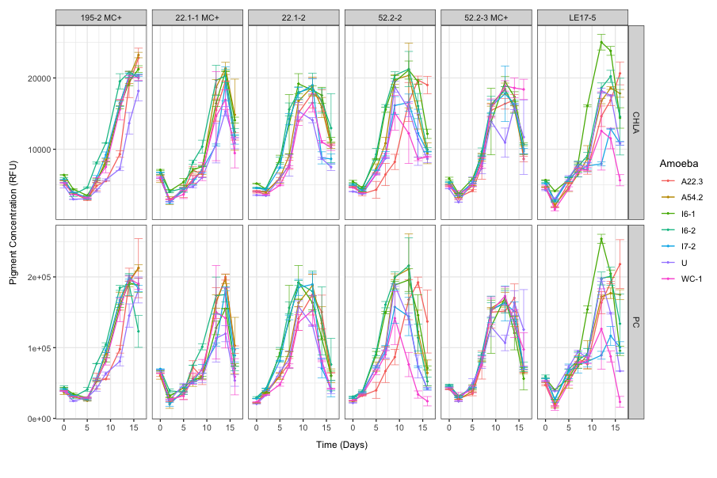

Figure 1: Each subplot represents one of the six Microcystis strains investigated. Each line color represents an amoeba strain grown in co-culture with the different Microcystis strains. The uninoculated control, Microcystis grown in the absence of amoeba (purple), will serve as a baseline for *Microcystis* growth. The y-axis quantifies either chlorophyll-a (CHLA) or phycocyanin (PC) pigment concentrations. The X-axis indicates the day the pigment concentration was measured.

1. Bibliography

Lai J, Cui D, Zhu W, Mao L. 2023. The Use of R and R Packages in Biodiversity Conservation Research. Diversity 15(12): 1202.

Mou H, Liu L, Xu Y. 2023. Panel Data Visualization in R (panelView) and Stata (panelview). J Stat Software 107(7).

Nishibe Y, Manage PM, Kawabata Z, Nakano S. 2004. Trophic coupling of a testate amoeba

and Microcystis species in a hypertrophic pond. Limnology 5: 71-76.

Van Wichelen J, Van Gremberghe I, Vanormelingen P, Debeer AE, Leporcq B, Menzel D,

Codd GA, Descy JP, Vyverman W. 2010. Strong effects of amoebae grazing on the biomass and genetic structure of a Microcystis bloom (Cyanobacteria). Environ Microbiol 12(10): 2797–2813.

Van Wichelen J, D’Hondt S, Claeys M, Vyverman W, Berney C, Bass D, Vanormelingen P.

2016. A Hotspot of Amoebae Diversity: 8 New Naked Amoebae Associated with the Planktonic Bloom-forming Cyanobacterium Microcystis. Acta Protozool 55(2): 61-87+ap1.

Xinyao L, Miao S, Yonghong L, Yin G, Zhongkai Z, Donghui W, Weizhong W, Chencai A. 2006.

Feeding Characteristics of an Amoeba (Lobosea: Naegleria) Grazing upon Cyanobacteria: Food Selection, Ingestion and Digestion Progress. Microb Ecol 51(3): 315 – 325.

1. Tutorial Analysis Final Presentation

<https://github.com/aaliyahgc24/5202work/blob/main/Tutorial_Analysis_Slides_Final_Draft.pptx>