TAYAN, AALIYAH OCTOBER 11, 2019

BSTM191/HRO191 MS. JEN ARROYO

What is a flowchart?

A flowchart is a diagram that depicts a process, system or computer algorithm. They are widely used in multiple fields to document, study, plan, improve and communicate often complex processes in clear, easy-to-understand diagrams. Flowcharts, sometimes spelled as flow charts, use rectangles, ovals, diamonds and potentially numerous other shapes to define the type of step, along with connecting arrows to define flow and sequence. They can range from simple, hand-drawn charts to comprehensive computer-drawn diagrams depicting multiple steps and routes. If we consider all the various forms of flowcharts, they are one of the most common diagrams on the planet, used by both technical and non-technical people in numerous fields. Flowcharts are sometimes called by more specialized names such as Process Flowchart, Process Map, Functional Flowchart, Business Process Mapping, Business Process Modeling and Notation (BPMN), or Process Flow Diagram (PFD). They are related to other popular diagrams, such as Data Flow Diagrams (DFDs) and Unified Modeling Language (UML) Activity Diagrams.

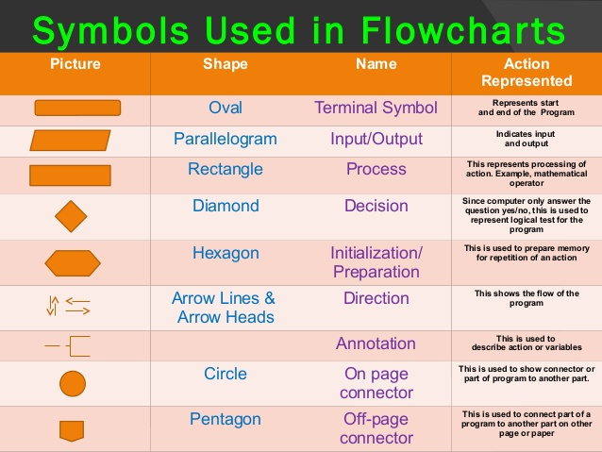

Types of flowcharts

Different authors describe various types of flowcharts in different terms. These people include published experts such as Alan B. Sterneckert, Andrew Veronis, Marilyn Bohl and Mark A. Fryman.

Sterneckert, in his 2003 book Critical Incident Management, listed four popular flowchart types, framed around the concept of flow controls rather than the flow itself:

Document Flowcharts: These “have the purpose of showing existing controls over document-flow through the components of a system. … The chart is read from left to right and documents the flow of documents through the various business units.”

Data Flowcharts: These show “the controls governing data flows in a system. … Data flowcharts are used primarily to show the channels that data is transmitted through the system rather than how controls flow.”

System Flowcharts: These “show the flow of data to and through the major components of a system such as data entry, programs, storage media, processors, and communication networks.”

Program Flowcharts: These show “the controls placed internally to a program within a system.

Veronis , in his 1978 book Microprocessors: Design and Applications, outlined three flowchart types based on scope and level of detail:

System Flowchart: Identifies the devices to be used.

General Flowchart: Overview.

Detailed Flowchart: Increased detail.

Bohl, in her 1978 book A Guide for Programmers, listed only two:

System Flowchart.

Program Flowchart.

But Fryman, in his 2001 book Quality and Process Improvement, differentiated the types in multiple ways from more of a business perspective than a computer perspective:

Decision Flowchart.

Logic Flowchart.

Systems Flowchart.

Product Flowchart.

Process Flowchart.

Additional flowchart types defined by others include:

Swimlane Diagram, a.k.a Swimlane Flowchart: To delineate who does what in cross-team processes.

Workflow Flowchart: To document workflows, often involving tasks, documents and information in offices.

Event-Driven Process Chain (EPC) Flowchart: To document or plan a business process.

Specification and Description Language (SDL) Flowchart: To brainstorm computer algorithms using three basic components: system definition, block and process

What is pseudocode?

Pseudocode is an informal high-level description of the operating principle of a computer program or other algorithm.It uses the structural conventions of a normal programming language, but is intended for human reading rather than machine reading. Pseudocode typically omits details that are essential for machine understanding of the algorithm, such as variable declarations, system-specific code and some subroutines. The programming language is augmented with natural language description details, where convenient, or with compact mathematical notation. The purpose of using pseudocode is that it is easier for people to understand than conventional programming language code, and that it is an efficient and environment-independent description of the key principles of an algorithm. It is commonly used in textbooks and scientific publications that are documenting various algorithms, and also in planning of computer program development, for sketching out the structure of the program before the actual coding takes place.

No standard for pseudocode syntax exists, as a program in pseudocode is not an executable program. Pseudocode resembles, but should not be confused with, skeleton programs which can be compiled without errors. Flowcharts, drakon-charts and Unified Modeling Language (UML) charts can be thought of as a graphical alternative to pseudocode, but are more spacious on paper. Languages such as HAGGIS bridge the gap between pseudocode and code written in programming languages.

References

cnx.org: Programming Fundamentals – A Modular Structured Approach using C++

Code Complete, page 54 "Avoid syntactic elements from the target programming language".

Invitation to Computer Science, 8th Edition by Schneider/Gersting, "Keep statements language independent" as quoted at [1]

Zobel, Justin (2013). "Algorithms". Writing for Computer Science (Second ed.). Springer. ISBN 1-85233-802-4.