Tayan, Aaliyah November 11, 2019

BSTM/HRO 191 PROGCON

Activity Four (4)

Machine Activity 1 – Adding Two Numbers

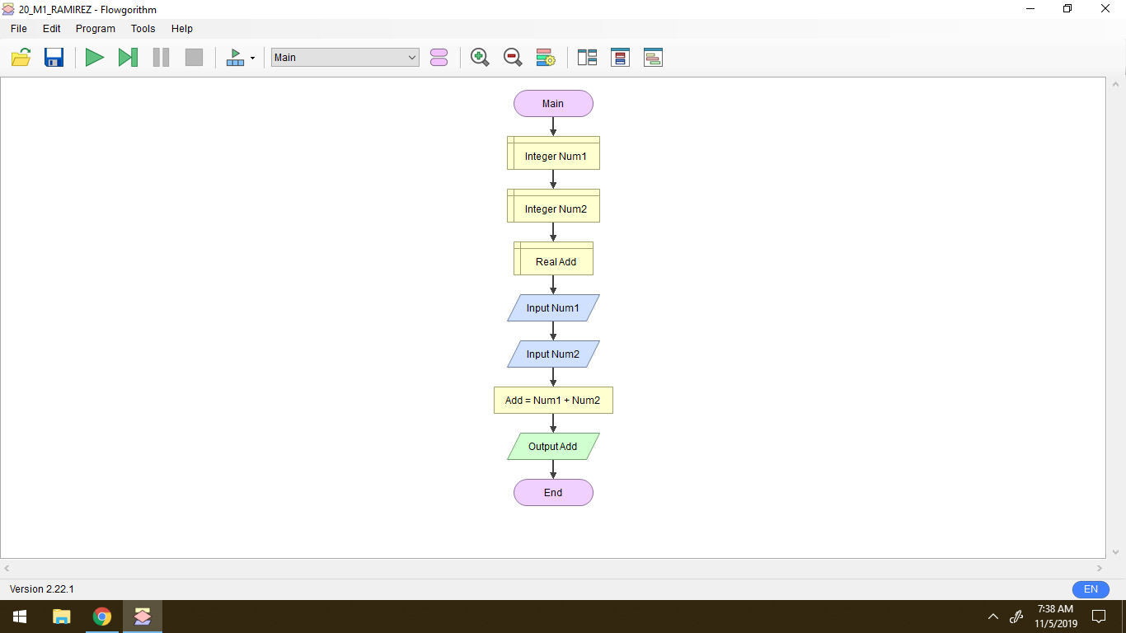

Machine Activity 2 – Finding the Area of a Circle using the Diameter and or the Radius

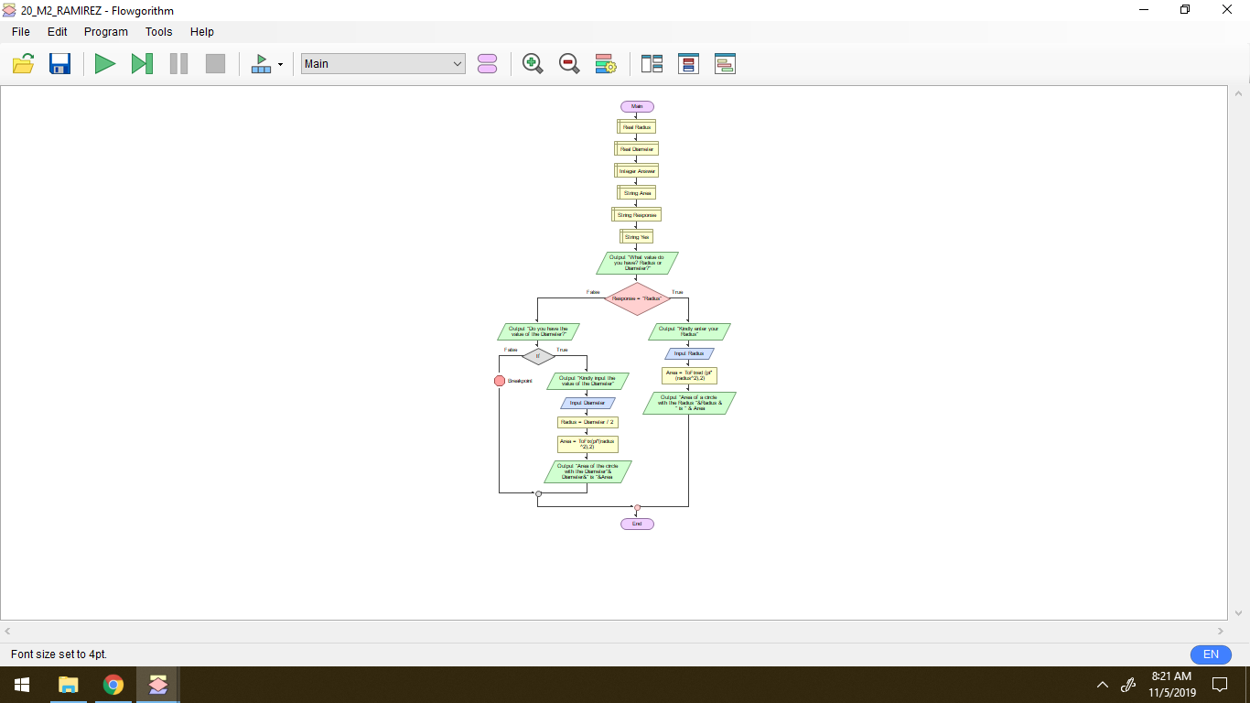

Machine Activity 3 – Identifying the Given Number if it is Odd or Even

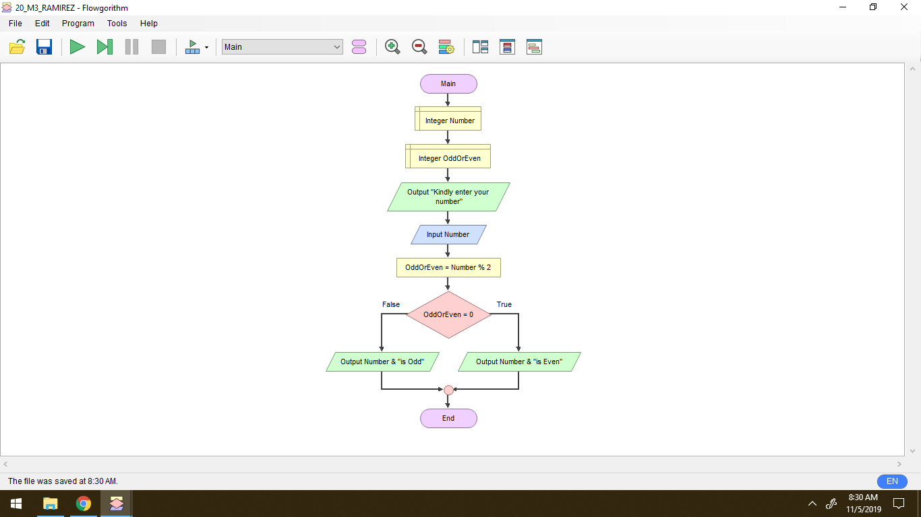

**Explanation**

Flowgorithm is an application where you can make your flowchart effectively. Dependent upon the language, this can either be straightforward or frustratingly inconvenient. By using flowcharts, you can concentrate on programming thoughts rather than all the nuances of an ordinary programming language. Notwithstanding that the application called 'flowgorithm' is a graphical composing apparatus which enables clients to compose and execute programs utilizing flowcharts. The methodology is intended to stress the calculation as opposed to the punctuation of a programming language. The flowchart can be changed over to a few significant programming dialects. It is a free application and you can undoubtedly download it like you won't stop for a second to download it and you won't stress over the infection. Utilizing a flowgorithm application you can without much of a stretch pick what shape you should utilize on the grounds that it will manage you in making your flowcharts. The application has its shapes called Input, Output, Declare, Assign, If (For choice), Call, While, for and Do.

With regards to my involvement with the exercises given to us, to be straightforward I can't comprehend the exercise or the method in making a flowchart utilizing the flowgorithm application yet when our teacher disclosed how to utilize it I had a thought on the most proficient method to utilize it and obviously I thank my seatmate for helping me when there are things I don't have a clue what to do. For me, utilizing a flowgorithm is a great deal accommodating for us understudies and for me as an individual who's not into innovations and such. I likewise enjoyed the "Run" strategy in the application since you will quickly know whether you made your flowchart right. I salute the maker of the application since not just the person will profit to it yet additionally the teachers and the understudies. I likewise thank my Professor in PROGCON because she is the person who acquaint Flowgorithm with us.