ParkSphere
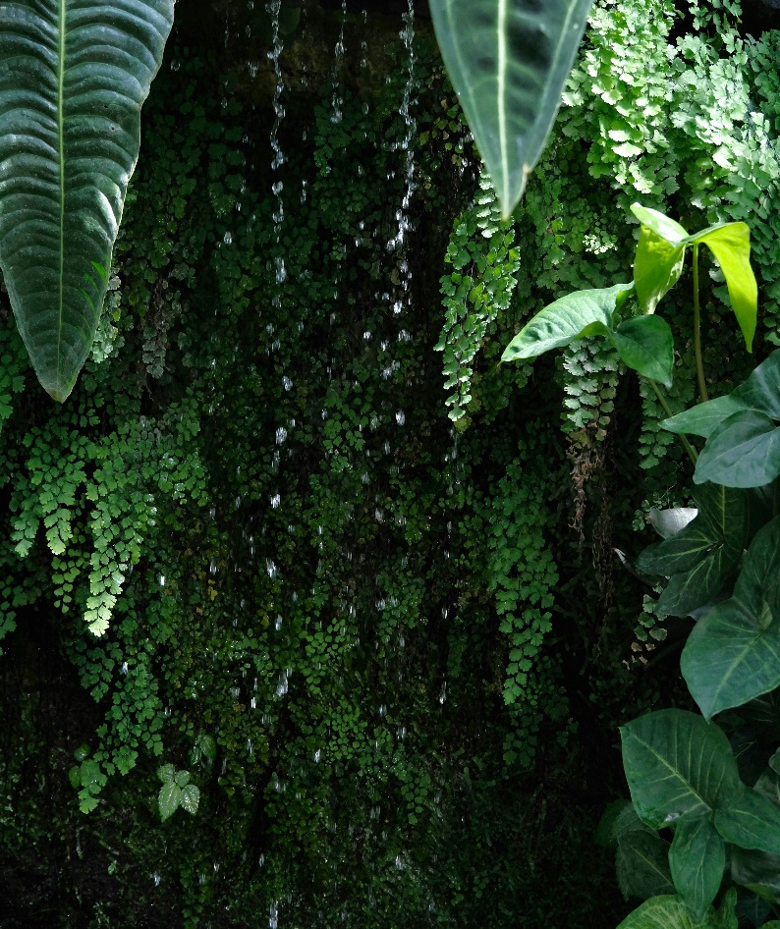 | Ayub Park- Rwp:  Ayub National Park, located in Rawalpindi, Pakistan, is a vast recreational space spanning over 900 acres. It features lush gardens, walking trails, picnic areas, and a serene boating lake. The park is also home to Jungle World, a zoo and amusement park with various animals and attractions. With its mix of nature and entertainment, it’s a favorite spot for families and visitors alike.

Benefits of Ayub park
Urban Nature Retreat | Wildlife & Zoo | Fun & Fitness
A refreshing green space with walking tracks, gardens, and shaded picnic spots for all ages. | Home to a variety of animals and birds, including deer, peacocks, and exotic species in a well-maintained zoo. | Features include a lake, playgrounds, fitness areas, and amusement rides for a full day of activity.

Ayub Park Wildlife:
Animal/Bird | Habitat | Population in park | Description
Deer | Forest, grassland | 13 | Graceful antlered herbivore
Kangaroo | plains, grasslands | 11 | Hopping marsupial from Australia
Monkey | Forest, grassland | 18 | Playful tree-dwelling primate
Peacock | Forests, farmlands | 14 | Colorful fan-tailed bird
Toucan | Rainforests | 15 | Big-beaked rainforest bird
Hornbill | Tropical Forest | 11 | Curved-bill tropical bird

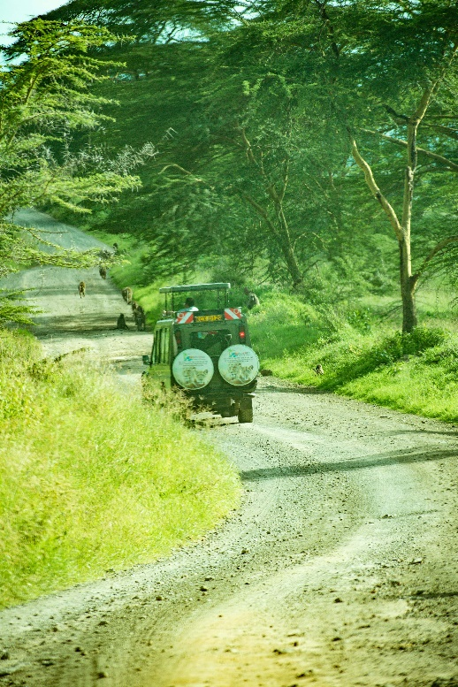 | Ayub park’s Adventures:  Visitors can enjoy boating on the lake, explore nature trails, or relax in the park’s scenic picnic areas. The highlight is Jungle World, which includes a zoo, amusement rides, and a playland for children. With open spaces for sports, horseback riding, and occasional events, the park provides a perfect mix of outdoor fun and family-friendly entertainment.

