ParkSphere
 | Lal Suhanra Park-Bwp:  Located on the edge of the Cholistan Desert, Lal Suhanra National Park is one of Pakistan's largest and most diverse parks. Spanning lush forests, arid plains, and freshwater lakes, the park offers a rare combination of ecosystems that support a wide range of wildlife. It's a haven for nature lovers, birdwatchers, and those seeking peaceful landscapes in Southern Punjab.

Benefits of lal Suhanra park
Diverse Habitats | Home to Rare Wildlife | Nature & Fun
Lal Suhanra features a rare blend of desert, forest, and wetlands, making it a unique habitat for diverse plant and animal species. | The park hosts endangered species like the Chinkara gazelle, desert reptiles, and numerous native and migratory birds. | Visitors can enjoy birdwatching, camel rides, nature walks, and photography in a peaceful natural setting.

Lal Suhanra Park Wildlife:
Animal/Bird | Habitat | Population in park | Description
Crocodile | Rivers. Wetlands | 9 | Large aquatic reptile
Tiger | Forests,grasslands | 6 | Striped wild cat
Zebra | Grasslands & woodlands | 10 | Black and & Herbivore
Eagle | Forests, mountains | 8 | Sharp-eyed soaring bird
Parrot | Rainforests, woodlands | 15 | Bright talking bird
Owl | Forests,grasslands | 11 | Nocturnal wise bird

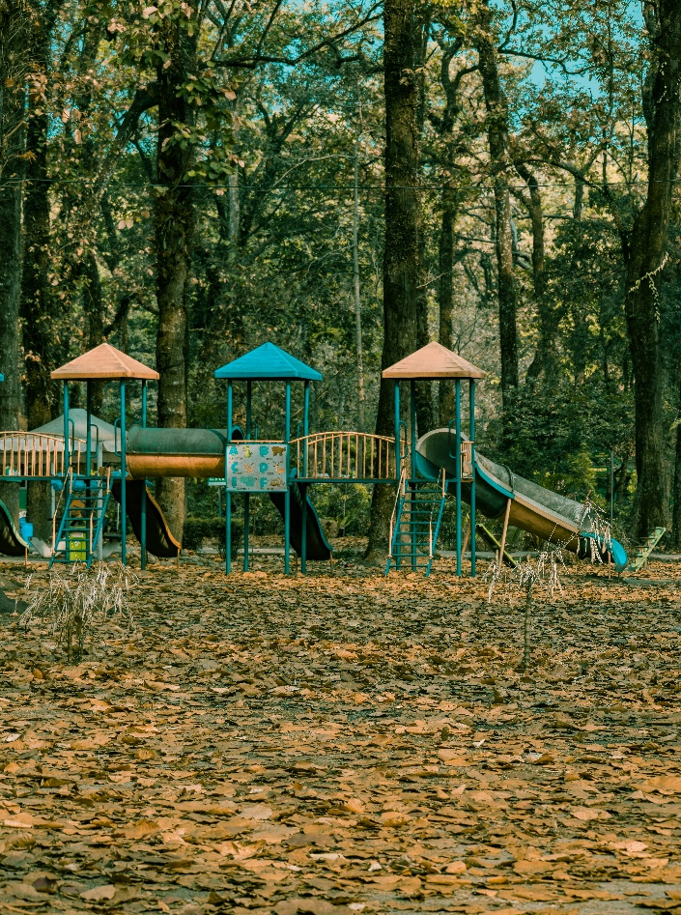 | Lal Suhanra’s Adventures:  Lal Suhanra National Park in Bahawalpur offers a range of outdoor adventures for nature lovers and thrill-seekers. Visitors can explore vast desert landscapes on jeep safaris, spot wildlife like deer and gazelles in their natural habitat, and enjoy birdwatching near the park’s serene lakes and wetlands. Nature trails and picnic spots make it perfect for family outings, while the blend of desert, forest, and water ecosystems adds a unique touch to every adventure.

