Programming Fundamentals — Assignment
Lab 02: Files, Type Conversion, Strings and Debugging
Name: Aaliyan Amjad
Roll No: 2603005
Date: 20-09-2026
Github Repo: https://github.com/aaliyann-exe/programming-fundamentals-lab

Task 1: Write a program that takes a student's name and 3 subject marks as input and writes them to a file named student.txt.

Output:
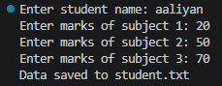
Final File:
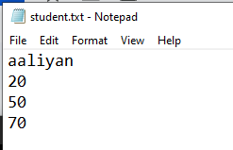

Task 2: Write a program that reads student.txt (from Task 1) line by line and prints its contents to the screen.

Output:
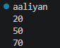

Task 3:
● Write a program that logs a "attendance" entry (name + today's date) to attendance.txt using
ios::app.
● Run the program twice with different names and confirm both entries appear in the file
afterward.

Output:

Run 1:
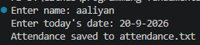
Run 2:
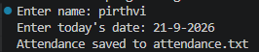
Final file:
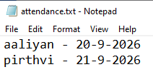

Task 4: Write a program that reads a number as a string (simulate data read from a file), converts it to an
integer using stoi, adds 10 to it, then converts the result back to a string using to_string and prints it.

Output:
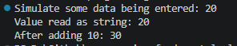
Task 5: Write a program that takes a full name as input and prints: the total number of characters, the name in all uppercase, and just the first 3 letters (using substr).

Output:
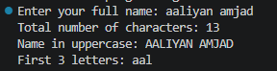

Task 6: Complete the Bug Hunt Challenge from Section 4: fill in a trace table by hand, then submit your
corrected, working program.

Output:

Console:
Marks.txt:
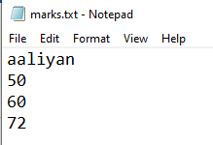
Results.txt:
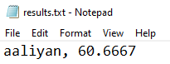
Trace Table:
Line | Statement executed | name | score1 | score2 | score3 | total | average | What happens
7 | ifstream inFile("marks.txt"); |  |  |  |  |  |  | marks.txt is opened for reading
8 | ofstream outFile("results.txt"); |  |  |  |  |  |  | results.txt opened in write mode, which erases anything already in it
10, 11 | string name;  int score1, score2, score3; | "" | ? | ? | ? |  |  | Variables declared but no values yet
12 | inFile >> name >> score1 >> score2 >> score3; | aaliyan | 50 | 60 | 72 |  |  | The four values are read from the file
14 | int total = score1 + score2 + score3; | aaliyan | 50 | 60 | 72 | 182 |  | 50 + 60 + 72 = 182
15 | float average = total / 3; | aaliyan | 50 | 60 | 72 | 182 | 60.6667 | 182 / 3 = 60.6667
17 | if (average >= 50) | aaliyan | 50 | 60 | 72 | 182 | 60.6667 | “>=” means that if average is greater than or equal to 50, then it returns true. Which is true for 60.6667.
18 | cout << name << " passed with average " << average; | aaliyan | 50 | 60 | 72 | 182 | 60.6667 | Prints: aaliyan passed with average 60.6667
21 | outFile << name << ", " << average << endl; | Aaliyan | 50 | 60 | 72 | 182 | 60.6667 | Writes "aaliyan, 60.6667", and it replaced the file instead of adding to it
26 | return 0; | Aaliyan | 50 | 60 | 72 | 182 | 60.6667 | Program ends.

