
Programming Fundamentals — Assignment
Lab 05: File Handling in C++: Opening, Reading, Writing and Error Handling
Name: Aaliyan Amjad
Roll No: 2603005
Date: 11-10-2026
Github Repo: https://github.com/aaliyann-exe/programming-fundamentals-lab
Task 1: Class Representative Record.

Code:
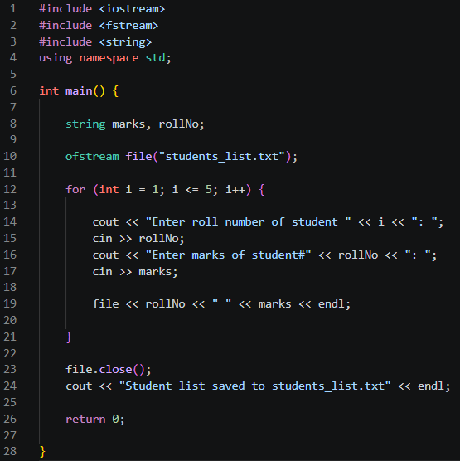
Output:
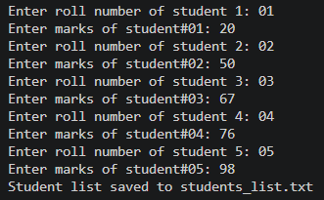
Task 2: Display the Saved List.

Code:
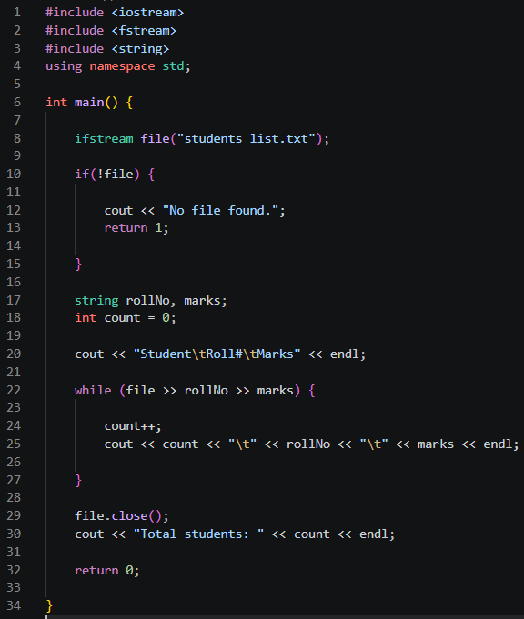
Output:
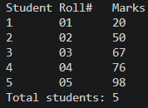
Task 3: Creating a File and Writing Student Information.

Code:
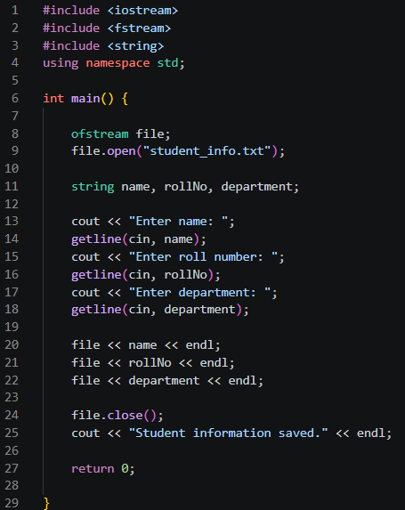
Output:
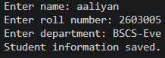
File:
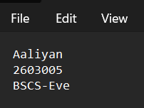

Task 4: Reading and Displaying File Content.

Code:
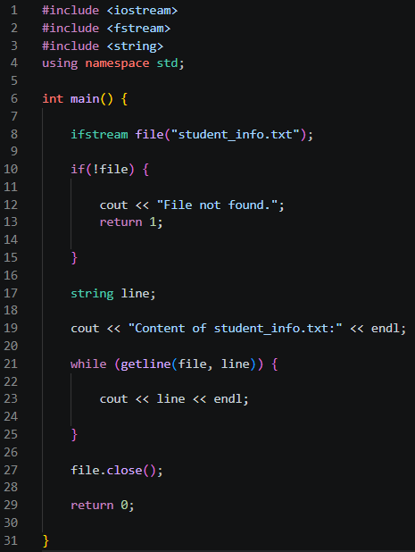
Output:
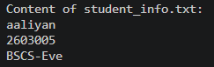

Task 5: Appending Data to a File.

Code:
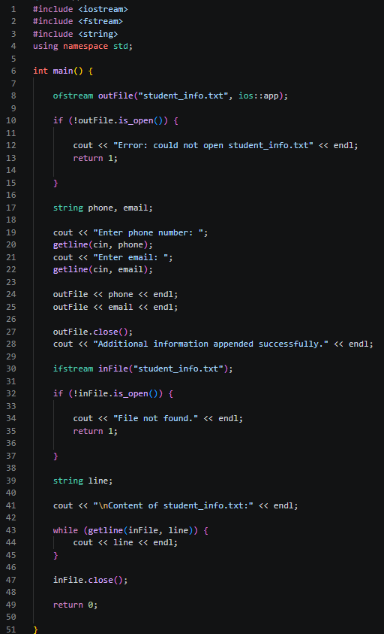
Output:
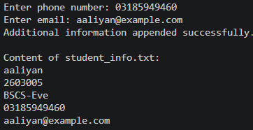
Task 6: File Truncation (Overwriting Content).

Code:
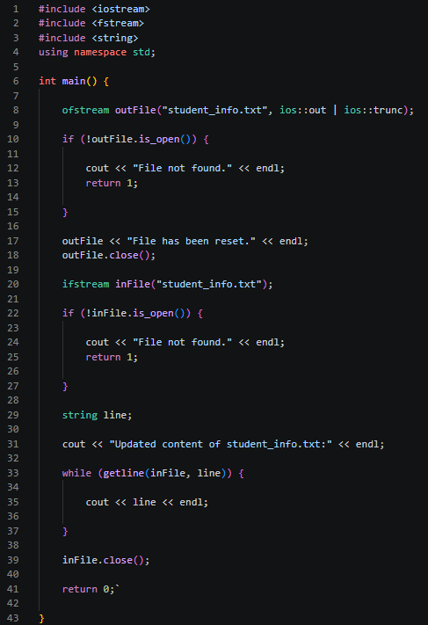
Output:
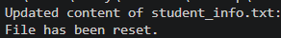
File:
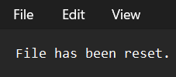

Home Task: Simple Student Menu

Code (1st half on left, 2nd half on right):
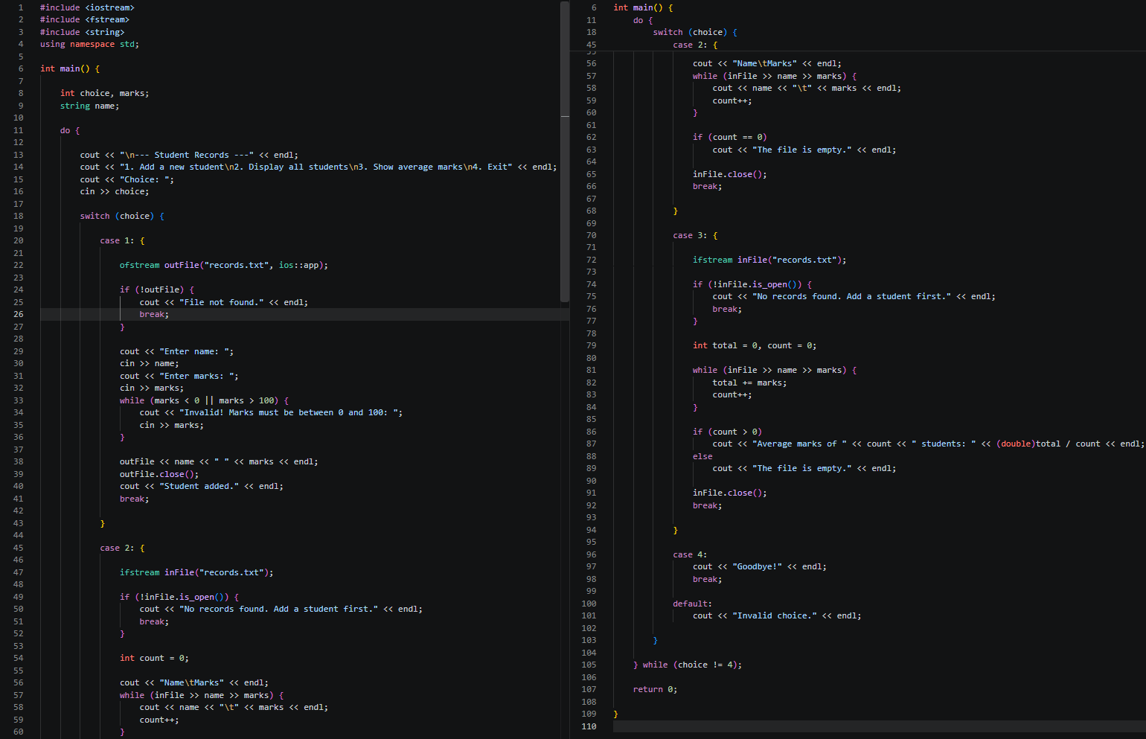
Output (1st half on left, 2nd half on right):
