
Programming Fundamentals — Assignment
Lab 04: Loops in C++
Name: Aaliyan Amjad
Roll No: 2603005
Date: 04-10-2026
Github Repo: https://github.com/aaliyann-exe/programming-fundamentals-lab

Task 1: A student is reading a 200-page book and reads 40 pages every day. Using a while loop, display the total pages read at the end of each day and finally print how many days it took to finish the book.

Code:
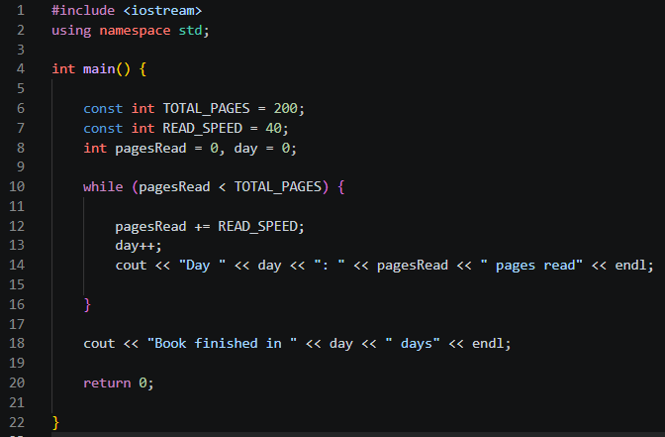

Output:
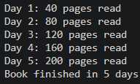
Task 2: Registration form. (a) Ask for the user's age and keep asking until it is between 18 and 60. (b) Then ask the user to create a 4-digit PIN (1000 to 9999) and keep asking until it is valid. (c) Finally ask the user to re-enter the PIN to confirm; allow only 3 attempts and display "Account created" or "Registration failed".

Code:
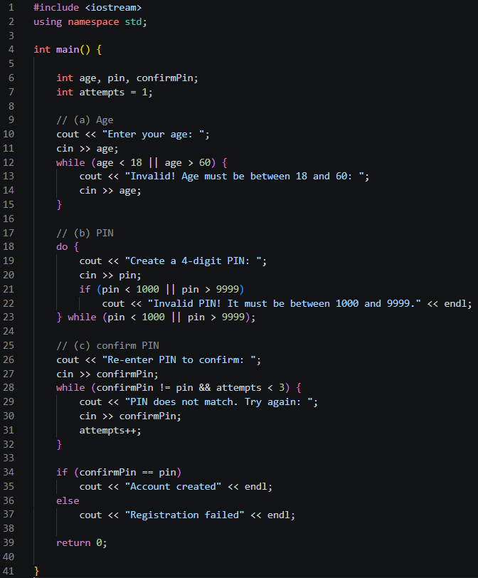

Output:
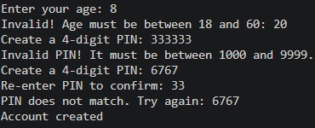
Task 3: Write a menu-driven mobile top-up program using a do-while loop. Menu: 1. Rs. 100 load 2. Rs. 200 load 3. Rs. 500 load 4. Show total and Exit. The menu repeats after every choice, an invalid choice shows an error message, and choosing 4 prints how many recharges were done and the total amount.

Code:
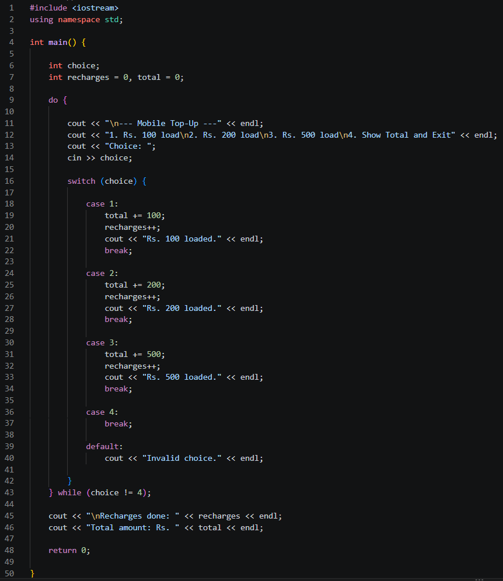

Output:
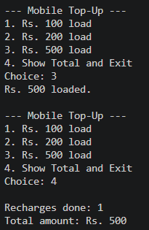
Task 4: Using a for loop, take a number N from the user and print a table of numbers from 1 to N with their squares and cubes (use \t). At the end also print the sum of all the cubes.

Code:
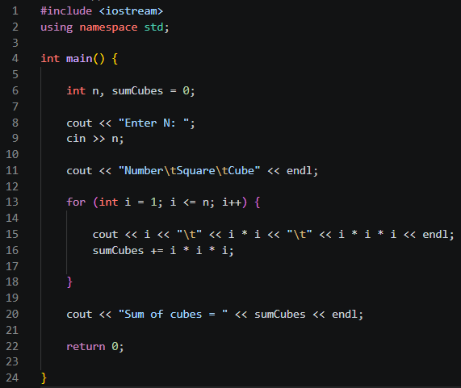

Output:
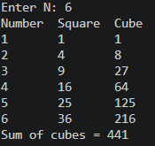

Task 5: Write a program that asks how many students are in a class, then reads each student's marks (0–100, validated using a loop) using a for loop. Using counters, display how many students got grade A (80 or above), how many passed (50 or above), and how many failed.

Code:
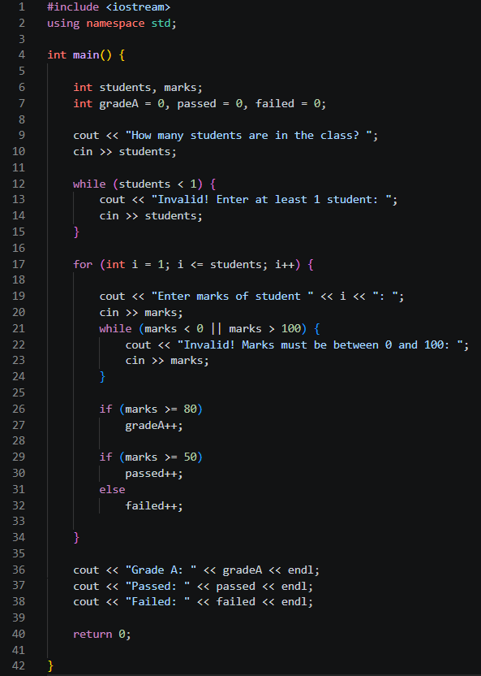

Output:
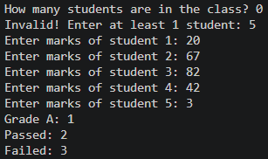
Task 6: Write a cashier program that reads item prices until the user enters 0 (sentinel). Display the number of items, the total, the highest price and the average price. If the total is more than Rs. 1000, give a 10% discount and display the final payable amount. If no items are entered, display "No items entered."

Code:
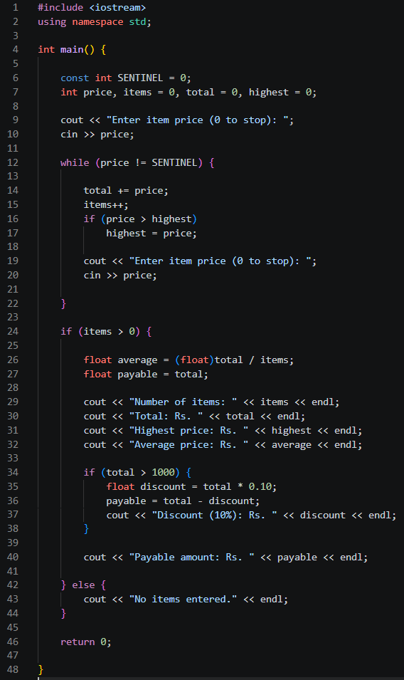

Output:
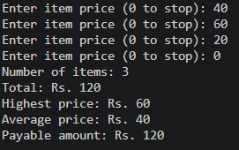
Pseudocode:

START
SENTINEL = 0, items = 0, total = 0, highest = 0
INPUT price

WHILE price != SENTINEL
total = total + price
items = items + 1
IF price > highest THEN
highest = price
END IF
INPUT price
END WHILE

IF items > 0 THEN
average = total / items
payable = total
PRINT "Number of items: ", items
PRINT "Total: Rs. ", total
PRINT "Highest price: Rs. ", highest
PRINT "Average price: Rs. ", average

IF total > 1000 THEN
discount = total * 0.10
payable = total - discount
PRINT "Discount (10%): Rs. ", discount
END IF

PRINT "Payable amount: Rs. ", payable
ELSE
PRINT "No items entered."
END IF
END

Flowchart:
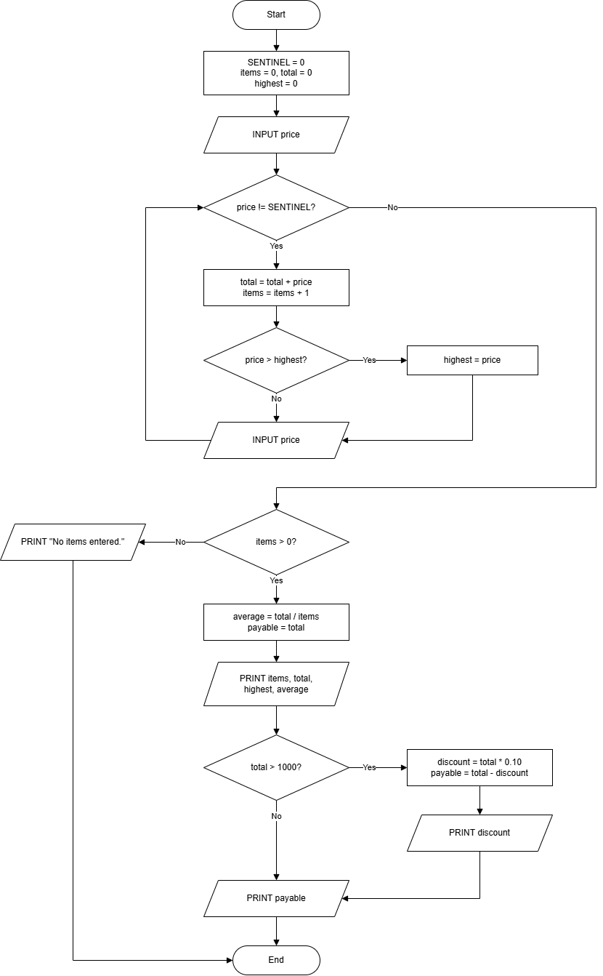

Task 7: Using nested loops, print the following three outputs (one program or three separate programs): (the images are attached in the original lab manual).

Code:
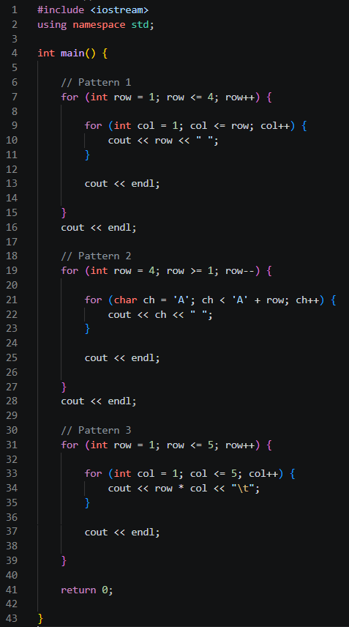

Output:
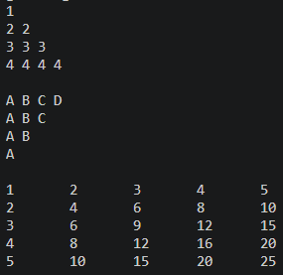
Pseudocode:

START
FOR row = 1 TO 4
FOR col = 1 TO row
PRINT row, " "
END FOR
PRINT newline
END FOR

FOR row = 4 DOWN TO 1
FOR ch = 'A' TO 'A' + row - 1
PRINT ch, " "
END FOR
PRINT newline
END FOR

FOR row = 1 TO 5
FOR col = 1 TO 5
PRINT row * col, TAB
END FOR
PRINT newline
END FOR
END

Flowchart:
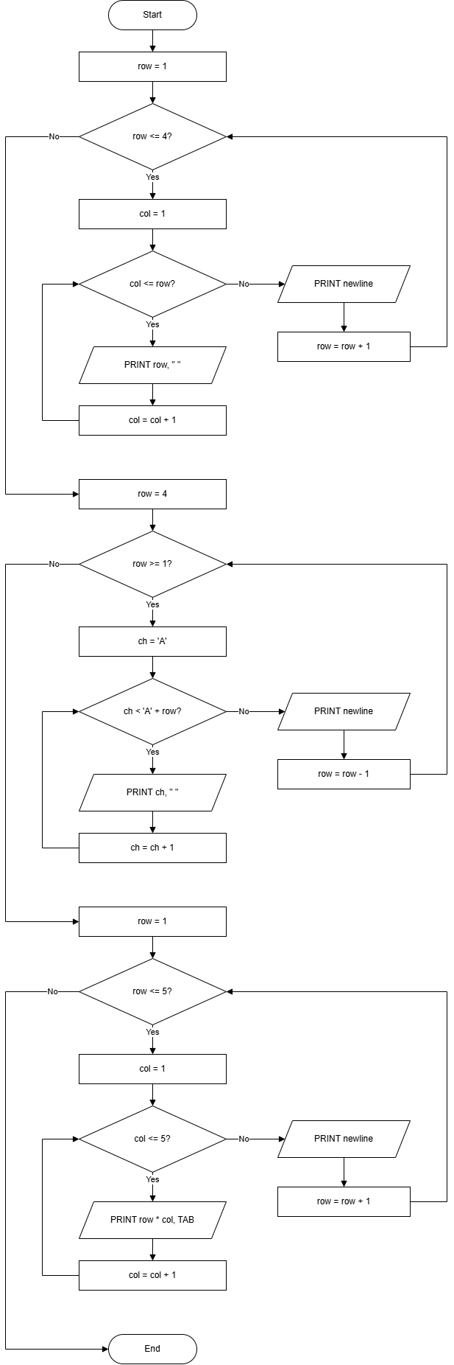
Task 8: Assume that you want to generate a table of multiples of any given number. Write a program that allows the user to enter the number and then generates the table, formatting it into 10 columns and
5 lines.

Code:
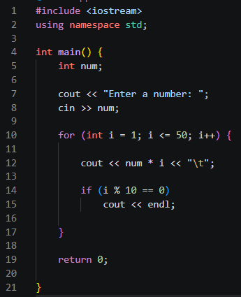

Output:
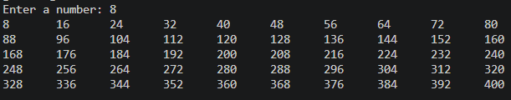

Pseudocode:

START
INPUT num
FOR i = 1 TO 50
PRINT num * i, TAB
IF i MOD 10 == 0 THEN
PRINT newline
END IF
END FOR
END

Flowchart:

