
Programming Fundamentals — Assignment
Lab 03: Decision Making in C++ (Selection Statements)
Name: Aaliyan Amjad
Roll No: 2603005
Date: 27-09-2026
Github Repo: https://github.com/aaliyann-exe/programming-fundamentals-lab

Task 1: Write a program that takes two integers from the user and displays the result of all six relational
operators (use boolalpha so the output shows true / false).

Output:
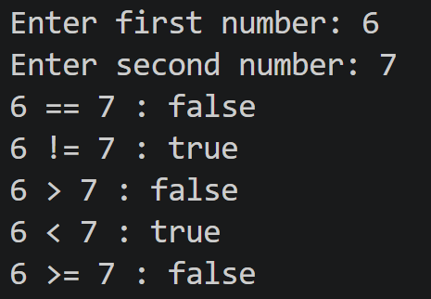

Task 2: Take the bill amount from the user. If the bill is more than Rs. 5000 give a 10% discount. Print the discount (only when it applies) and the amount payable.

Output:
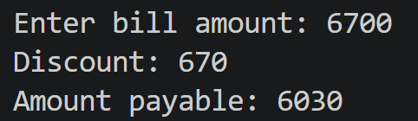

Task 3: Take the age of a person. If the age is 18 or more, print that they are eligible to apply for a driving licence; otherwise print how many more years they must wait.

Output:

Above 18:
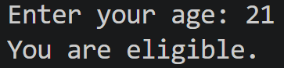

Below 18:

Task 4: The correct user ID is the string cs101 and the correct password is the number 1234. Take both from the user. Using a nested if, first check the ID; only if it is correct check the password. Print "Wrong user ID", "Wrong password" or "Login successful" accordingly.

Output:

Successful Login:
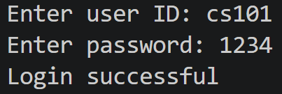

Unsuccessful Login:
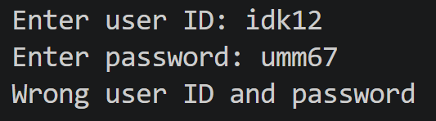

Task 5: Take the units consumed and calculate the bill. The rate per unit depends on the bracket the total units fall in and applies to all units: up to 100 units = Rs. 10, 101 to 300 units = Rs. 15, above 300 units = Rs. 22. If the units are negative, print "Invalid units".

Pseudocode:
START
INPUT units
IF units < 0 THEN
PRINT "Invalid units"
ELSE
IF units <= 100 THEN
rate = 10
ELSE IF units <= 300 THEN
rate = 15
ELSE
rate = 22
END IF

bill = units * rate
PRINT "Rate per unit: Rs. ", rate
PRINT "Total bill: Rs. ", bill
END IF
END

Output:

Correct Units:
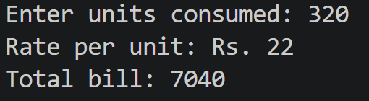

Negative Units:
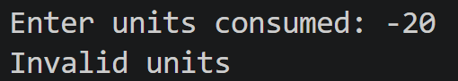
Flowchart:
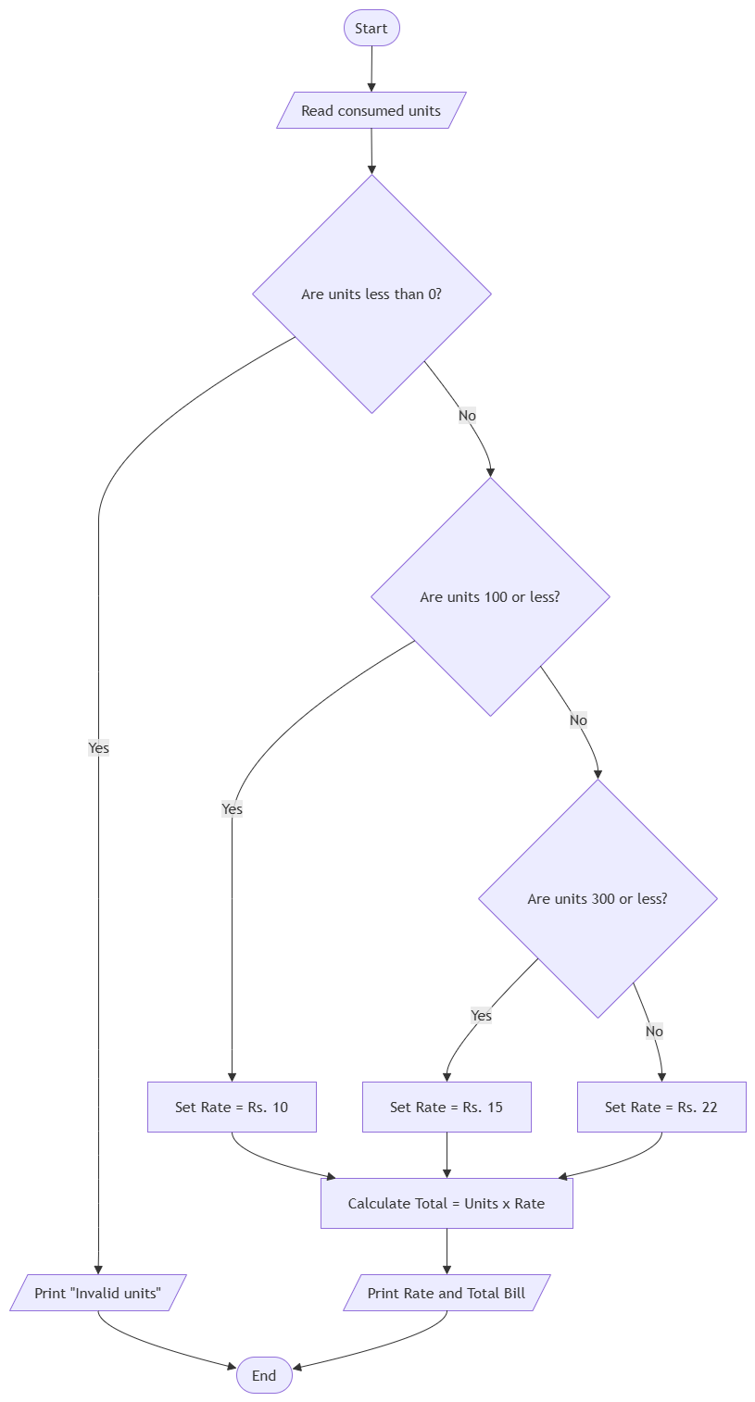

Task 6: Take a year from the user and tell whether it is a leap year. A year is a leap year if it is divisible by 4 and not divisible by 100, or it is divisible by 400. Test with 2024, 1900 and 2000.

Output:

Leap Year:
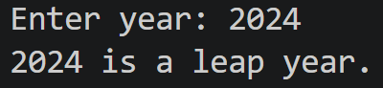

Normal Year:
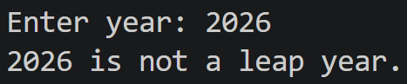

Task 7: Take two numbers and an operator (+, -, * or /) from the user. Use a switch on the operator to print the result. For / with a second number of 0 print "Cannot divide by zero", and for any other operator print "Invalid operator".

Output:

Correct Operator and Non-Zero:
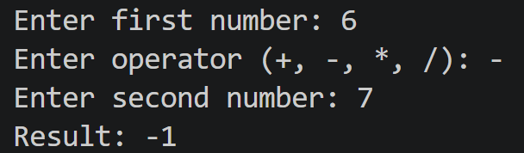

Dividing by Zero:
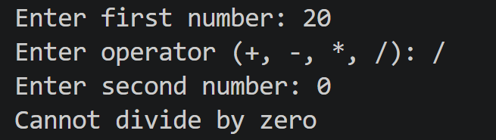
Invalid Operator:
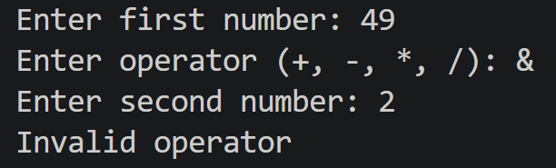

Task 8: A cinema counter needs a program that works out the amount to pay. Students are given the scenario only, not the code, and must (1) write the pseudocode, (2) draw the flowchart, then (3) implement it. The program uses a switch, logical operators and if-else-if together.

Pseudocode:
START
INPUT units
IF units < 0 THEN
PRINT "Invalid units"
ELSE
IF units <= 100 THEN
rate = 10
ELSE IF units <= 300 THEN
rate = 15
ELSE
rate = 22
END IF

bill = units * rate
PRINT "Rate per unit: Rs. ", rate
PRINT "Total bill: Rs. ", bill
END IF
END

Output:
Test Run: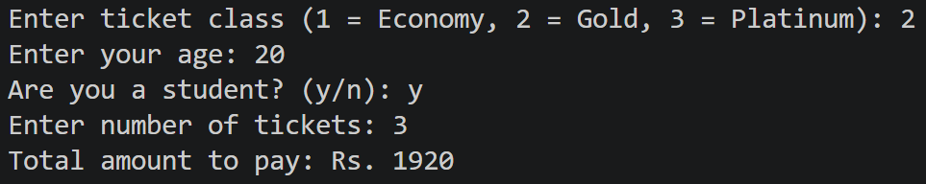
Flowchart:
