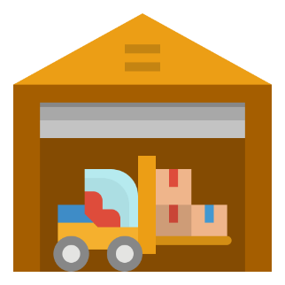

Inventory System

Ali Aljamid

2/27/2020

­



[github.com/aaljamid/Inventory_System](https://github.com/aaljamid/Inventory_System)

**Table of Contents**

1. Introduction …………………………………………………………………………………………………………...………….. 2
2. User Stories …………………………………………………………………………………………………………………......… 3
3. Wireframe
   1. Desktop View .………………………..…………………………………………….………………………………… 4
   2. Mobile View .………………….…………………………………………….………………………………………... 5
4. Mockup
   1. Desktop View ………………………………………………………………….…………………………………….. 6
   2. Mobile View ………..…………………………………………………….…….…………………………………….. 7
5. Code documentation
   1. Tools and frameworks used ………………………………………………....…………………………….. 8
   2. Dependencies installation .………………………………………………....……………………………….. 9
   3. Components Tree ….……………………………………………....……………………………………………. 10

**Introduction**

**This project is about creating an inventory system using React-JS.**

**The system is applicable to any type of business that requires an inventory system. The application helps managing the inventory o by proving tracking the quantity, date entered, and the location stored.**

**User Stories**

* As a user, I should be able to add new item(s)
* As a user, I should be able to edit the entered item(s)
* As a user, I should be able to remove the entered item(s)
* As a user, I should be able to remove all selected item(s)
* As a user, I should be able to extract a summary of the inventory
* As a user, I should be able to search for specific item

**Wireframing**

1. **Desktop View**

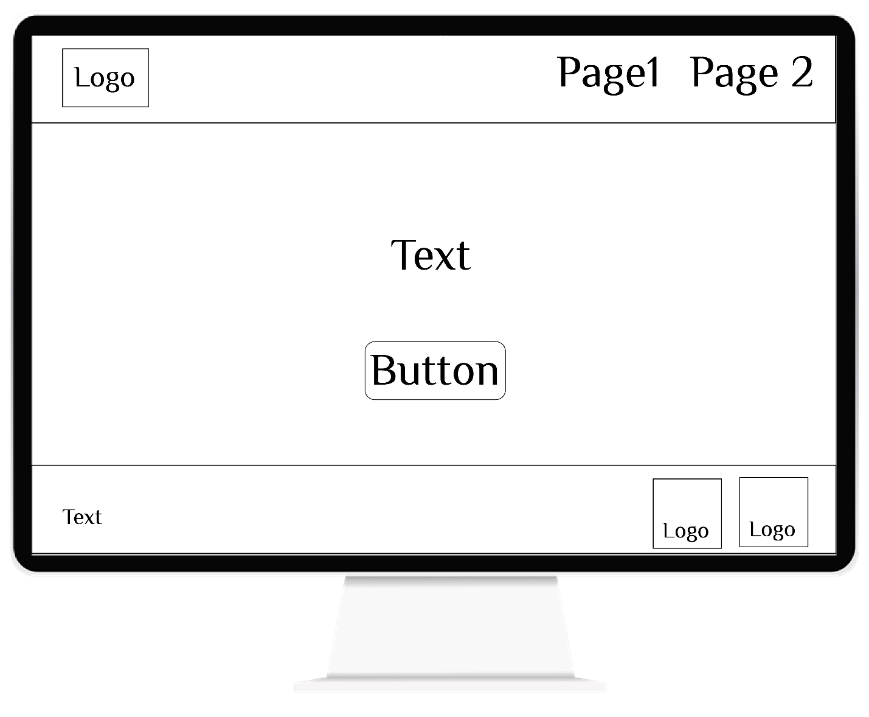

**Wireframing**

1. **Mobile View**

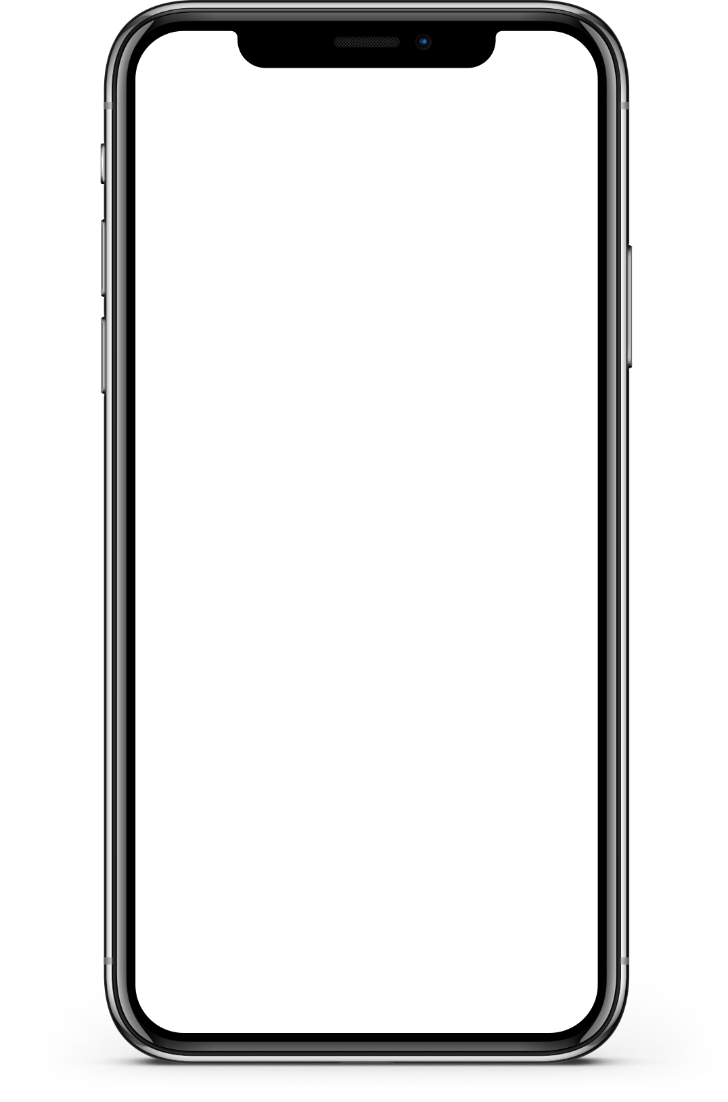

**Mockup ­**

1. Desktop View



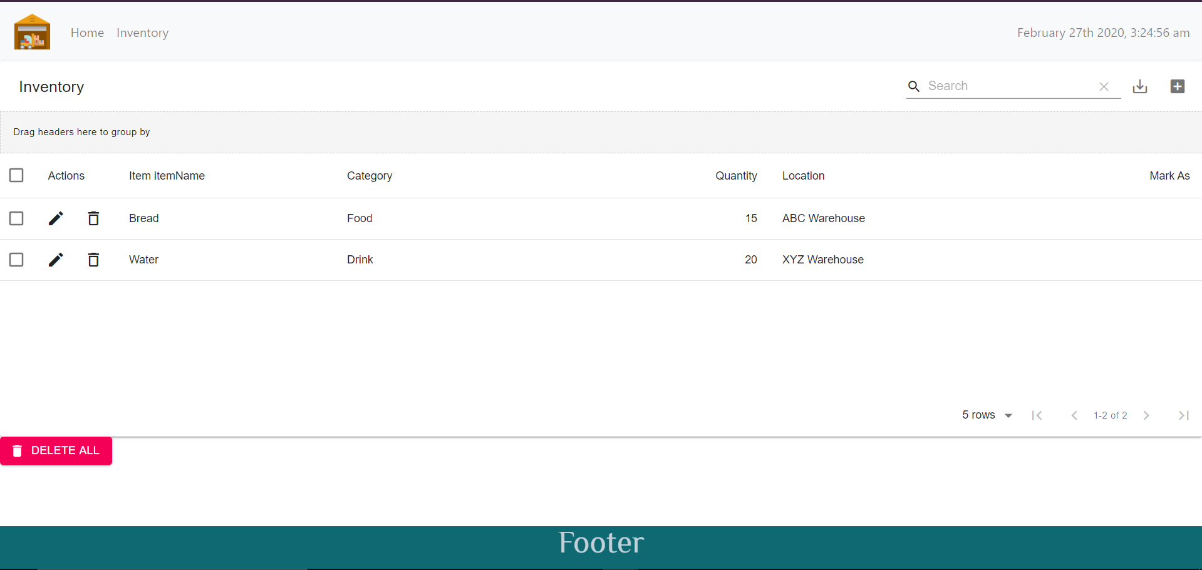

**Mockup**

* Mobile View

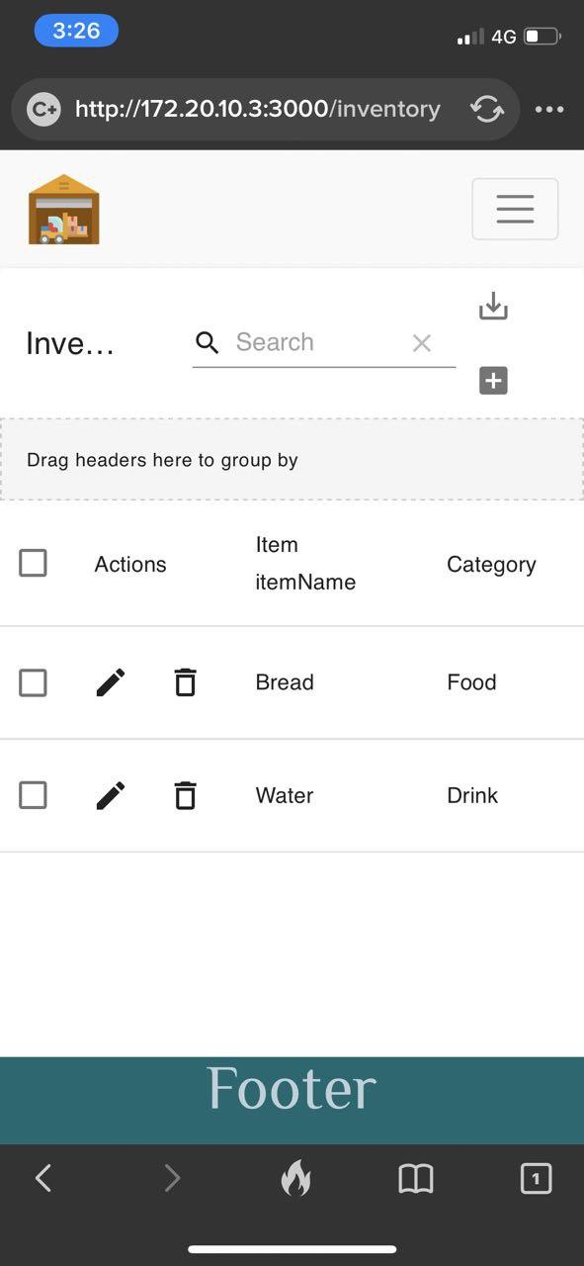

**­­­­Tools and frameworks used**

* **React JS**
* **Bootstrap**
* **Moment.js**
* **Axios**
* **Material-UI**

**Installing all the dependencies**

* **Bootstrap** 
  1. **Install:** npm install react-bootstrap bootstrap –save
  2. **Import to index.js:** import "bootstrap/dist/css/bootstrap.css";
* **Moment.js** 
  1. **Install:** npm install moment
  2. **Import:** import moment from "moment";
* **Axios**
  1. **Install:** npm install axios
  2. **Import:**
* **React Router** 
  1. **Install:** npm install react-router-dom
  2. **import:** import{ BrowserRouter as Router, Switch, Route, Link } from "react-router-dom";
* **FontAwesome** 
  1. **Install:** npm i --save @fortawesome/fontawesome-svg-core @fortawesome/free  
      solid-svg-icons @fortawesome/react-fontawesome
  2. **import:**  { FontAwesomeIcon } from '@fortawesome/react-fontawesome'

**import:** { faCoffee } from '@fortawesome/free-solid-svg-icons'

* **Marital UI** 
  1. **Install:** npm install @material-ui/core
* **material-table**
  1. **Install:** npm install material-table –save

**Components Tree**

