Project #­1:

Tic-Tac-Toe Game

­

Ali Aljamid

X | O

**Table of Contents**

1. Introduction & Game Info …………………………………………………………………….. 2
2. Requirements …………………………………………………………………………………... 3
3. User Stories …………………………………………………………………………………...… 4
4. Wireframe
   1. Desktop View .………………………..………………………………………………… 5
   2. Mobile View .………………….………………………………………………………... 6
5. Mockup
   1. Desktop View …………………………….…………………………………………….. 7
   2. Mobile View ………..…………………….…………………………………………….. 8
6. Code documentation
   1. Tools and frameworks used …………………...…………………………………….. 9
   2. HTML Code ..………………...……………………………….……………………….. 10
   3. CSS Code …..……………...……………………………….………………………….. 11
   4. JS Code ………...………...……………………………………………………………. 12

**Introduction**

This project is about creating an online version of the famous game "Tic Tac Toe".

I have implemented the knowledge that acquired during the past 2 weeks to design, build, and deploy the game.

**Game Info :**

* The game allows two players
* a player wins if 3 boxes in a row (vertically, horizontally, or from corners) have the same value ( X || O )
* A message will appear to confirm the winner name

**Requirements**

* Render a game board in the browser
* Switch turns between X and O (or whichever markers you select)
* Visually display which side won if a player gets three in a row, or show a draw if neither player wins
* Include separate HTML / CSS / JavaScript files
* Stick with KISS (Keep It Simple Stupid) and DRY (Don't Repeat Yourself) principles
* Use JavaScript and/or jQuery for DOM manipulation
* Deploy your game online, where the rest of the world can access it
* We will be walking you through this process!
* Use semantic markup for HTML and CSS (adhere to best practices)
* Have well-formatted, and well-commented code

**User Stories**

* As a user, I should be able to start a new tic tac toe game
* As a user, I should be able to click on a square to add X first and then O, and so on
* As a user, I should be shown a message after each turn for if I win, lose, tie or who's turn it is next
* As a user, I should not be able to click the same square twice
* As a user, I should be shown a message when I win, lose or tie
* As a user, I should be able to play the game again without refreshing the page
* As a user, I would like to see the score of the previous games

**Wireframing**

1. **Desktop View**



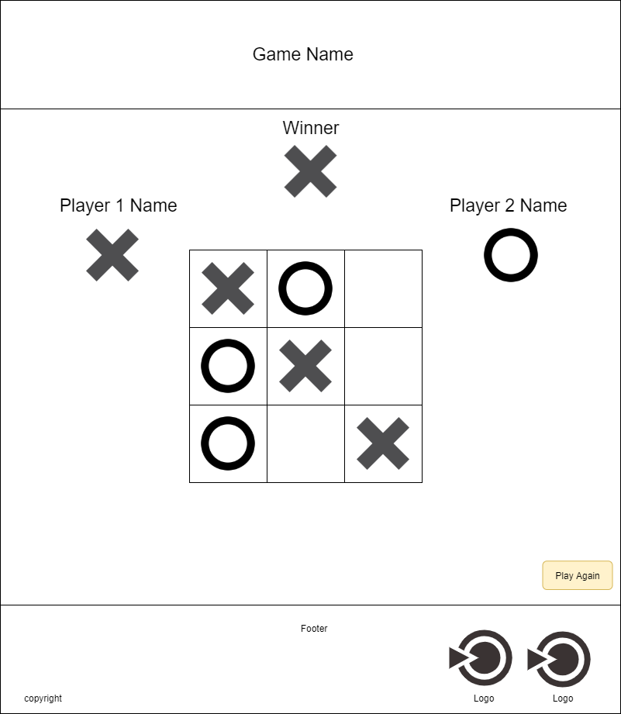

**Wireframing**

1. **Mobile View**

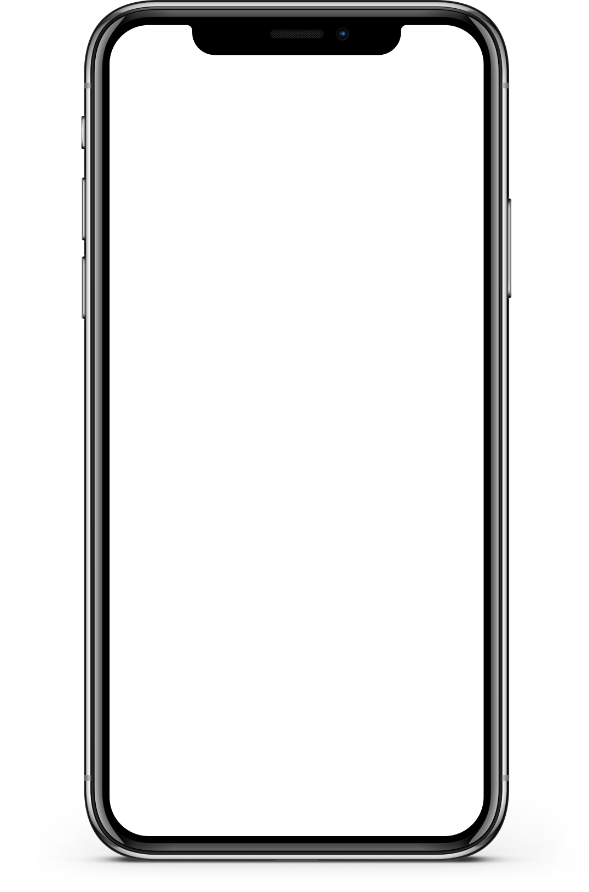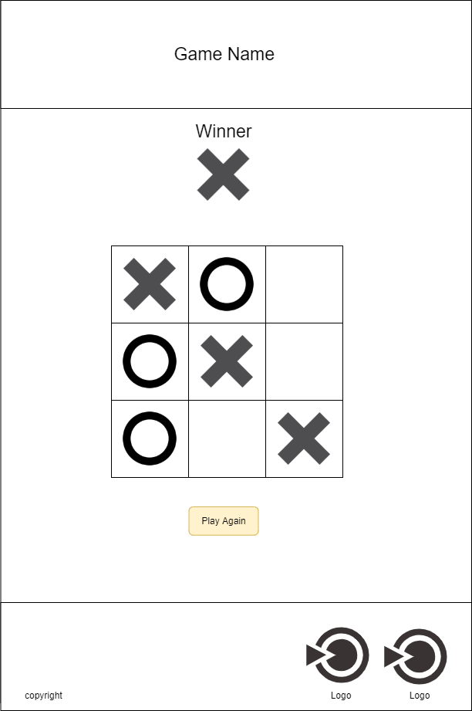

**Mockup ­**

1. Desktop View



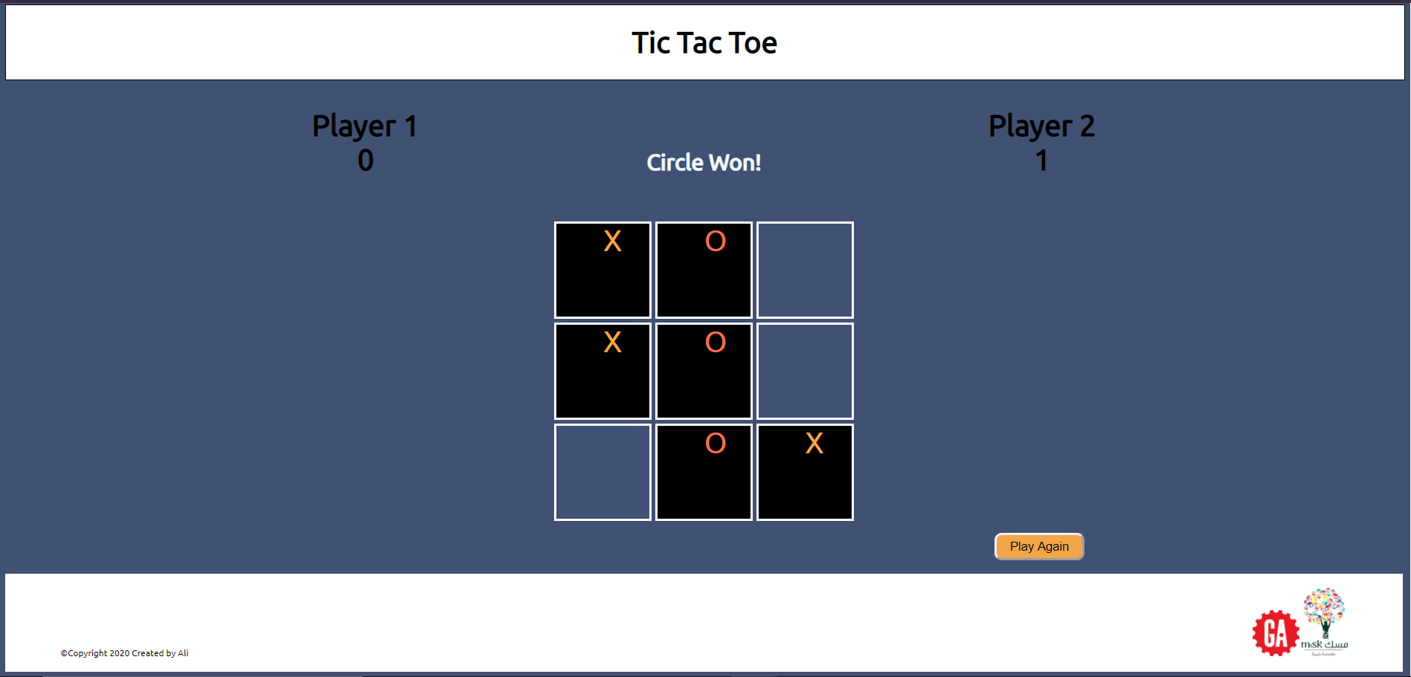

**Mockup**

* Mobile View

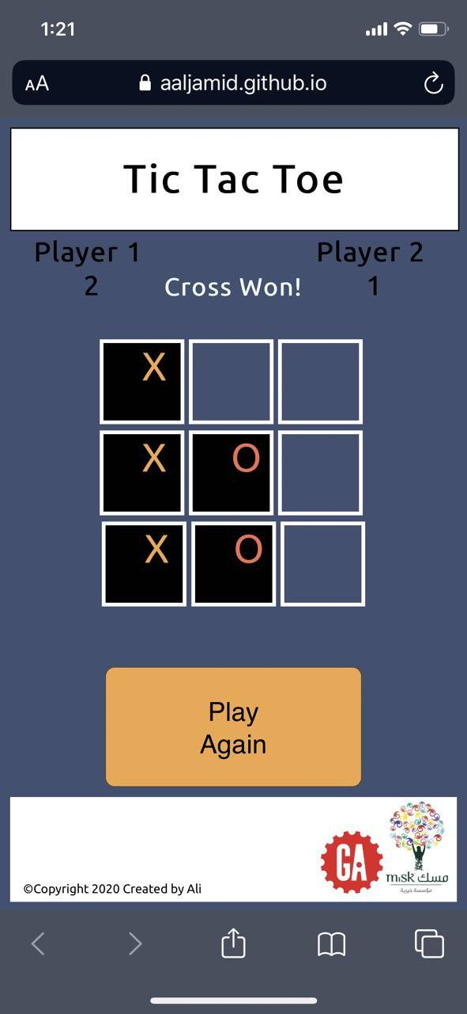

**­­­­Tools and frameworks used**

* **HTML** 
  + To build the Skelton of the game
* **CSS**
  + To add a style, alignment, colors, and make it responsive and user friendly for mobile
* JavaScript
  + Add the functionality to the game
* jQuery
  + Leveraging jQuery library to take advantage

