**MTRE 2610 – Intermediate Programming for Mechatronics**

**Homework – Python Applications**

1. This problem trains a simple artificial neural network (ANN) with a single neuron to divide the *x-y* plane into the classes of blue and yellow points shown below. These four points are saved in the file data.txt where the first column contain *x* values and the second column *y*.

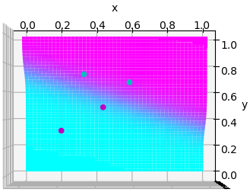

Output of the neural network is defined by the equation



which is computed for any (*x*,*y*) point given the network parameters *u*, *v*, and *b*. These network parameters must be chosen to best classify points 1 and 2 as belonging to one class and points 3 and 4 to another. To accomplish that, it is desired that *z* be near zero in the vicinity of points 1 and 2 (cyan shading in the graph above) while producing near unity values for points 3 and 4 (magenta shading). Accuracy of the ANN is evaluated by the sum squared error



which judges how close the ANN models the desired values for the four (*x*,*y*) pairs. Optimal values for network parameters *u*, *v*, and *b* are determined through gradient descent, which aims to update them depending on how sensitive the error is to changes in them, i.e. parameters affecting the error more should be changed more. To begin, choose random values for *u*, *v*, and *b*. The three parameters are updated according to



where *η* is the learning rate, and the subscript *i* indicates the current value and *i*+1 the new updated value. Note the minus sign in these expressions reflects that derivatives indicate an *increase* in error whereas *decreasing* error is desired. Repeatedly updating these parameters will eventually converge on a solution with a sufficiently low error measurement. ANNs trained with large learning rates will train faster, but may suffer from instability for values too high. For this problem, *η* = 7 is reasonable, and updating parameters 50 times should be sufficient. Finding the required partial derivatives is cumbersome by hand, but can be found easily with the sympy symbolic math module. Remember that *x*1 and *y*1 through *x*4 and *y*4 are constants throughout this problem.

Create symbolic variables for *E*, *u*, *v*, and *b* as well as the three derivatives. Then initialize the network parameters *u*, *v*, and *b* to random values between 0 and 1. Write a loop to iteratively update their values according to the gradient descent equations. To visualize accuracy of the ANN, evaluate *z* on a numpy.meshgrid for the entire domain. Overlay the resulting surface plot and the four points used for training with their appropriate colors, and use mpl_toolkits.mplot3d.axes3d.view_init(90,-90) to look directly down the *z* axis. The plot can be repeatedly produced inside the loop to view how the solution changes during training (although this is not required), just be sure to include matplotlib.pyplot.pause to update the figure every iteration. The final output should appear similar to the figure above. The example in the next problem can be used as a reference for visualizing this problem.

Useful functions:

* numpy.loadtxt, numpy.random.random, numpy.exp
* sympy.symbols, sympy.diff, sympy.exp, sympy.subs
* mpl_toolkits.mplot3d.axes3d.plot_surface, mpl_toolkits.mplot3d.axes3d.scatter

2. In problem 1, the ANN and its optimization was coded from scratch. This is possible for small ANNs, but becomes increasingly difficult for deep learning projects. PyTorch is a Python module supporting training of ANNs. In order to use PyTorch, a custom class must be created that inherits from torch.nn.Module. The default constructor must be overloaded and the forward function defined to take in the ANN input data and return the ANN output.

When training, data is organized with one variable for the input data, and another for the desired output data (also called ground truth labels). These variables must be of the torch tensor data type, with functions to convert between numpy arrays and torch tensors (for example, see lines 30 and 61 in the sample code). The data in most deep learning problems is so large that it cannot be processed at once, requiring it be handled in batches. In this problem, a single batch is reasonable although Torch still requires the single batch be organized. For this reason, the input training data (see line 26) is a 1×4×2 three-dimensional array (technically a Torch tensor) where the first dimension has size 1 (for the one batch), the second dimension is size 4 (for the four data points), and the third dimension is size 2 (for the two inputs, *x* and *y*). The output labels (see line 29) has size 1×4×1 corresponding to 1 batch, 4 data points, and 1 output. When evaluating the ANN over the entire domain, the input data (see line 40) has dimension 1×2500×2 where the 50×50 meshgrid contains 2500 data points.

Before training, an instance of the class is initialized (line 43). How ANN performance is measured (line 44) is often defined using the mean squared error (MSE) which is the same as the definition of *E* in the previous problem, except dividing by the number of data points (four in this case) to give a *mean* squared error instead of a *sum* squared error. Finally, the strategy for updating parameters is defined (line 45). The stochastic gradient descent (SGD) used here is a more complicated version of the gradient descent equations used in the previous problem that, among other things, supports training in multiple batches. Use this same code for the current problem, although the learning rate (LR) in line 45 will need to be modified.

Like the previous problem, training occurs in a loop (line 47), and the code for performing an iteration of updating ANN parameters (lines 52-56) is the same for every instance of an ANN class (assuming the same variable names are used). Output for inputs different from the training data can be evaluated (line 60) and then visualized (lines 64-73).

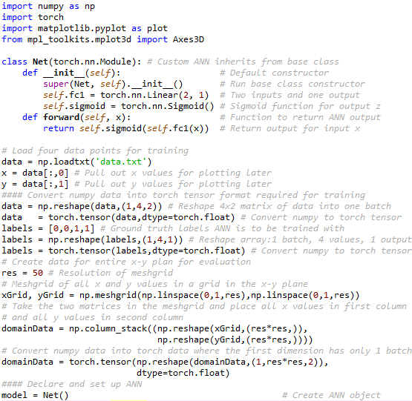

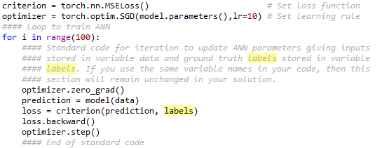

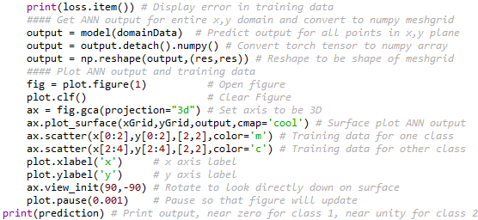

The solution to this problem, will train an ANN to recognize whether an image contains a face or not. The grayscale images are reasonably small, 19 pixels by 19 pixels, so each image produces 19×19 = 361 input values. Like previously, there will be a single output where zero indicates “not a face” and unity “is a face”. Use a more complicated architecture than previously, where additional “hidden” nodes are inserted between the input and output nodes, see the figure below. In this problem *j* = 361 for the inputs, *m* = 50 for the hidden nodes, and *n* = 1 for a single output node. Use the example given above as a template for building the solution, and more information is available in the online post [PyTorch: Introduction to Neural Network – Feedforward / MLP](https://medium.com/biaslyai/pytorch-introduction-to-neural-network-feedforward-neural-network-model-e7231cff47cb). Especially useful is the class inheritance under the heading “Feedforward Neural Network”, where input_size is 361 and hidden_size is 50 in our case (this online example, like our situation, has a single output). Use either sigmoid (as all examples here have) or ReLU (as the online post does) for the hidden nodes, but be sure of the sigmoid on the output node (as in all examples).

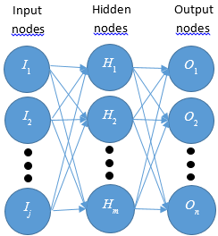

The input data is organized as two folders, one with 50 images of faces and another folder of not face images. The glob.glob function returns a list containing strings of all the filenames in a given directory. Loop through each filename in both of the directories to read in each image, and reshape the 19×19 image into a single row to store the input data. The result will be two Torch tensors, one for the pixel inputs values and another for the ground truth outputs for each image. The input data will be of size 1×100×361 (1 batch, 100 images, 361 pixel values) and the output 1×100×1 (1 batch, 100 images, 1 output). The ground truth output values should be 0 (not a face) or 1 (is a face). Run a sufficient number of iterations so that the ANN correctly classifies all 100 images, i.e. the output is greater than 0.5 for faces, and less than 0.5 for not faces.