Abdulaziz Salem Almalki

aalmalky88@gmail.com

Aqar Historic Data

**CASE STUDY**

**Data**

Historical data for sales deal indicators, including the number of sale deals, their total values, and the average price per meter according to location and property classification

.

**Objectives:**

1. EDA which exploring the data examining and understanding the characteristics of your dataset
2. Cleaning the data and make it more ready for the analysis and visualization
3. visualizing the data for gaining insights, identifying patterns, and communicating findings in a clear and effective manner
4. applying a regression technique for to more understanding of the relationship between prices and time

**Tools:**

1. Python.
2. SQL.
3. Excel.
4. Tableau

**Step 1:**

EDA :

1. Basic Information about the Dataset:

* the first few rows of the dataset to get an overview.
* the data types of each column.
* missing values.
* Summary of the dataset

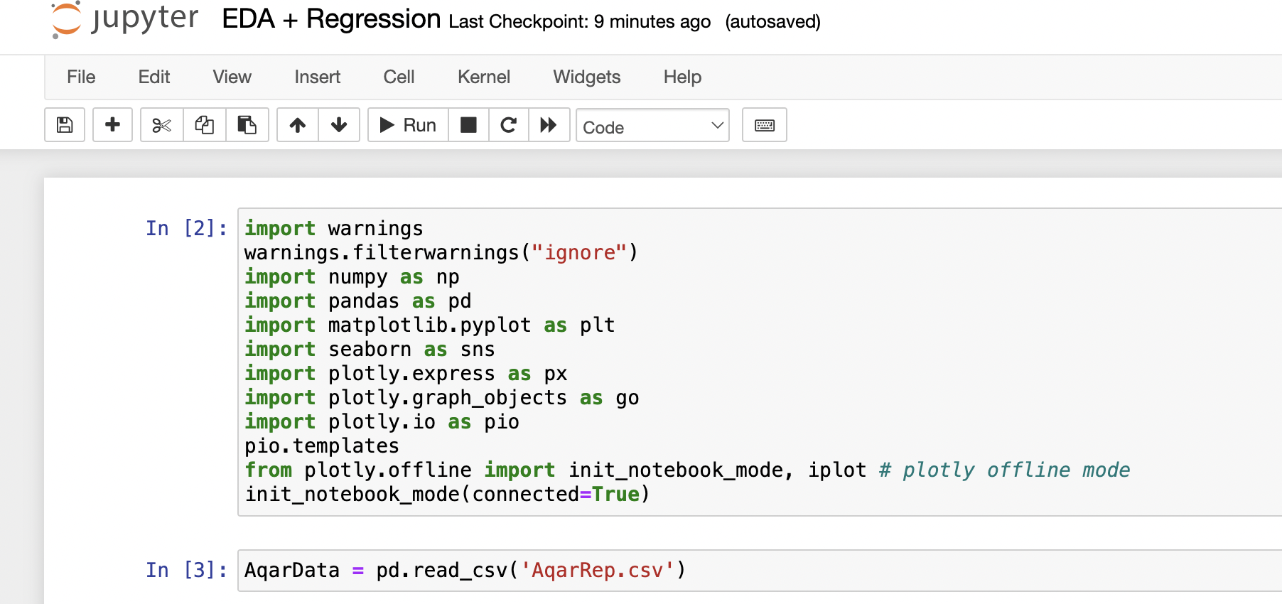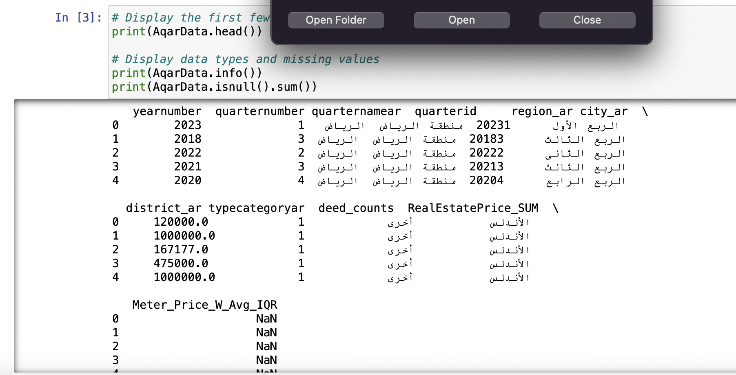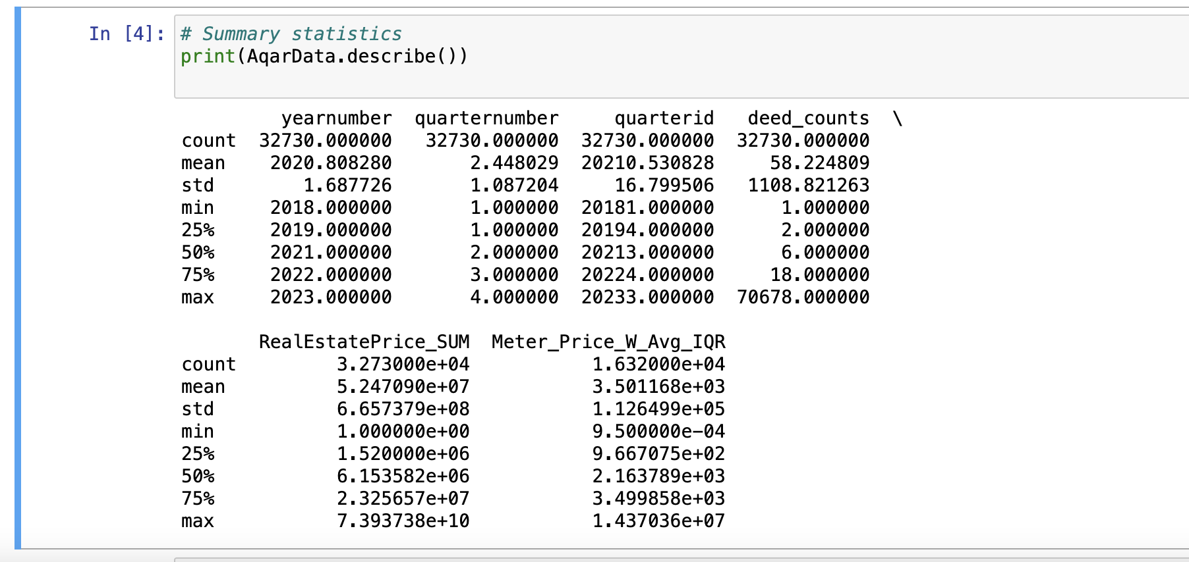

1. visualization for more clear understanding

* Histogram.
* distribution of categorical variables.
* Boxplot to identify outliers.

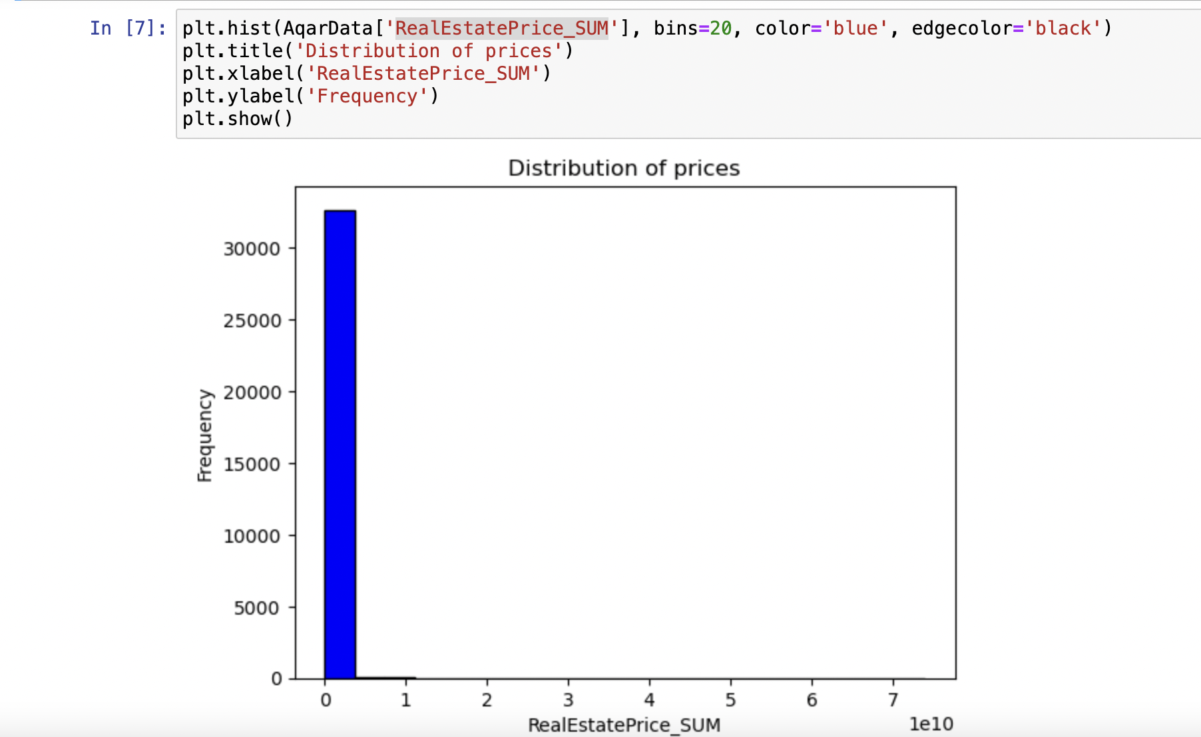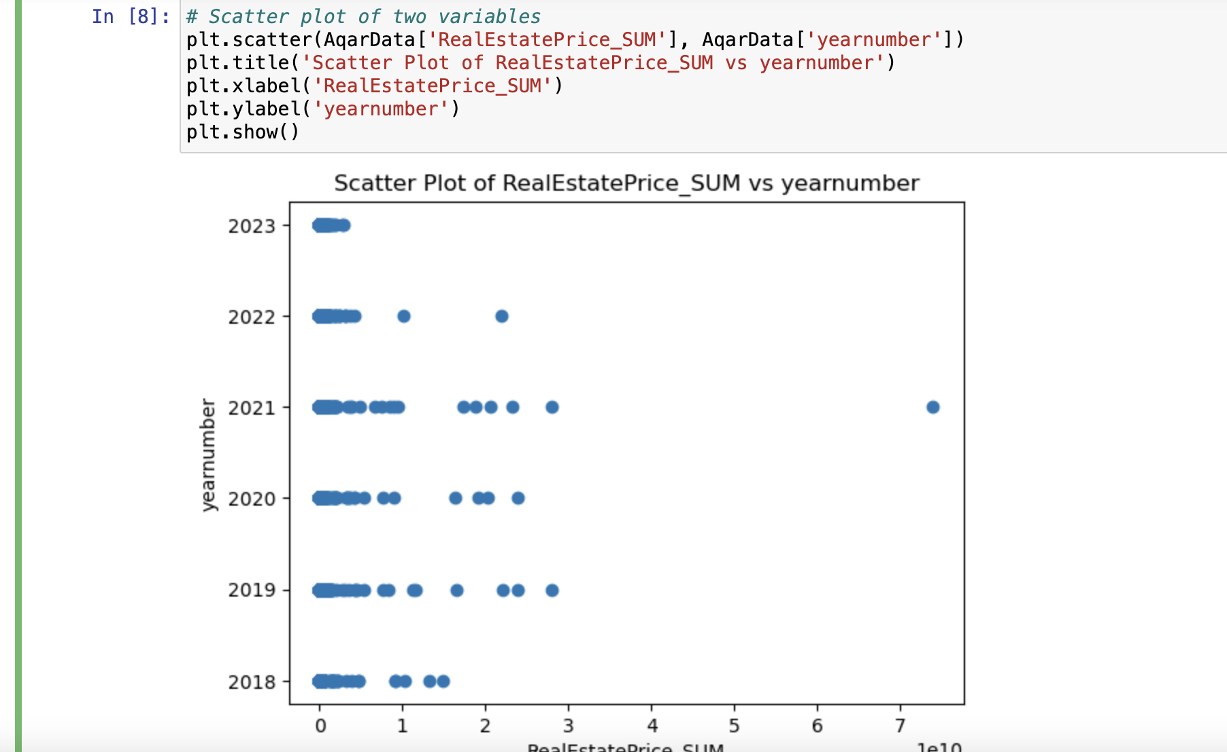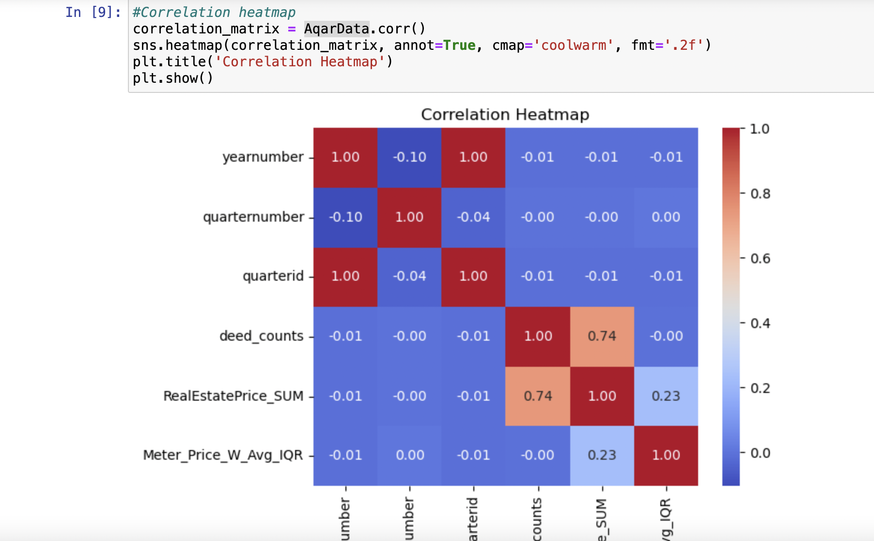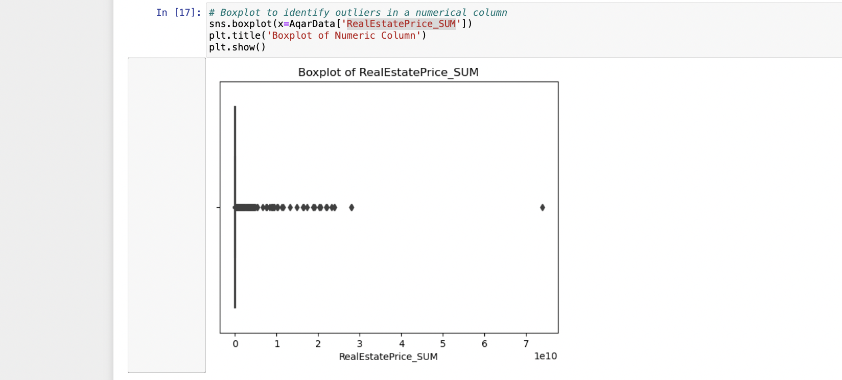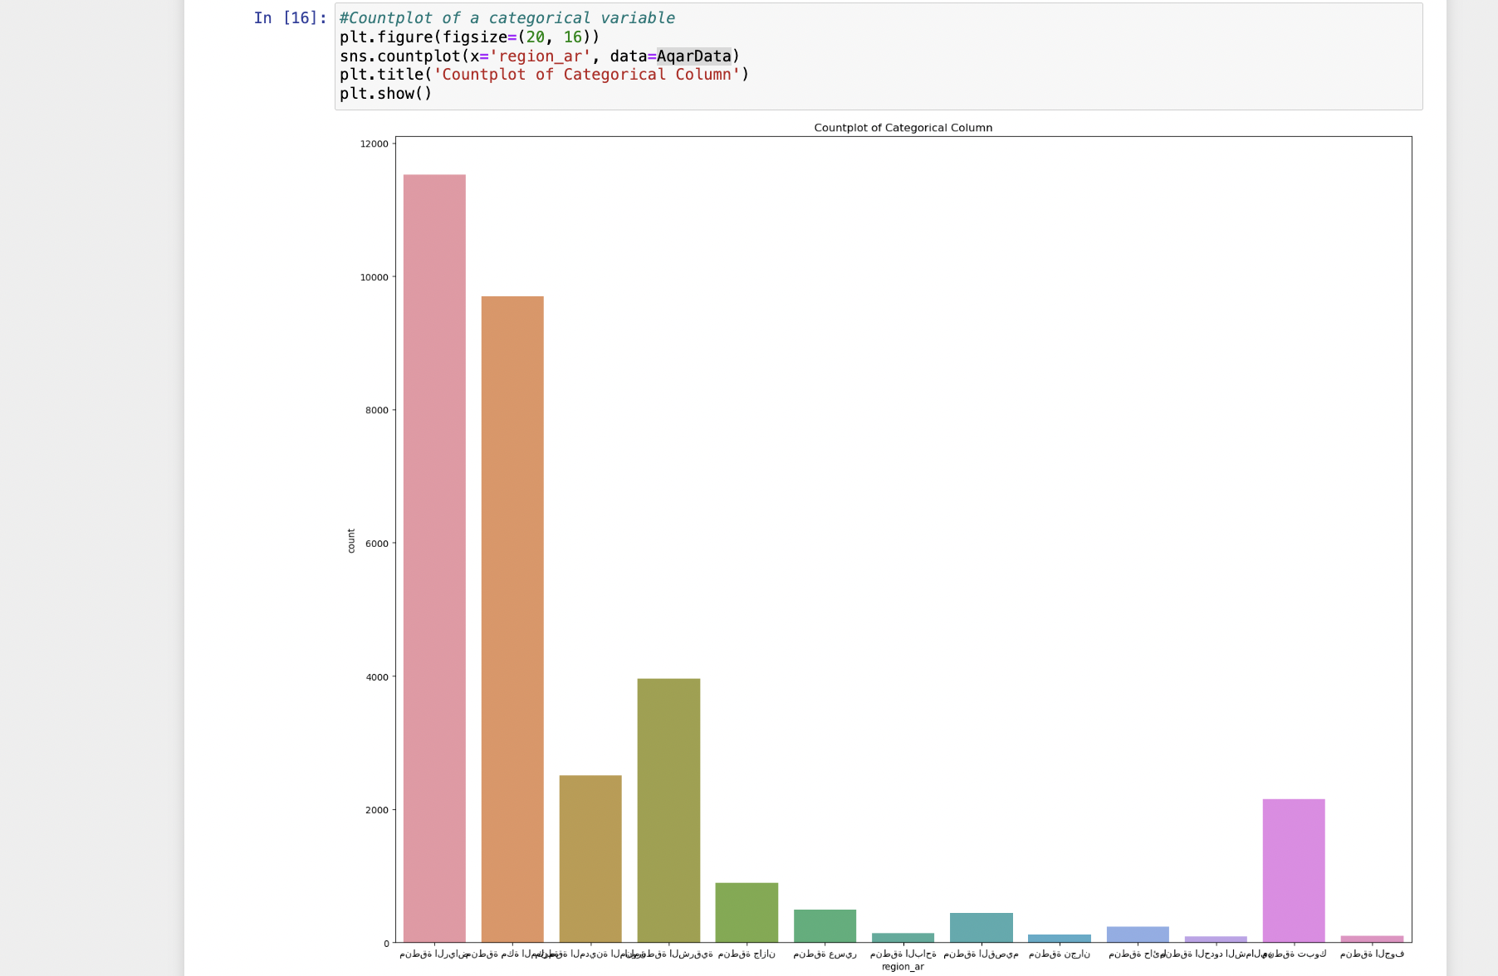

1. Regression analysis

* LinearRegression.

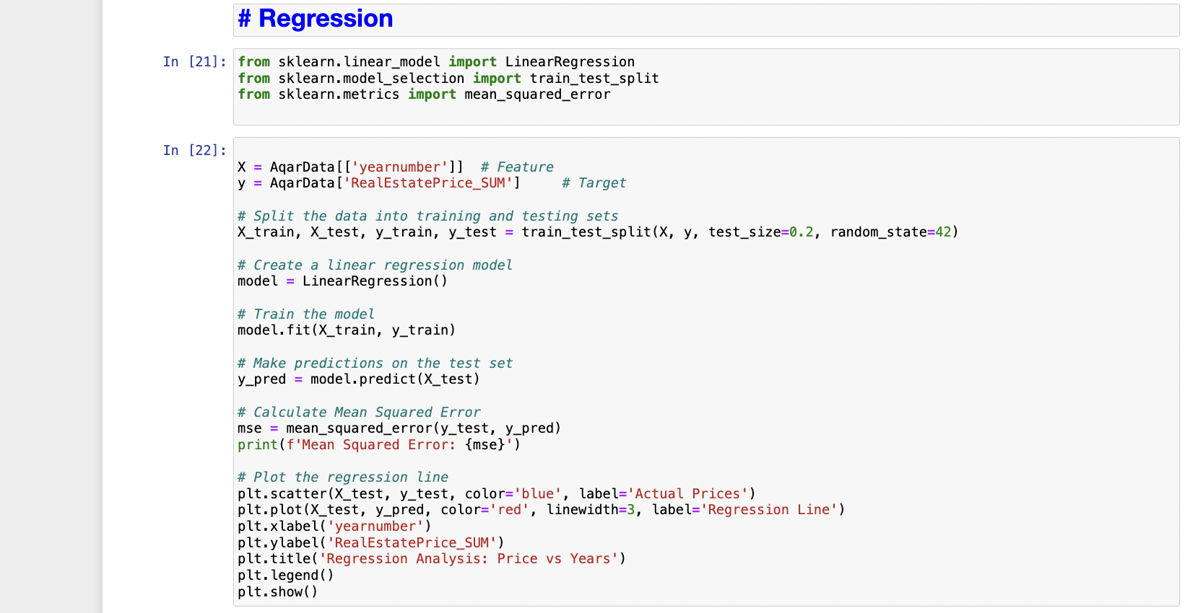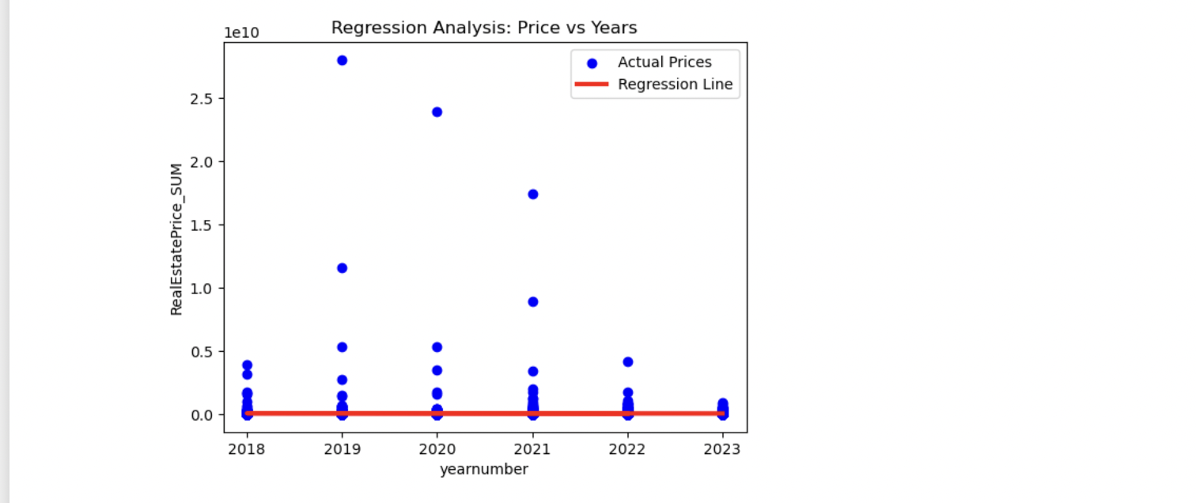

.

**Step 2:**

Data Cleaning :

* Rename some columns.
* Replacing blanks and nulls.

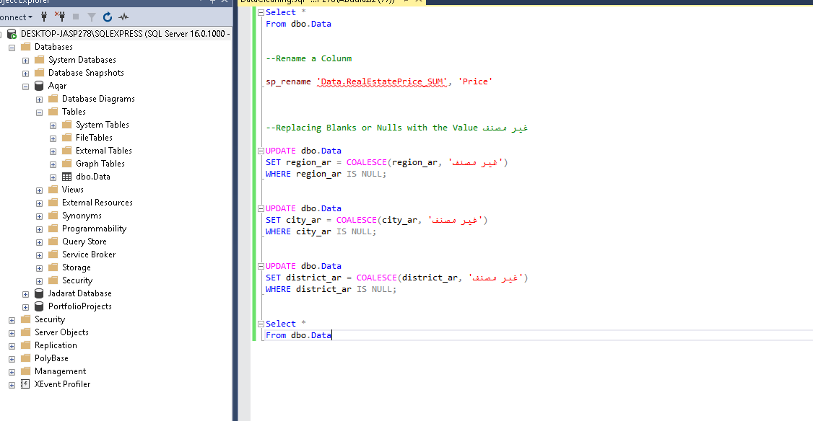

**Step 3:**

Exporting data into Excel :

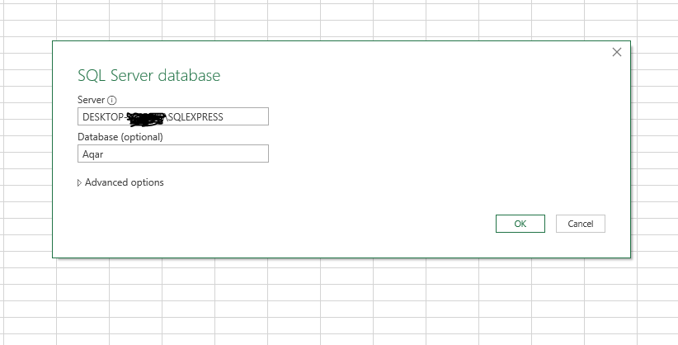

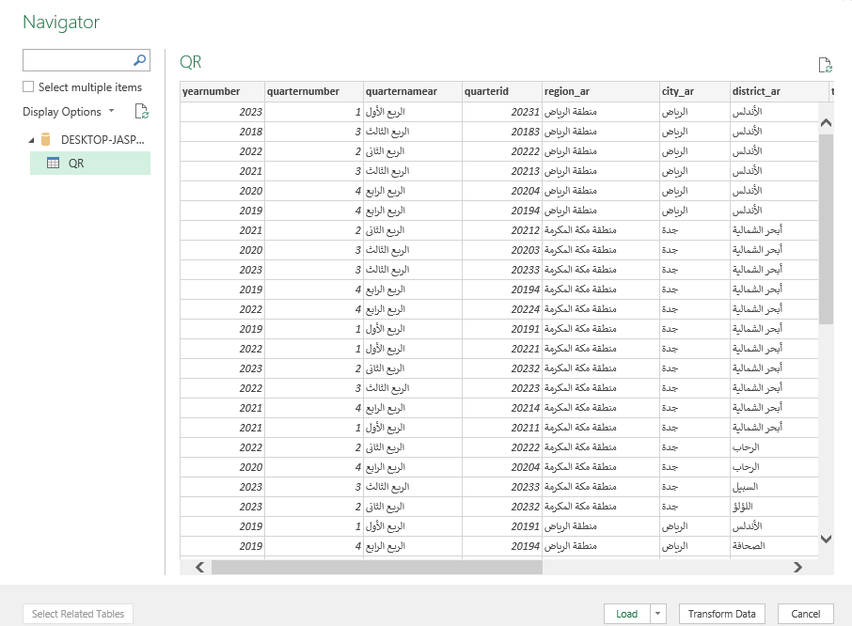

**Step 4:**

Creating the Dashboard Using Tableau:

* Number of total Records and Deeds.
* AVG for Prices by Region and Meter Price by Region.
* Total sales Prices by Regions and top 5 Regions.

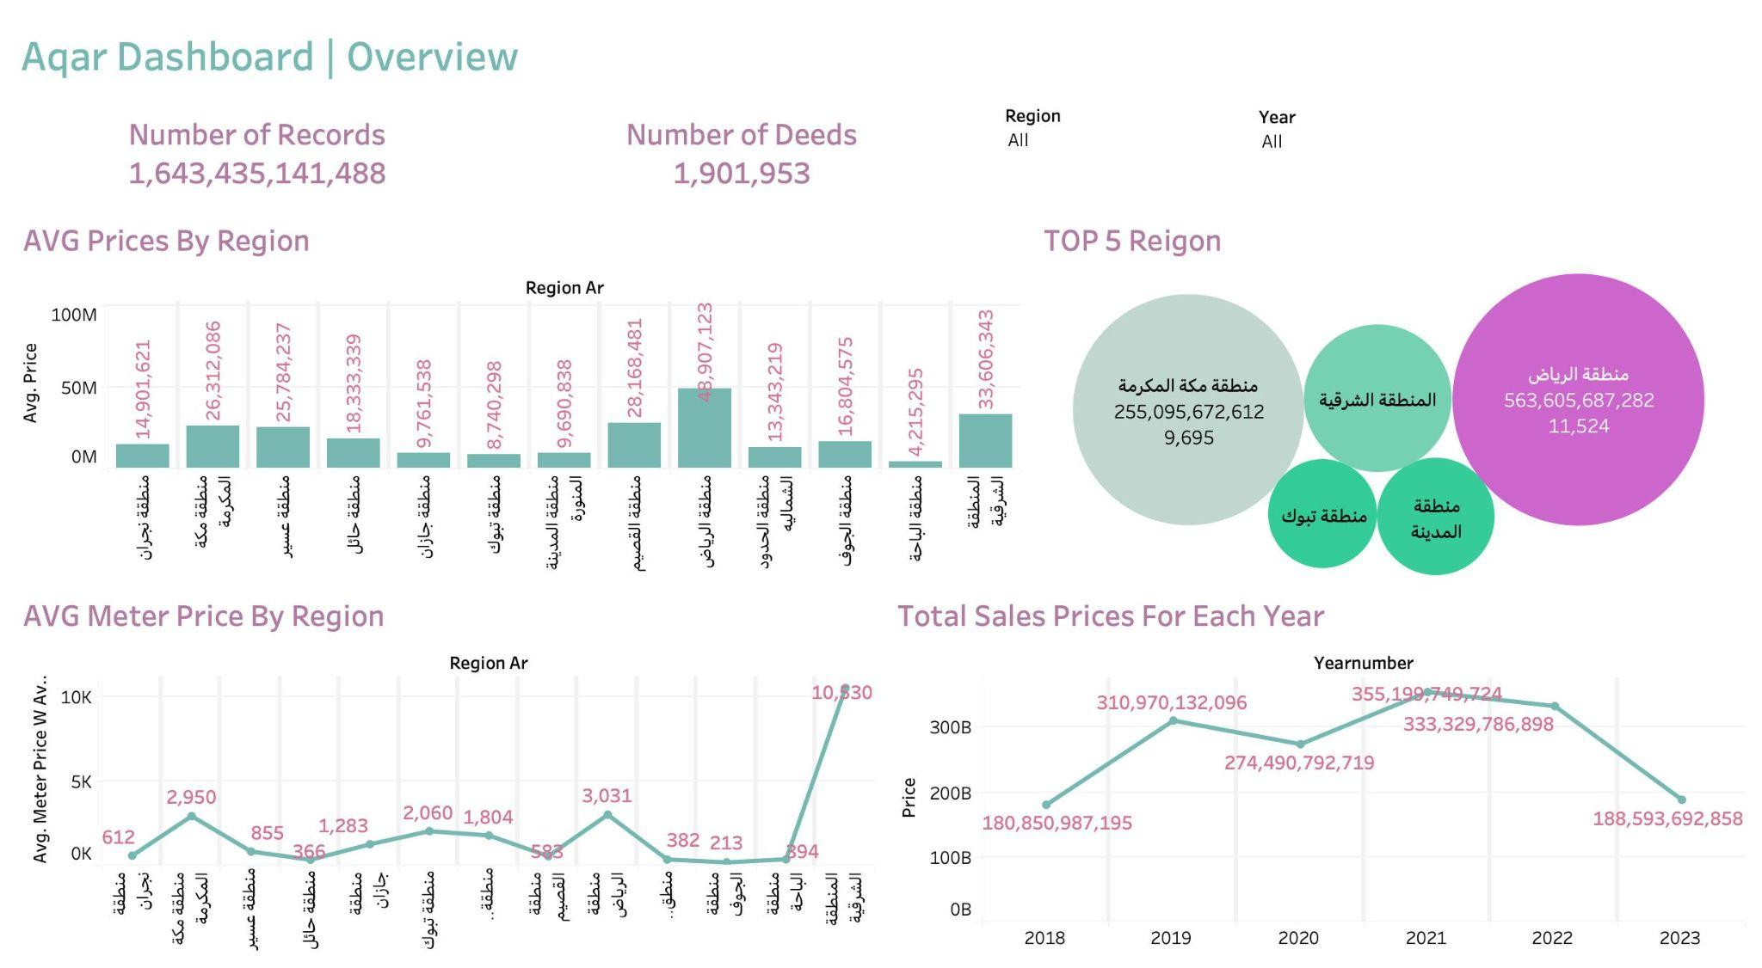

Access the live Dashboard By Clicking [Here](https://public.tableau.com/views/AqarDashboard/Dashboard?:language=en-US&publish=yes&:display_count=n&:origin=viz_share_link)

**Insights**

In this study, we try to describe and analyze historical ٍRealestate “Aqar” data through the use of a type of analysis called descriptive analysis, and what we have achieved is describing the current data and clarifying the relationship between the columns and various factors such as “price changes in each year”.

The final result is a comprehensive analysis and understanding of the historical data.