

Lab 5

Operating Systems

ITSC 200: Network Protocols and Security

Table of Contents

Lab Outcome 2

Reading 2

Introduction 2

1.0 Use Basic Linux Commands 3

References 6

Lab Outcome

* Gain familiarity with the Linux (Bash) command line and bash shell scripting.

Reading

* Linux Cheat Sheet 1

Introduction

This lab is to familiarize you with using shell commands and Bash shell scripts in a Linux environment. Use the VM you created on the Proxmox cluster; you can also practice this lab at home on your laptop.

1.0 Use Basic Linux Commands

1. Use your account to connect to the Proxmox cluster.
2. Log in into your VM with the account you created during the install. Open a Terminal window.
3. You will see a window as in Figure 1.

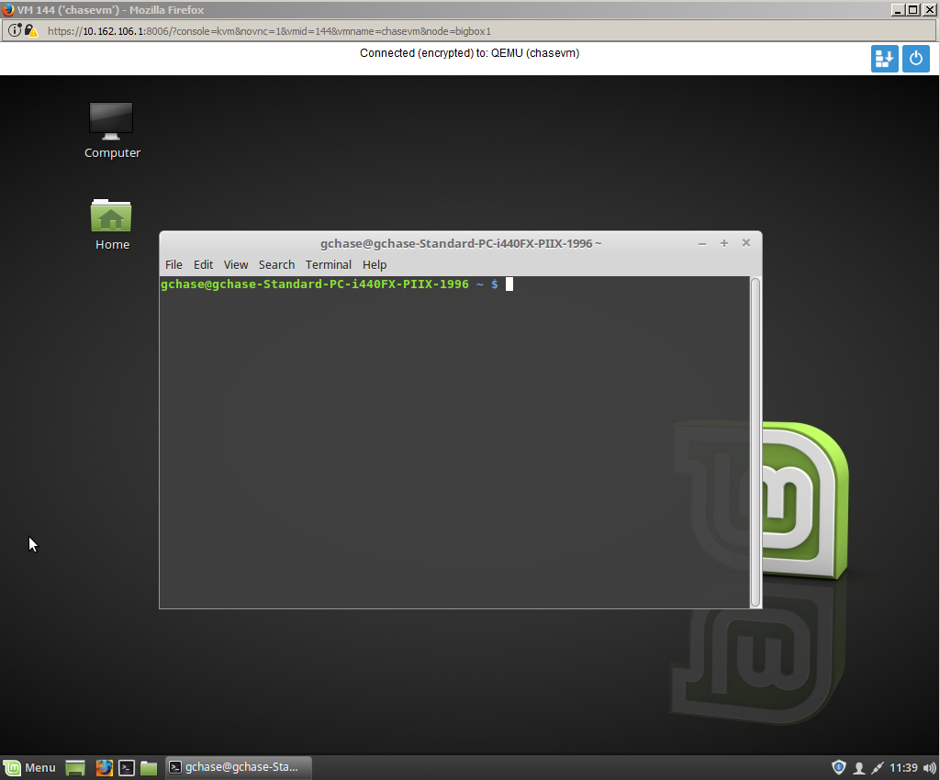  
Figure 1:

1. Find the IP address of the VM.  
     
   IP Address 10.162.106.155
2. Close your Proxmox console connection and log out of Proxmox.
3. SSH into your server using Tera Term or Putty.
4. Use one command to list the contents of the /etc/skel directory in long format and sent the output to a file in your home directory called skel.txt (ls –al /etc/skel > skel.txt)
5. Add the date and the current logged-in user to skel.txt

who >> skel.txt

date >> skel.txt

1. Use a command to print out, from /etc/passwd, the username and shell (i.e., /bin/bash) sorted by last name to a file called allusers.txt in your home directory.  
   cat /etc/passwd | cut –d: =f1,3 | sort : more > alluser.txt
2. Modify your previous command do the same thing, but to print only those users using /bin/bash to a file called loginusers.txt in your home directory.

cat /bin/bash | cut –d: =f1,3 | sort : more > loginuser.txt

1. Use the set command to see all of the environment variables that are set in your current login. Use those environment variables to create a small Bash script that will produce the output shown in Figure 2 on the screen (using your username and machine name).  
   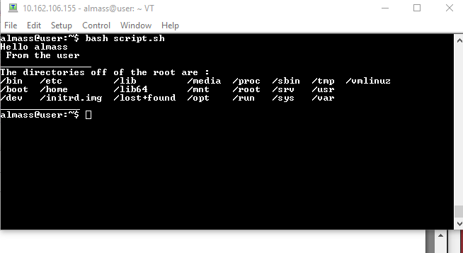
2. Modify your script to send it to a file named <machinename>.txt and add the current directory to the file shown in Figure 3.

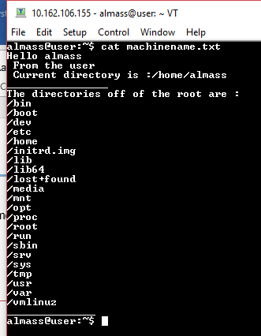

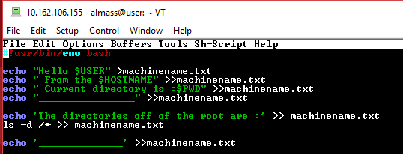

1. Create a small script to find all of the files on your computer that are larger than 100 MB. Write the output to the screen.

