1.0 Build a Linux Server

1. Use your Proxmox account to connect to the Proxmox cluster and install a Debian 9 Linux server. Create user1 and user2 accounts.  
   **sudo adduser user1**

**sudo adduser user2**

1. Write a Bash shell script that will update your system and install the following software.  
   1. Wireshark

**#!bin/bash**

**apt-get update**

**apt-get install wireshark**

* 1. Apache2

**#!bin/bash**

**apt-get update**

**apt-get install wireshark**

* + Your script should create a text file (<yourname>.txt) in your home directory that searches for Apache2 running daemon(s) and outputs the result to your text file.  
    **ps aux | grep apache2 > ahmeda.txt**
  + It should list all the users on the system that use /bin/bash as their shell.  
    **cat /etc/passwd | grep /bin/bash | cut –d: -f1 >> ahmeda.txt**
  + It should check what ports are listening on the NIC address (not the loopback) and write that out to the text file as well.  
    **netstat –lp | grep | -v “127.0.0.1” >> ahmeda.txt**
  + Your script should check the IP address and print only the IP address to the text file. (Hint: Use *ifconfig* and pipe it to *grep* and *cut* to isolate the IP address.) It is very useful to have a shell script that can figure out the IP address. **ifconfig | grep "inet addr" | grep -v "127.0.0.1"| cut -d ':' -f 2 | cut -d ' ' -f 1' >> ahmeda.txt**

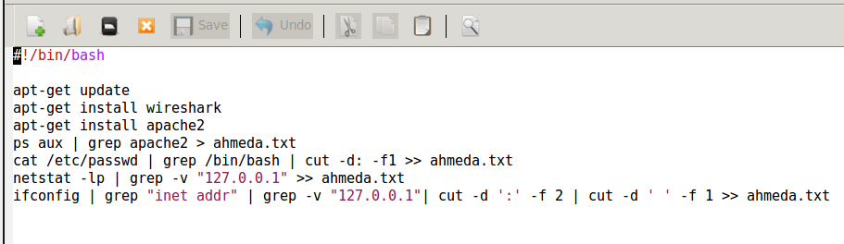

1. Write another Bash shell script to create the directory structure in Figure 1.

/home/<username>/info1

Info5

Info4

Info2

Info3

|

**#!bin/bash**

**mkdir /home/user/info1**

**mkdir /home/user/info1/info2**

**mkdir /home/user/info1/info2/info3**

**mkdir /home/user/info1/info4**

**mkdir /home/user/info1/info4/info5**

The same script should also:

* 1. Set the ownership of the info2 branch (and subdirectories) to user1.

chown –R user1:user2 info2

* 1. Do the same for the info4 branch, but set ownership to user2

chown –R user2:user2 info4

* 1. Modify the permissions of the info2 branch to allow full access to user1 and no access to anyone else.

chmod –R 700 /home/user/info1/info2

* 1. Modify the permissions of the info4 branch to allow full access to user2 and read and execute access to anyone else.

**chmod –R 755 home/user/info1/info4**

