
Lab 4: Run-Time Kernel Memory Patching
Operating Systems Exploitation
Table of Contents
Lab Outcomes 2
Introduction 2
1.0 Patching Kernel Code 2
2.0 Patching Call Statements 2
3.0 Allocating Kernel Memory 2
4.0 Inline Function Hooking 2
5.0 Cloaking System Call Hooks 2
6.0 Sign-Off – Lab 4: Run-Time Kernel Memory Patching 3

Operating Systems Exploitation
Lab 4: Run-Time Kernel Memory Patching

Lab Outcomes
- Patch kernel code.
- Patch kernel memory.

Introduction
In this lab, you will experiment with functions to access kernel data, compare techniques to cloak system call hooks, elevate privileges of processes and threads, skew forensics and take full control of a system. You will find the examples for this lab in your textbook, Designing BSD Rootkits: An Introduction to Kernel Hacking.

1.0 Patching Kernel Code
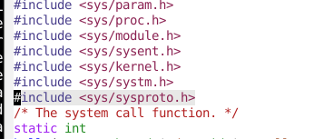
Go to pp. 68–69 in your textbook and convert the BSD example to perform the same functionality in your Linux environment.

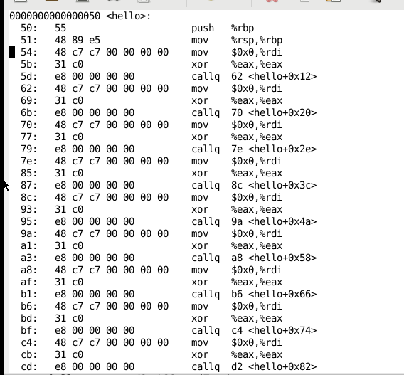

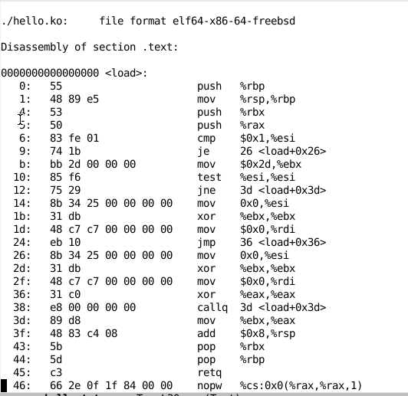

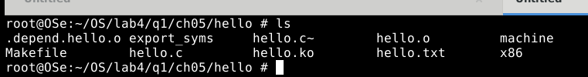

2.0 Patching Call Statements
Go to pp. 71–72 in your textbook and convert the BSD example to perform the same functionality in your Linux environment.

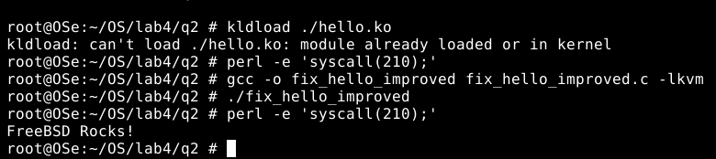

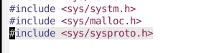

3.0 Allocating Kernel Memory
- Go to pp. 75–77 in your textbook and convert the BSD example to perform the same functionality in your Linux environment.
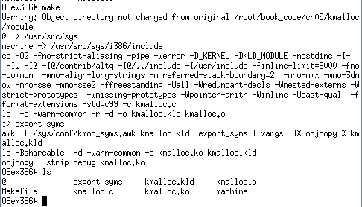

- Go to pp. 77–80 in your textbook and convert the BSD example to perform the same functionality in your Linux environment.
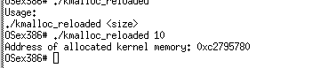

4.0 Inline Function Hooking
Go to pp. 84–87 in your textbook and convert the BSD example to perform the same functionality in your Linux environment.
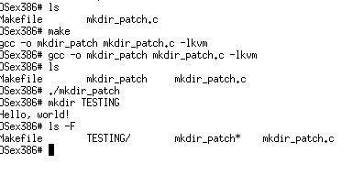

5.0 Cloaking System Call Hooks
Go to p. 89 in your textbook and convert the BSD example to perform the same functionality in your Linux environment.

6.0 Submission – Lab 4: Run-Time Kernel Memory Patching
Submit it to D2L

Weight: 6%

